Nginx Ingress Controller with k8s cluster
Documentation prepared by Tulasi
Install the docker (apt install docker.io -y)
Start and enable the docker
systemctl start docker
systemctl enable docker
Create index.html
Write some content
Create docker file
# Use the official Nginx image as the base image
FROM nginx:latest

# Remove the default Nginx website
RUN rm -rf /usr/share/nginx/html/*

# Copy the application files to the Nginx html directory
COPY index.html /usr/share/nginx/html

# Expose port 80
EXPOSE 80

# Start Nginx when the container launches
CMD ["nginx", "-g", "daemon off;"]
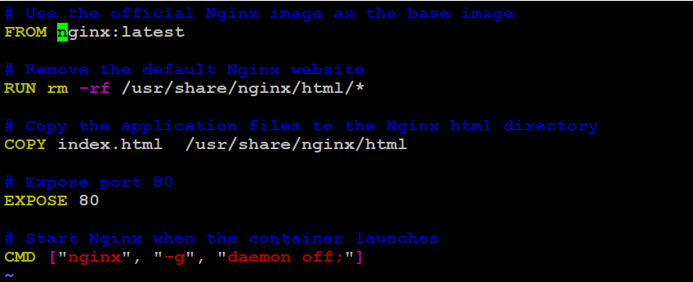
docker build -t ramatulasi/nginx:latest .
docker run -d -p 80:80 --name my-app ramatulasi/nginx:latest
docker push ramatulasi/nginx:latest
I followed steps by this website https://medium.com/@fawazcp/kubernetes-ingress-controller-00331801103d
Step 1 :
Enter the below command to create the controller
kubectl apply -f https://raw.githubusercontent.com/kubernetes/ingress-nginx/controller-v1.10.1/deploy/static/provider/aws/deploy.yaml
We have created the ingress controller but let’s see what and all the things are created
Step 2 :
Run
kubectl get ns
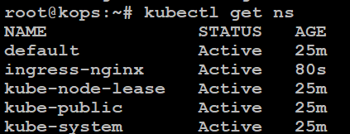
Step 3 :
kubectl get all –n ingress-nginx
Now we can see the load balancer is also created. If you go to the AWS management console we can see the network load balancer has been created
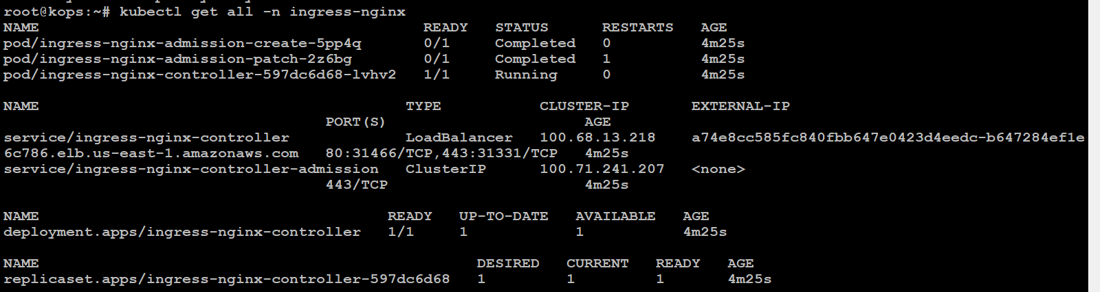

Step 4 :
we can deploy our application using the ingress controller.
vi dep.yaml
apiVersion: apps/v1
kind: Deployment
metadata:
name: my-app
spec:
selector:
matchLabels:
run: my-app
replicas: 1
template:
metadata:
labels:
run: my-app
spec:
containers:
- name: my-app
image: ramatulasi/nginx
ports:
- containerPort: 80

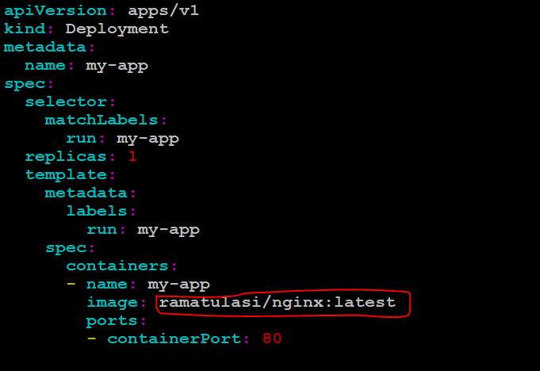
Pull the image from our docker hub
kubectl apply -f deploy.yaml
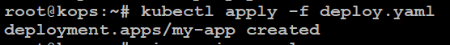
deployment is created
run kubectl get pod
Step 5 :
Create a new file to create a service
vi service.yaml
apiVersion: v1
kind: Service
metadata:
name: my-app
spec:
ports:
- port: 80
protocol: TCP
targetPort: 80
selector:
run: my-app
type: ClusterIP

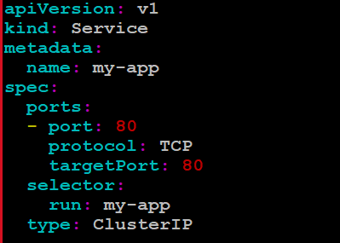
Run this command
kubectl apply -f service.yaml
service is created
let’s check our service is running.
kubectl get service
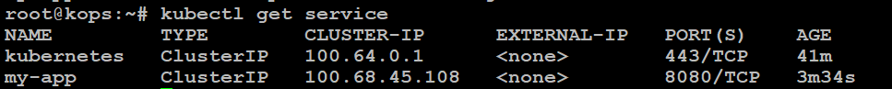
Step 6 :
kubectl describe service my-app
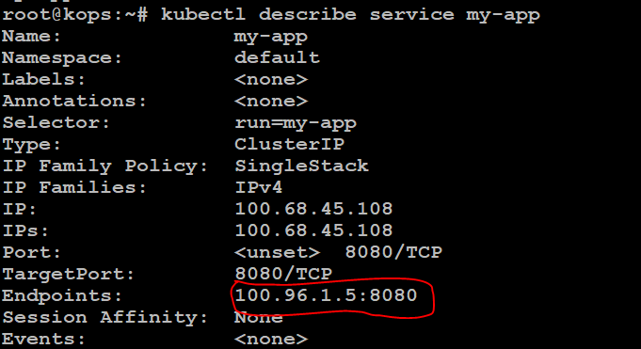
Our service is up and running. Now let’s create the ingress controller.
Step 7 :
Create new file to create ingress controller
vi ingress.yaml
apiVersion: networking.k8s.io/v1
kind: Ingress
metadata:
name: nginx-ingress
annotations:
nginx.ingress.kubernetes.io/use-regex: "true"
spec:
ingressClassName: nginx
rules:
- host:
http:
paths:
- path: /
pathType: Prefix
backend:
service:
name: my-app
port:
number: 80
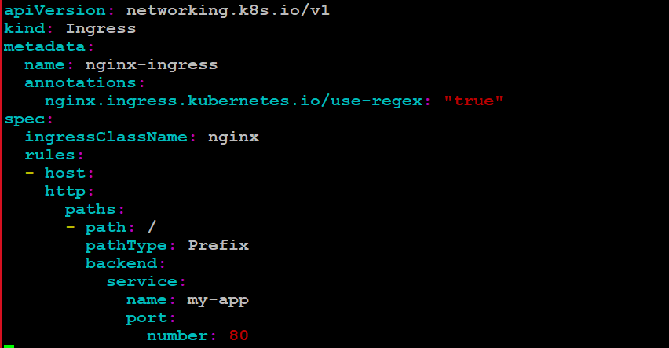
run
kubectl apply –f ingress.yaml
ingress is created
kubectl get ingress
The load balancer will route the traffic to the service where our app/pod is running
We copy the domain name and paste it in the browser we can see our app is working
