Title : Machine Learning Based Simulation Approach To Predict Electrostatics Of Nanoscale Transistors

Objective: Simulating electrostatics of nanoscale transistors through traditional approaches like tight binding method is extremely tedious and time consuming.An ML based approach is required to counteract these issues and produce faster results.

Project Work:

n(x)/nmax = (n0 + sinh^2((a1*pi*x)/tsi))*cos^2((a0*pi*x)/tsi))
Problem : For the above equation , optimize the input parameters(a0,n0,n1,a1) in a systematic trend using ML to predict at extrapolated regions.

Solution:
1.Data Preparation
2.Finding the best optimization algorithm
3.Modelling

ML has optimization algorithms which are used to predict the input parameters , when the output and the equation is given .Differential evolution is one such algorithm used when the shape of the data is not known or changing continously. This works by generating a set of random samples for each input , inculcating math(mutation,crossover) and finds the best set of parameters with lowest error rate.

A.Differential Evolution is used on all the input parameters without any signifcant boundaries to figure out the behaviour of the parameters.The trend is shown below for 2nm at 200K plotted against gate voltage(Z).
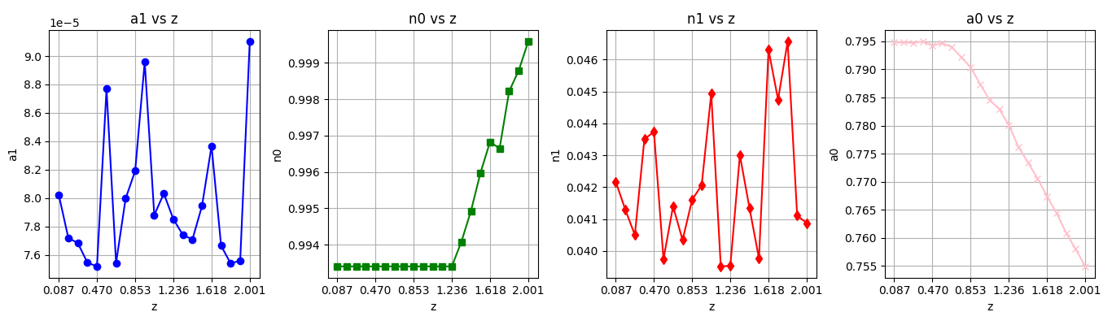
The above prepared data isnt showing a systematic trend , so i again ran DE algorithm with three unknowns instead of 4 unknowns by keeping n0=nc/nmax.The trend is shown below

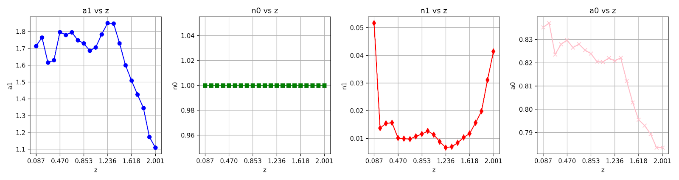

Observed n0 has a trend , this trend goes decreasing as thickness increases , even though i dont seem to find any trend for 3 unknowns with one output , so i took the average value of a0 per voltage and started optimizing with 2 unknowns(n1,a1).The trend is shown below for 2nm at different temperatures against voltage (Z).

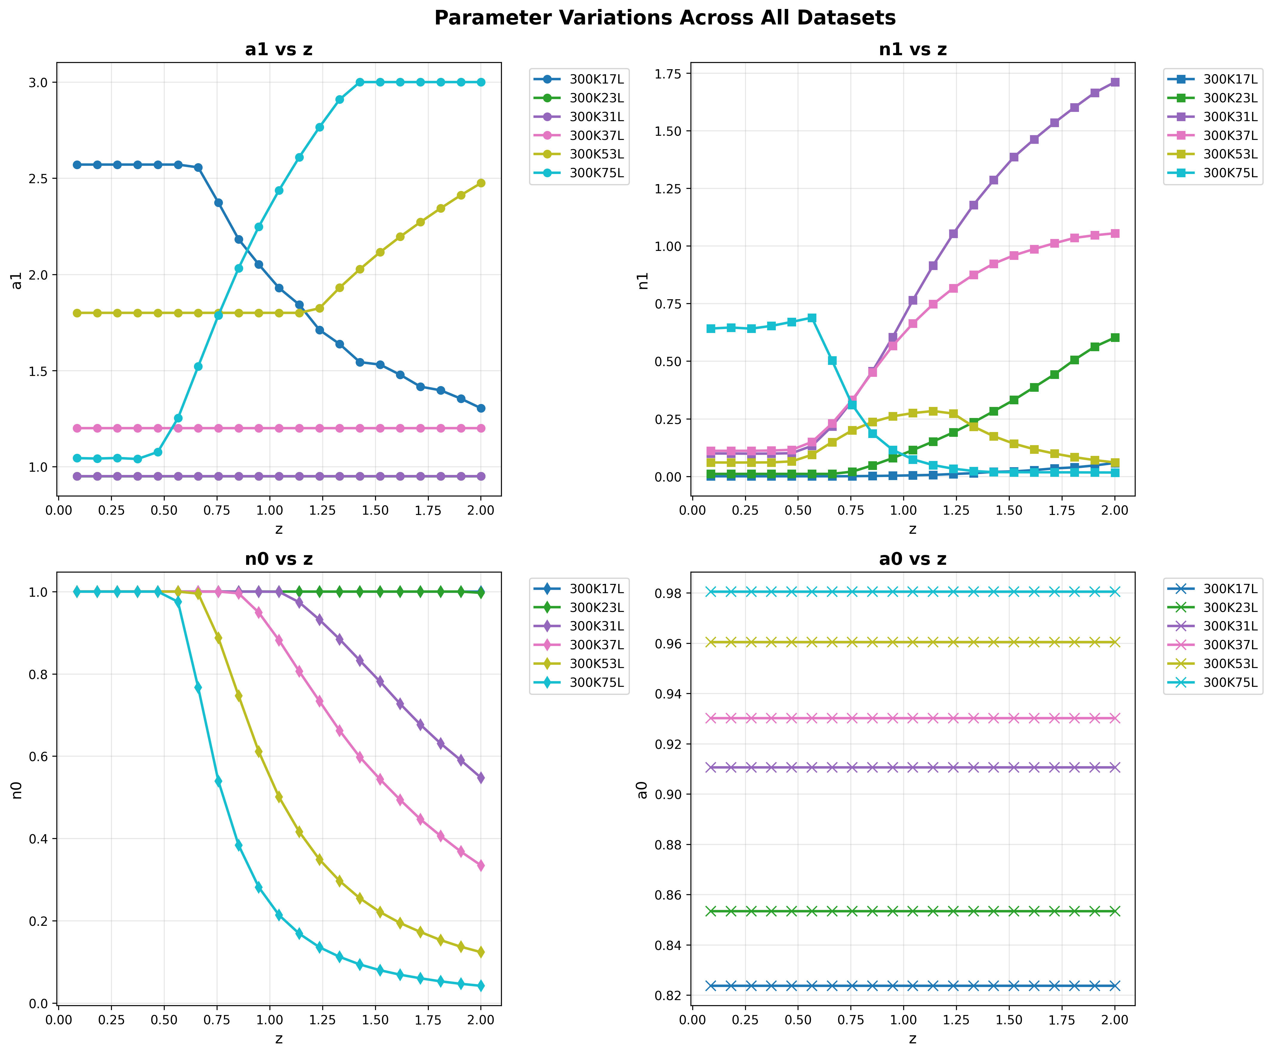
Looking at the above graph , i have achevied the systematic trend , no zig zag motion, no outliers, etc , a smooth non linear trend is observed in n1 and a1. The concept of datapreparation is done and moving on to the modelling part , results when predicted at intrapolated regions shows 100% accuracy , and when predicted at extrapolated regions(testing 10nm by training upto 7nm dataset) , the n0 and a0 were showing a good accuracy 99% , but the n1 and a1 werent good while predicting outside , below are the results.
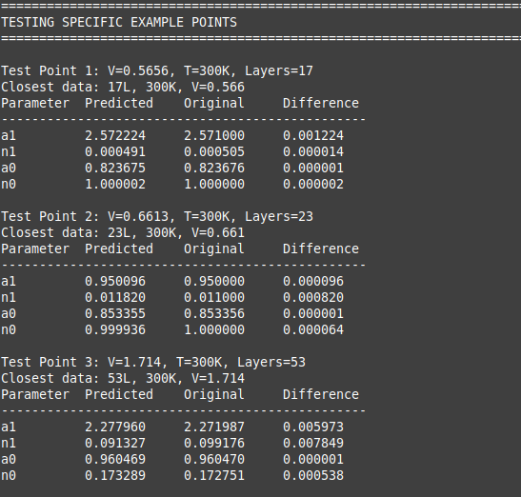

Intrapolation region results
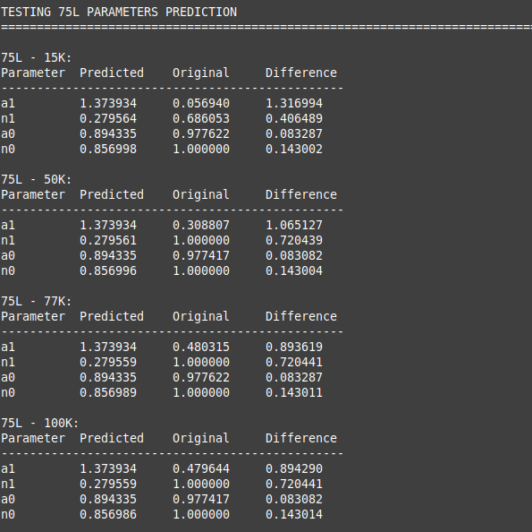

Extraploltaed region results

currently working on checking the obtained input data working for potential equation as well.

Conclusion: Im able to get the systematic trends for all the layers , still need some tuning in a1 and n1 parameters , i will work on optimizing in a better way.

