Recovery of Image Using One Dimensional Signal

Often images will be damaged and to recover images various algorithms such as wiener filtering, 2 dimensional filtering and many more but this algorithms PSNR (peak signal noise ratio called as image quality) is low and to increase quality of damaged/restoration images we are using 1 dimensional array which will convert image to single dimensional array.

Propose algorithm takes damaged image and its mask image as input and then convert both images into single dimensional array and then remove all damage mask part from the damaged image to restore original image. One dimensional restoration image quality or PSNR is high compare to 2 dimensional array.

To implement this project we have designed following modules

1. Upload Damaged Image: using this module we will upload damaged images
2. Upload Mask Image: using this module we will upload mask images
3. Two Dimensional Restoration: using this module we will apply two dimensional image restoration filtration on damaged and mask image to recover images
4. One Dimensional Restoration: using this module we will apply one dimensional filtering algorithm on damaged images to restore images and then calculate PSNR value.
5. PSNR Graph: using this module we will plot comparison PSNR graph of both one and two dimensional algorithms

SCREEN SHOTS

To run project double click on ‘run.bat’ file to get below output

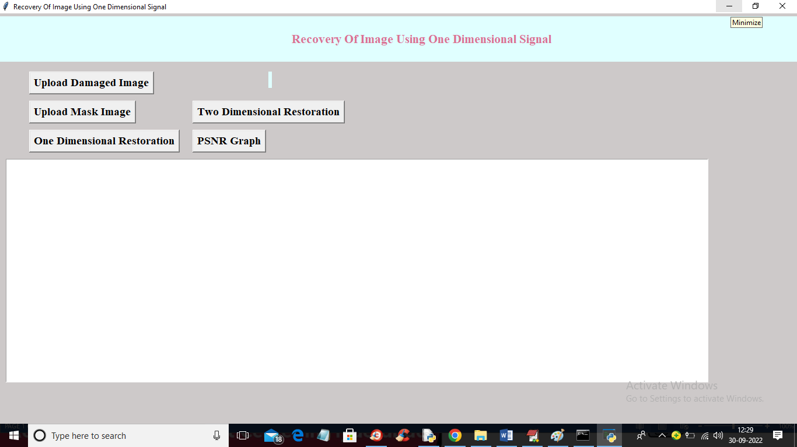

In above screen click on ‘Upload Damaged Image’ button to upload image

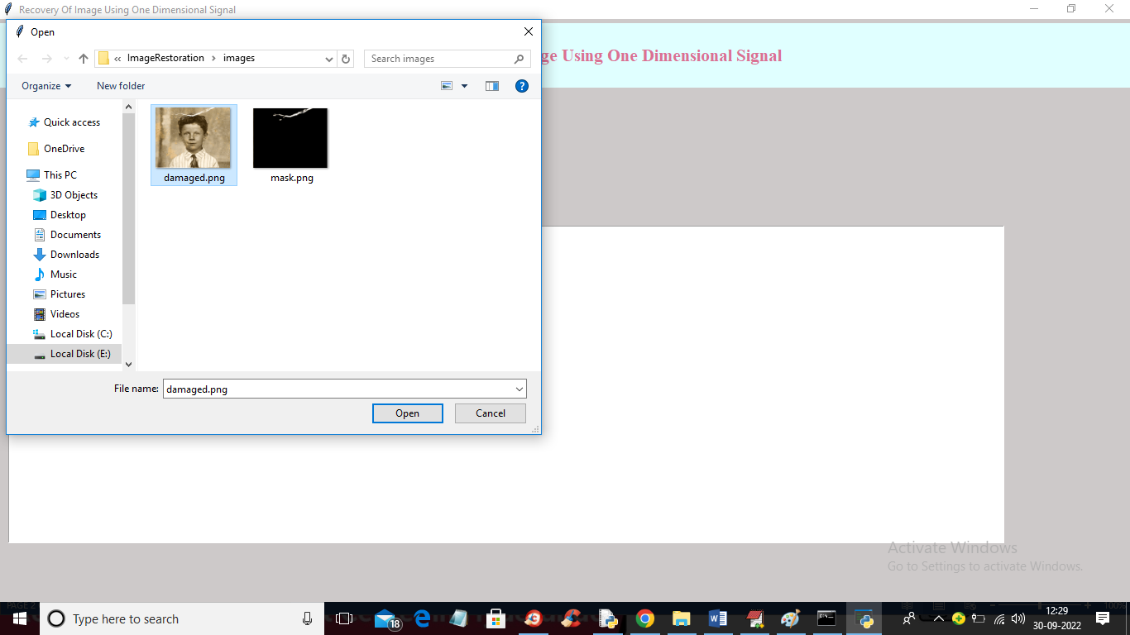

In above screen selecting and uploading ‘damaged.png’ image and then click on ‘Open’ button to upload image and get below output

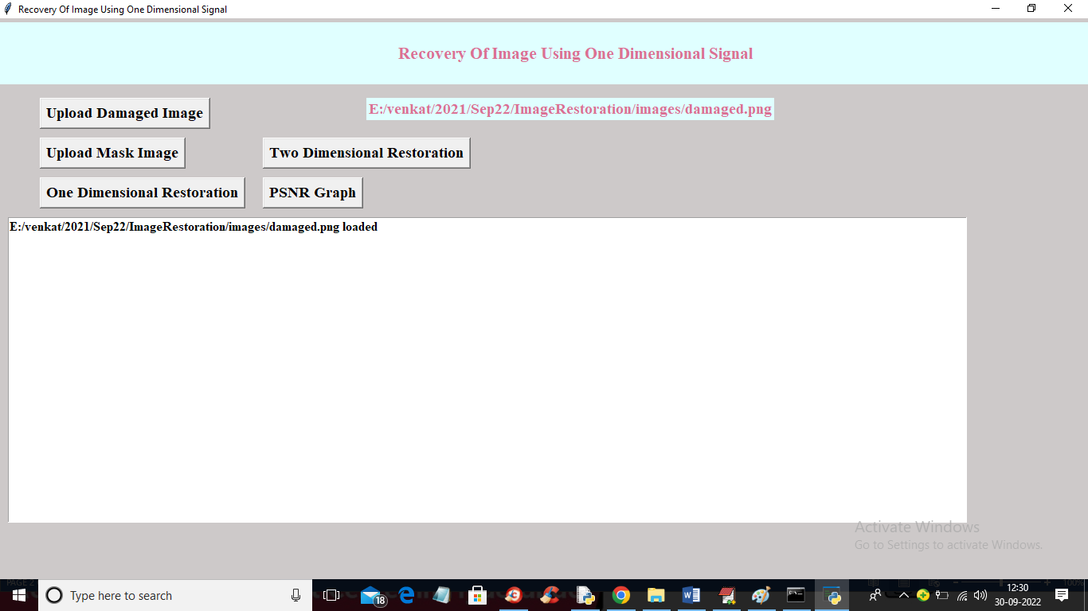

In above screen damaged image is uploaded and now click on ‘Upload Mask Image’ button to upload mask image and get below output

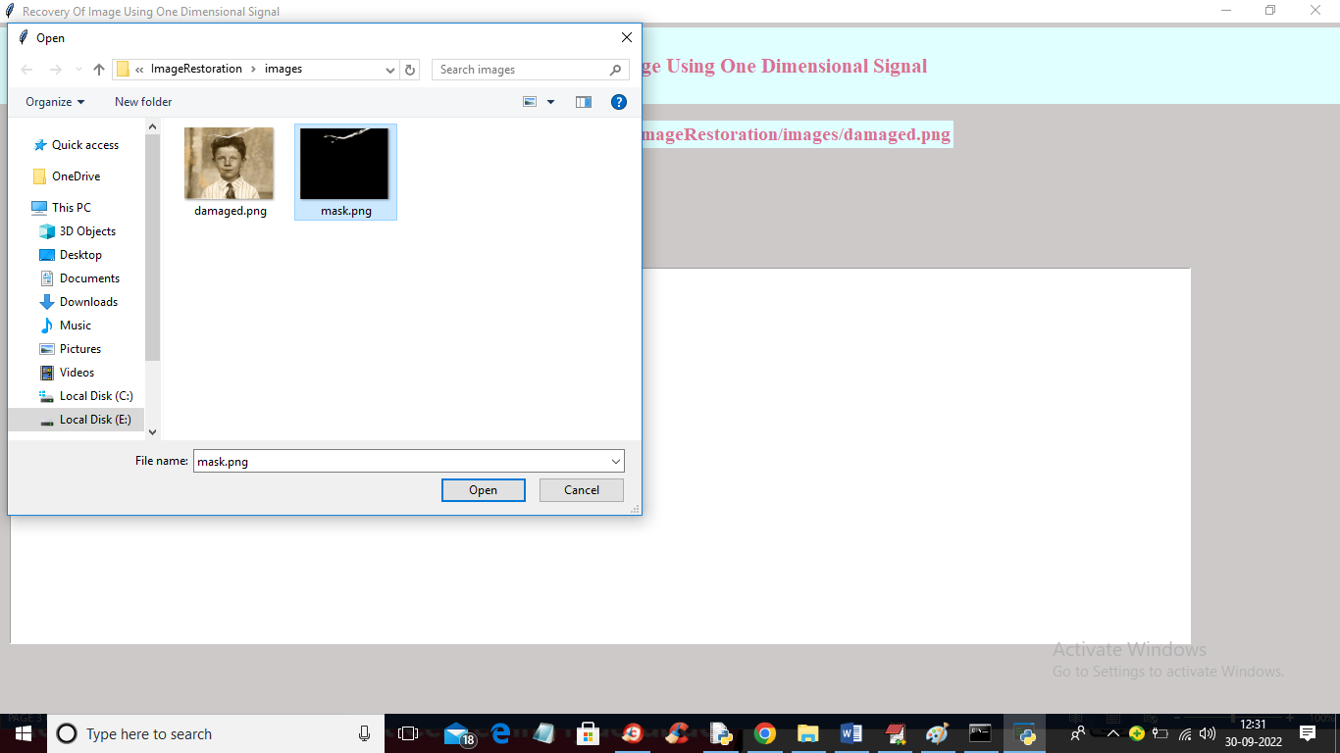

In above screen selecting and uploading mask image and now click on ‘Open’ button to load mask image and get below output

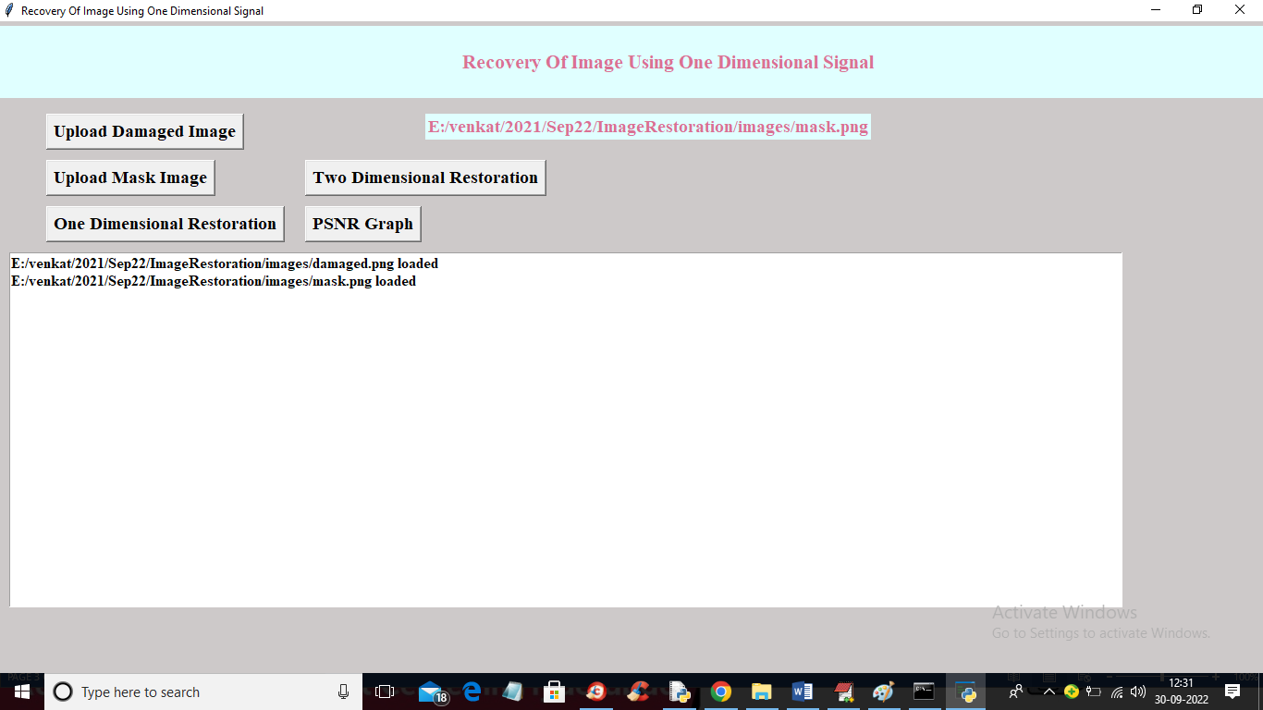

In above screen both images are loaded and now click on ‘Two Dimensional Restoration’ button to restore image using two dimensional technique and get below output

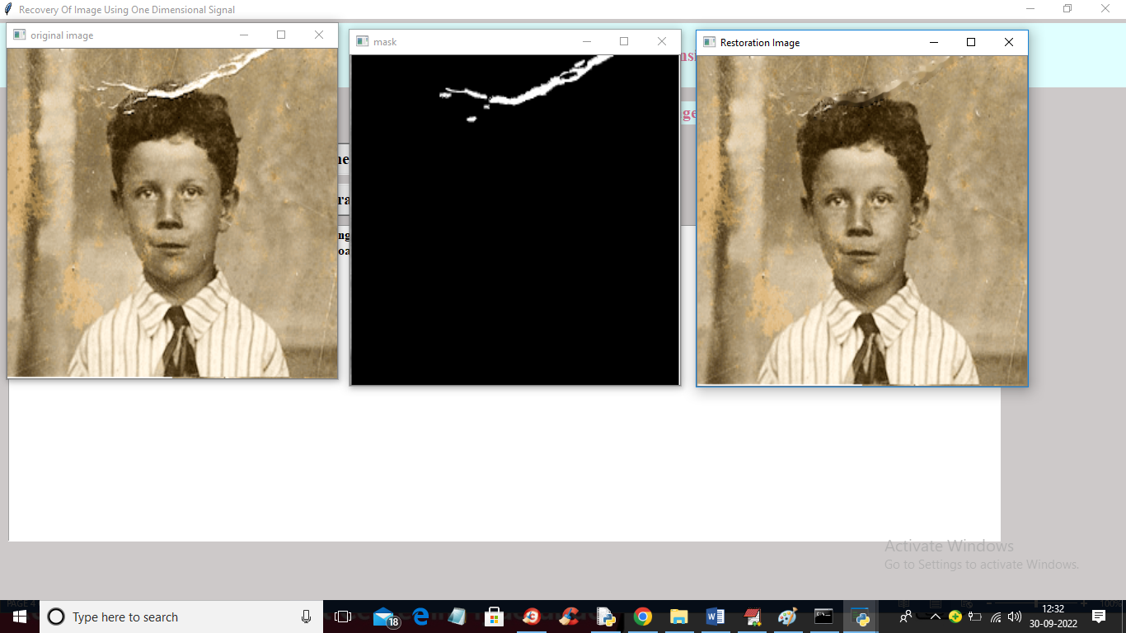

In above screen first image is the damaged image and second is the mask image of damage part and 3rd image is the two dimensional restored image and now close above images to get below PSNR

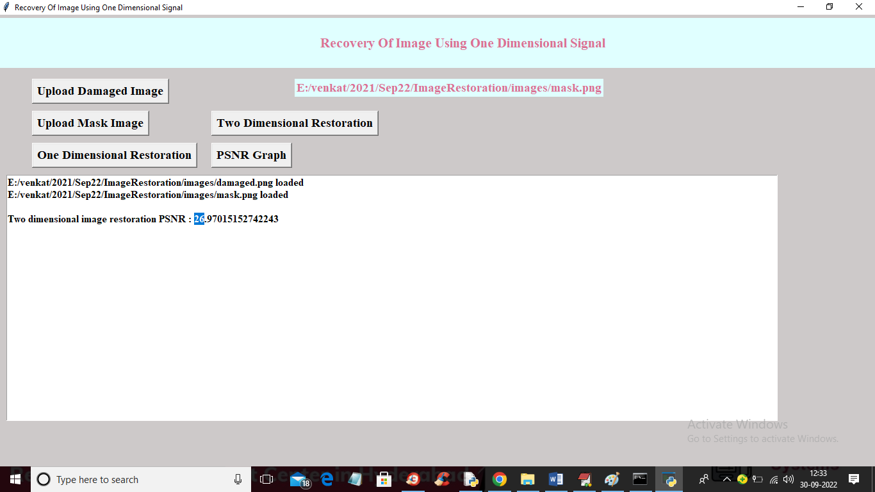

In above screen with TWO DIMENSIONAL algorithm ewe got PSNR as 26 and now click on ‘One Dimensional Restoration’ button to restore image using one dimension and get below output

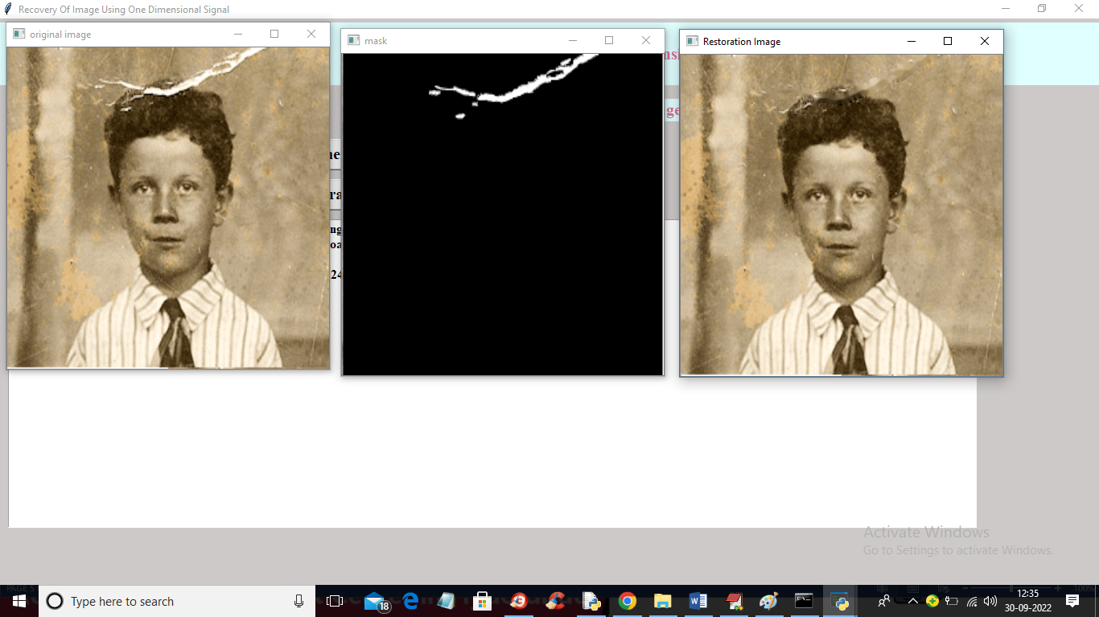

In above screen with one dimension we got little better quality image and now close above images to get below output

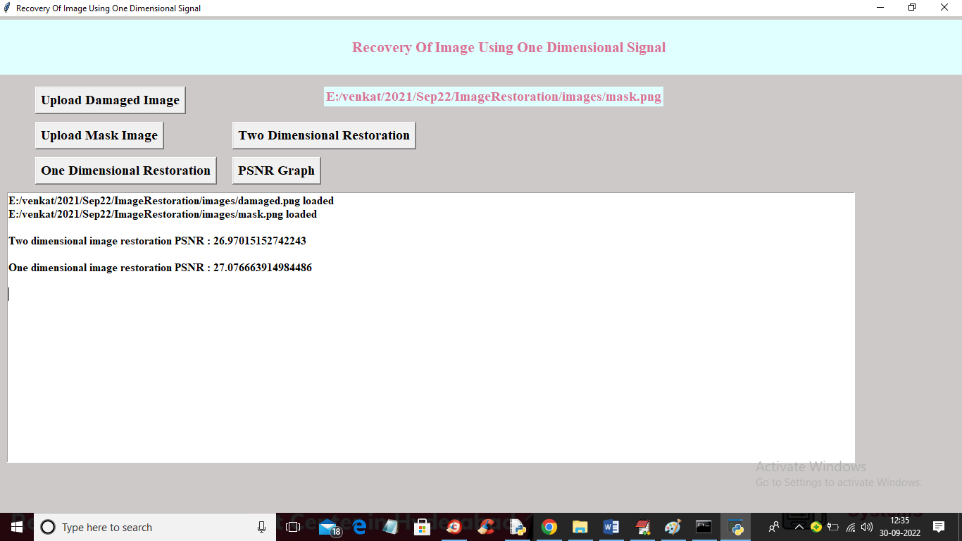

In above screen with one dimension we got PSNR as 27% and now click on ‘PSNR Graph’ button to get below graph

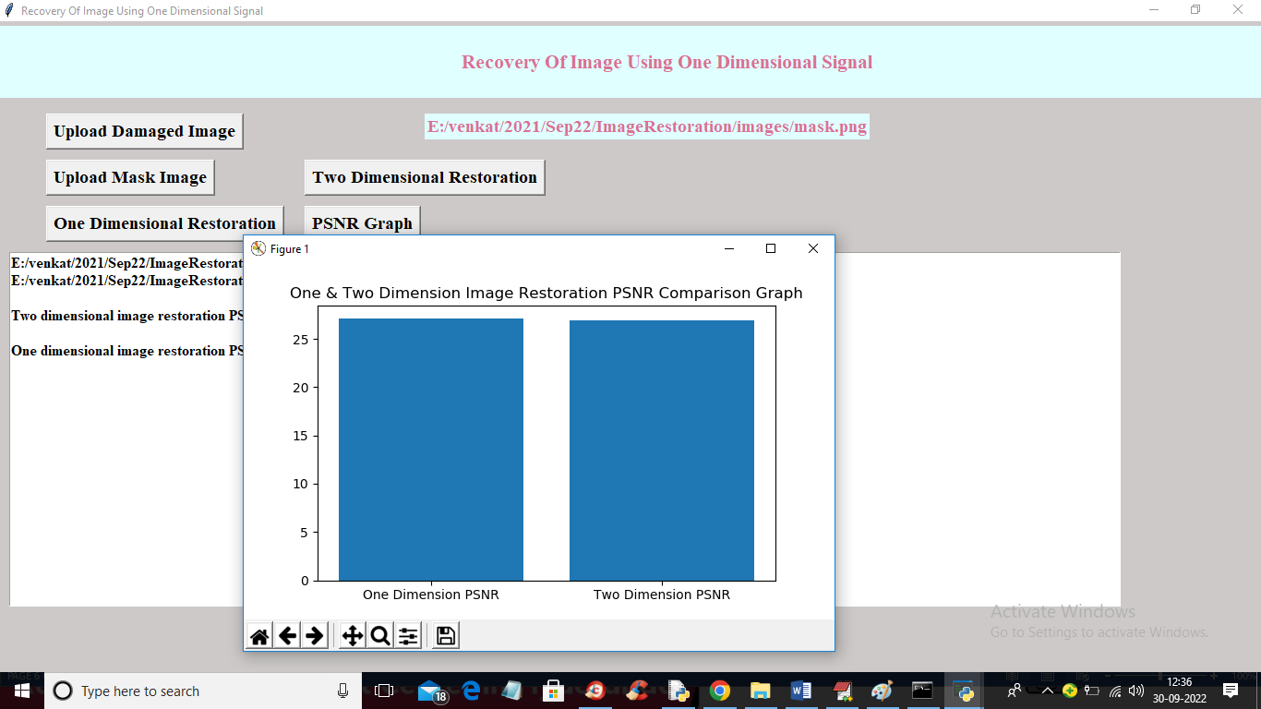

In above graph x-axis represents algorithm names and y-axis represents PSNR and the higher the PSNR the better is the image quality and with one dimension we got little higher PSNR compare to two dimensional