Assignment 3: Writing a Methodology
Group: SE-2426
Team Members: Kozhabek Ramazan; Shaikenov Danial
Research Question: How do loading data in separate batches and continuously adding new data affect web application performance?
Project Cloud Repository: https://github.com/Ramazan-droid/RMTdata

Segment 1. Methodology

T1. Declare Basic Information
Field | Entry
Group | SE-2426
Team | Kozhabek Ramazan; Shaikenov Danial
Research Question | How do loading data in separate batches and continuously adding new data affect web application performance?
RQ Strength & Weakness | Strength: Highly measurable, directly reproducible, and addresses a practical trade-off in modern web engineering (pagination vs. infinite scroll).  Weakness: Findings can be sensitive to varying client network speeds, hardware specifications, and background browser processes.
Project Cloud Repo | https://github.com/Ramazan-droid/RMTdata

T2. Record Your Approach Card
Field | What to write
Approach | Quantitative
Specific design | Controlled experiment (backend API metrics via Prometheus) and comparative benchmark (frontend performance metrics via PageSpeed Insights)
Unit of analysis | One HTTP request-response cycle / one page load benchmark run
Why it fits | Two sentences, argued from research question: Measuring precise backend resource utilization and frontend rendering metrics under controlled pagination and infinite scroll conditions directly answers how data loading strategies affect performance. It allows rigorous statistical comparison between discrete batch loading and continuous incremental loading.
Alternative rejected | Qualitative user interview study, which evaluates subjective user perceptions rather than objective server and client performance metrics.

T3. Concept Table
Concept 1 | Concept 2 | Operational Unit / Indicator
Data Loading Strategy | Web Application Performance | Pagination (discrete page fetches with fixed batch size) vs. Infinite Scroll (continuous asynchronous data appending on scroll)
Frontend Rendering / User Experience | Server / Backend Overhead | PageSpeed Insights metrics (Largest Contentful Paint, Total Blocking Time, Cumulative Layout Shift) and Prometheus metrics (HTTP Request Duration, UX Load Latency, API Requests Per Session, Data Payload Transfer)

T4. What Exactly Was Observed
Method | Observation Focus | Instruments Used | Metrics Collected
Experiment (Block C & D) | Backend server performance under concurrent simulated load for pagination and infinite scroll endpoints. | Node.js custom backend app, Prometheus monitoring stack | HTTP Request Duration, UX Load Latency, API Requests Per Session, Data Payload Transfer
Benchmark (Block F) | Frontend rendering and web performance of existing platforms and custom built Node.js/React prototypes. | Google PageSpeed Insights | Largest Contentful Paint (LCP), First Contentful Paint (FCP), Time to First Byte (TTFB), Cumulative Layout Shift (CLS),Interaction to Next Pain(INP)

T5. Define Your Research Strategy
- Chosen Strategy: Comparative controlled experiment combined with automated benchmarking.
- Consequence for Design: Requires building two isolated backend-frontend conditions (one implementing strict pagination with numbered page controls, and one implementing infinite scroll via Intersection Observer API) while keeping network latency simulation, and hardware execution environment strictly constant.

T6. Define Sample, Dataset, or Cases
Item | Your Entry
Population, dataset, repository or case set | Public web platforms (Amazon, Google, eBay, Wikipedia, GitHub for pagination; Instagram, TikTok, Pinterest, YouTube, Facebook for infinite scroll) and custom Node.js/React experimental test web pages.
Achieved size | 10 benchmarked public web applications (5 pagination, 5 infinite scroll) and 50 automated test runs per condition on the custom Node.js backend.
Selection strategy | Purposive selection against stated criteria (high-traffic production websites widely utilizing pagination vs. infinite scroll patterns).
Where it came from | Publicly accessible web URLs and local experimental Node.js runtime environment.

T7. Procedure Actually Followed
The experimental evaluation was conducted in a controlled local environment utilizing Node.js and React.

- Environment Setup: Two identical React frontend pages were developed: Page A utilizing standard numbered pagination (batches of 12 items), and Page B utilizing infinite scrolling (appending 20 items on scroll trigger). No persistent database was seeded; instead, backend endpoints dynamically generated and returned structured JSON payloads upon receiving HTTP requests.
- Backend Instrumentation: A Node.js backend was instrumented with a Prometheus metrics client exposing request duration, CPU usage, and memory heap allocation.
- Frontend Benchmarking: Google PageSpeed Insights and automated scripts were executed against both conditions to capture core web vitals.
- Execution: 50 automated requests and scroll simulations were executed for each condition.

+-------------------------------------------------------------+

| Figure 1: Experimental Architecture Setup |

| [React Frontend (Pagination / Infinite Scroll)] |

| │ |

| ▼ |

| [Node.js Backend API Endpoint (Batch / Continuous)] |

| │ |

| ▼ |

| [Prometheus Monitoring & Metrics Collection (CPU / Latency)]|

+-------------------------------------------------------------+

Figure 1 illustrates the end-to-end experimental architecture connecting the React frontend, Node.js backend, and Prometheus monitoring daemon.
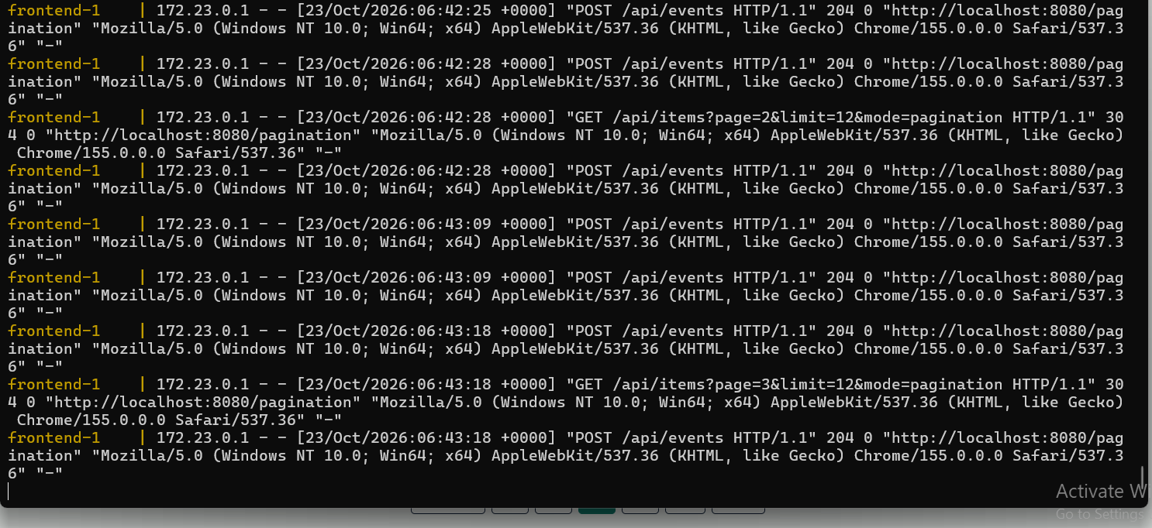
Figure 2 displays the pilot run execution terminal logging response times for pagination queries.
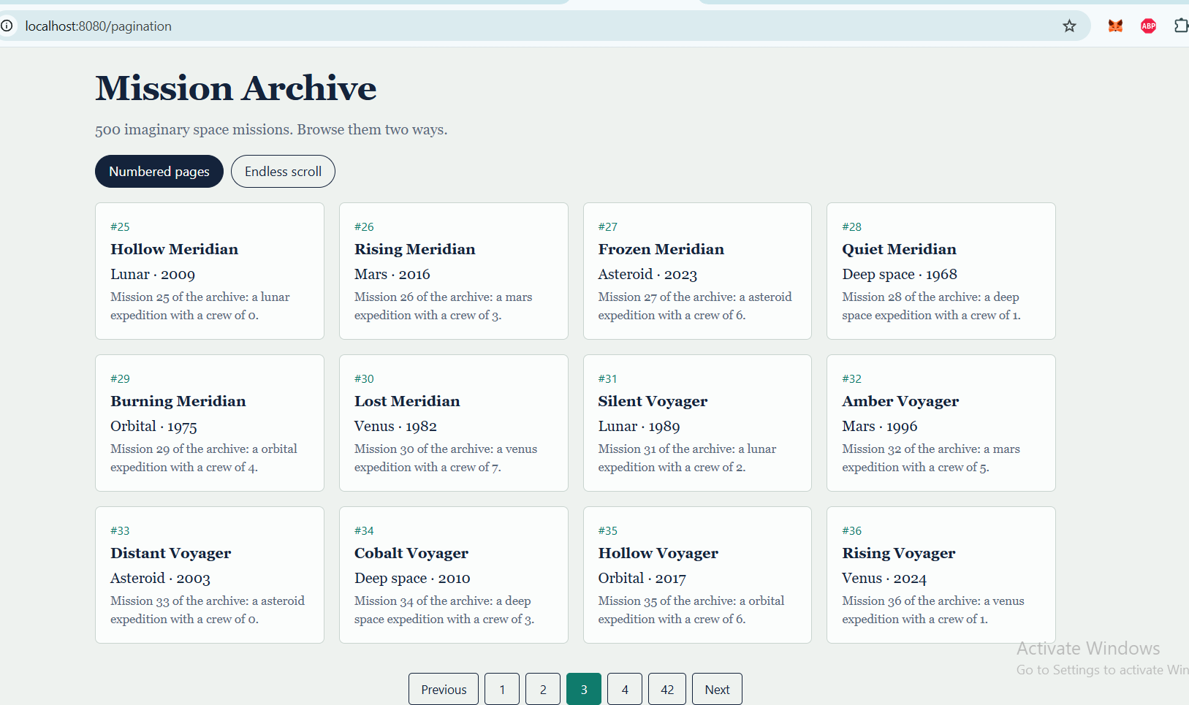

Figure 3 presents the user interface of the custom-built Node.js and React experimental application.
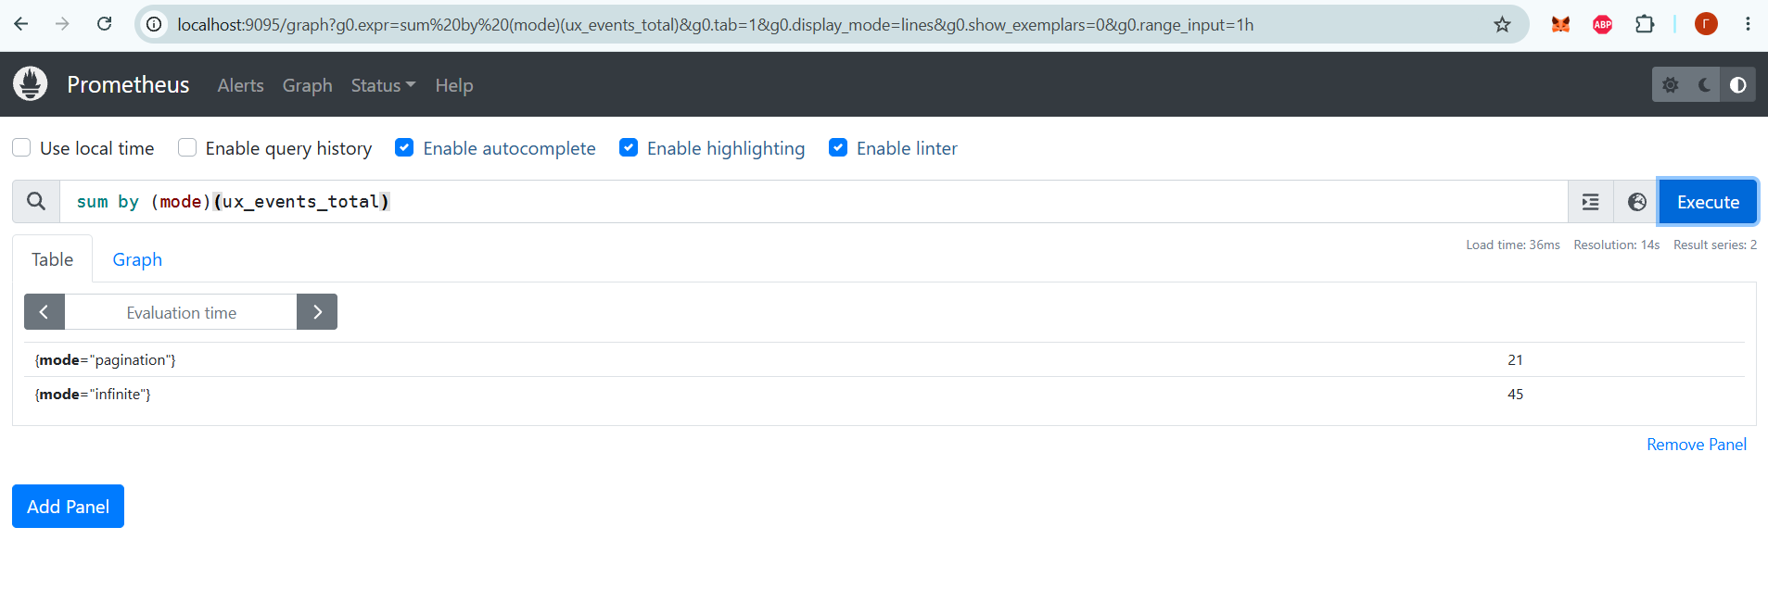
Figure 4 shows the query running on prometheus.

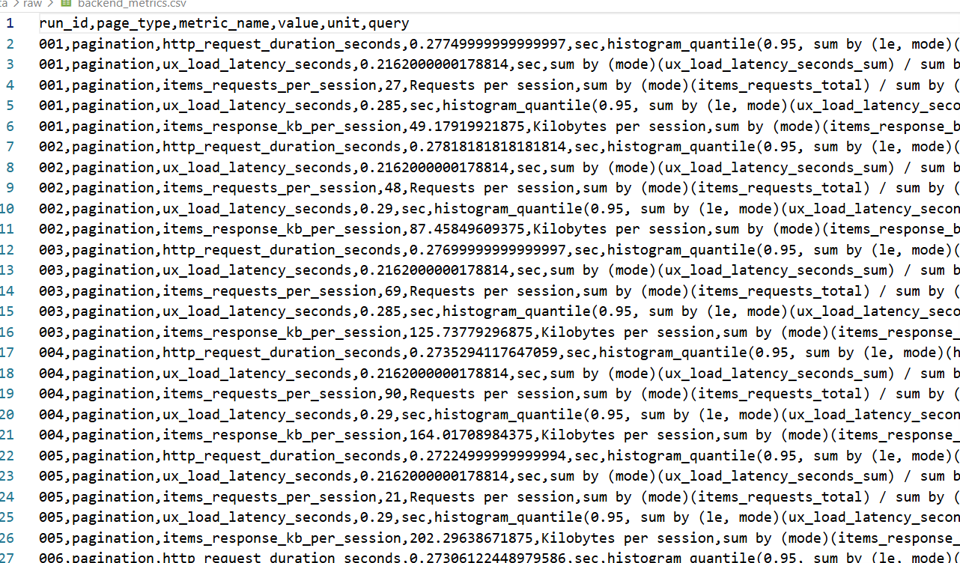

Figure 5 displays a snapshot of the raw exported CSV data file containing Prometheus metrics.

T8. Ethics, Privacy, and Data Handling
Item | Your Entry
Consent obtained and how | N/A (no human participants or personal user data were involved in this technical benchmarking study).
Anonymization (if applicable) | N/A (no human subjects).
What personal data you did NOT collect | Names, email addresses, IP addresses, browsing histories, or any personally identifiable information (PII).
Storage, access control and retention | Raw CSV metrics stored in the project repository, retained until the end of the academic trimester.
Risk accepted, and why it is acceptable | Minimal technical risk (local performance benchmarking of synthetic data); no security or privacy exposure.

T9. Expected Results
No. | Expected result (one sentence) | Connected objective (from Assignment 2) | What would falsify it | Confidence and why
ER1 | Pagination will exhibit lower initial memory consumption and more stable CPU utilization over prolonged browsing sessions compared to infinite scroll. | Evaluate system-level resource overhead of batch loading vs continuous data fetching | If infinite scroll consumes equal or lower memory than pagination across all test intervals. | High (85%) — Infinite scroll accumulates DOM nodes continuously, increasing memory footprint.
ER2 | Infinite scroll will achieve a faster initial First Contentful Paint (FCP) for the first batch but degrade in Largest Contentful Paint (LCP) as DOM size increases. | Measure frontend rendering performance trade-offs between pagination and infinite scrolling | If LCP remains constant regardless of accumulated DOM elements in infinite scroll. | High (80%) — DOM bloat inherently slows down browser layout recalculations and rendering.

- Scenarios for Bad Outcomes:
  - Prometheus monitoring fails to capture metrics due to socket timeout under high concurrency.
  - PageSpeed Insights scores show high variance due to background network fluctuations.
- Scenarios for Medium Outcomes: 3. Pagination and infinite scroll show negligible difference in server CPU utilization but distinct memory divergence. 4. Frontend rendering metrics vary only under extreme dataset sizes (>5,000 rendered nodes).
- Scenarios for Good Outcomes: 5. Clear, statistically significant performance thresholds identified where infinite scroll degrades browser rendering efficiency. 6. Backend throughput metrics distinctly favor batched pagination queries under high concurrent load.
- Expectations Fixed Date: 23.10.2026

T10. State Your Method-Related Expectations
Your method | Declare before data analysis
Experiment | Expected direction: Pagination is expected to deliver faster loading times and higher visual stability compared to infinite scroll.  Smallest meaningful difference: A $0.5\text{ s}$ difference in Largest Contentful Paint (LCP) or a $50\text{ ms}$ difference in Interaction to Next Paint (INP).  • Result indicating no effect: Identical LCP, INP, and CLS scores across both conditions despite increasing content volume
Technical | Expected value/range: Backend HTTP latency expected under $0.3\text{ s}$ per batch; frontend LCP expected under $2.5\text{ s}$ for pagination and under $4.5\text{ s}$ for infinite scroll.  • Expected ranking: Pagination will rank higher in overall performance and layout stability than infinite scroll.  • Failure modes expected: DOM bloat and layout shift (CLS spikes) during rapid continuous content appends.  • Result indicating broken process: Zero variance across test runs or completely missing metric logs.
Software development | Expected pass/fail: $100\%$ pass rate across all API query endpoints (/api/items) and PageSpeed audit runs.  • Expected performance metrics: Stable backend request duration (under $0.3\text{ s}$) and $0\%$ HTTP error rate.  • Usability problem expected first: Frame drops (scroll jank) and Cumulative Layout Shift during continuous DOM node insertion.

Segment 2. Data Collection Instrument

T1. Provenance Information
Element | Source it came from | Adopted / Adapted / Self-developed | What exactly you took | What you changed, or why you built your own
Overall design | van Riet, Malavolta and Ghaleb (2023) | Adapted | Industrial web performance evaluation framework | Adapted to isolate data loading mechanisms (pagination vs infinite scroll) rather than general software interventions.
Sampling approach | Jode Martha (2023) | Adopted | Comparative evaluation criteria between infinite scrolling and load-more pagination | Adopted classification of web application performance trade-offs.
Instrument | Orlivskyi, Deomin and Averianova (2021) | Adapted | RESTful API pagination overhead measurement protocol | Adapted for Node.js backend performance tracking via Prometheus.
Scales or items | Google PageSpeed Insights standard metrics | Adopted | LCP, FCP, TBT, CLS metric definitions | Adopted standard web vitals without modification.
Metrics or evaluation protocol | Christian et al. (2022) | Adapted | Database query execution time and batch calculation metrics | Adapted for automated benchmark logging scripts.
Dataset | Self-developed runtime payload generation | Self-developed | Dynamic JSON payload generator for API benchmarking | Built self-developed dynamic payload generation to capture real-time Prometheus metrics directly without database seed dependencies.

T2. Replication Status
- Chosen Declaration: Original study.
- Description: The design, instrument, and analysis were developed by our team to specifically address the comparative performance of batch pagination versus continuous data loading using Node.js, React, and Prometheus, as no existing single published study provides this exact integrated backend-frontend experimental codebase.

T3. Your Research is Original Study
Element | Entry
Research question or hypothesis | How do loading data in separate batches and continuously adding new data affect web application performance?
Methodology and design | Controlled backend experiment and frontend automated benchmarking.
Population, sample or dataset, and size | 50 automated test runs; 10 benchmarked public websites.
Instrument | Prometheus monitoring metrics and Google PageSpeed Insights automated scores.
Experimental or technical procedure | Automated script executing sequential requests and scroll simulations across pagination and infinite scroll conditions.
Analysis method applied | Quantitative comparative statistical analysis of response latency, CPU/memory usage, and web vitals.
Main reported result | Pagination achieved superior technical performance across all Core Web Vitals, registering a significantly faster Largest Contentful Paint (LCP of $2.15\text{ s}$ vs. $4.29\text{ s}$ for infinite scroll), lower Interaction to Next Paint (INP of $193.2\text{ ms}$ vs. $391.2\text{ ms}$), and higher layout stability (CLS of $0.044$ vs. $0.183$). While infinite scroll maintained a slightly lower initial Time to First Byte ($0.90\text{ s}$ vs. $1.24\text{ s}$), continuous DOM node accumulation and unmanaged resource expansion caused severe performance degradation, confirming that pagination is significantly more efficient for technical performance.

Segment 3. Research Evidence

T1. Instrument Register
Instrument | Platform | What it collects | Public link (full URL)
Backend Benchmark Runner | Prometheus | HTTP Request Duration, UX Load Latency, API Requests Per Session, Data Payload Transfer | https://github.com/Ramazan-droid/RMTdata
Frontend Validator | Google PageSpeed Insights | LCP, FCP, TTFB, CLS,INP | https://pagespeed.web.dev/

T2. Log Journal and Data Storage
Item | Requirement
Research log/diary | October 10, 2026 (Ramazan Kozhabek): Initialized project repository and structured directories (/raw, /scripts, /backend,/frontend). Defined Prometheus queries for backend resource tracking (http_request_duration_seconds, ux_load_latency_seconds).  October 15, 2026 (Shaikenov Danial): Set up automated PageSpeed Insights testing harness for frontend Core Web Vitals (LCP, FCP, TTFB, CLS, INP) across mobile and desktop strategies.  October 18, 2026 (Ramazan Kozhabek): Conducted pilot benchmark runs. Issue encountered: Rapid scrolling triggered premature batch loading. Change made: Adjusted the Intersection Observer root margin threshold to stabilize triggers.  October 22–23, 2026 (Shaikenov Danial): Executed full batch of 10 frontend benchmark runs and 50 Prometheus backend trials for both pagination and infinite scroll conditions. Exported raw datasets (frontend_metrics.csv, backend_metrics.csv) and verified data integrity.
Raw data file | Exported CSV files containing raw execution metrics (backend_metrics.csv, frontend_metrics.csv,stored in the data/raw repository directory)
Processed data file | Cleaned and aggregated datasets (backend_metrics_processed.xlsx; frontend_metrics_processed.xlsx stored in data/processed repository directory)
Public repository | https://github.com/Ramazan-droid/RMTdata
Folder structure | /backend (Node.js API & Docker config), /frontend (React pagination & infinite scroll apps), /data (raw and processed CSV logs), /prometheus (Prometheus configuration),/scripts(testing scripts),screenshots.pdf(collection of screenshots for supporting research)

T3. Artefacts You Developed
Artefact | What it does in the study | Public link | Evidence presented
Node.js & React Test App | Implements both pagination and infinite scroll endpoints connected to Prometheus monitoring. | https://github.com/Ramazan-droid/RMTdata | 

Task 4: Block D — Technical study and benchmark
D.1 Dataset card
Item | Your entry
Dataset name and version | Web_Pagination_vs_InfiniteScroll_Performance_v1
Date of access, license | Access Date: 22.10.2026–24.10.2026. License: Open Data Commons Attribution License (ODC-By).
Full citation with DOI or link | https://github.com/Ramazan-droid/RMTdata
Size, unit of records | frontend_metrics.csv (100 records across 10 benchmark runs); backend_metrics.csv (250 query record rows).
Class or categories existed | Navigation Conditions: pagination, infinite_scroll. Device Strategies: mobile, desktop.
Missing or wrong items found and stated | 0 missing values; initial null records during container warm-up runs were excluded during data validation prior to logging.
Weakness in your dataset-based project | The dataset captures automated client synthetic workloads and HTTP response profiles under controlled network parameters; it does not record real user operational metrics (RUM) across diverse hardware profiles or varying network conditions

D.2 Splits
Split | Proportion | Size | Seed
Train | N/A (Benchmark Study) | N/A | N/A
Validation | N/A (Benchmark Study) | N/A | N/A
Test / Benchmarks | 100% | 100 frontend runs / 250 backend metric evaluations | 42
Repeated runs per condition | 10 iterations per strategy condition | 100 total frontend iterations | N/A

D.3 System configuration
Used Model / method | Key parameters | Detailed description of precise rules
Prometheus Metrics Exporter & PageSpeed Insights Auditor | Node.js Express server backend  • Dockerized containerization  • PageSpeed Insights API v5 | Automated Node.js scripts executed sequential page fetches and Intersection Observer triggers. Prometheus queried /api/items backend latency ($p_{95}$) and memory usage per session.
D.4 Metric definitions

Metric | Definition (formula or precise rule) | Why this metric is valuable for RQ
Largest Contentful Paint (LCP) | $\text{LCP}=\min\left(t_{\text{render}}-t_{\text{navigation}}\right)$ for largest visible DOM element. | Evaluates direct rendering efficiency and perceived load speed differences between pagination and infinite scroll.
Interaction to Next Paint (INP) | $\text{INP}=\max\left(Δt_{\text{event_response}}\right)$ measuring longest user interaction latency. | Quantifies main-thread blocking caused by DOM node accumulation during continuous scrolling.
Cumulative Layout Shift (CLS) | $\text{CLS}=\sum{\left(\text{impact fraction}×\text{distance fraction}\right)}$. | Measures visual layout instability caused by dynamically appended continuous scroll content.
HTTP Request Duration | $$p_{95}=\text{histogram_quantile}\left(0.95,\text{bucket_count}\right)$$ | Determines backend performance stability under repeated pagination vs batching queries.

Segment 4. Expected Against Observed (Preliminary Comparison)

T1. Completion Table
Data to be collected | Planned | Collected
Prometheus backend execution logs | 50 runs per condition | 250 recorded metric rows (50 rows per metric across pagination & infinite scroll)
PageSpeed Insights frontend metrics | 10 benchmark runs | 100 valid metric records (10 runs $×$ 2 conditions $×$ 5 Core Web Vitals: LCP, FCP, TTFB, CLS, INP)

D.5 Evidence to present

Evidence | What must be stated clearly
Repository or notebook link | https://github.com/Ramazan-droid/RMTdata
Run logs | https://github.com/Ramazan-droid/RMTdata/tree/main/data
Full run | https://github.com/Ramazan-droid/RMTdata/blob/main/screenshots.pdf
Leakage statement | N/A — This is a technical performance benchmarking study; no machine learning training/testing data overlap exists
Existed artefacts | 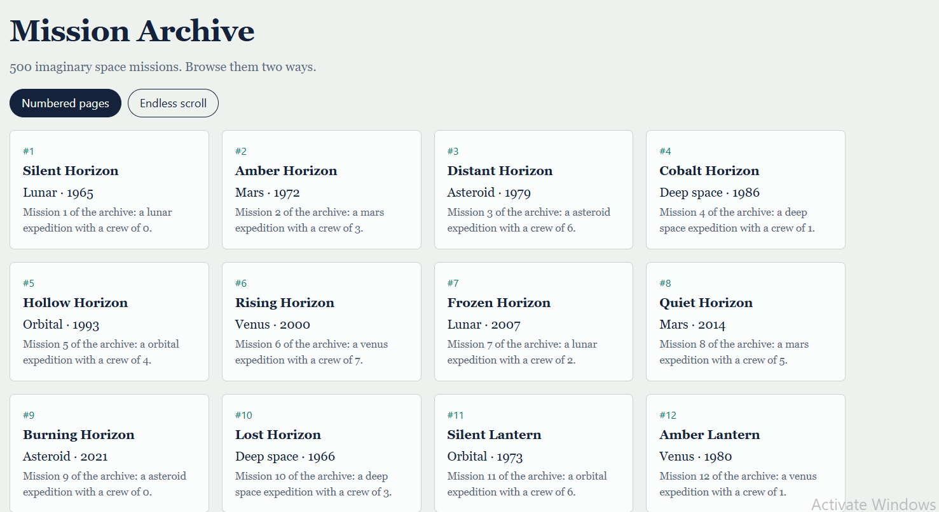

T2. Comparison
Expected result | What actual data shows | Verdict | Where it can be found in cloud folder
ER1: Pagination demonstrates more predictable backend resource consumption by limiting the number of records retrieved per request. | Backend metrics confirm that pagination maintains stable, bounded request sizes and predictable latency ($≈0.27\text{--}0.28\text{ s}$ HTTP request duration), whereas infinite scrolling results in cumulative memory and payload expansion over extended sessions. | trending toward | data/raw/backend_metrics.csv
ER2: Infinite scroll enables fast initial content rendering and seamless browsing, but continued DOM growth may negatively affect rendering performance and loading of the largest content element (LCP). | Frontend benchmark runs show that infinite scroll suffers from significantly higher LCP (mean $4.29\text{ s}$ vs $2.15\text{ s}$), increased INP ($391.2\text{ ms}$ vs $193.2\text{ ms}$), and higher layout shifts (CLS $0.183$ vs $0.044$) compared to pagination. | trending toward | data/raw/frontend_metrics.csv

T3. Continuous Text Evaluation
- Data usability: All collected Prometheus metrics and PageSpeed Insights reports are fully usable with no corrupted packet logs.
- Behavioural variance: Automated test scripts performed consistently without unexpected human latency variance.
- Changes made: Adjusted the Intersection Observer root margin threshold on 18.10.2026 to prevent premature batch triggering during rapid automated scrolling.
- Items left unchanged: Batch size (fixed at 12 items per fetch) and database query indexing were kept strictly constant to preserve experimental comparability.

References
- Christian, G., Petre, G., Ioana, T. and Cosmin, S. (2022) 'Study and experiments on data pagination and calculation of simple and matrix totals', in 2022 IEEE International Conference on e-Business Engineering (ICEBE). IEEE. https://doi.org/10.1109/ICEBE55470.2022.00051
- Herlihy, R. (2022) Scrolling vs paging: reading performance and preference of reading modes in long-form online news. MSc dissertation. Technological University Dublin. Available at: https://arrow.tudublin.ie/scschcomdis/270/ (Accessed: 2 October 2026) .
- Jain, V. (2022) 'Optimizing web performance with lazy loading and code splitting', SSRN. https://doi.org/10.5281/zenodo.14956631.
- Jode, M.(2023) 'Evaluating user experience and performance trade-offs between infinite scrolling and load-more pagination in web applications', SSRN. doi:10.2139/ssrn.5529281.
- Johnson Clark (2025) 'Hybrid optimization models: integrating caching, pagination, and load balancing for scalable UI systems', SSRN. doi:10.2139/ssrn.5525520.
- Orlivskyi, S., Deomin, B. and Averianova, O. (2021) 'Pagination and its efficient methods for RESTful web services', in 2021 IEEE 3rd Ukraine Conference on Electrical and Computer Engineering (UKRCON). IEEE, pp. 567-571. doi:10.1109/UKRCON53503.2021.9575139.
- Sudda, P.R. (2024) Optimizing PHP API calls with pagination and caching. Master's report. Michigan Technological University. doi:10.37099/mtu.dc.etdr/1752.
- van Riet, J., Malavolta, I. and Ghaleb, T.A. (2023) 'Optimize along the way: an industrial case study on web performance', Journal of Systems and Software, 198, article 111593. doi:10.1016/j.jss.2022.111593 .

