

Faculty of Computer Technology and Cyber Security

**Laboratory work №5**

By discipline: “Fundamentals of logic design”

Done by student of group IT2CCO-2201

Omirkhan Bekzat

Checked by: senior-lecturer

Iskakov E.A

Almaty, 2024

**Introduction**

In this lab work, The task was to make any object with a minimum of four fasteners (any switch, socket, etc.). I chose to make a switch panel with four fixtures. Later in “tollbox” I selected the appropriate fastener and moved the screw to the panel.

**Laboratory work 5**

Firstly I created a rectangle which will be the base, inside which we will place the holes for the switch and screws.The dimensions for the screw holes are 9.525mm, the length of the outer rectangle is 95.25mm, the height of the outer rectangle is 190.05mm.The height of the center rectangle is 38mm with a length of 19.05mm.

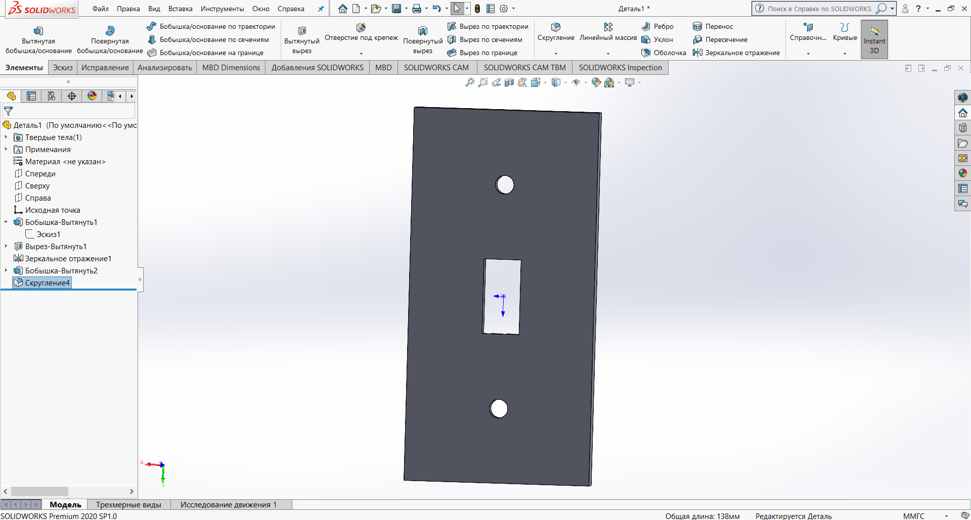

Figure 1.1 - Sketch for the switch

There are still some parts left to finish such as the back, rounding the back corners and adding the remaining screw holes.

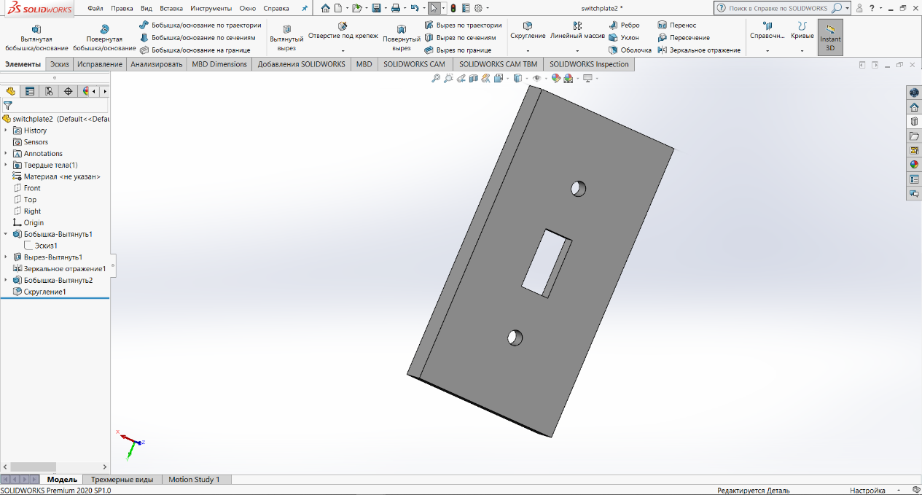

Figure 1.2 – Completed switch

In Toolbox Explorer select ANSI Inch,Bolts and Screws , Machine Screws in the catalogue tree add Pan Cross Head. Insert them into the holes and set the required width parameter under the holes.

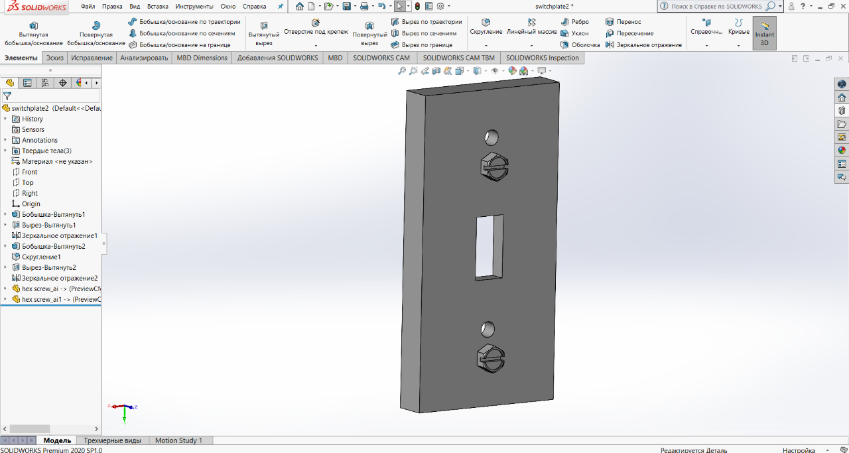

Figure 1.3 – Finished model

**Conclusion**

In conclusion, during this laboratory work, I had learnt the following practical skills:I automatically selected fasteners based on the diameter and depth of holes, and I used fastener concepts such as considering thread length, screw size, and screw diameter.I learnt how to use the Toolbox Explorer and identify the type of threads for fasteners.I was able to relate the diameter of a screw to its size.I gained an understanding and knowledge of fasteners made from different materials from a scientific perspective.