**January 23, 2023**

**What is a Web Page ?**

It consists of fonts, images, videos, text etc

**What is Website ?**

**What is Web Development ?**

**What is Web Designing ?**

**What is Domain ?**

[www.abc.com](http://www.abc.com)

140.80.80.400

**What is Hosting ?**

**HTML**

Hyper Text Markup Language

**CSS**

Cascading Style Sheet to style a document

**JavaScript**

Scripting Languages

Used every where now a days

We can use either on Front End side or the same can be used as Back End Development, in addition, the JavaScript is also used in various other fields as well.

Tags in HTML

<tagName >

Video provides a powerful way to help you prove your point.

When you click Online Video, you can paste in the embed code for the video you want to add. You can also type a keyword to search online for the video that best fits your document. To make your document look professionally produced, Word provides header, footer, cover page, and text box designs that complement each other. For example, you can add a matching cover page, header, and sidebar.

</tagName>

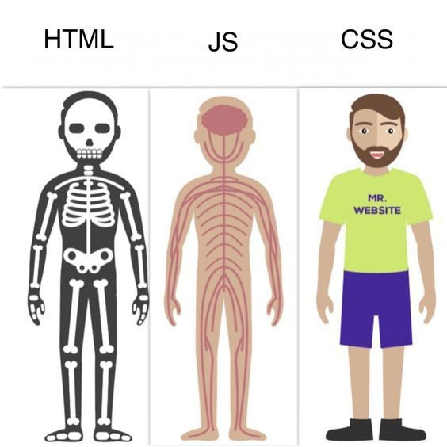

List

* Eggs lay ayn
* Bread lay ayn
* Sabzi
* Chicken (desi)

1. Eggs lay ayn
2. Bread lay ayn
3. Sabzi
4. Chicken (desi)

Pakistan is the beautiful country

We live in order to spend our lives here in this country

But unfortunately the entire system is derailed in a very worst manners due to some political and other allied issues.

All efforts nip-in-the-bud

Lists in HTML

There are two types of html

Ordered List

<ol>

<li> Eggs </li>

<li> Breads </li>

<li> Milk </li>

<li> Chicken </li>

</ol>

Abc

1, 2, 3,

i, ii, iii

UnOrdered List

⃝ ⃝ ⃝

<ul>

<li> Eggs </li>

<li> Breads </li>

<li> Milk </li>

<li> Chicken </li>

</ul>