Ospan Ramazan, 38045, it2-2310

Lab 2, HomeWork.

On last page code sources.

Task1. Write a program that asks a user to input an integer n. The program should prompt the user to input n integers and store them in an one-dimensional array. Then the program should find the sum of elements between two zeros.

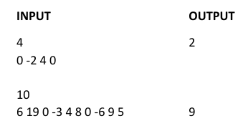

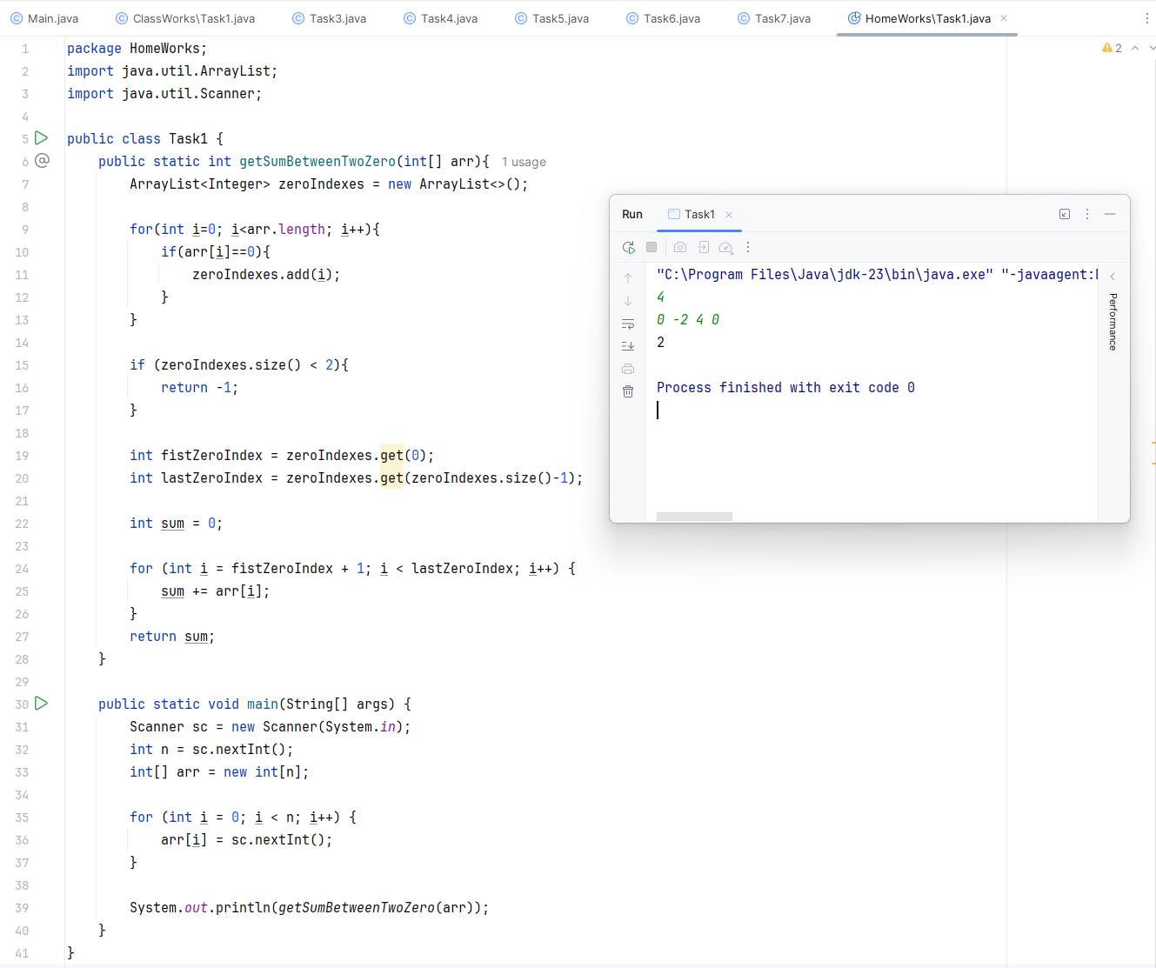

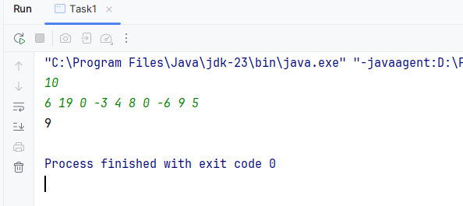

Task2. Write a program that asks a user to input an integer n. The program should prompt the user to input n integers and store them in an one-dimensional array. Then the program should prompt the user an integer m and output the “Yes” and index of the integer m in the array, otherwise output “No”.

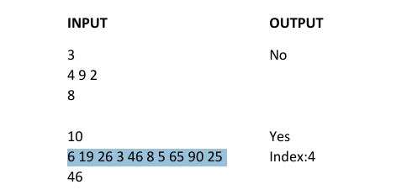

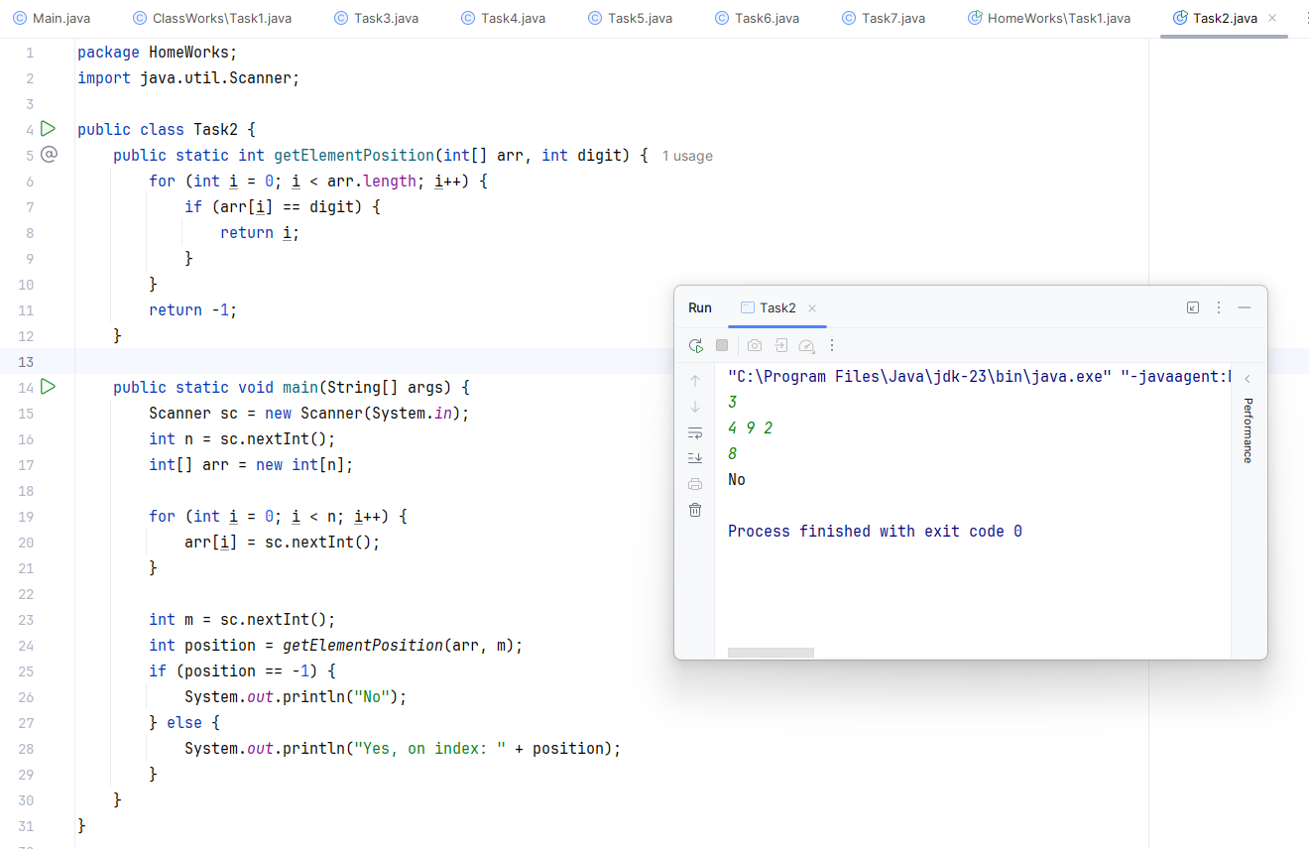

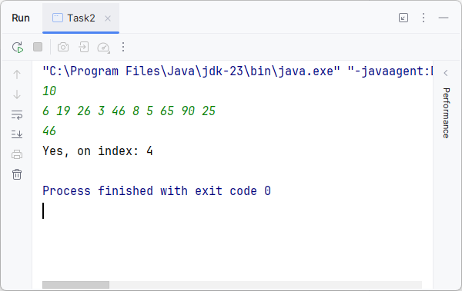

Task3. Write a Java program to find the second largest element in an array.

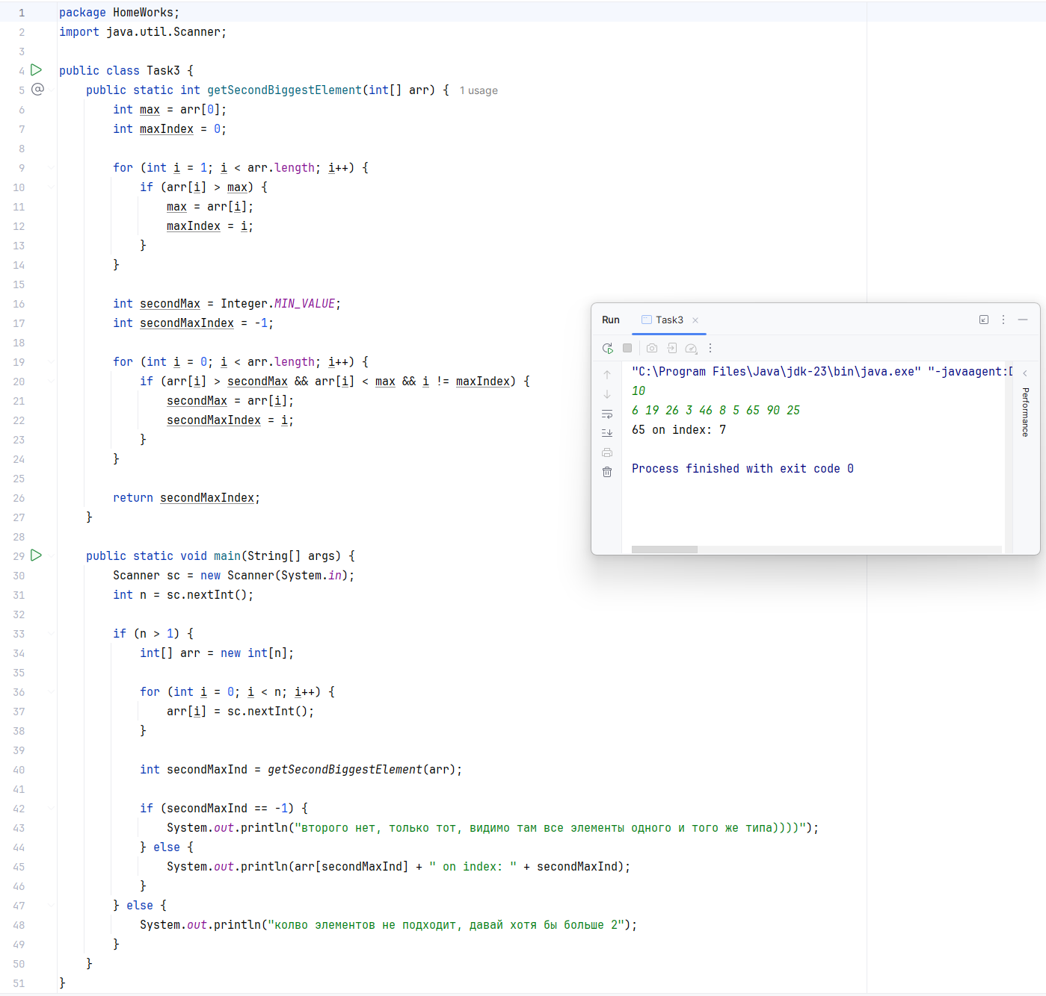

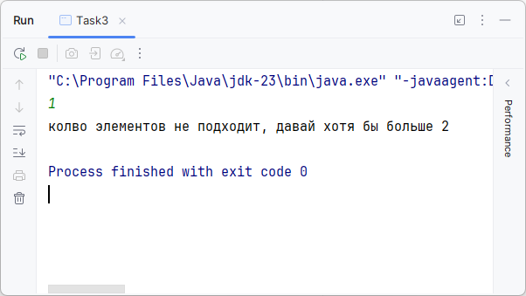

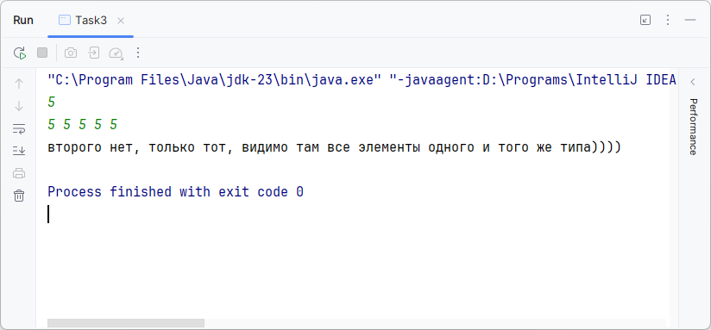

Task4. Time sorting

From input your program have to read N (1<=N<=100) - the total number of time interval than have to be sorted. Each line contains data in following format HH MM SS

HH (hours) - from 0 to 23

MM (minutes) - from 0 to 60

SS (seconds) - from 0 to 60

The output have to contain time intervals in nondescending order in give format.

**Input sample:**

4

10 20 30

7 30 00

23 59 59

13 30 30

**Output sample:**

7 30 0

10 20 30

13 30 30

23 59 59

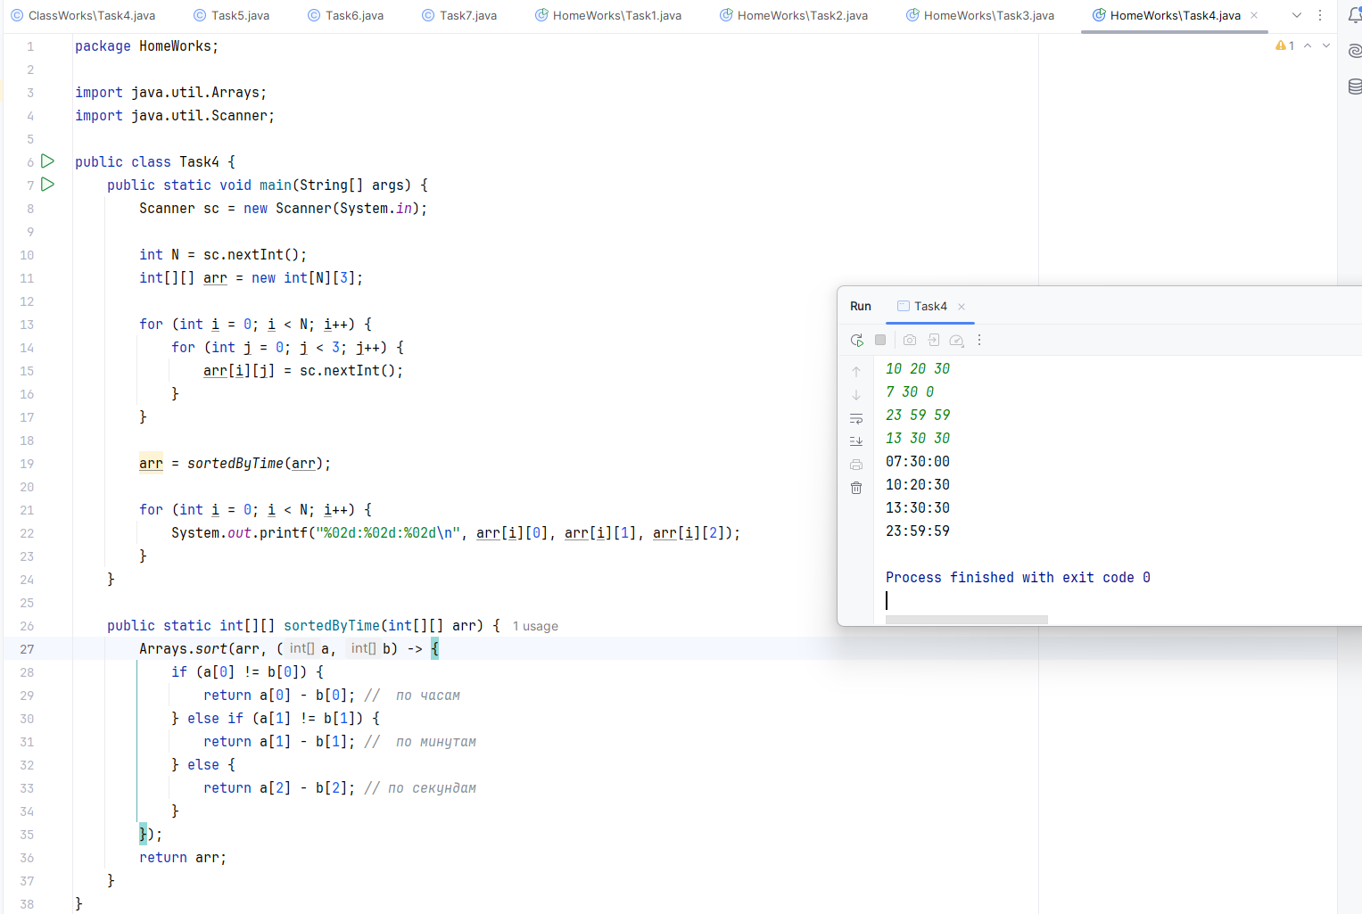

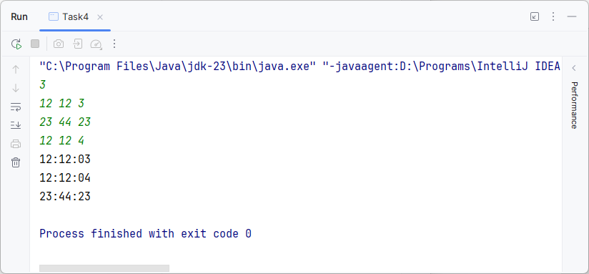

*ArrayList*

Task1. Write a Java program to convert an array to an ArrayList.

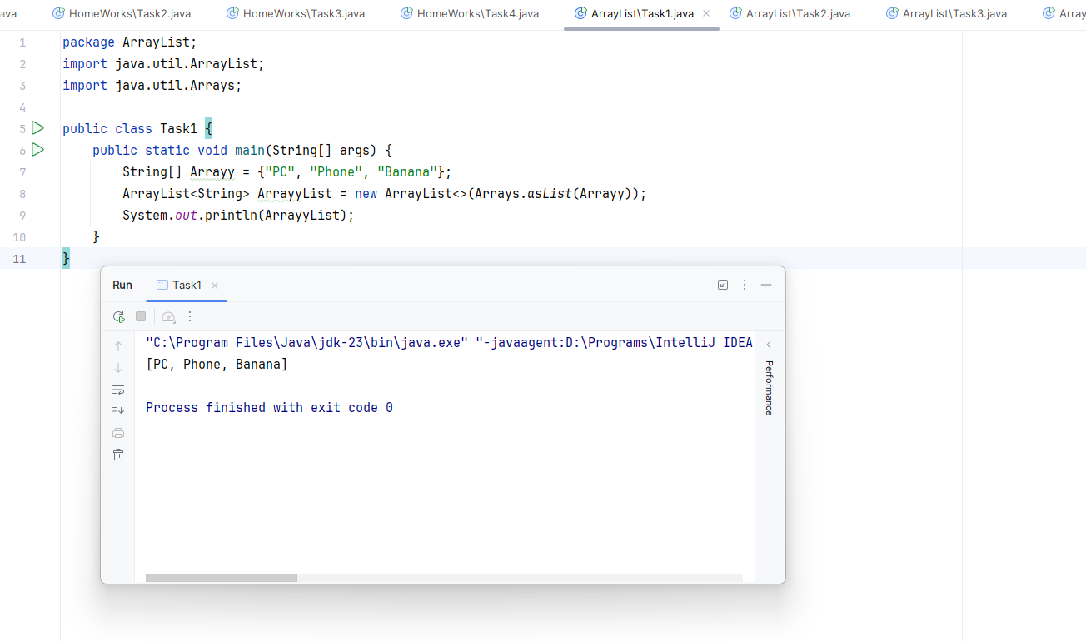

2. Write a Java program to convert an ArrayList to an array.

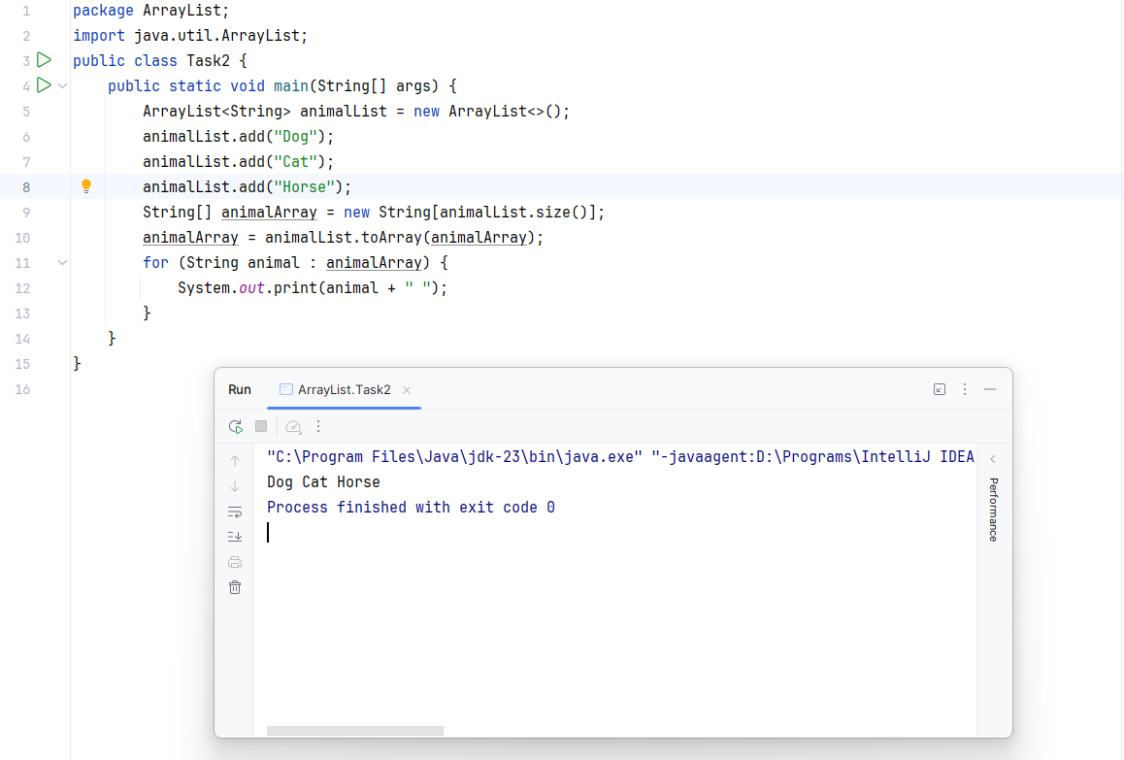

3. Write a Java program to search for an element in an array list.

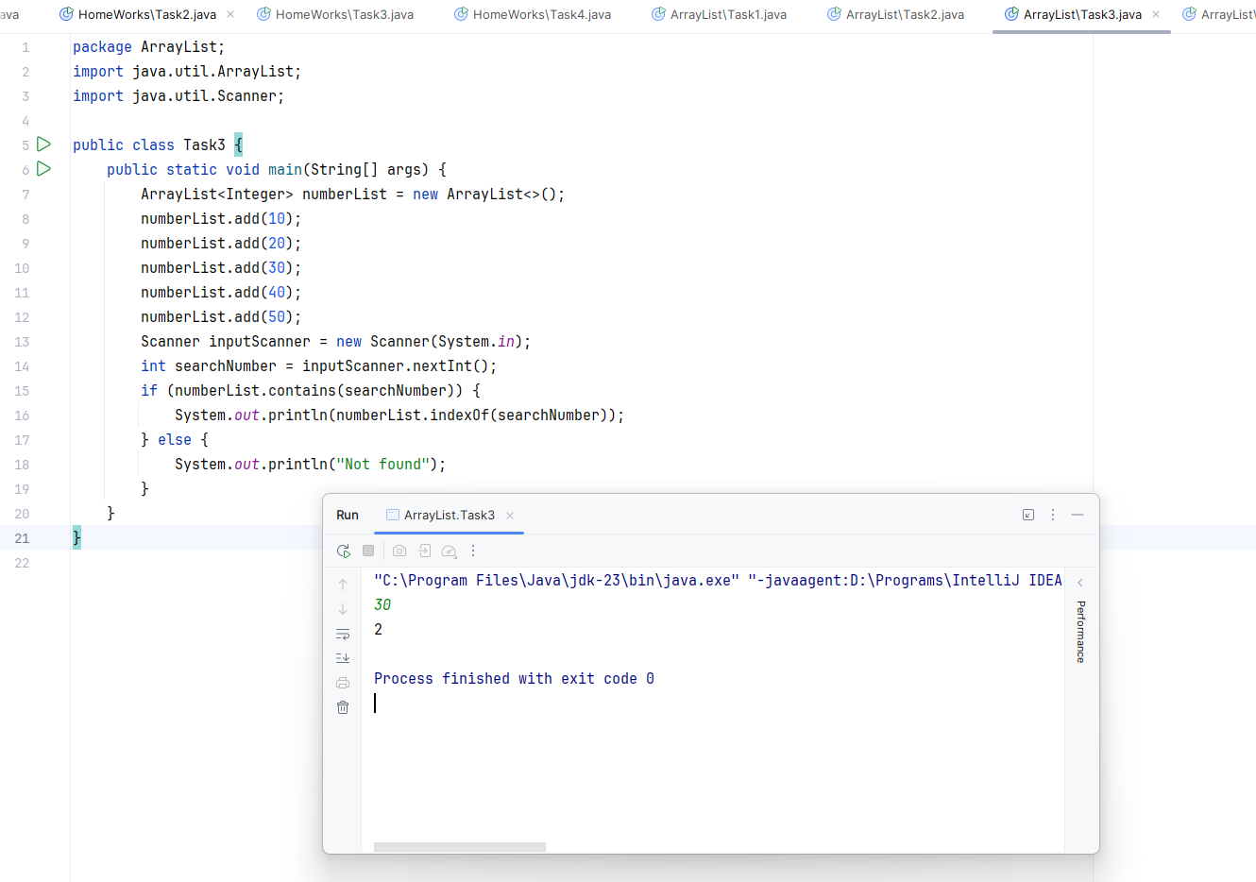

4. Write a Java program that swaps two elements in an array list.

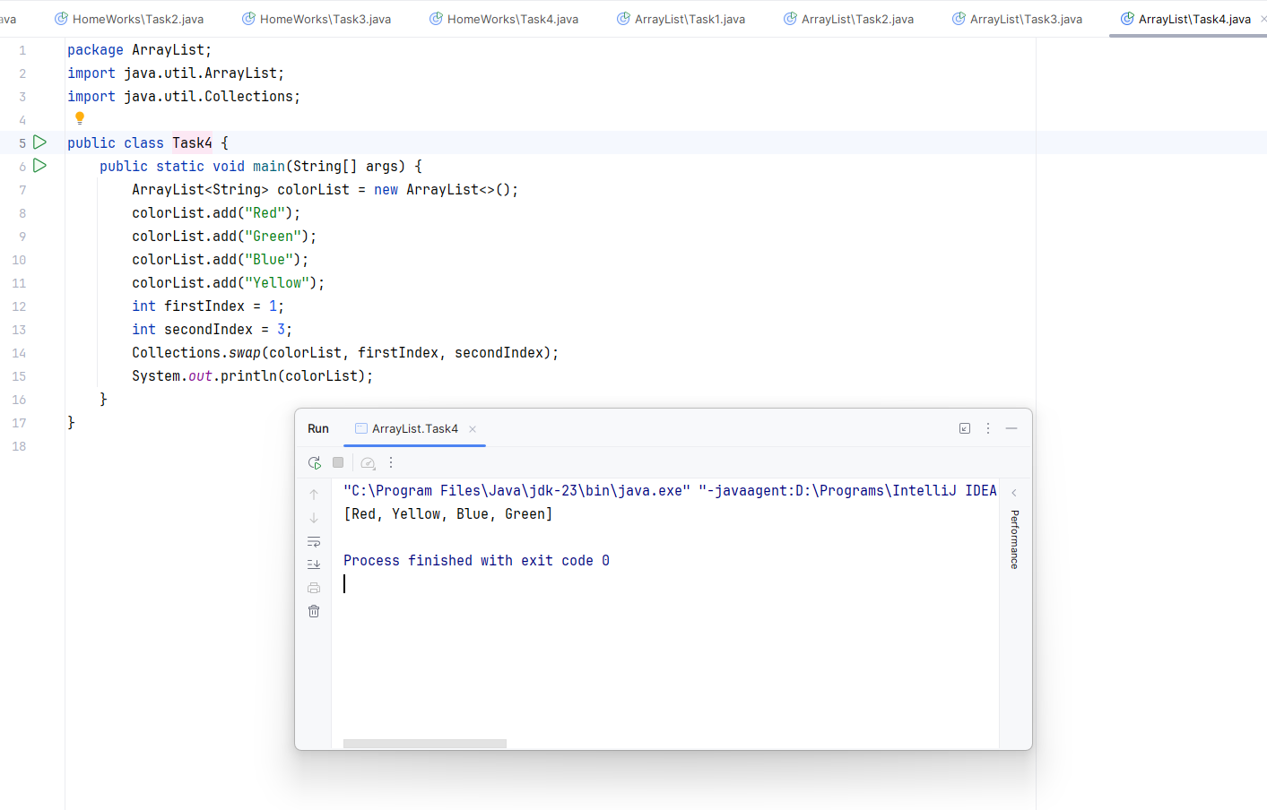

Code sources:   
HomeWork



ArrayList

