Ospan Ramazan it2-2310, 38045

*Class Work:*

Task1: Write a program that asks a user to input an integer n. The program should prompt the user to input n integers and store them in an one-dimensional array. Then the program should output only positive integers in the array.

**INPUT OUTPUT**

3 4 9

4 9 -2

10 6 19 26 46 8 5 90 25

6 19 26 -3 46 8 5 -65 90 25

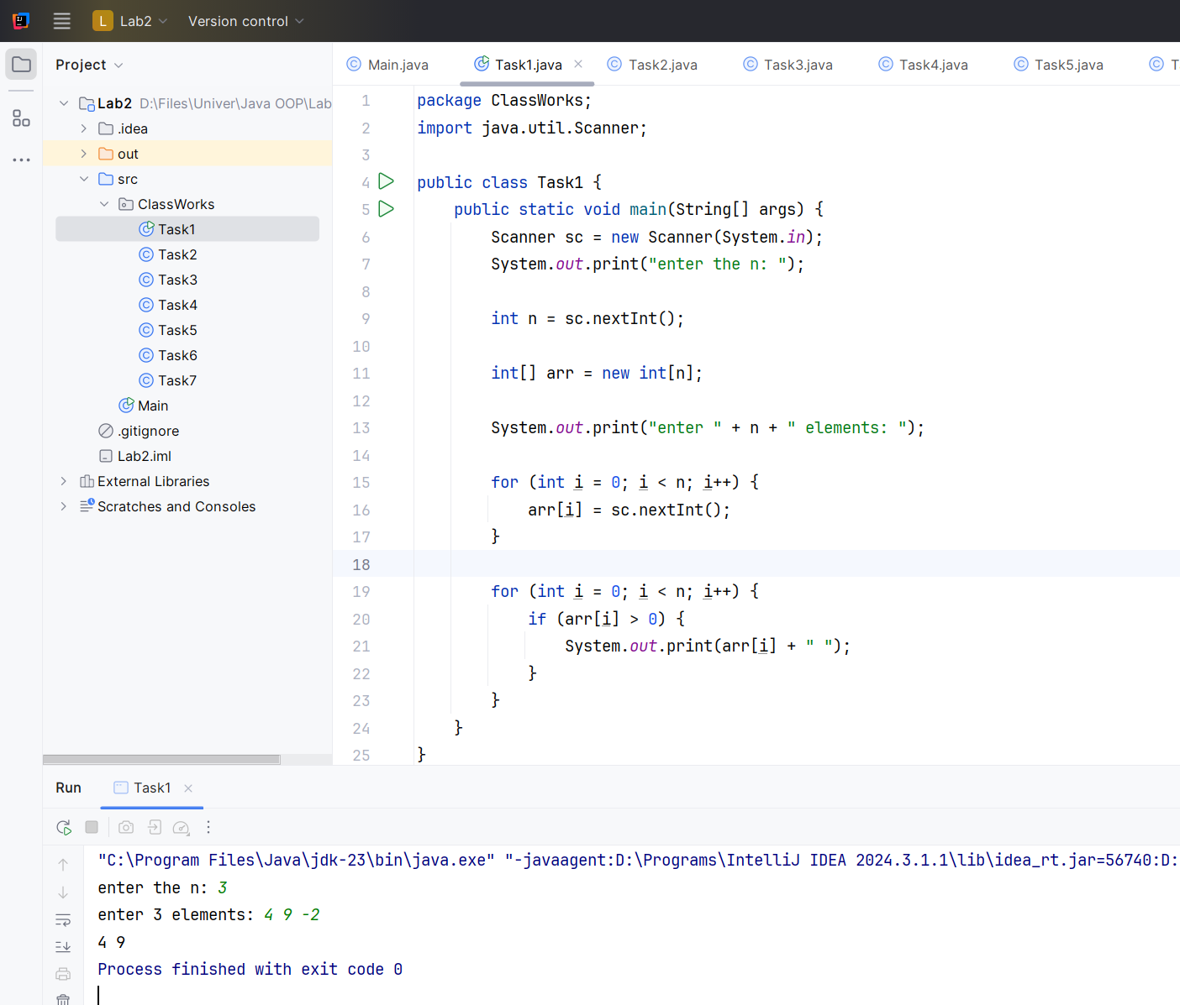

Task2: Write a program that asks a user to input an integer n. The program should prompt the user to input n integers and store them in an one-dimensional array. Then the program should output the minimum, maximum and their indexes elements.

**INPUT OUTPUT**

3 Min:2 Index:2

4 9 2 Max:9 Index:1

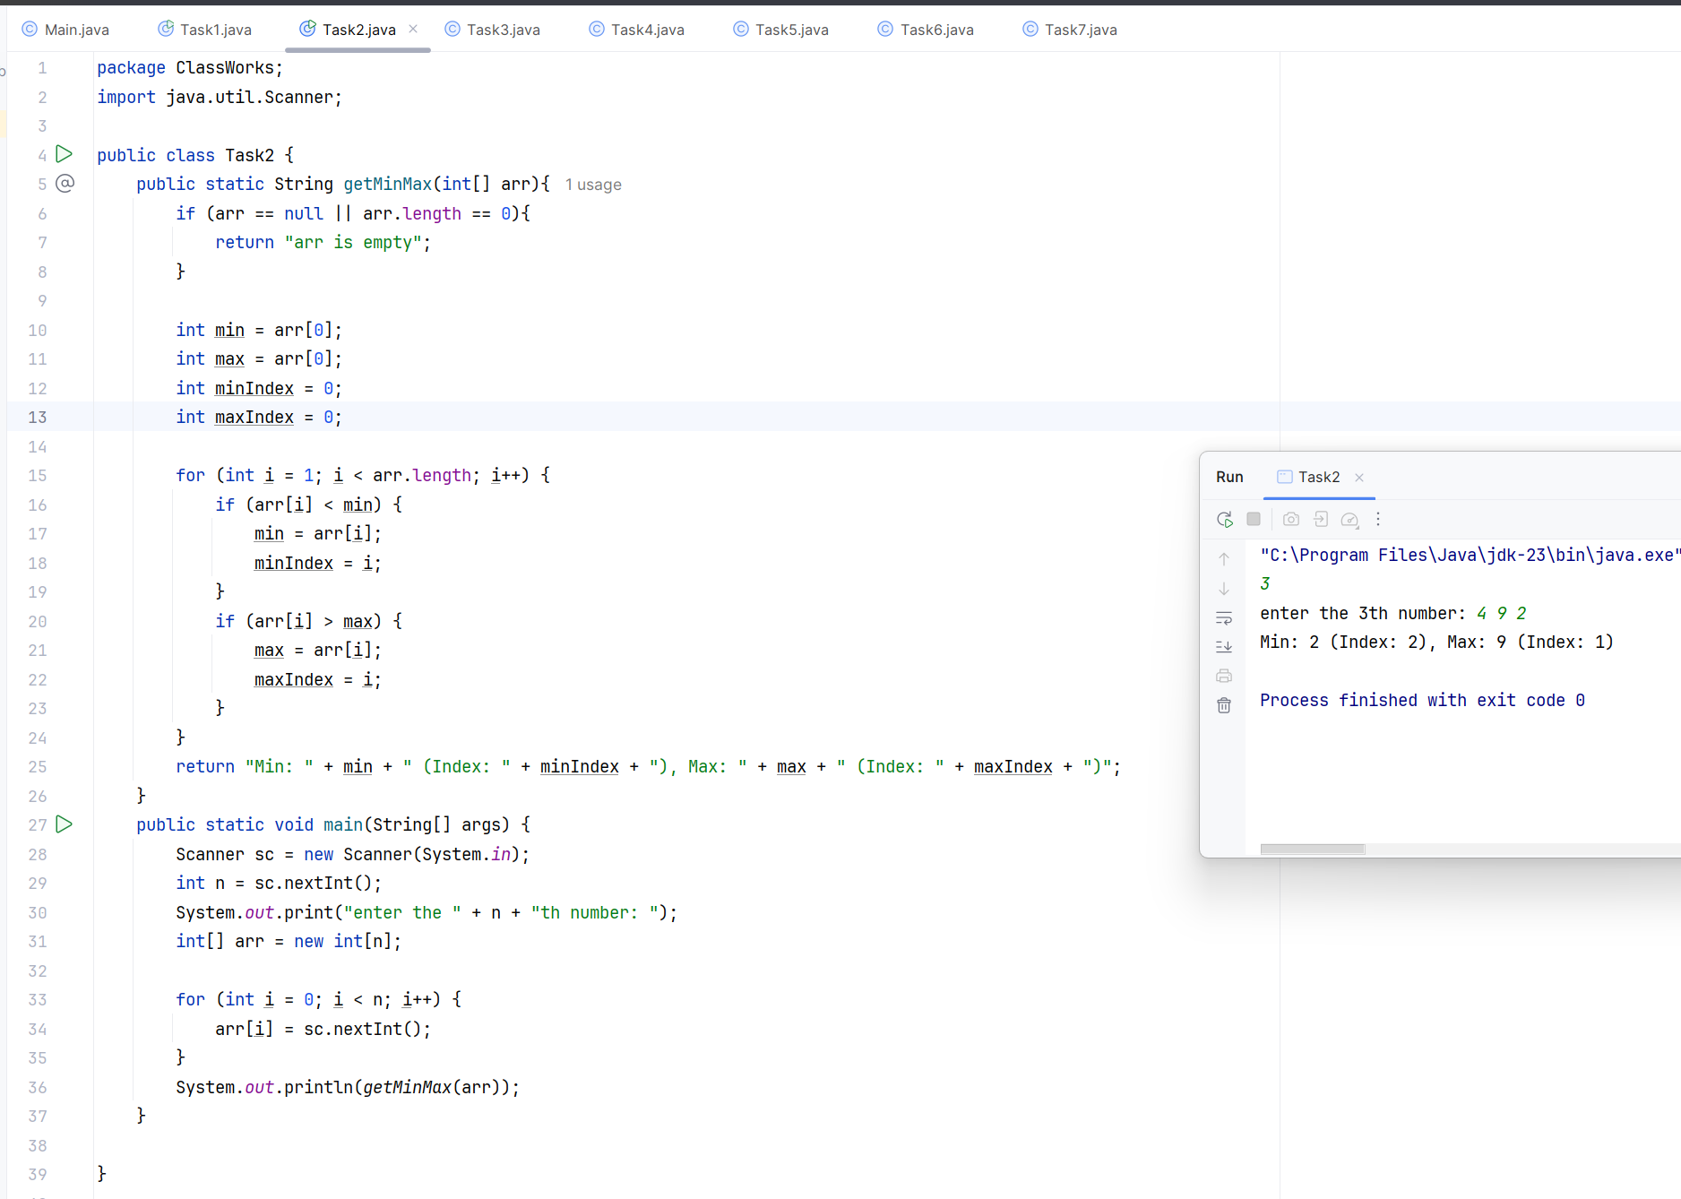

Task3. Write a program that asks a user to input an integer n. The program should prompt the user to input n integers and store them in an one-dimensional array. Then the program should swap the minimum with maximum and output the array.

**INPUT OUTPUT**

3 4 2 9

4 9 2

10 6 19 26 9 46 8 90 65 5 25

6 19 26 9 46 8 5 65 90 25

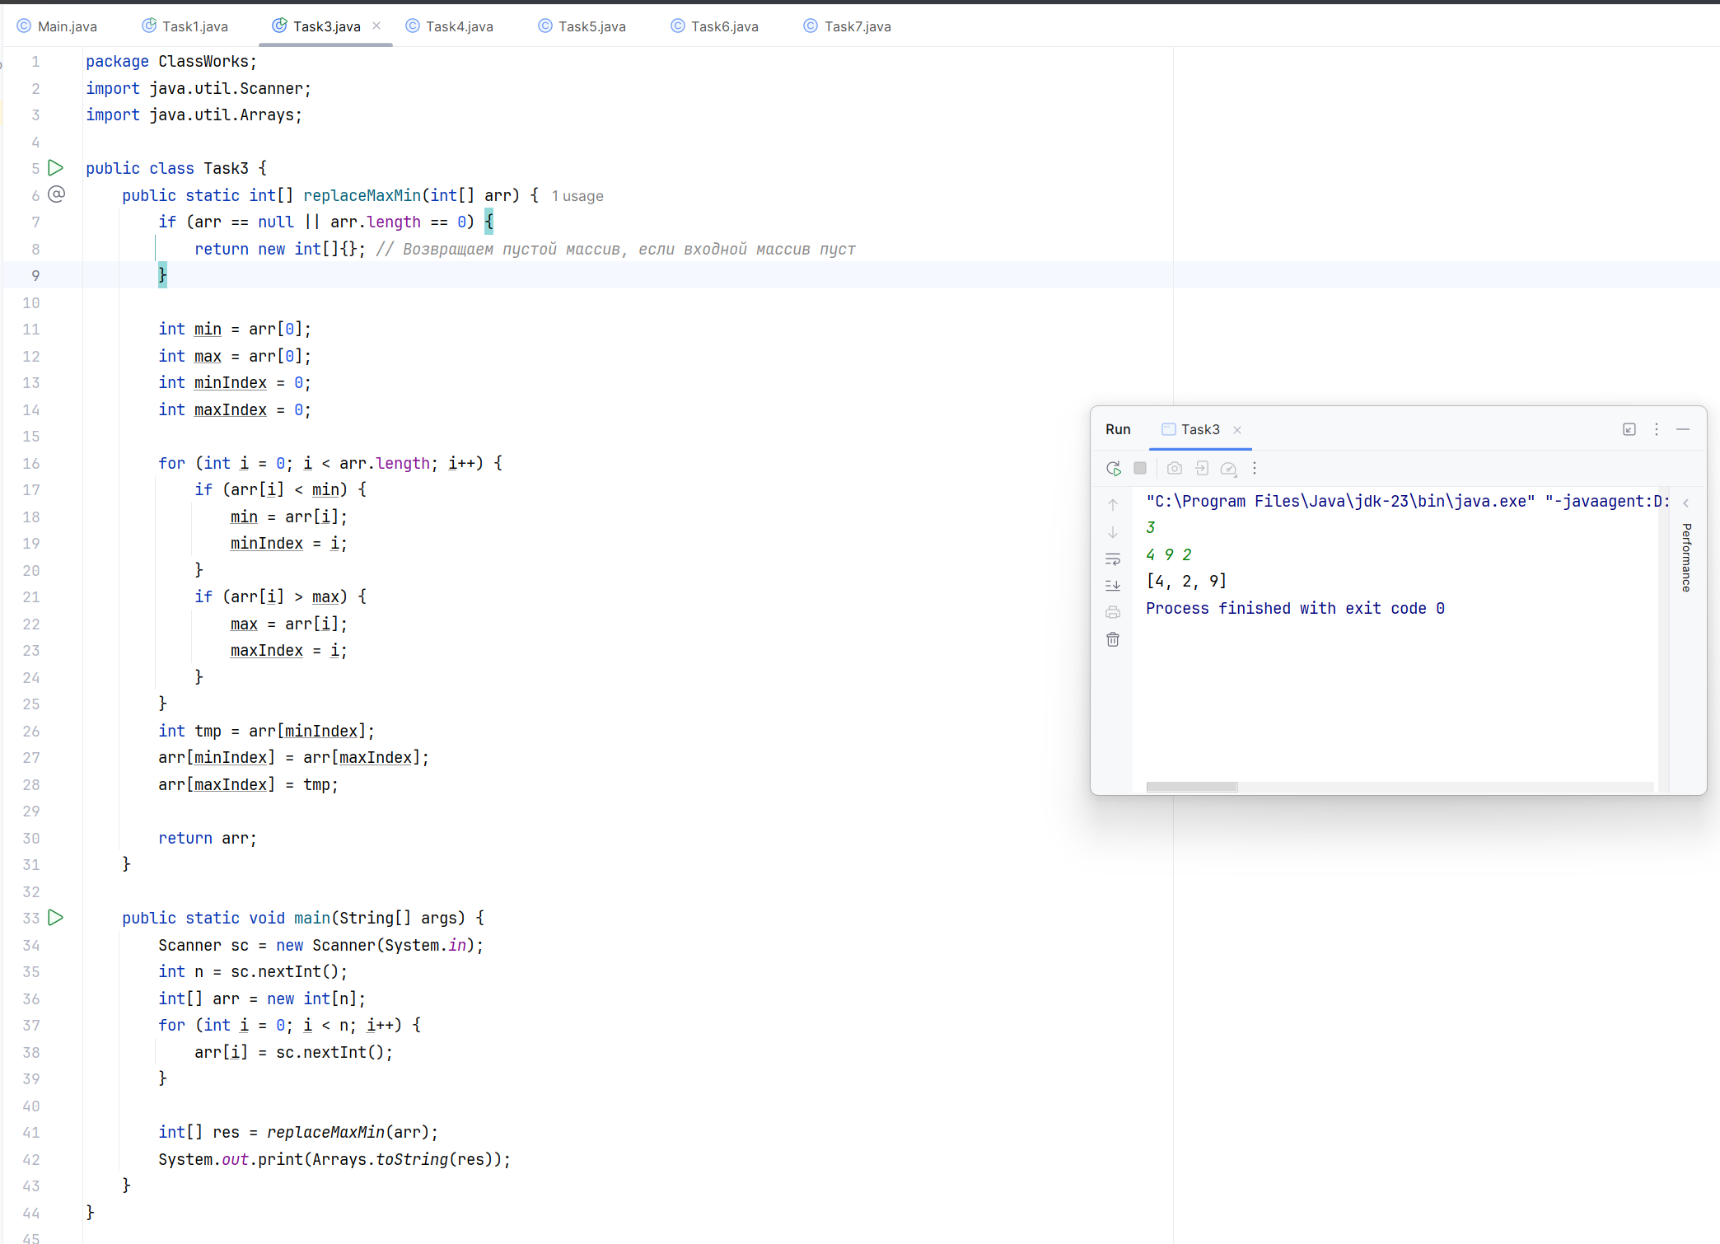

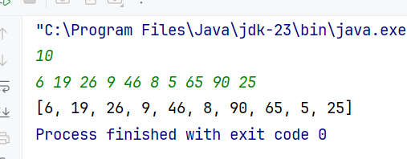

Task4. Write a program that asks a user to input an integer n. The program should prompt the user to input n integers and store them in an one-dimensional array. Then the program should output firstly positive elements, then zero element and at last negative elements.

**INPUT OUTPUT**

4 9 4 0 -2

9 -2 4 0

10 6 19 4 8 9 5 0 0 -3 -6

6 19 0 -3 4 8 0 -6 9 5

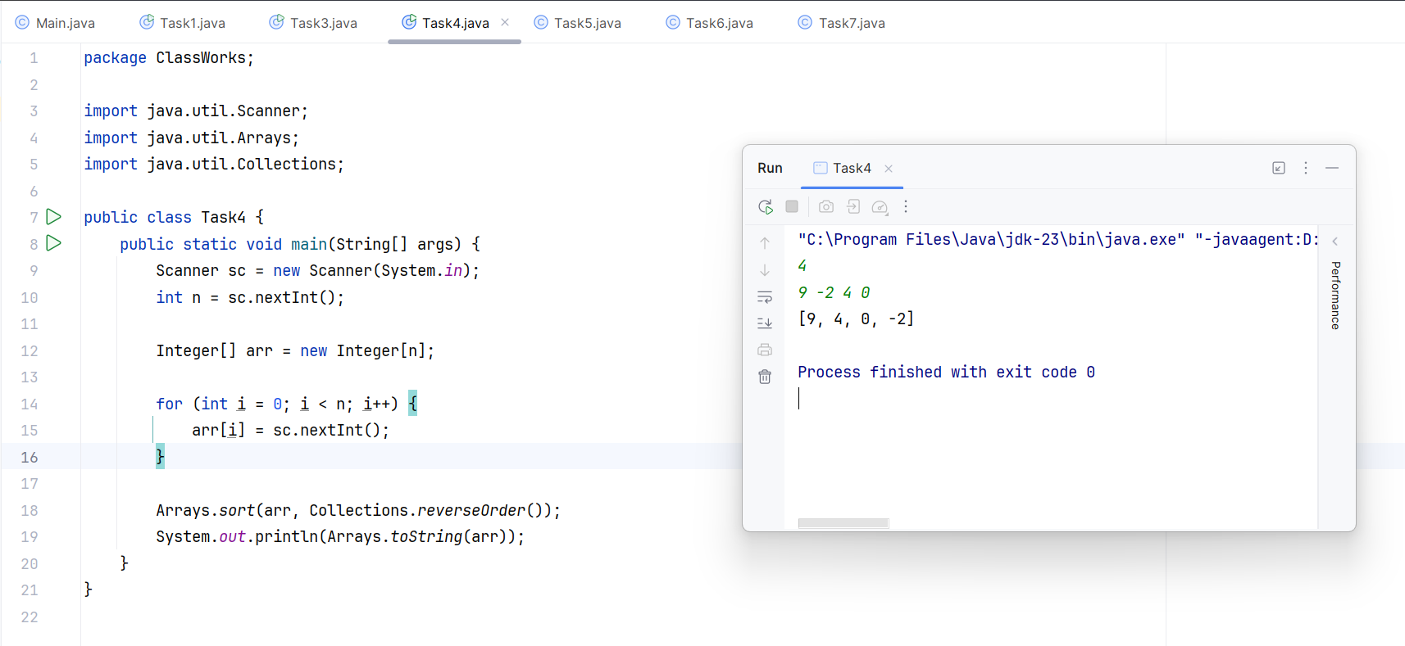

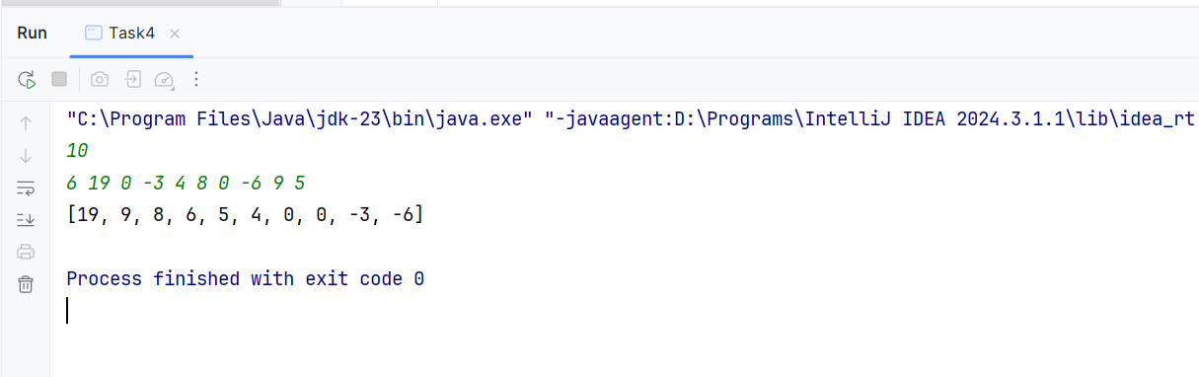

Task5. Write a program that asks a user to input an integer n. The program should prompt the user to input n integers and store them in an one-dimensional array. Then the program should output the product of all non-zero elements in the array.

**INPUT OUTPUT**

4 72

9 2 4 0

10 2954880

6 19 0 -3 4 8 0 -6 9 5

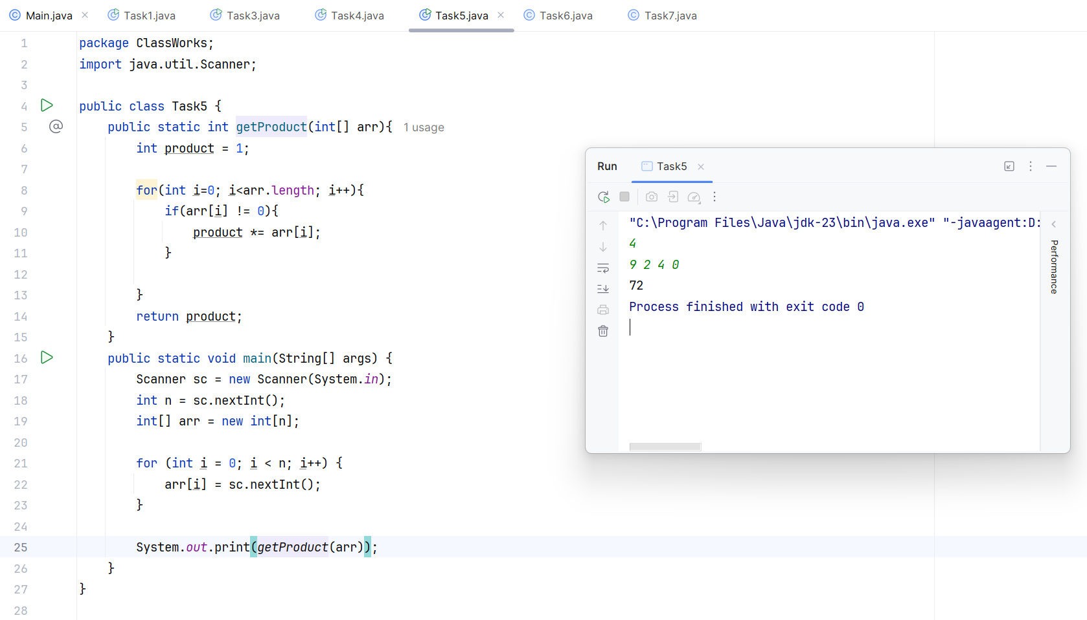

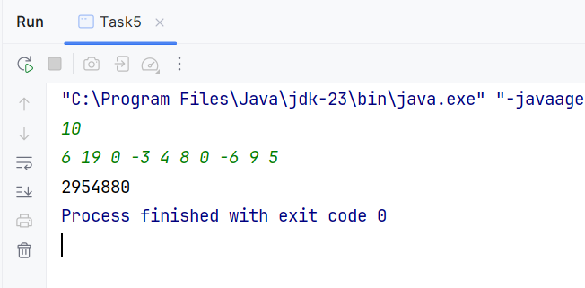

Task6. Write a program that asks a user to input an integer n. The program should prompt the user to input n integers and store them in an one-dimensional array. Then the program should output the geometric mean of all non-zero elements in the array.

**INPUT OUTPUT**

4 4.16017

9 2 4 0

10

6 19 0 -3 4 8 0 -6 9 5 6.43899

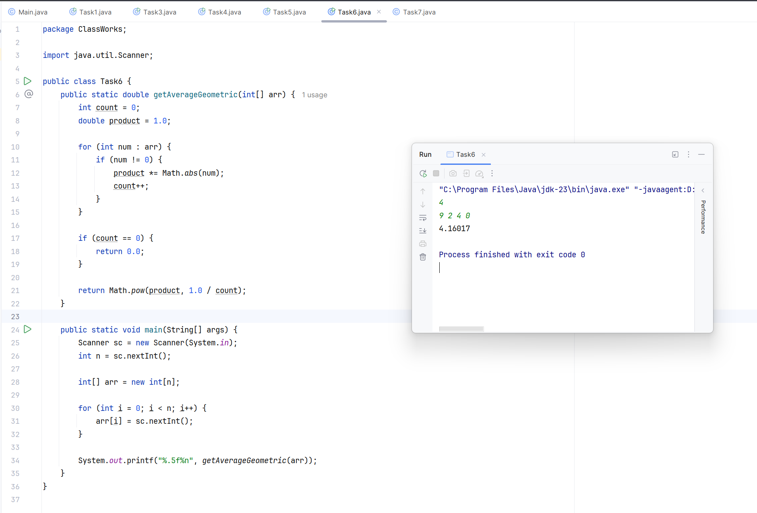

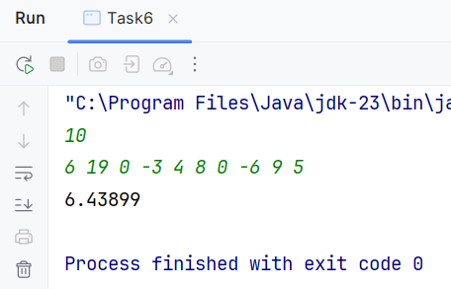

Task7. Write a program that asks a user to input an integer n. The program should prompt the user to input n integers and store them in an one-dimensional array. Further, the program should read an integer m. The program should output the number of elements in the array that are greater than m.

**INPUT OUTPUT**

4 2

9 -2 4 0

1

10 4

6 19 0 -3 4 8 0 -6 9 5

5

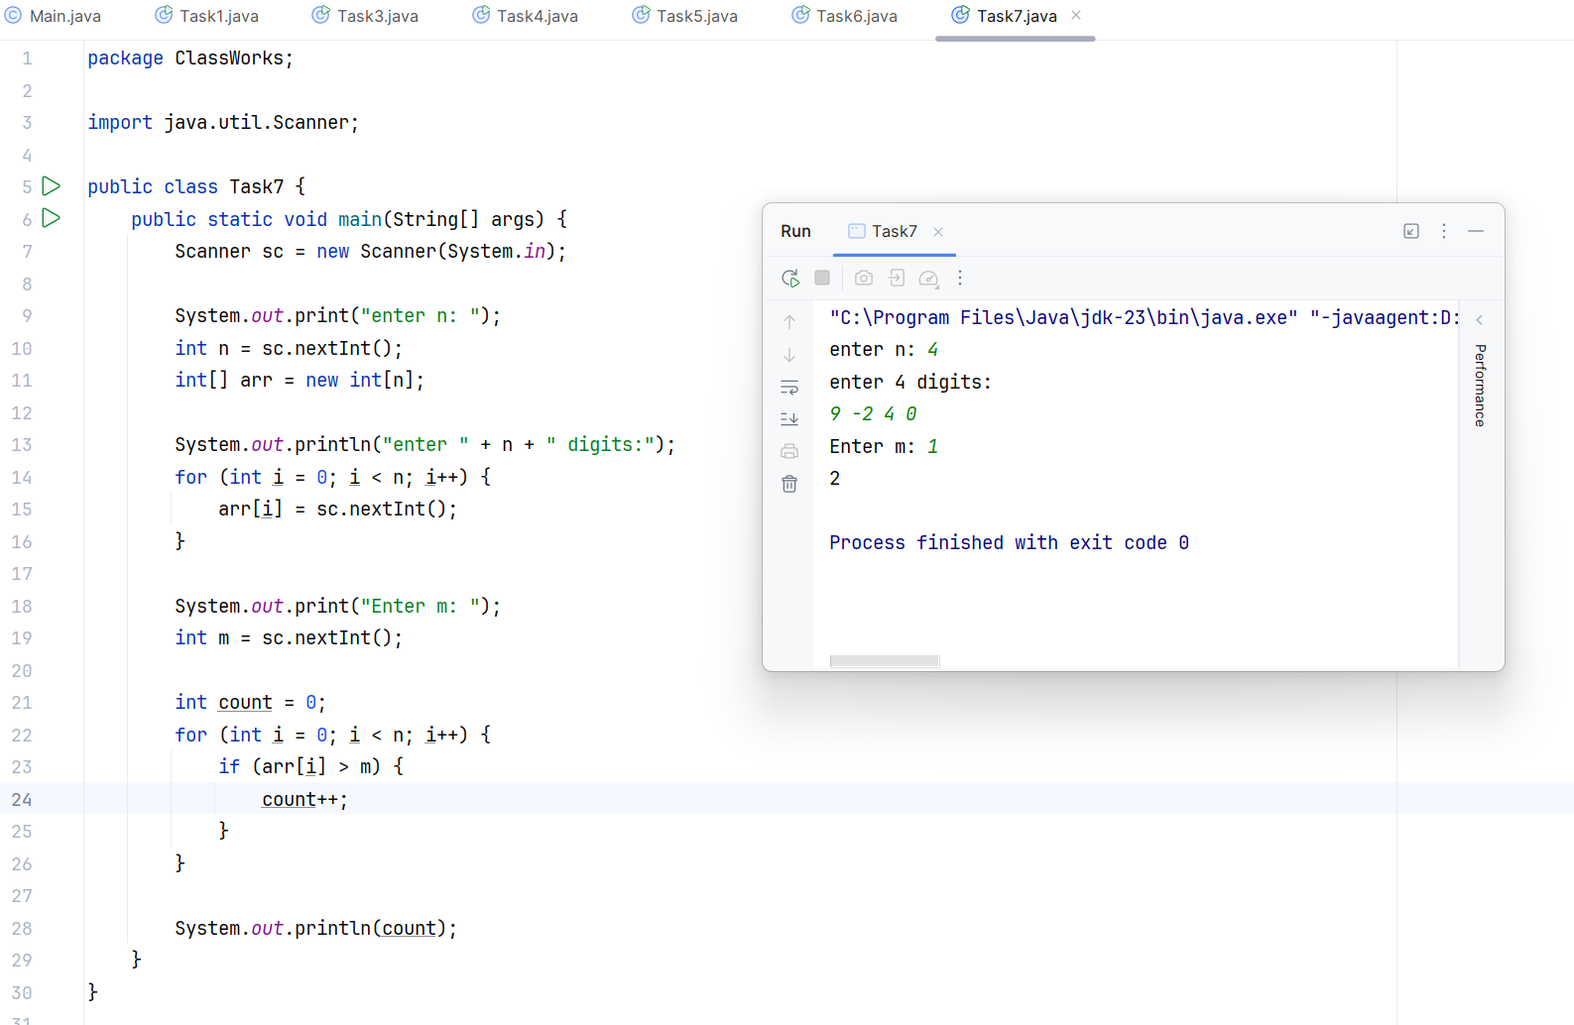

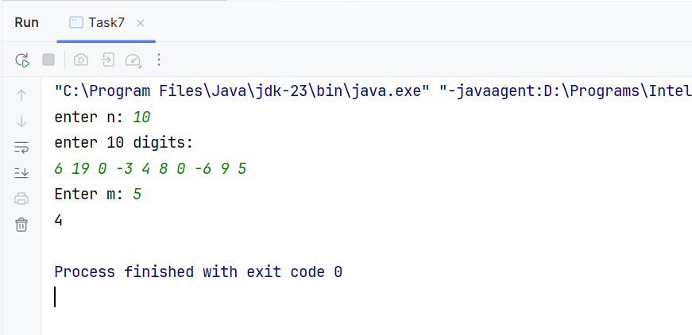

Task solve source files:

