Ospan Ramazan it2-2310, 38045

*HomeWorks:*

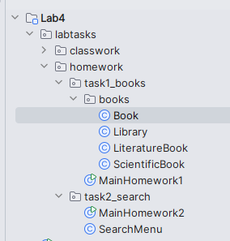

Work structure

Task1:

Book class

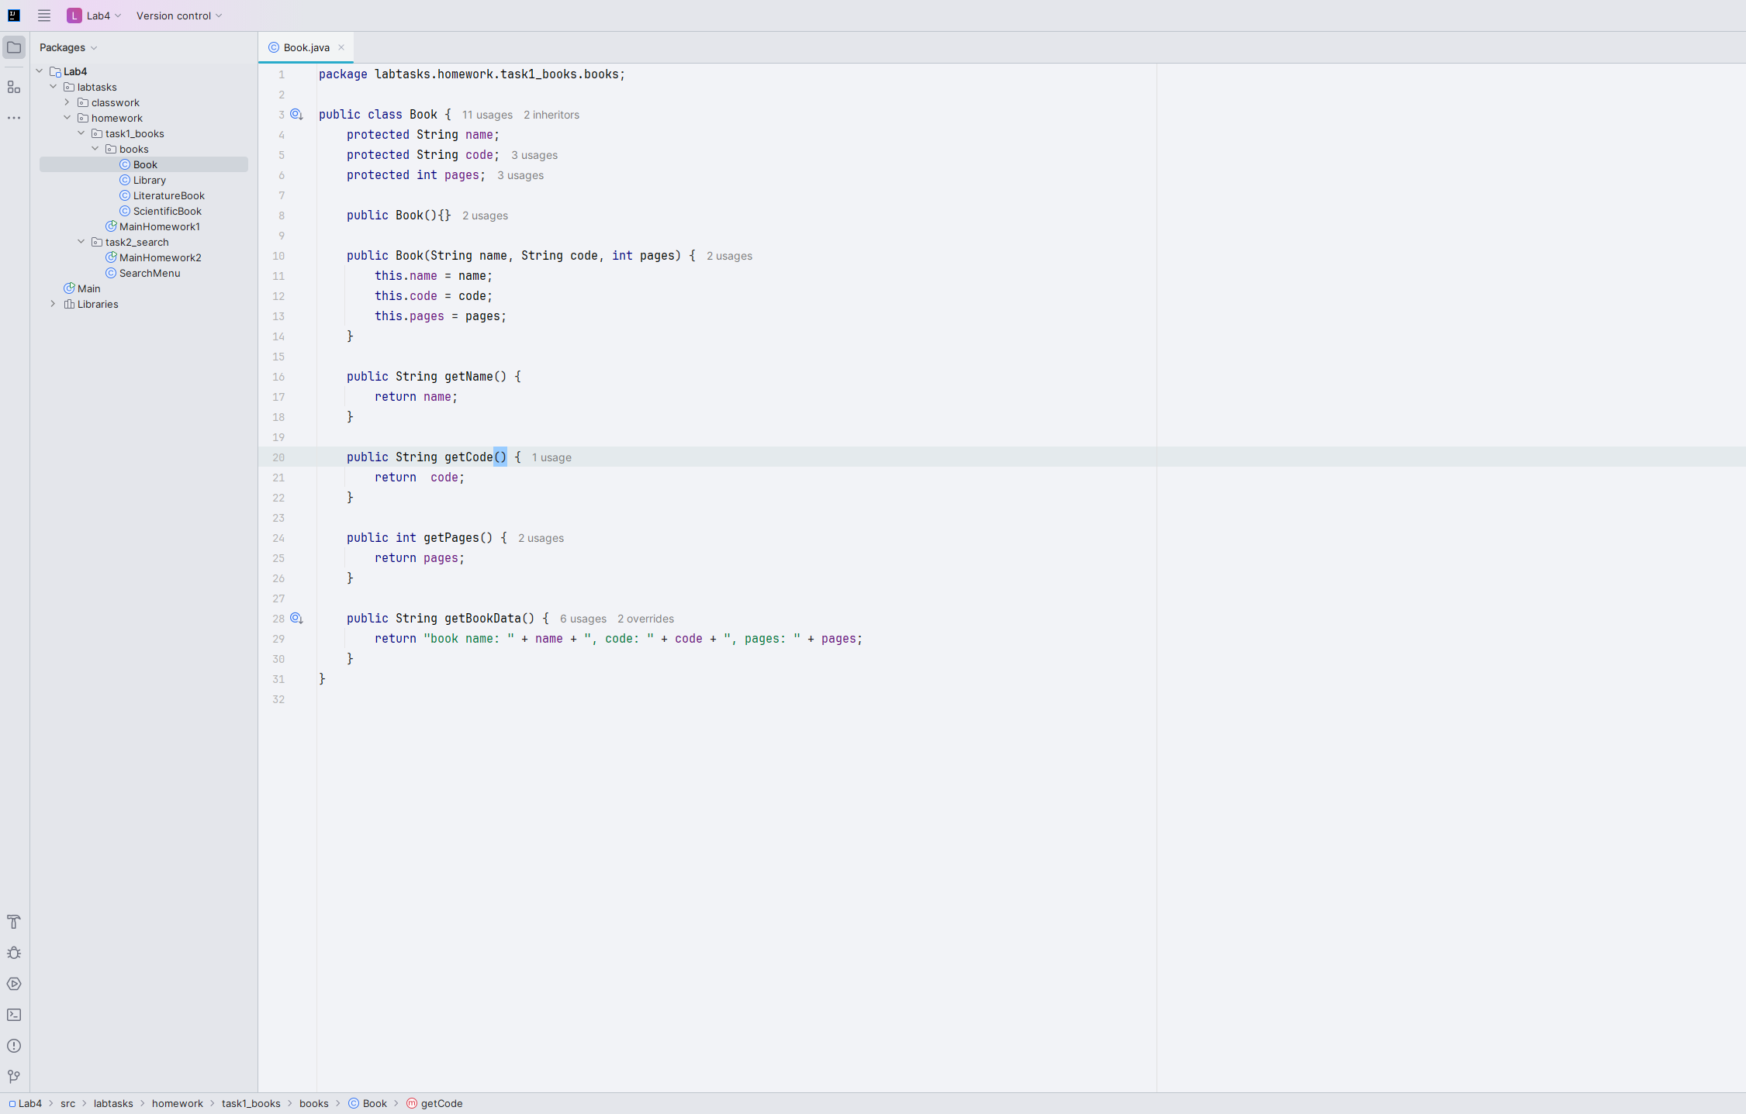

Library class

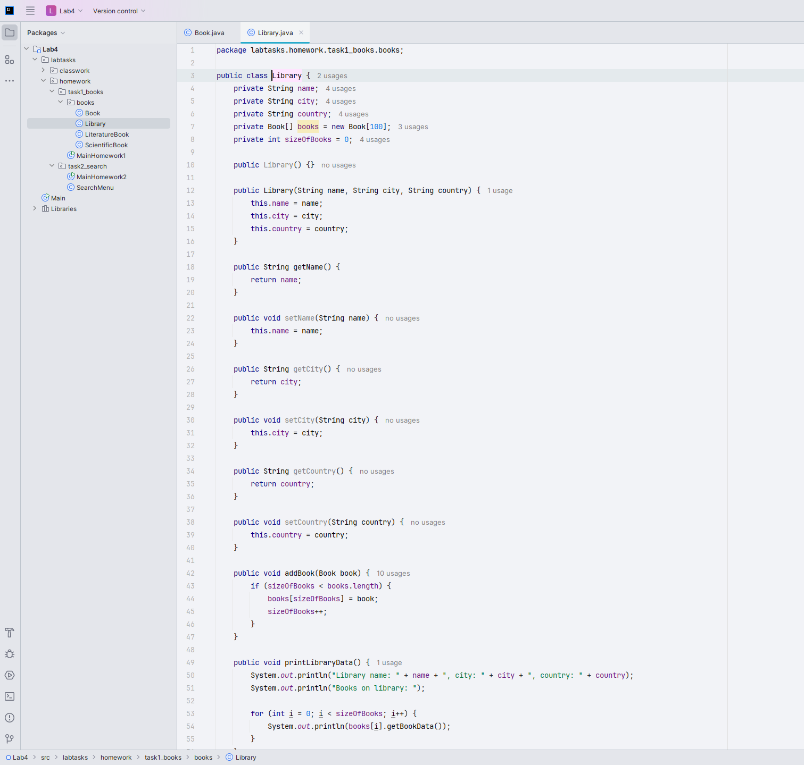

LiteratureBook class

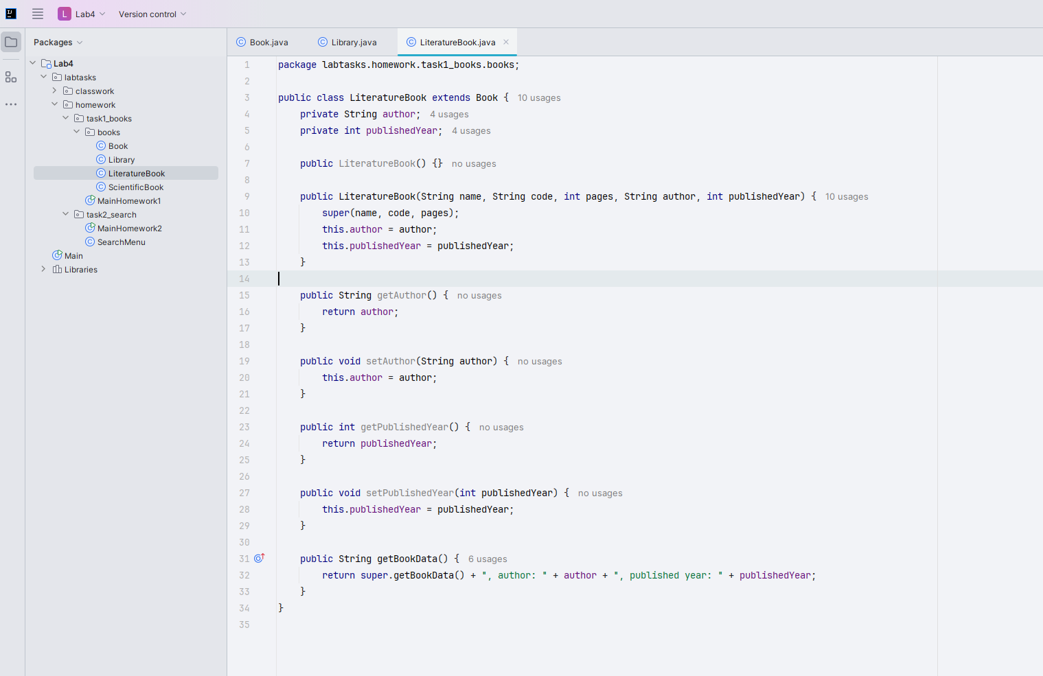

ScientificBook class

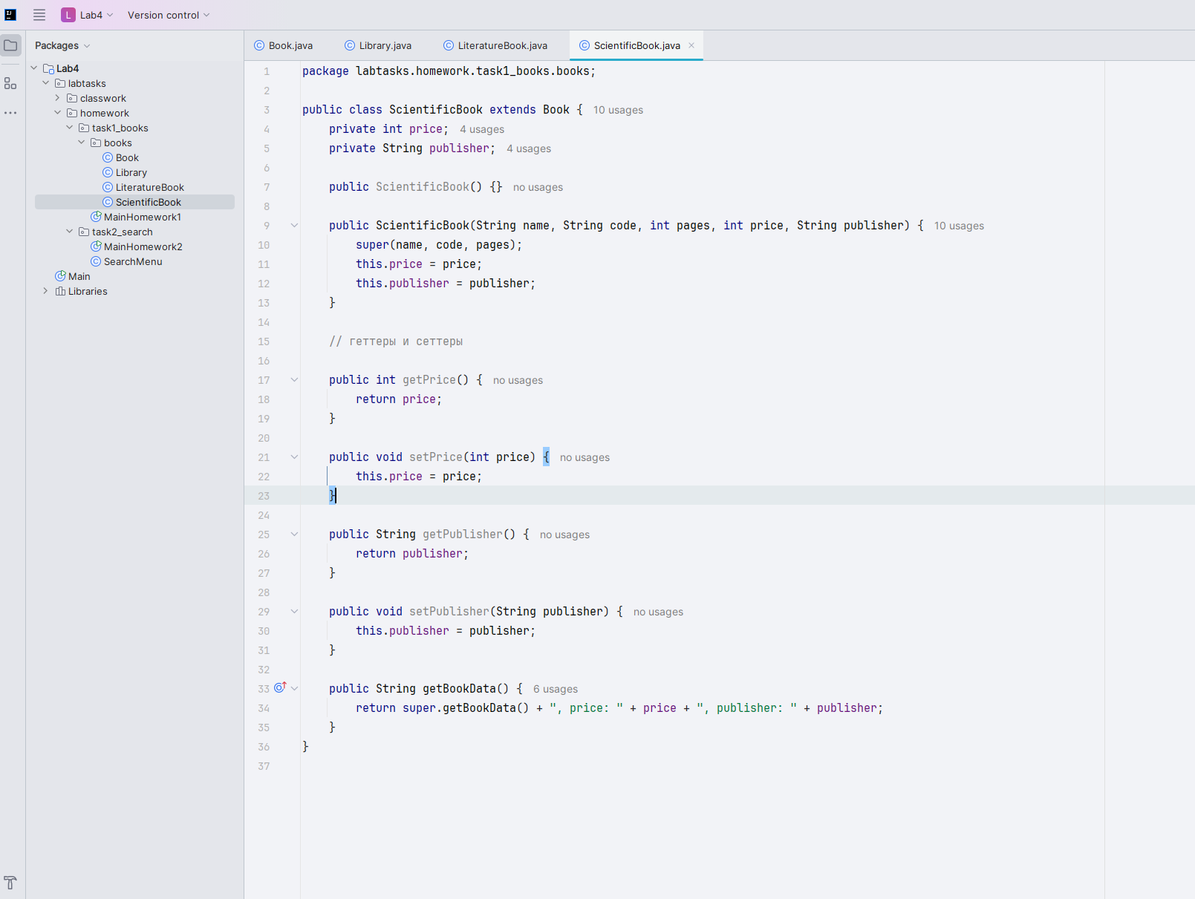

Main class

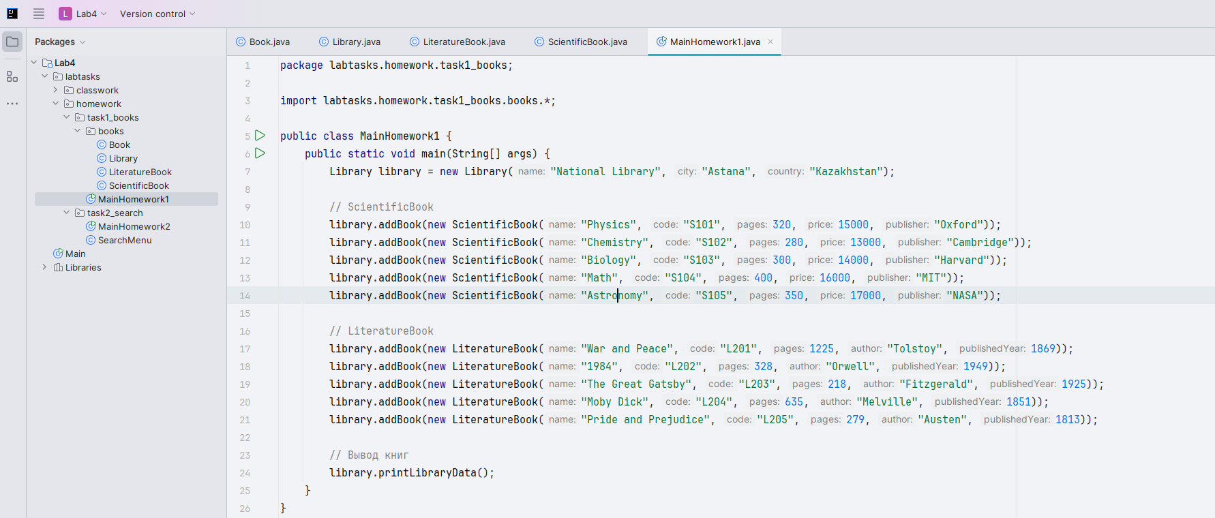

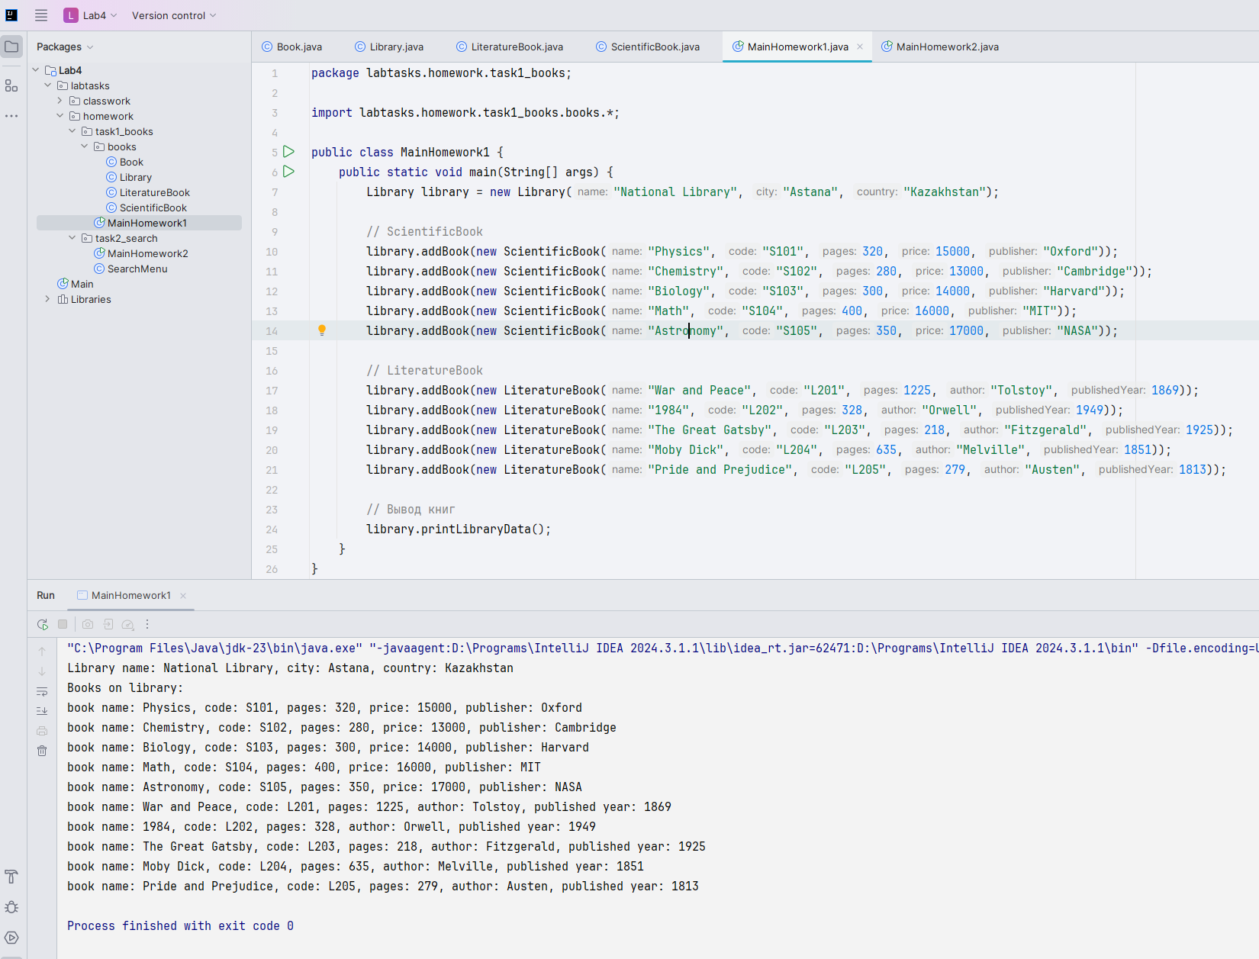

Task 2:

Main class

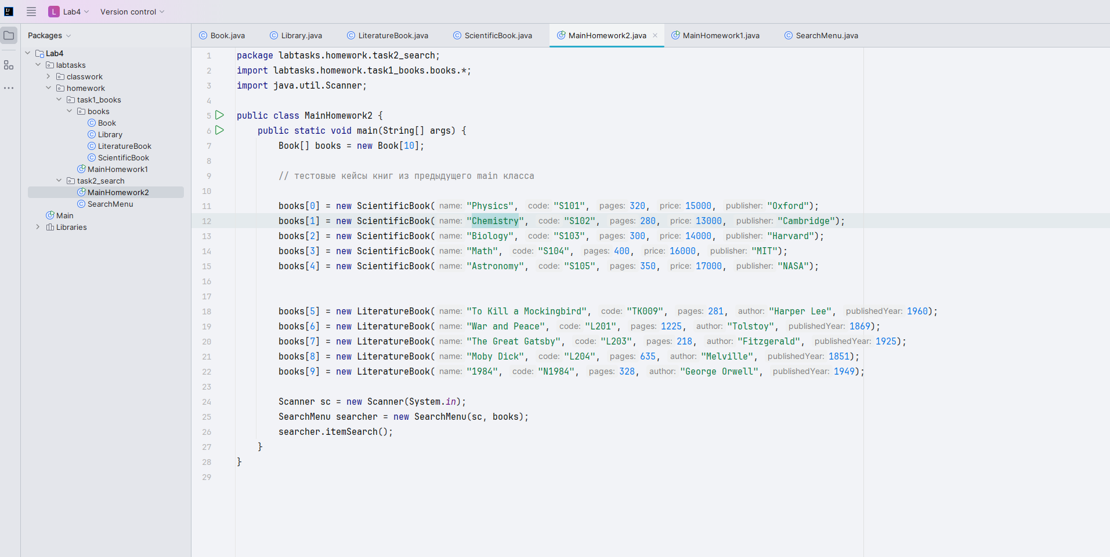

Searcher class menu:

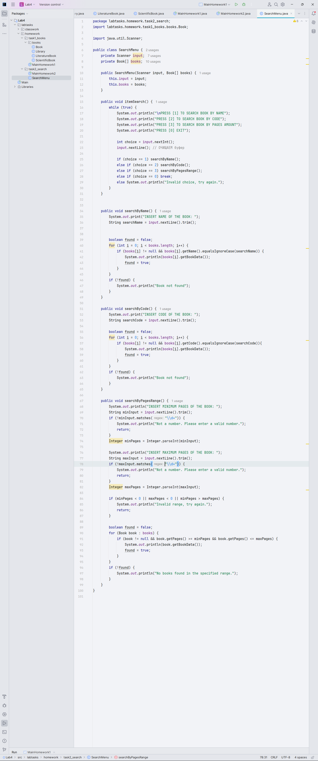

Present searching by name and code

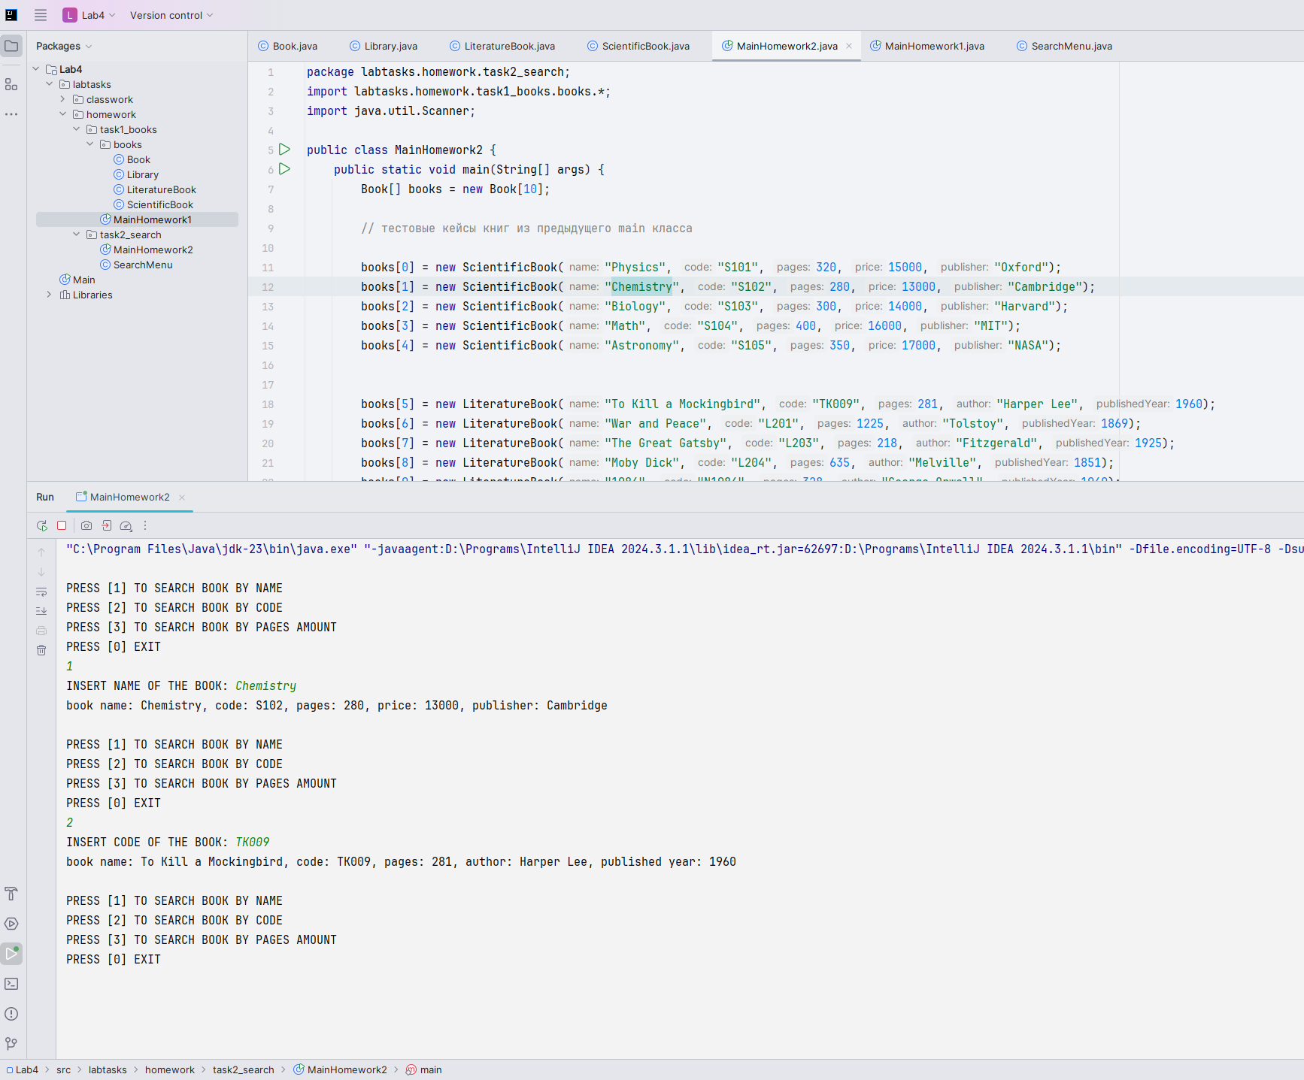

Saerch by pages range

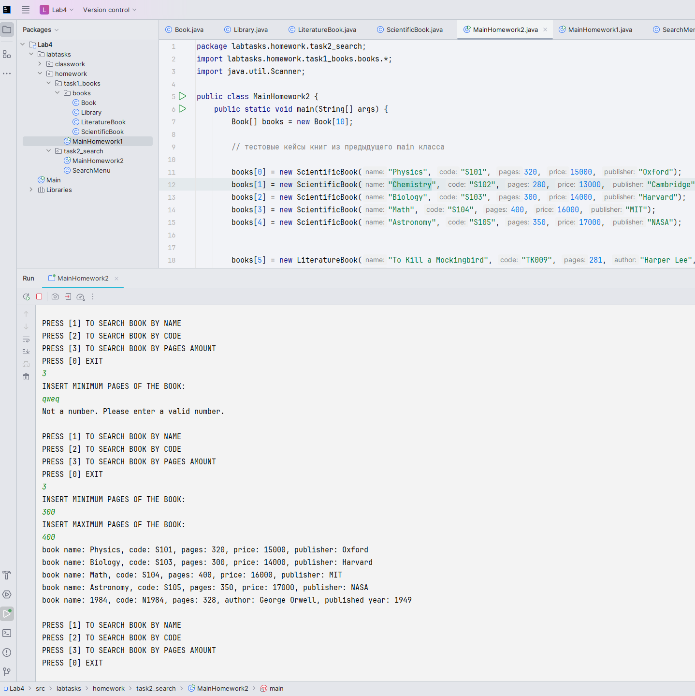

Code sources:



Or on my GitHub profile: <https://github.com/Ramazanm1nd3R/univer_learning_materials/tree/main/Java_OOP/Lab4>