

Rambhupal Payyavula (Payyavula.r@northeastern.edu)
ALY 6980 - Capstone, 20719, Winter 2023.
Module 12 Assignment: Individual Project Proposal Draft
SPONSOR: AECOM
Instructor: Roy Wada, PhD
Date: 03/28/23

Table of Contents
Introduction: 3
Sponsor: AECOM 3
Understanding Business Problems: 4
Individual Project Objective: 5
Understanding Datasets: 5
Data Preparation: 9
Exploratory Data Analysis: 11
Handling Null Values: 16
Correlation matrix: 17
Methods: 18
Preliminary Results: 19
Regression Models: 19
Classification Models: 22
Conclusion: 25
Future Work: 25
References: 26

Introduction:
As a part of the individual project proposal, I have primarily focused on the bridge logs and the advance notification dataset, Weather dataset, and tidal levels dataset to perform the machine learning model to predict the starting hour of the bridge lifting. That way it would be easy for the sponsor ACOM to display the bridge lifting prediction hour to the commuters of the bridge, which will avert the traffic on the Chelsea bridge.

Sponsor: AECOM
The engineering, design, construction, and management firm AECOM serves customers in a variety of industries, including transportation, buildings, water, the environment, energy, and government, and offers a wide range of services. The business was established in 1990, and its main office is in Los Angeles, California. It has offices in over 150 countries and employs over 50,000 employees, giving it a global footprint. Planning, consulting, architecture, engineering, program management, and construction management are just a few of the many services that AECOM provides. The Abu Dhabi International Airport, the Cross-rail project in London, and the design and building of the SoFi Stadium in Los Angeles are a few of its significant projects (aecom, n.d.).
The company AECOM is dedicated to sustainability and has received praise for its work in this area. It is a member of the United Nations Global Compact, which is a commitment to promote sustainable and socially responsible activities and has often been recognized as one of the World's Most Ethical Companies by the Ethisphere Institute. Aside from its work in engineering and construction, AECOM also engages in a few charitable endeavors. The business created the AECOM Foundation, which provides funding to groups working on clean water, energy, and infrastructure-related concerns (aecom, n.d.).

Understanding Business Problems:
The Chelsea Street Bridge in Boston, Massachusetts, is a bascule bridge that crosses the Chelsea River and links the Chelsea and East Boston neighborhoods. Access to the Seaport District, Logan International Airport, and other significant locations is made possible via the bridge, which serves as the region's main transit link. In the past, there have been delays and traffic congestion for cars on the Chelsea Street Bridge. Although there are two lanes of traffic on the bridge in each direction, during rush hour or when cruise ships are in the dock, traffic may get quite crowded. The bridge is regularly raised to let ships pass, which can result in lengthy waits for motorists.
The Massachusetts Department of Transportation (MassDOT) has launched several initiatives in recent years to address these traffic issues, including the installation of new traffic signal systems, the use of real-time traffic monitoring technology, and the introduction of a "Smart Corridor" system that makes use of technology to improve traffic flow. To reduce traffic congestion on the bridge and in the neighborhood, MassDOT has also collaborated with local partners to encourage alternate modes of mobility including public transportation and biking.
Despite these initiatives, traffic congestion on the Chelsea Street Bridge and in the neighborhood continues to be a concern, especially during rush hour. MassDOT is still looking into measures to ease congestion and enhance local traffic flow (How to Handle Missing Data: A Step-by-Step Guide , n.d.).

Individual Project Objective:
AECOM is closely working with MassDOT to solve the Chelsea Street Bridge traffic challenge. AECOM is working on the project to predict the bridge lifting time to inform the commuters in advance about the bridge lifting timings to manage the traffic on the bridge.
The objective of this individual project is to do data analytics and create a more precise model to forecast when future bridge lifts will occur using data sources such as Chelsea Street Bridge notification tracking dataset that involves bridge logs and advance notification data. And tidal levels, sun level, and weather data are available on the internet.
However, in this project, I have only concentrated on the excel data comprised of bridge logs and advance notifications to predict the machine learning model.

Understanding Datasets:
Dataset: Chelsea Street Bridge logs and advance notification data (Provided by sponsor). This dataset comprises 5,857 records and 15 variables. First, eight variable describes the advance notification data and the last seven variables signify the bridge logs data.
Among the 15 variables, four are the date time variable and the rest are the categorical variables. Vehicle Id and lift ID are merely serial numbers which are unique values. So, They have a uniform distribution which are significant for training the machine learning model.
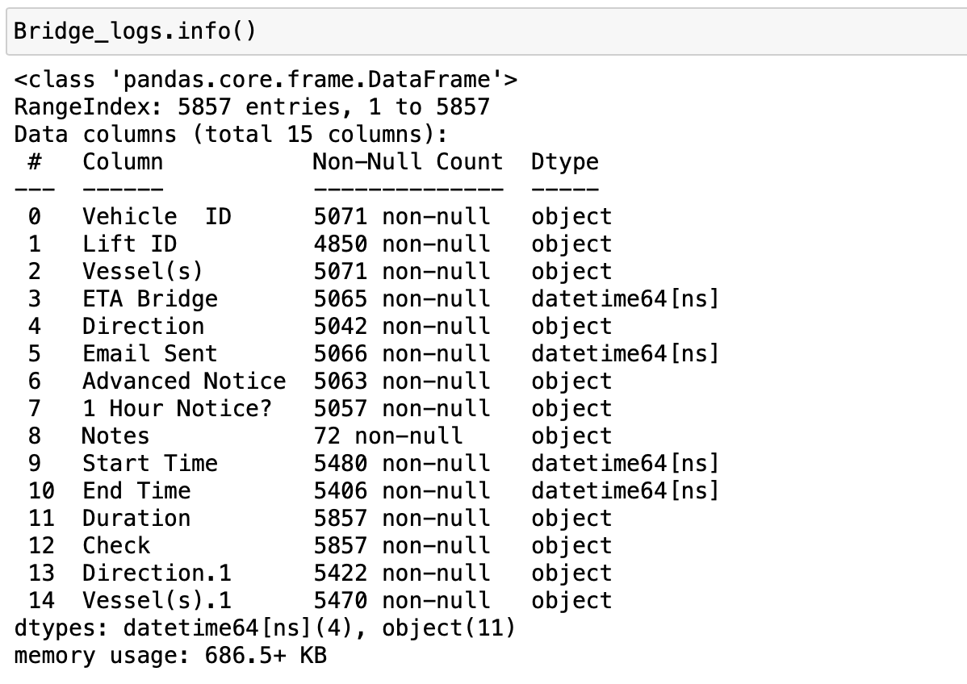
The notes variable has more than 98 percent of null values, which is not of much use to us.
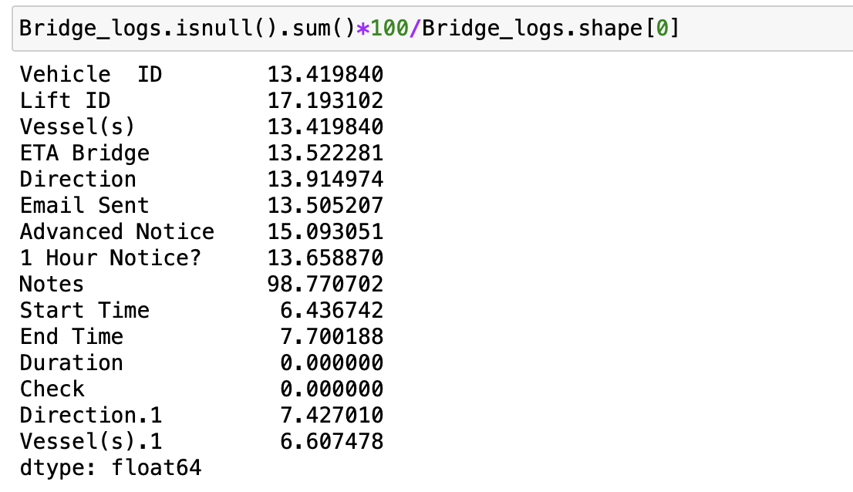

Weather Dataset:
This dataset comprises of 4,063 records and 30 features. And this dataset is taken from NOAA website.
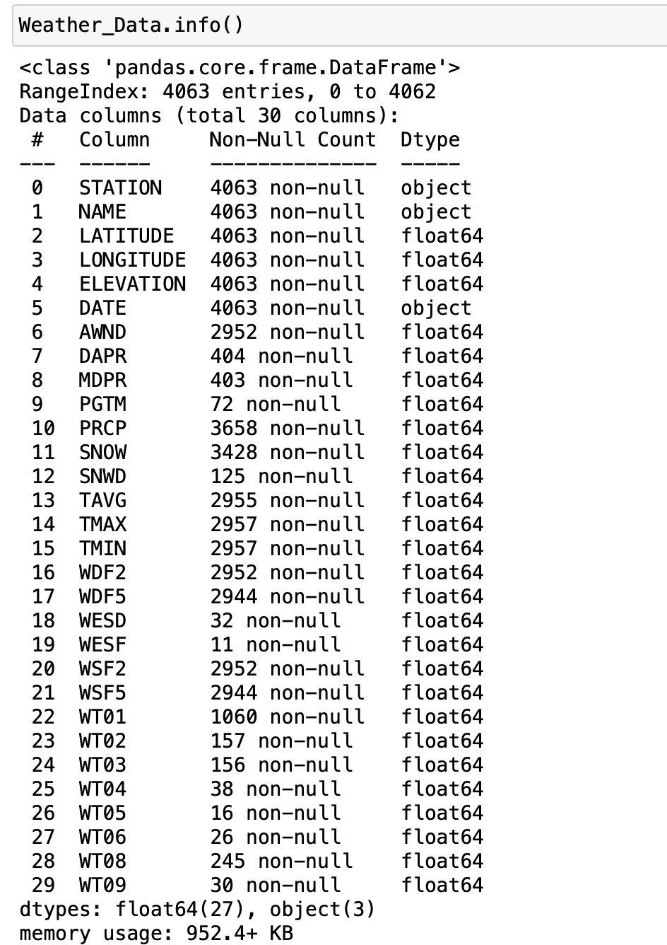
Tidal level Data:
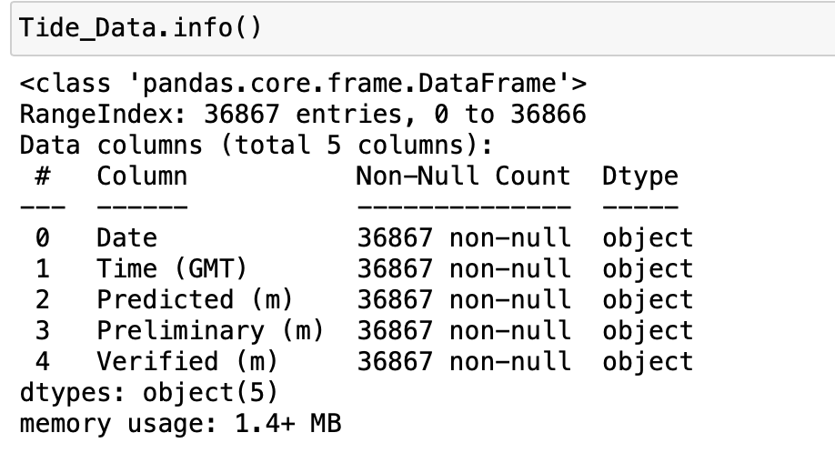
This dataset comprises 36,867 records and five features. And this dataset is taken from NOAA website.

Data Preparation:
As I am predicting the lift time of the bridge, it is crucial to extract the year, month, day, and hour from the start time variable. Start_hour will be the target variable in the supervised machine learning model.
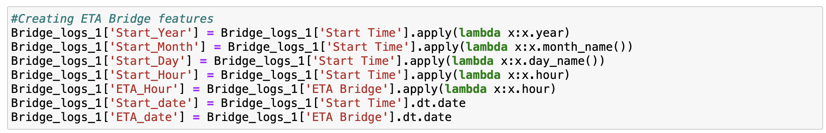
Creating the notice time difference and lift duration from the datetime variables in the dataset to find if there is any relation between the lift time and the duration. Above is the used python code for the feature engineering.
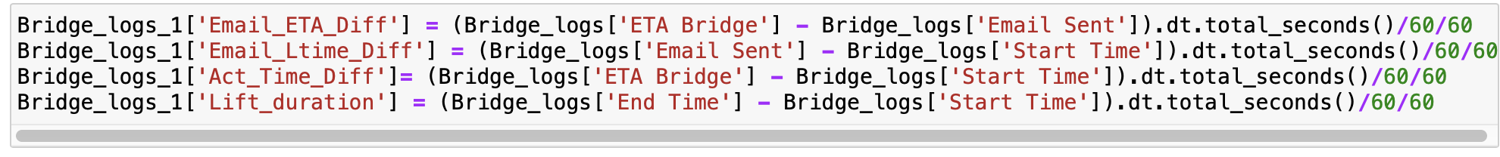
Dropped the unwanted variables such as 'Vehicle ID', "Lift ID", "ETA Bridge", 'Email Sent', 'Advanced Notice', 'Notes', 'Start Time', 'End Time', 'Duration', and 'Check'. 'Vehicle ID', and "Lift ID" are the serial numbers, and the advanced features have been created the date variables such as 'Start Time', 'End Time', "ETA Bridge", 'and Email Sent', Thus no use of them for the machine learning model. Check is a uniformly distributed variable. Hence, not much use for the training machine learning model.
Below is the description of the data.
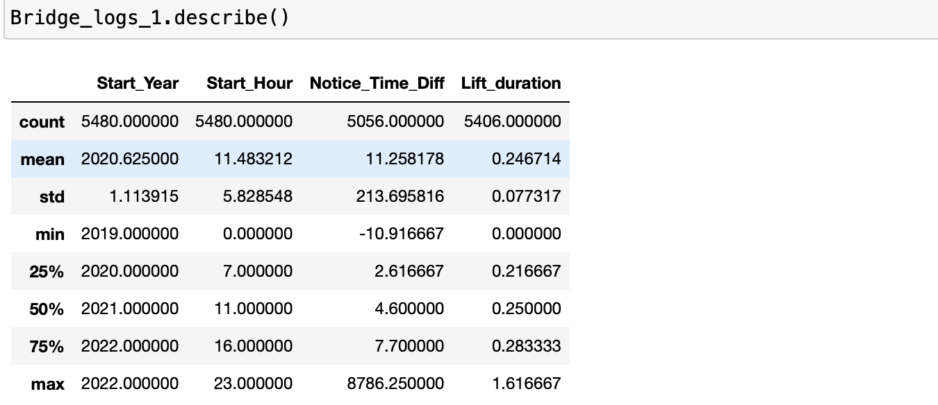
Weather and Tide Dataset:
As we only need the data from 2019 to 2022, I have filtered the required data for both the wether and tide datasets to join it with bridge logs.
Replacing the ‘-‘ with null values and dropping the null values.
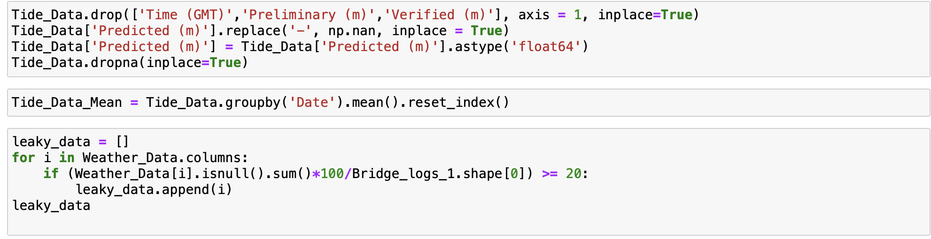

Exploratory Data Analysis:
Frequency of bridge lifting from 2019 to 2022:
The below bar graph shows the frequency of bridge lifting caused by vessels passing through the bridge.
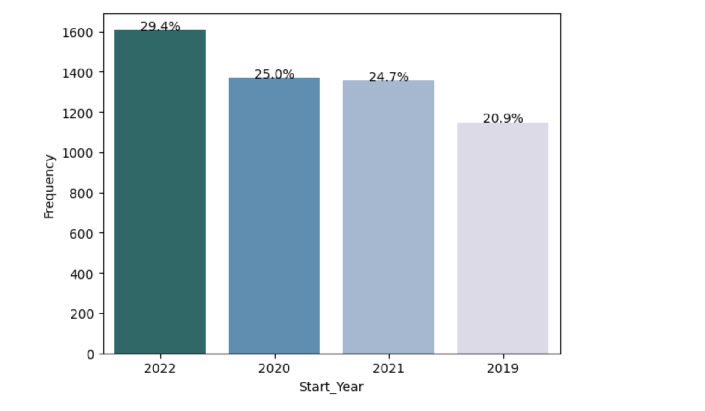
We can see from the above graph that 2022 is evident for more than 29 percent of bridge lifting followed by 2020, 2021, and 2019.
Frequency of vessels for different months from 2019 to 2022:
The below graph shows the frequency of the vessels passing through the bridge in 12 different months over the span of 2019 to 2022.
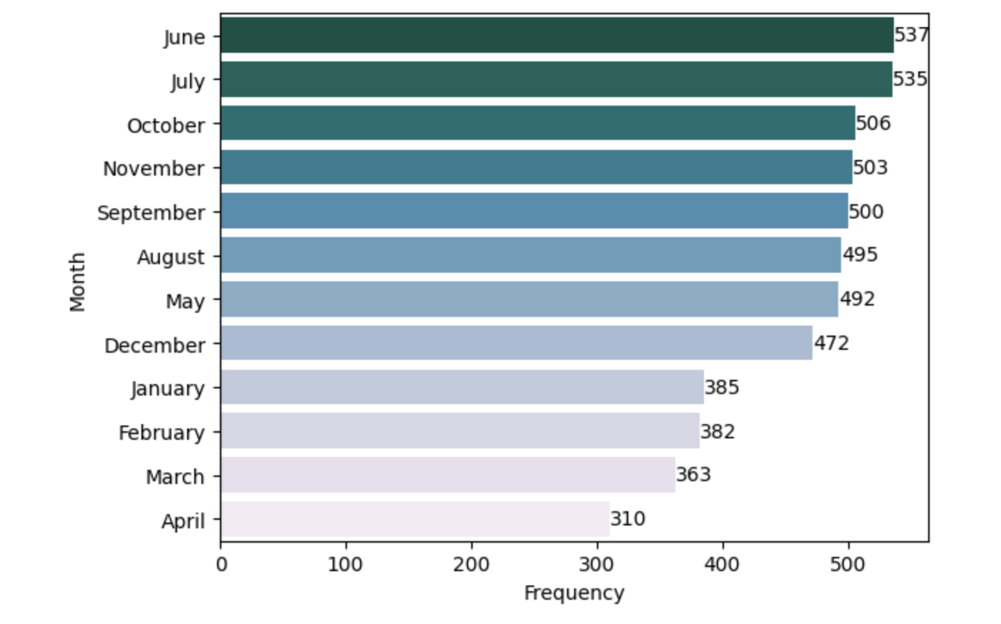
In the first four months, the number of vessels passing through the bridge is compared to the other months. And touched its peak the June, July then gradually decreased by the end of November.

Distribution of bridge lifting over a week:
The below graph shows the frequency of the vessels passing through the bridge in a week over the span of 2019 to 2022.
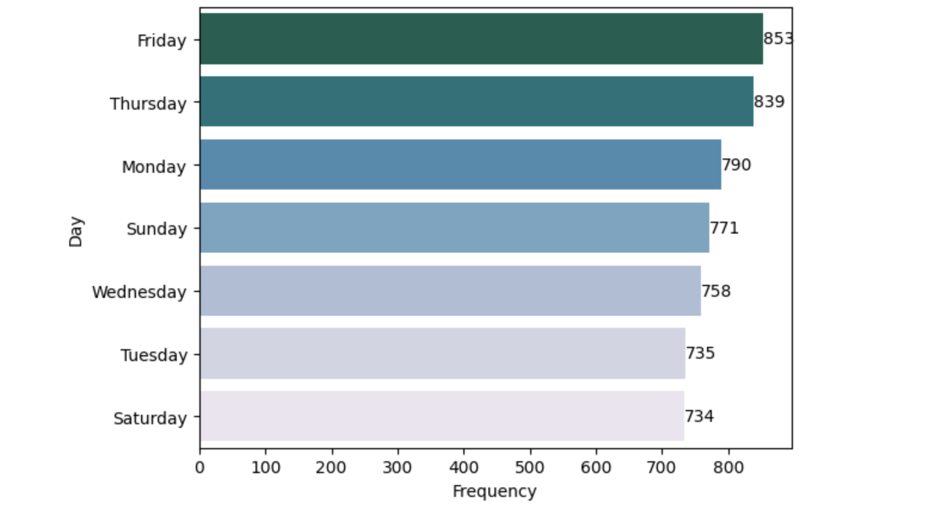
We see from the above bar graph that more than 830 ships have passed the bridge on Fridays and Thursdays.
Frequency of vessels based on hours:
The below graph shows the frequency of the vessels passing through the bridge in a week over the span of 2019 to 2022.
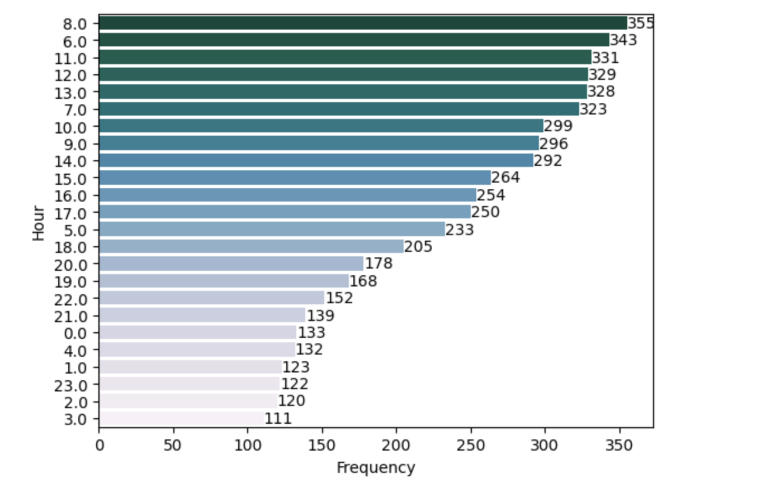
We can see from the above graph that most of the vessels passed the bridge between 7 AM and 1 PM and was peak at 8 AM. So, it would be good for commuters to avoid in those timings.
Top ten types of vessels that passed the bridge:
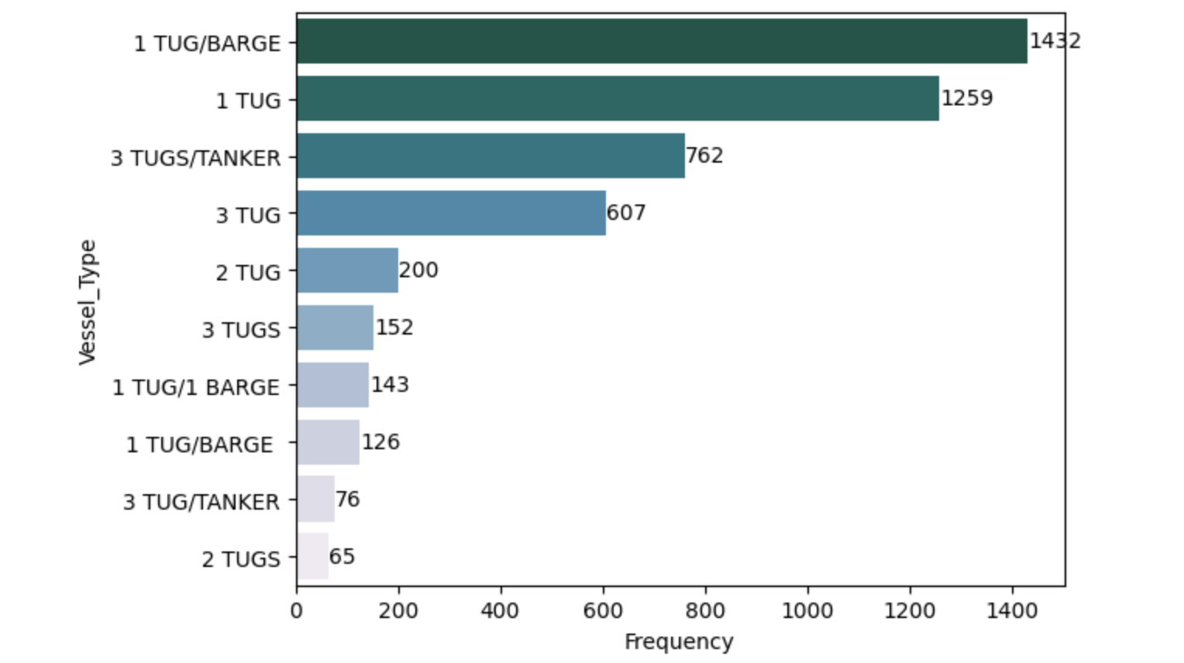
We can see from the above bar chart that 1TUG/BARGE is the most frequent type of vessel that passes the bridge. It passed, more than 1400 times in the span of 2019 to 2022 followed by 1TUG.
1 Hour Acceptable Notice:
Below is the graph that depicts the frequency of vessels that passes the bridge in 1 Hour notice. We can Cleary see from the below graph that 96.3 percent of vessels have passed the bridge in the accptable notice and 3.7 percent of vessels passes the bridge with a un acceptable notice of 1 hour.
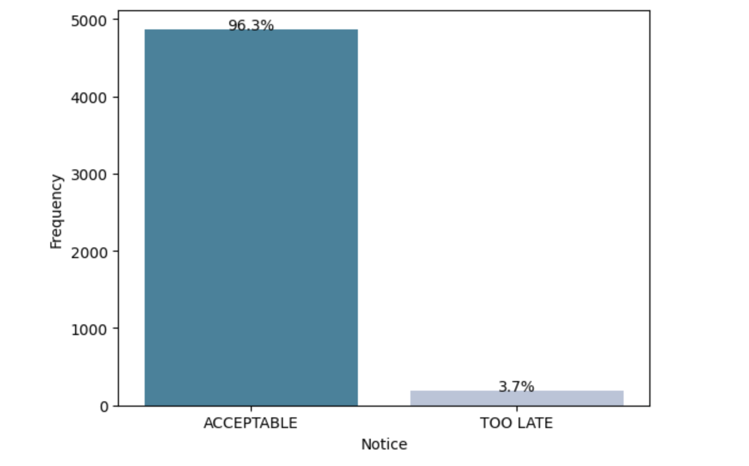
The 96.3 percent of acceptance rate shows that, the ETA of the bridge lifting is mostly close to the actual bridge lifting time. ETA of the brodge lifting will have a high correlation with the actual brdige hour and will the crucial variable in predicting the actual bridge lifting.

Handling Null Values:
Each variable in the dataset amount to less than 14 Percent of null values.
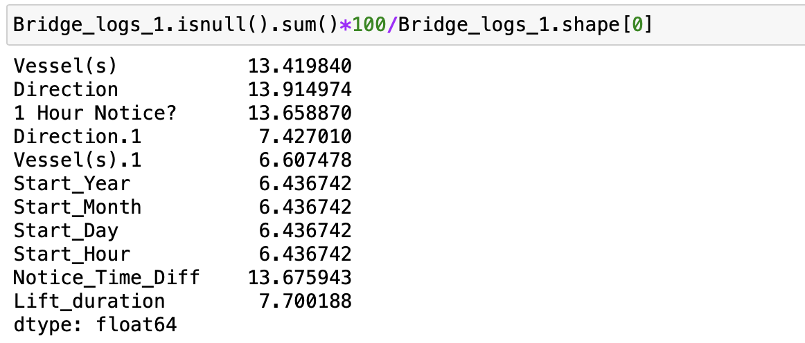
Imputing missing values with median and mode would lead to the training of inappropriate data. So, It is reasonable to drop the null value rows in the data for better accuracy of the model.
After properly cleaning the data, we are left with 10 variables and 4,647 records, which will be useful for training the machine learning model.
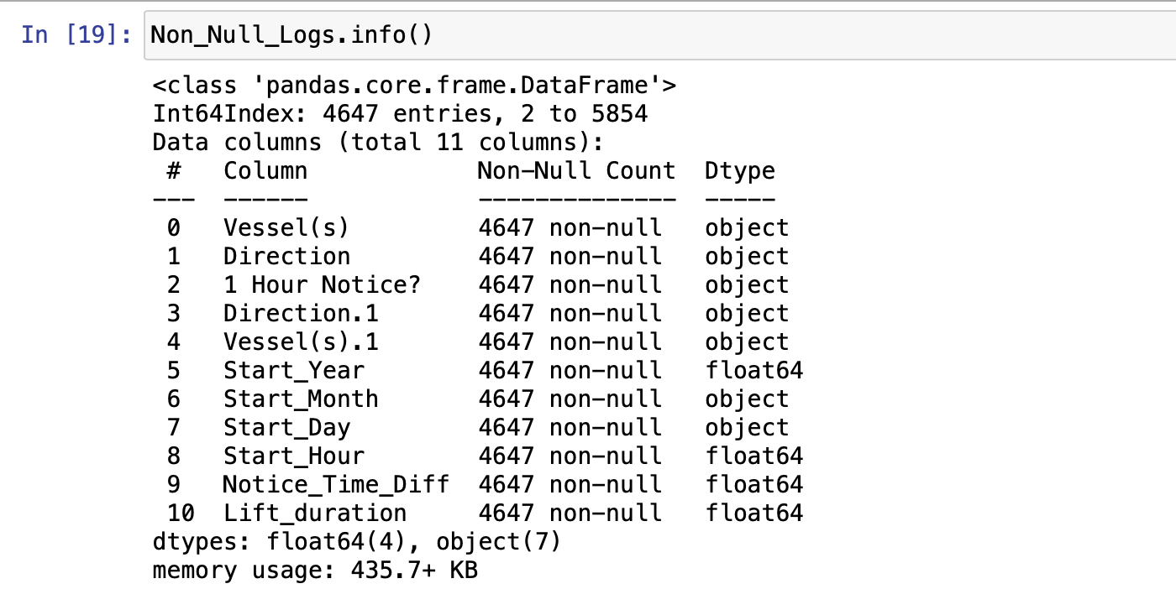
Encoding the categorical data for performing the random forest regression model. Below is the python code used for encoding the categorical data.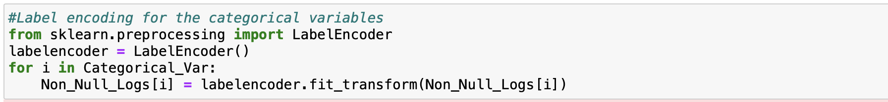

Correlation matrix:
We can see from the below correlation plot that there is not much correlation between the variables, The only variable that is correlated is direct and direction.1. So, performing the linear regression would be a bad idea as there is no collinearity between the variables.
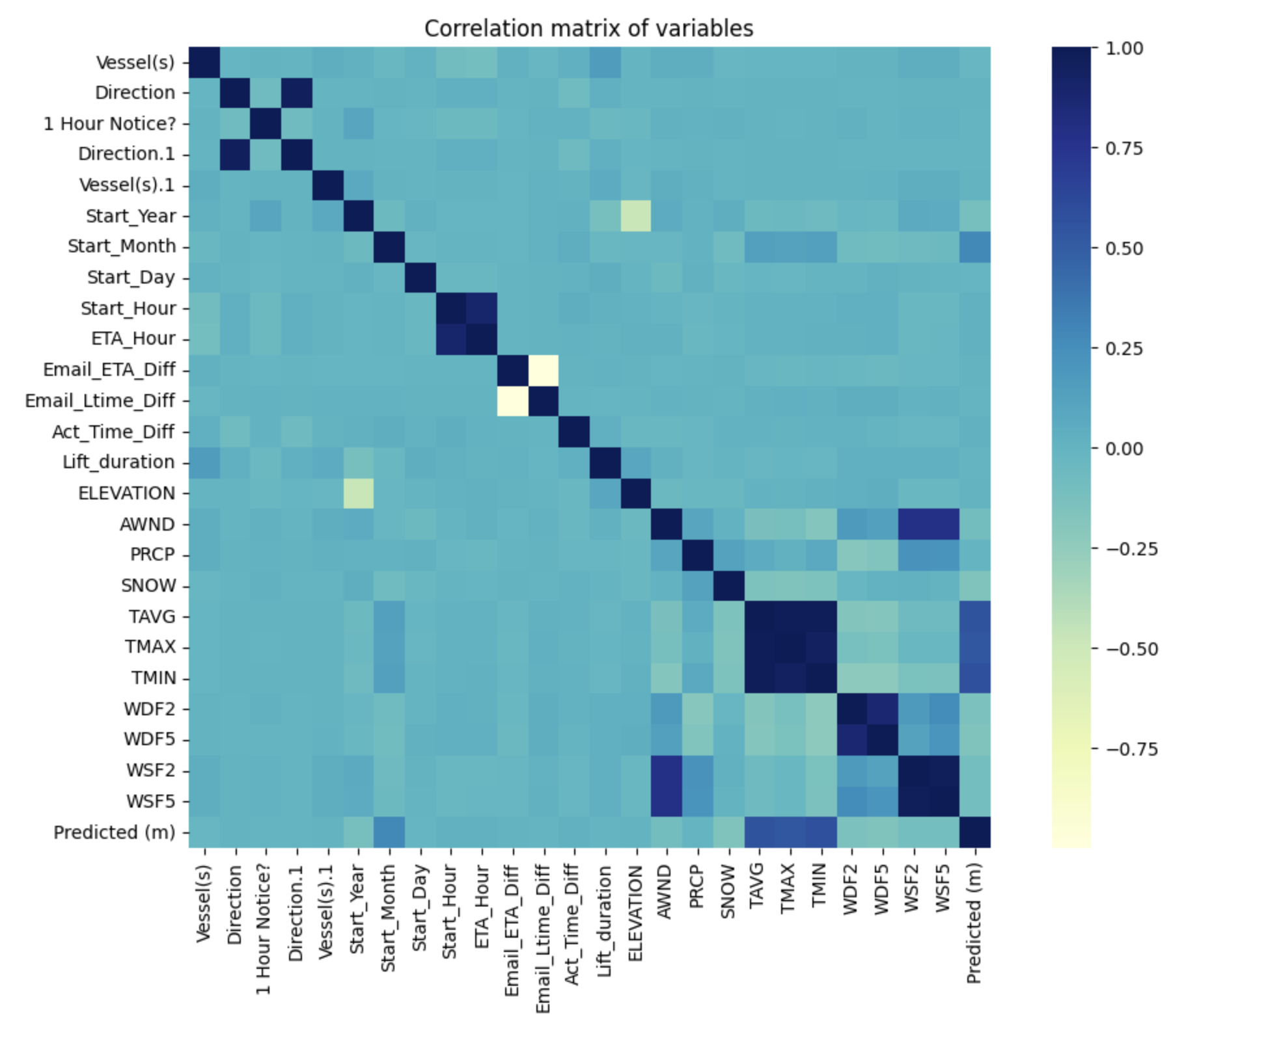

Methods:
Random Forest regression:

Random Forest, A machine learning algorithm that is a member of the family of ensemble learning techniques is regression. In regression issues where the objective is to predict a continuous numerical output, it is a supervised learning approach. A huge number of decision trees are constructed as part of the method, and each tree is trained using a random portion of the training data and a random subset of the features. Bootstrap aggregating, often known as bagging, is a method for training decision trees that entails training each tree on a separate sample of data to prevent overfitting (Random Forest Regression in Python, n.d.).

Each decision tree in the random forest independently guesses the output value based on its subset of the data and characteristics when generating a prediction. Depending on the specific implementation, the final prediction is subsequently determined as the weighted average or average of each individual tree forecast. In conclusion, Random Forest Regression is a potent machine-learning method that integrates the results of many decision trees to create a forecast that is more reliable and accurate. It is extensively utilized in many different fields, including finance, healthcare, and social sciences (Random Forest Regression in Python, n.d.).

Preliminary Results:

Regression Models:

Importing the required libraries and splitting the test and train data.
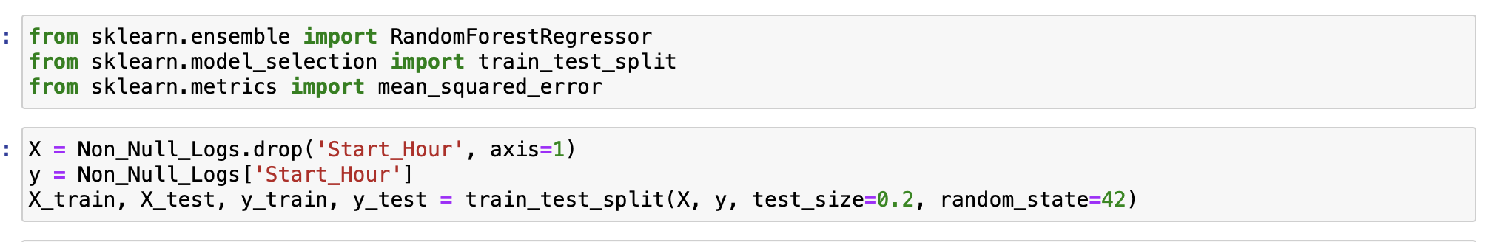

Training the model with the train data
Mean square error and R-squared value for the performed regression model. MSE is 29.33 and the R-squared value is 0.11, which is far less than 0.5. Which shows that the variables are less correlated.
Random forest regression Feature importance:
Among all the variables, only ETA hour, notice time difference, and vessels are the top three most important variables for the model training.
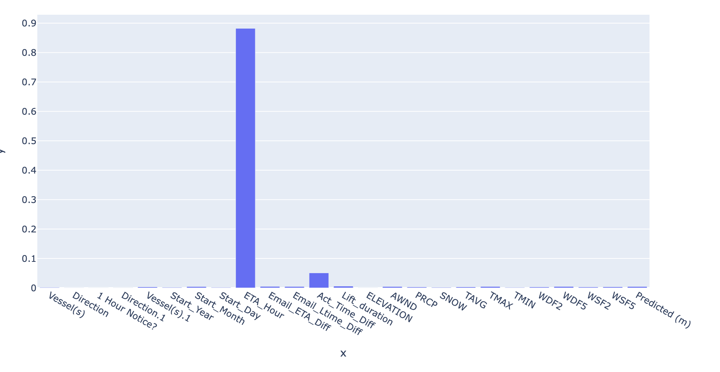

Based on the feature importance, I have trained three models with the top three important variables, and below are the results for root mean square error and R squared value.
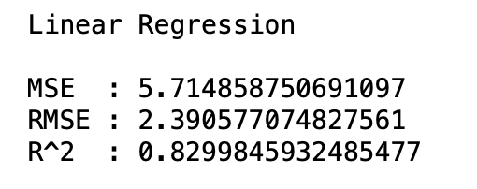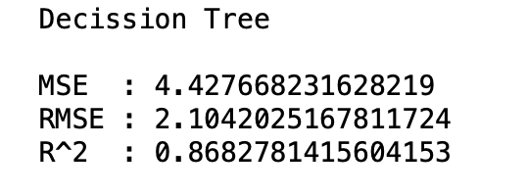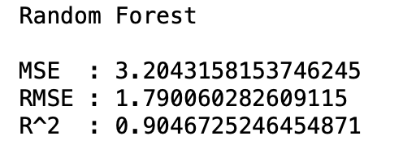

Root Mean Squared Error:
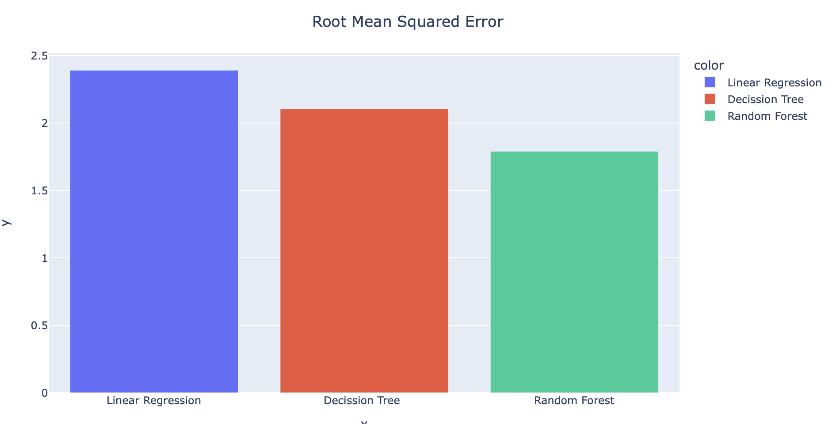
Among the three models, the Random forest model has a low RMSE error of 1.79 compared to the other models such as linear regression and Decision tree regression.
R-Squared value comparison:
Among the three models’ the Random forest model has a High R-squared value of 0.90 compared to the other models such as linear regression and Decision tree regression.

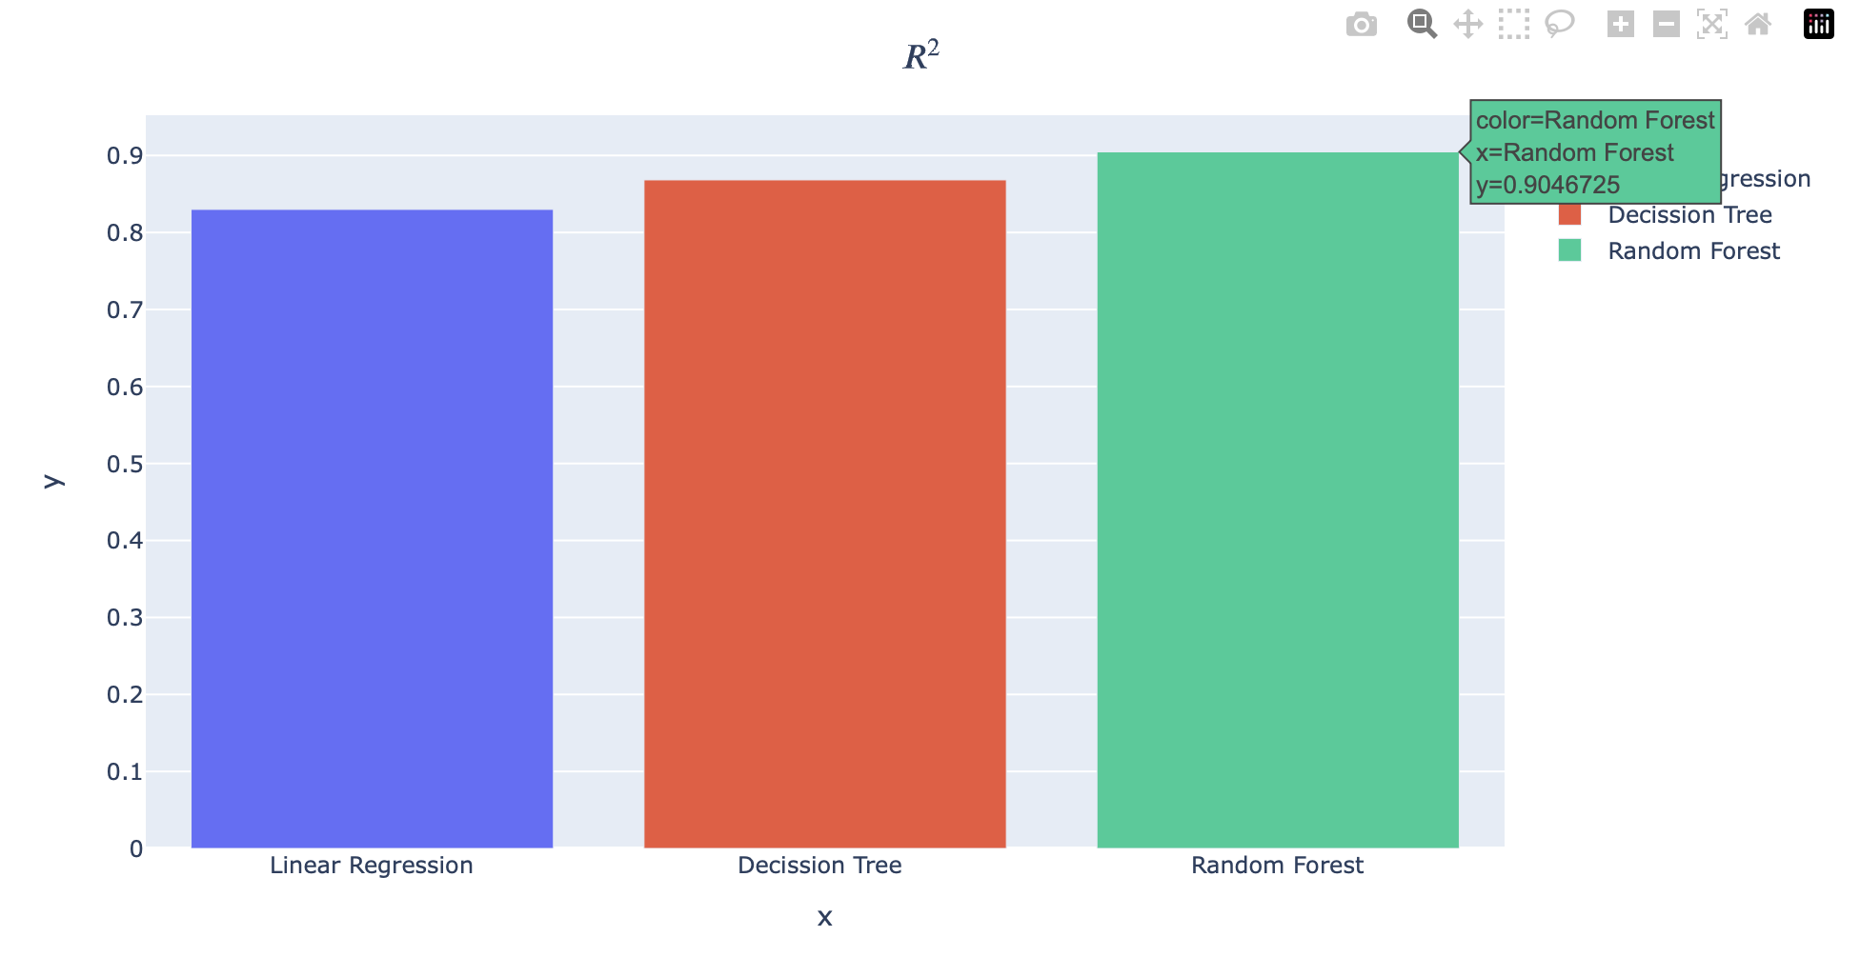

Classification Models:
Start hour has been binned into four groups such as 'Morning', 'Afternoon', 'Evening',and 'Night'
'Morning' : 5 am to 12:00pm
'Afternoon': 12 pm to 5pm
'Evening': 5 pm to 8pm
'Night': 8pm to 5 am
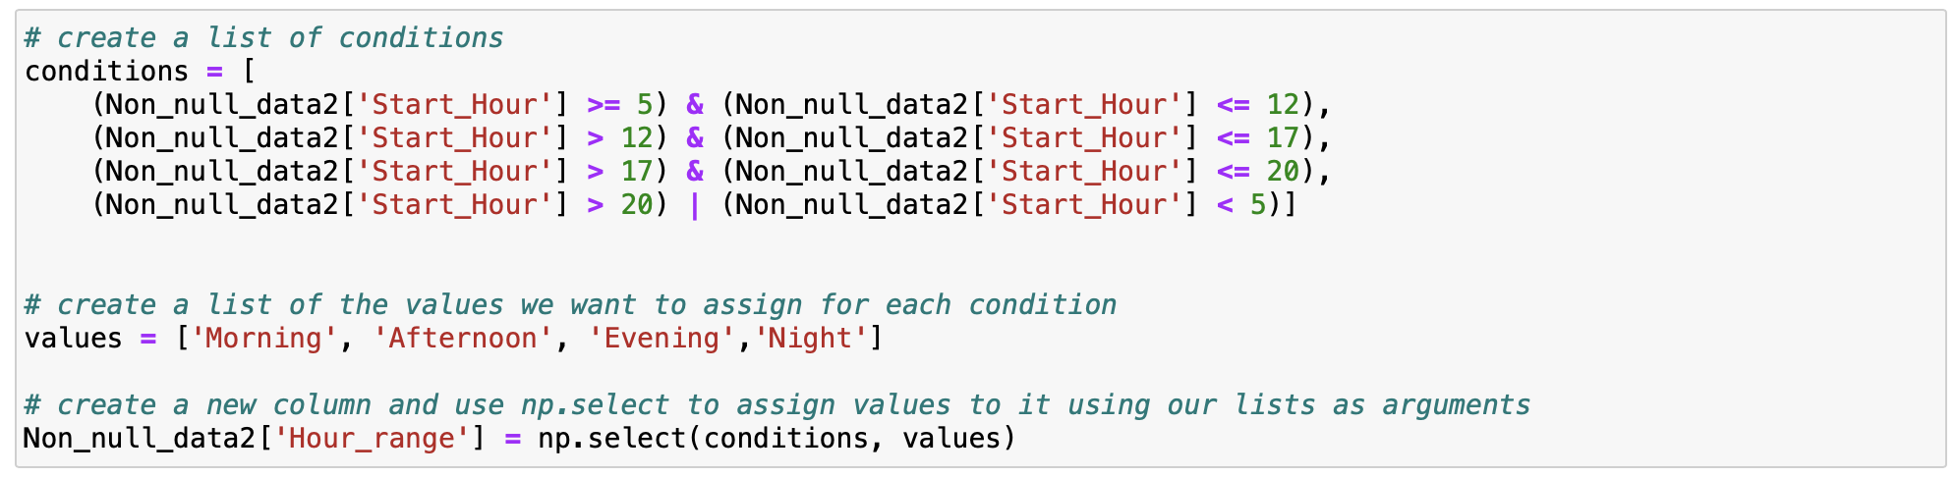

Classification Models used:
Extreme Gradient Boosting Classifier:
XGBClassifier is a machine learning algorithm based on gradient boosting that is used for classification tasks. It stands for "Extreme Gradient Boosting Classifier" and is a popular algorithm due to its high accuracy and efficiency. It uses decision trees as weak learners and combines them to make strong predictions.
KNeighbors Classifier:
KNeighborsClassifier is a machine learning algorithm used for classification tasks. It is a type of instance-based learning or lazy learning, where the algorithm memorizes the training dataset and makes predictions based on the similarity of new data points to the training data. It works by finding the k nearest neighbors of a new data point and assigning it the class label of the majority of its neighbors. The value of k is a hyperparameter that can be tuned to improve the accuracy of the model.
Gaussian Naïve Bayes Classifier:
GaussianNB is a machine learning algorithm used for classification tasks. It is based on the Bayes theorem and assumes that the features of a dataset are normally distributed. It calculates the probability of a new data point belonging to each class using Bayes theorem and selects the class with the highest probability as the predicted class. It is a simple and efficient algorithm that can be used for both binary and multiclass classification tasks. However, it may not work well for datasets with non-normal distributions of features.
Random Forest Classifier:
Random Forest Classifier is an ensemble learning algorithm that builds multiple decision trees using randomly sampled subsets of the training data and randomly selected subsets of the features. It combines the predictions of these trees to make the final prediction, resulting in a more accurate and robust model than a single decision tree.

Gradient Boosting Classifier:
Gradient Boosting Classifier is also an ensemble learning algorithm that builds multiple decision trees, but unlike Random Forest Classifier, it does so sequentially. It builds each decision tree to correct the errors of the previous tree, resulting in a model that can be highly accurate and robust.
Feature importance:
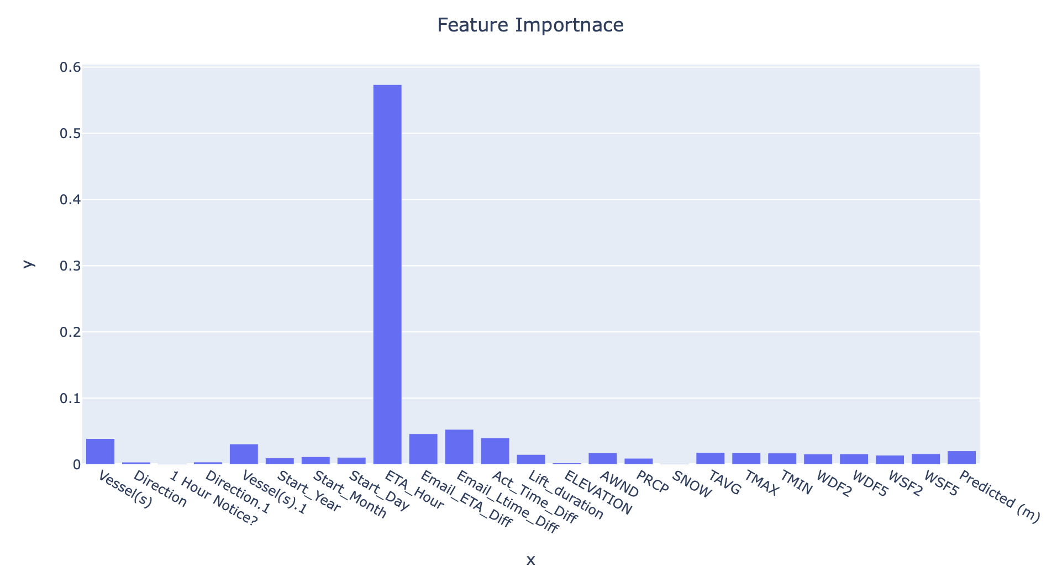
From the above chart, we can see that 'ETA_Hour', 'Email_Ltime_Diff', 'Email_ETA_Diff', 'Act_Time_Diff', and 'Vessel(s)' are the top 5 important features.

Results:
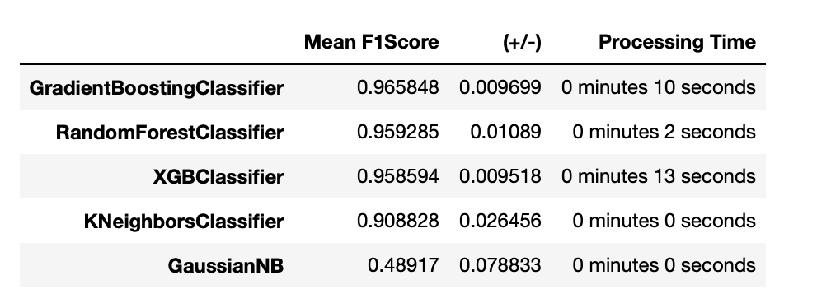
Gradient boosting classifier has a high F1 score of 0.96 followed by the random forest classifier, XGB classifier, KNeighbours classifier, and Gaussian Naïve Bayes classifier.

Conclusion:
After integrating the bridge logs, and weather, we have implemented regression and classification models. We have implemented three regression models and five classification models. Among the regression models, we have got a high R-Squared value of 0.90 for Random Forest Regression and high mean high F1 score for Gradient boosting classifier.

Future Work:
As a part of future work, we will Optimize the hyperparameters of the model to achieve the best performance using Hyperparameter tuning. And we will use ensemble methods to combine multiple models to create a stronger model. This can be done by using techniques such as bagging, boosting, or stacking. Moreover, we will also try to increase the size of the dataset by adding new data points through Data augmentation techniques such as data sampling, synthesis, or transformation, which can help to improve the robustness and generalization of the model.

References:
aecom. (n.d.). Retrieved from www.globaldata.com: https://www.globaldata.com/company-profile/aecom/
How to Handle Missing Data: A Step-by-Step Guide . (n.d.). Retrieved from www.analyticsvidhya.com: https://www.analyticsvidhya.com/blog/2021/05/dealing-with-missing-values-in-python-a-complete-guide/
Ma, X. (n.d.). Restriction Analysis of Transport Policy for Bridges Using the Trajectory Data. Retrieved from www.hindawi.com: https://www.hindawi.com/journals/jat/2020/8880335/
MARTELLI, M. (n.d.). An Outlook on the Future Marine Traffic Management System for Autonomous Ships. Retrieved from arxiv.org: https://arxiv.org/pdf/2207.04140.pdf
MassDOT Finding Challenges With Advanced Notification on Chelsea Street Bridge. (n.d.). Retrieved from chelsearecord.com: https://chelsearecord.com/2019/08/30/massdot-finding-challenges-with-advanced-notification-on-chelsea-street-bridge/
Park , K., Sim, S., & Bae, H. (n.d.). Vessel estimated time of arrival prediction system based on a path-finding algorithm. Retrieved from www.sciencedirect.com: https://www.sciencedirect.com/science/article/pii/S2666822X21000046#bib0013
Random Forest Regression in Python. (n.d.). Retrieved from www.geeksforgeeks.org: https://www.geeksforgeeks.org/random-forest-regression-in-python/

