Brian Dekker

Brian.dekker@hva.nl

Portfolio

Cloud Minor

# My Motivation / Learning goal

Brian Dekker  
500718509

I am following the course HBO-ICT software engineering. My motivation for doing this minor is that i want to learn more about the cloud in general all I know about it at the moment is that a cloud is basically a large datacenter with a lot of computers. I want to learn more about how it works from the inside and what cloud computers are capable of the advantages and disadvantages. Another part for why I choose this minor is because one of the sub subjects is data and I really like working with data so I thought it might be good to have some experience with how to interact between data and the cloud. I have done some research and came across courses that azure offers for people that want to learn about their cloud system so i think i will use that was a guide line on what type of path I want to take in learning more about azure.  
  
 For now my roadmap looks something like this:

First i will study the material for the azure fundamentals (AZ-900). After that you can look at the associate level courses like right now I’m thinking of Data Scientist(DP-100), Data Engineer((DP-200/201) and Developer(AZ-203). And as the final expert course I’m thinking of looking at DevOps Engineer(AZ-400) if I get that far this minor.

Right now that is my plan for this minor in terms of individual learning goals.

# Screenshots fundamental courses.

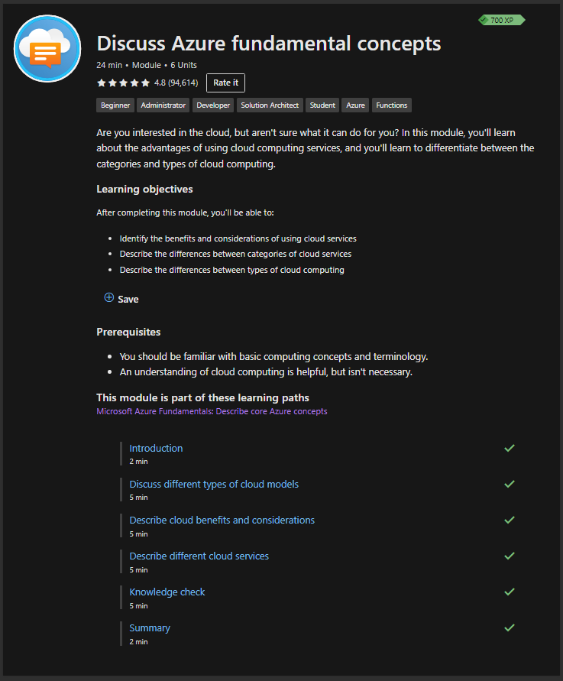

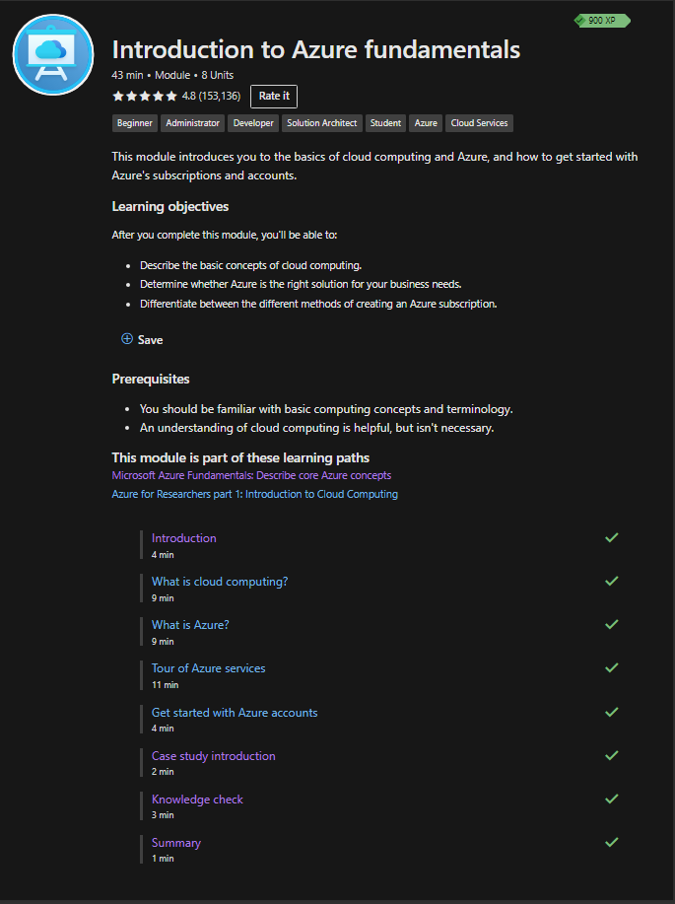

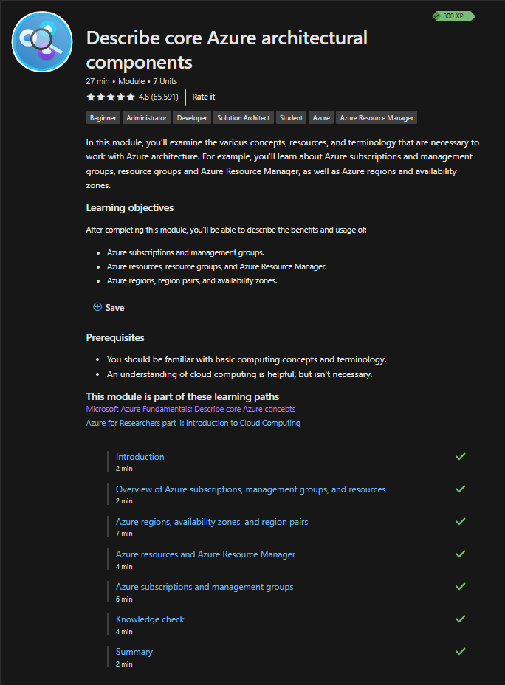

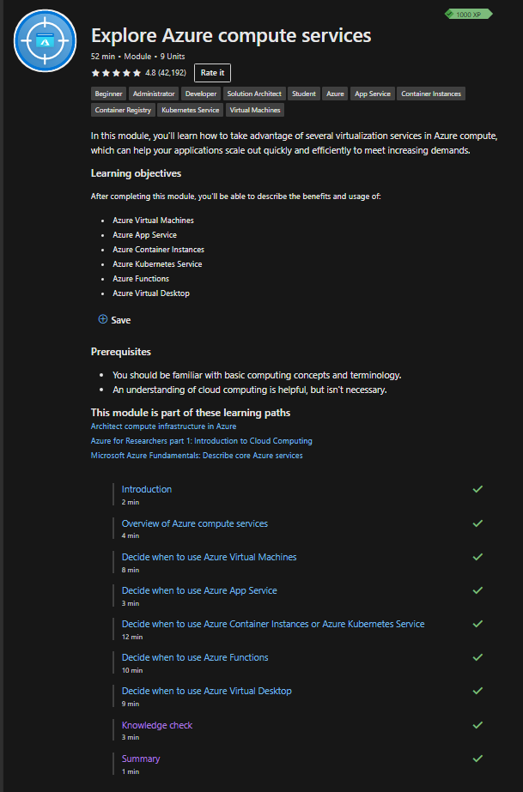

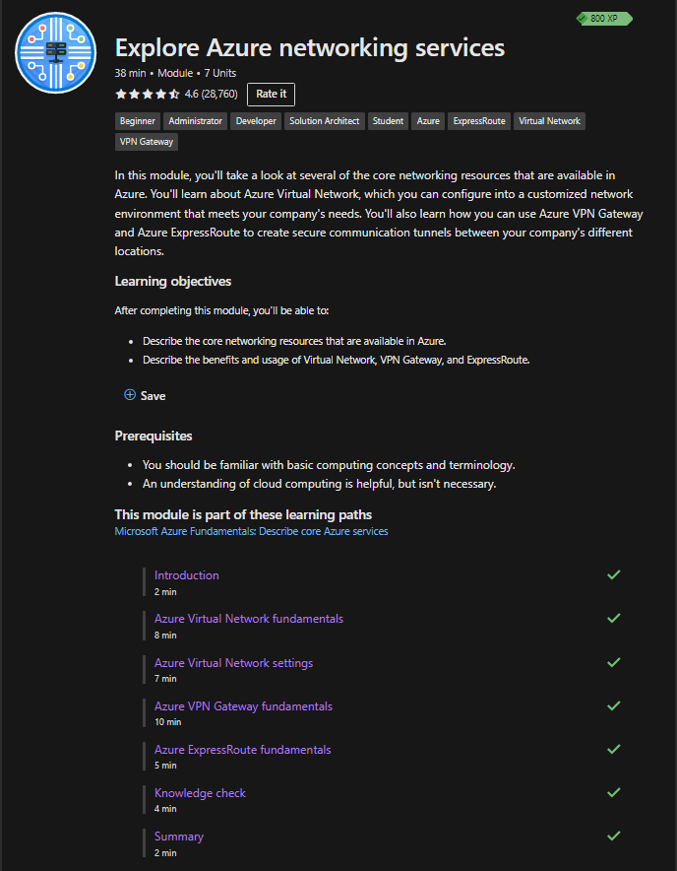

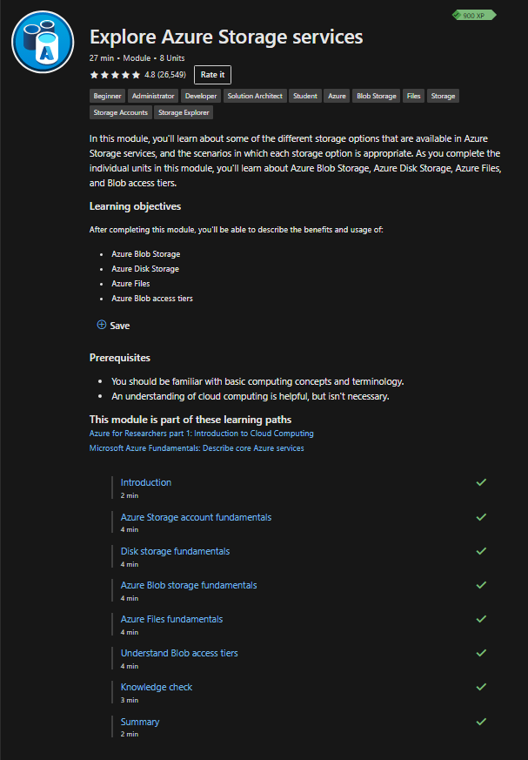

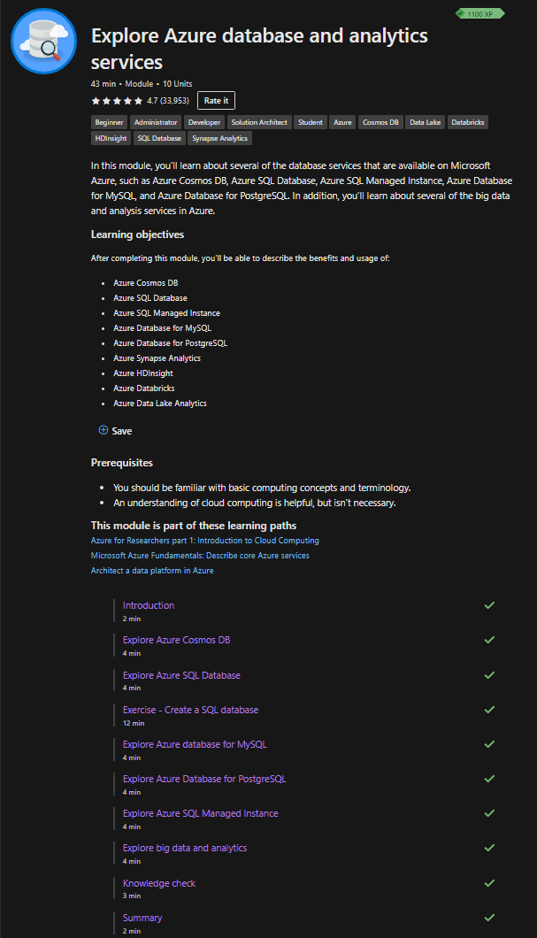

# Screenshots of other courses.

# Git Link

# Screenshots DevOps Courses

