Brian Dekker 500718509

Brian.Dekker@hva.nl

Portfolio

Cloud Solutions Minor

Inhoud

1.General Cloud Computing. 0

Serverless 0

Elestic Computing 0

SaaS/PaaS/IaaS 0

1.General DevOps. 0

2.Solution Architecture Programming 0

Function Apps. 0

Logic Apps. 0

Wiki. 0

Servicebus. 0

3.Solution Architecture Storage and Databases 2

Storage Account. 2

CosmosDB. 2

ServiceBus. 2

3.Solution Architecture Security 2

Managed Identity 2

SAS Keys 2

Key Vault 2

|  |  |  |  |  |  |
| --- | --- | --- | --- | --- | --- |
| Rubric Cloud Solutions V1.0 | Student name:Brian Dekker |  | Student nr:500718509 |  |  |
|  | Date: 07-02-2022 |  | Teacher: |  |  |
|  |  |  |  |  |  |
| 1. **General Cloud Solutions** | **Insufficient** | **Marginal** | **Good** | **Excellent** | **Proof** |
| Cloud Computing | The student has no idea of the concepts involved in Cloud Computing | The student can explain at most two of the basic concepts involved in Cloud Computing among which  *On-demand self-service* , *Resource pooling, Rapid elasticity* and *Measured service* | The student can explain in detail 3 concepts involved in Cloud Computing | *Additional to Good:*  The student can explain in detail more than 5 concepts involved in Cloud Computing |  |
| DevOps | The student has no idea of the processes and concepts involved in the life cycle of DevOps | The student can explain at most two of the processes involved in the life cycle of DevOps | The student can explain all four processes involved in in the life cycle DevOps | *Additional to Good:*  The student can explain in detail all the advantages of a DevOps culture |  |
| 2. Business model  Understand the usage patterns (or estimated usage patterns) and determine which of the providers best fits your business model, budget, timeline, and so on. |  |  |  |  |  |
| Manage Change | The student has no idea how business processes or a product team could benefit from Cloud solutions | The student knows the characteristics of the business process or the product team involved in the Cloud solution | The student can explain how to empower a business process or a product team in such a way that they benefit the most of a an existing implementation of a Cloud solution | *Additional to Good:*  The student is able to convince stakeholders in order to change business processes or product teams in such a way that they benefit the most of a an existing implementation of a Cloud solution |  |
| Costs and workload | The student has no idea of costs and workloads when it comes to comparing on premise versus Cloud solutions | The student can explain only the costs involved in a certain implementation of a cloud solution, not regarding the workload | The student can explain why a certain implementation of a Cloud solution is the best fit for a certain estimated usage pattern | *Additional to Good:*  For all possible usage patterns the student can explain the best fit for a business model, budget and timelines |  |
| 3. Solution Architecture  Advising stakeholders and translating business requirements into secure, scalable, and reliable cloud solutions. |  |  |  |  |  |
| Programming | The student has no idea of the used coding scripts in a Cloud solution | The student can explain only coding scripts for implementing a Cloud solution, on which the student has prepared for | The student can explain all used coding scripts for implementing a Cloud solution, no matter the used Programming language or environment | *Additional to Good:*  The student has taken care of the hand-over in terms of documenting all the coding scripts for implementing a Cloud solution in an easy accessible |  |
| Storage and databases | The student has no idea of the pros and cons of different storage options | The student has only a basic understanding of different storage options like files, blob, SQL database and NOSQL | The student can explain both from a business as from a IT point of view the pros and cons of at least 3 different storage options from a certain provider | *Additional to Good:*  The student can discuss in detail all options for structured on unstructured data and give practical advises in a real life situation based on all kinds of performance metrics |  |
| Security | The student has only a basic understanding of security issues involved in using Cloud Solutions and IAM | The student can explain not more than 2 the different options for securing Cloud solutions and implementing IAM | The student can explain in detail at least 3 different options for securing Cloud solutions  and implementing IAM | *Additional to Good:*  The student can discuss in detail options for securing Cloud solutions and implementing IAM. Moreover, the student can give practical advises in a real life situation |  |
| 4. Cloud Administration  Learn how to configure and manage network capabilities like connectivity services, application protection, application delivery, and network monitoring services. |  |  |  |  |  |
| Services, APIs and networking | The student can only mention services for storage, networking and compute services of the different services, but has no idea of the pros and cons of these services | The student can mention services for storage, networking and compute services and has some idea of the pros and cons of these services | The student can mention services for storage, networking and compute services and can explain in detail of the pros and cons of these services | *Additional to Good:*  The student can explain how to optimize a combination of services in a real life situation |  |
| Manageability | The student has no idea of metrics, management and orchestration tools involved in managing Cloud solutions | The student can mention some of the metrics, management and orchestration tools involved in managing Cloud solutions | The student can motivate in detail the metrics, management and orchestration tools involved in an existing implementation of a Cloud solution | *Additional to Good:*  The student has an overview of all metrics, management and orchestration tools involved in the implementation of a Cloud solutions |  |

|  |  |  |  |  |  |
| --- | --- | --- | --- | --- | --- |
| **Professional skills** | 1 | 2 | 3 | 4 | **Proof** |
| Future oriented organisation |  |  |  |  |  |
| Problem solving research |  |  |  |  |  |
| Personal Leadership |  |  |  |  |  |
| Targeted interaction |  |  |  |  |  |

**Requirements to pass the semester**

All students needs to score

1. General, both Cloud Computing and DevOps, at least GOOD
2. Professional skills at least level 2

In addition, since students can set up their own learning stories, there are different possibilities but it will come down to

*You’ll need to score at least 2 rows good and 2 others marginal, but not all combinations are allowed*

1. Business model
   1. Both aspects ( = rows) of Business model good
   2. One aspect of Solution Architecture marginal
   3. One aspect of Cloud administration marginal

Or

1. Solution Architecture
   1. At least two out of three aspects of Solution Architecture good
   2. One aspect of Business model marginal
   3. One aspect of Cloud administration marginal

Or

1. Cloud administration
2. Both aspects of Cloud administration good
3. One aspect of Business model marginal
4. One aspect of Solution Architecture marginal

**Grading**

1. Failing the above requirements for either Business model, Solution Architect or Cloud Administration
   1. No score good at all 🡺 2
   2. Only one aspect of either Business model, Solution Architect or Cloud Administration is good, all others are insufficient 🡺 3
   3. Only one aspect of either Business model, Solution Architect or Cloud Administration is good, the other aspect of either Business model, Solution Architect or Cloud Administration is marginal, all others are insufficient 🡺 4
   4. All 2 aspects of either Business model, Solution Architect or Cloud Administration are good, one of the others is marginal and one of the others is insufficient 🡺 5
2. Passing the above requirements
   1. By the bare minimum 🡺 6
   2. Additional to a. : All 4 of the *General Competences* GOOD🡺 7
   3. Additional to b. :
      1. All 4 selected aspects of either Business model, Solution Architect or Cloud Administration are good 🡺 8
      2. All 2 aspects of either Business model, Solution Architect or Cloud Administration are excellent, the others are marginal 🡺 8
   4. Additional to c. : All *General Competences* EXCELLENT 🡺 9
   5. All aspects through all requirements EXCELLENT 🡺 10

# 1.General Cloud Computing.

**The student can explain in detail 3 concepts involved in Cloud Computing**

1. Serverless
2. elastic computing / cloud elasticity
3. SaaS/PaaS/IaaS

## Serverless

Serverless is a different way of thinking about how to make use of the cloud infrastructure. In the traditional sense, you use your own server to run your own software, but with Serverless architecture, the software is run in the cloud. Only when it is needed.

Example: Azure functions and Logic App are serverless.

## Elestic Computing

Elastic computing is a concept in cloud computing in which computing resources can be scaled up and down easily by the cloud service provider. Elastic computing is the ability of a cloud service provider to provision flexible computing power when and wherever required. The elasticity of these resources can be in terms of processing power, storage, bandwidth, etc.

## SaaS

Software as a service (SaaS) allows users to connect to and use cloud-based apps over the Internet. Common examples are email, calendaring, and office tools (such as Microsoft Office 365).

## PaaS

Platform as a service (PaaS) is a complete development and deployment environment in the cloud, with resources that enable you to deliver everything from simple cloud-based apps to sophisticated, cloud-enabled enterprise applications. You purchase the resources you need from a cloud service provider on a pay-as-you-go basis and access them over a secure Internet connection.

## IaaS

Infrastructure as a service (IaaS) is a type of cloud computing service that offers essential compute, storage, and networking resources on demand, on a pay-as-you-go basis.

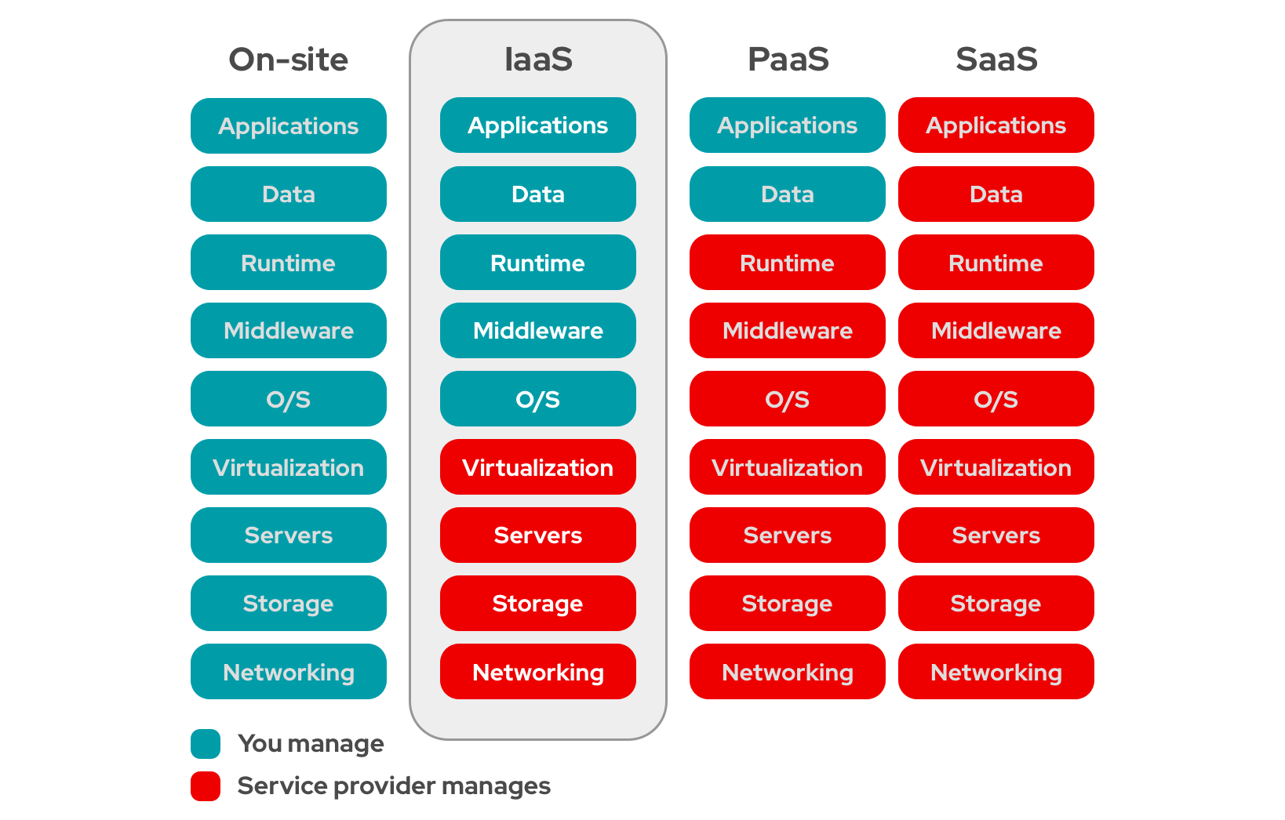

# 1.General DevOps.

**The student can explain all four processes involved in in the life cycle DevOps**

1. 2
2. 3
3. 4
4. 5

# 2.Solution Architecture Programming

**The student has taken care of the hand-over in terms of documenting all the coding scripts for implementing a Cloud solution in an easy accessible**

1. Function Apps
2. Logic Apps
3. Wiki
4. Servicebus

## Function Apps.

Il refer to my function app folder on my github: <https://github.com/RamboBD/CloudMinorDocumenten/tree/main/Function%20Apps>

## Logic Apps.

Il refer to my logic app folder on my github: <https://github.com/RamboBD/CloudMinorDocumenten/tree/main/Logic%20App>

## Wiki.

Il refer to the Wiki we created on azure devops: <https://dev.azure.com/mydevAUAStest/Mixit/_wiki/wikis/Mixit.wiki/16/Mixit-Project-Wiki>

My main contributions to this wiki are

## Servicebus.

Il refer to the servicebus folder on my github: <https://github.com/RamboBD/CloudMinorDocumenten/tree/main/ServiceBus>

# 3.Solution Architecture Storage and Databases

**The student can explain both from a business as from a IT point of view the pros and cons of at least 3 different storage options from a certain provider**

1. Storage Account
2. CosmosDB
3. ServiceBus

## Storage Account.

Il refer to the servicebus folder on my github: <https://github.com/RamboBD/CloudMinorDocumenten/tree/main/StorageAccount%2BCosmosDB>

## CosmosDB.

Il refer to the servicebus folder on my github: <https://github.com/RamboBD/CloudMinorDocumenten/tree/main/StorageAccount%2BCosmosDB>

## ServiceBus.

Il refer to the servicebus folder on my github: <https://github.com/RamboBD/CloudMinorDocumenten/tree/main/ServiceBus>

# 3.Solution Architecture Security

**The student can explain in detail at least 3 different options for securing Cloud solutions and implementing IAM**

1. Managed Identity
2. SAS keys
3. Key Vault

## Managed Identity

Managed identity’s fix the issue of having to use secrets or certificates to access service principles. A service principle is a representation of a app instance. So let’s say I want to use a Netflix AAD in my AAD(Azure Active Directory) it will create a service principle in my AAD that points to the Netflix AAD. Now for the app in my resource to use my AAD we need to connect the two one way of doing this is by using secret keys or certificates but we don’t want to do that so we will use managed identity’s instead.

In a resource you can turn on an identity that azure is going to manage.

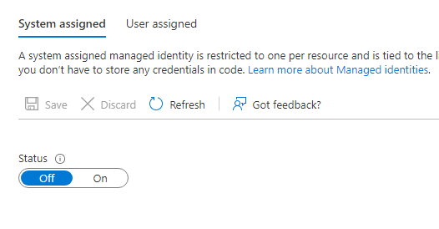

When you turn this on it will create service principle in you AAD with the same name as the azure resource. Now this service principle and Resource are linked with a shared life cycle so if I delete the resource the SP is also deleted. Now if we create a second resource we can give permissions to Resource 1 service principle to do things in this resource with RBAC(Resource based access control).

Now there are two different types of managed identity’s

### System assigned

System assigned managed identity’s are managed identity’s that can only have one resource connected to it and a resource can only have one managed identity. The life cycle between the two is shared if you delete the resource the managed identity is also deleted. System identity is a One to One relationship with resources.

### User assigned

With this managed identity the user creates a managed identity as a separate resource. A user can create a managed identity in a AAD and then assign it to multiple resources. So the life cycle between the two is different if you delete a resource the managed identity stays. So user identity is a many to many relationship with resources.

So let’s say for example I have a storage account with some blob storage I can now create a managed identity and give it permission to read the blob data in that storage account now any resource that I give that manged identity to has permission to read the blob data.

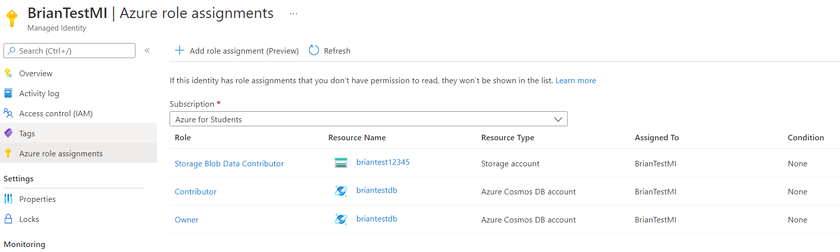

Here is an example of a managed identity I created and use it to give my logic app permission to send data to my storage account and CosmosDB.

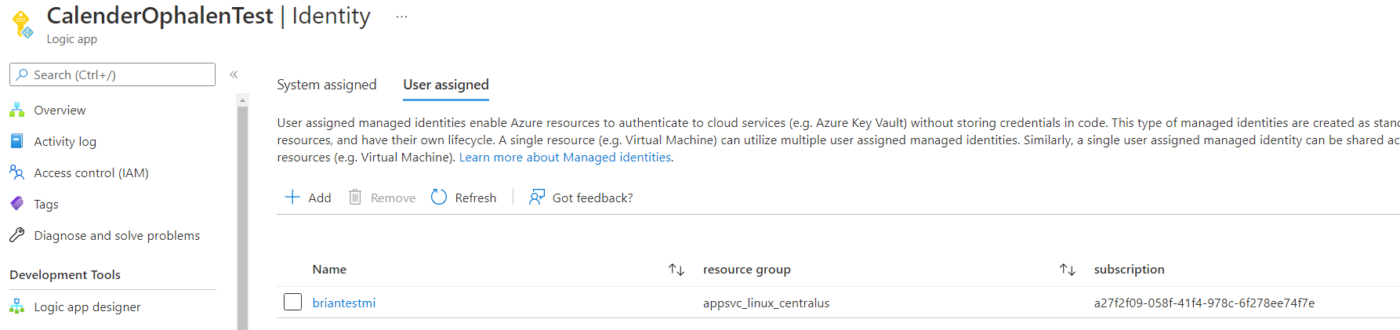

Here you can see that the logic app has the managed identity

## 

## SAS Keys

SAS policys are keys that you can use to connect to certain services in azure for example a service bus or queue within the service bus we used this in our project.

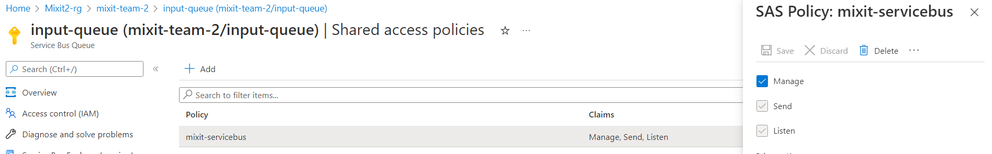

Here you can see a SAS policy we created so we can use it so send messages to this specific queue from the WebApp. We store these connection strings in a key vault.

## Key Vault

A key vault is a service in azure where you can store secrets that you want to shield from the outside. For example we use the key vault to store our SAS policys (connection strings) that we use to connect to our services that need to work together like the webapp and the servicebus.

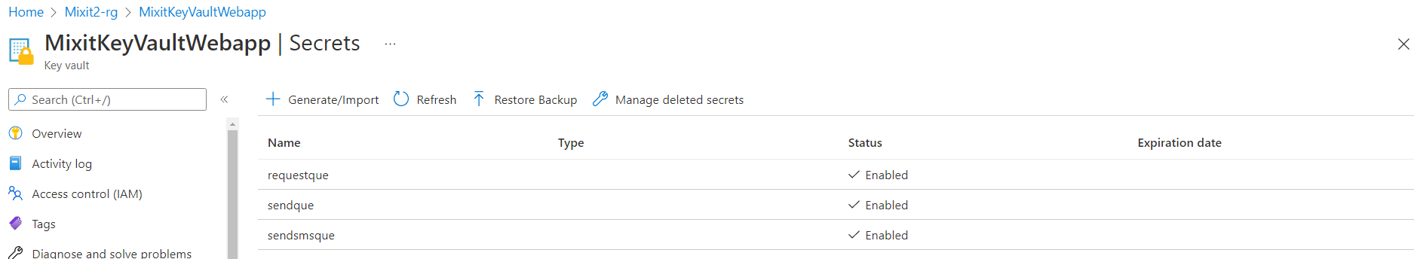

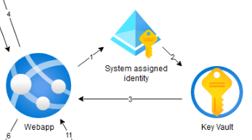

Code in webapp to get secrets from key vault

# Azure KeyVault name + URL

keyVaultName = "MixitKeyVaultWebapp"

KVUri = f"https://{keyVaultName}.vault.azure.net"

# For auto selecting user/identity, if run local, it use users, if in webapp on azure, it runs on managed identity of the webapp.

# credential = DefaultAzureCredential()

credential = AzureCliCredential()

client = SecretClient(vault_url=KVUri, credential=credential)

# Get secrets from keyvault "MixitKeyVaultWebapp" for acces to servicebus.

# The first variable gets que string, the second variable sets que name.

sendsmsque = client.get_secret("sendsmsque")

sendsmsquename = "smsrequestqueue"

sendque = client.get_secret("sendque")

sendquename = "input-queue"

requestque = client.get_secret("requestque")

requestquename = "output-queue"

# Courses I completed.

