AI FOR FINANCE – CIA-2
AI-Powered Project Development

FraudShield AI
AI-Powered Fraud Detection System
Step-by-Step Project Report
Project Option 3 – flags suspicious financial transactions based on unusual patterns
Student name : ______________________________
Register number : ______________________________
Class / Section : ______________________________
Faculty : ______________________________
Date of submission : ______________________________
Contents
Part A – Project at a Glance 3
A1. Objective 3
A2. The problem 3
A3. The solution in one picture 3
A4. Key results 3
A5. Assignment requirements checklist 3
Part B – Step-by-Step Development 5
Step 1 – Understand the problem and choose the project 5
Step 2 – Choose the tools and set up the environment 5
Step 3 – Create the transaction dataset 5
Step 4 – Feature engineering 7
Step 5 – Train AI model 1: Random Forest (supervised learning) 7
Step 6 – Train AI model 2: Isolation Forest (anomaly detection) 8
Step 7 – Combine into a hybrid score and tune the threshold 8
Step 8 – Make the AI explainable 8
Step 9 – Evaluate the model on unseen data 9
Step 10 – Build the web application 10
Step 11 – Test the application with sample data 11
Step 12 – Package and submit 15
Part C – Step-by-Step User Guide 17
C1. Start the application 17
C2. Check a single transaction 17
C3. Scan a batch of transactions 17
C4. Other pages 17
Part D – Applications, Limitations and Conclusion 19
D1. Benefits and practical applications 19
D2. Limitations 19
D3. Future work 19
D4. Conclusion 19
Appendix A – How AI tools were used to build the project 19

Part A – Project at a Glance

A1. Objective
Build a working application that uses Artificial Intelligence to analyse financial transactions and identify potentially fraudulent activity based on unusual transaction patterns – and explain each decision in plain language.

A2. The problem
- Fraud is rare – about 3% of transactions – so a model that always says "genuine" is 97% accurate and still useless.
- Fraud keeps changing – fixed rules such as "block everything above ₹50,000" quickly become outdated.
- Mistakes are costly both ways – a missed fraud loses money; a false alarm blocks a genuine customer.

A3. The solution in one picture
Stage | What happens
1. Input | Transaction details – amount, customer's usual spend, merchant, channel, time, distance, device, recent activity
2. Feature engineering | Raw fields become behavioural signals (e.g. amount ÷ usual spend, night-time flag)
3. AI model 1 – Random Forest | Supervised learning: probability that the transaction is fraud
4. AI model 2 – Isolation Forest | Anomaly detection: how unusual the transaction is
5. Hybrid risk score | 0.75 × Random Forest + 0.25 × Isolation Forest → score 0–100
6. Decision | Low → approve · Medium → verify with OTP · High → block
7. Explanation | Plain-language red flags + Shapley-value chart

A4. Key results
Measure | Result
Fraud caught (recall) | 87.7%
Alerts that were real fraud (precision) | 90.6%
Fraud money caught | 96.5%
Genuine customers wrongly flagged | 0.3%
ROC AUC (1.0 = perfect) | 0.998

A5. Assignment requirements checklist
General requirement | Where it is met
Use AI tools to assist in designing and developing the project | Step 2 and Appendix A – an AI coding assistant (Claude Code) was used to plan, code, debug and test
Build a working application with a user-friendly interface | Step 10 – Streamlit web app with 5 pages, one-click examples and colour-coded results
Demonstrate the main features with sample data | Step 11 – three example transactions, a 10-customer Excel file and a 1,000-transaction batch
Explain how AI is used in the project | Steps 5–8 and the app's "How the AI Works" page
Submit the project source code and a brief project report | Step 12 – GitHub repository, submission zip and this report
Present the project and explain practical applications | Part C (user guide) and Part D (applications)

Part B – Step-by-Step Development
The project was built in 12 steps. Each step lists what was done, why, and its output.

Step 1 – Understand the problem and choose the project
- Read the CIA-2 assignment brief and its five project options.
- Chose Option 3 – AI-Powered Fraud Detection System: build a system that analyses financial transactions and flags fraud based on unusual patterns.
- Studied how real card fraud behaves: stolen cards are used quickly, at odd hours, far from home, for big amounts at merchants where goods are easy to resell (gift cards, crypto, electronics).
- Defined success: catch most fraud and keep false alarms on genuine customers low, and explain every decision.

✔ Output of this step
Clear problem statement and list of fraud warning signs to model.

Step 2 – Choose the tools and set up the environment
Tool | Used for
Python 3.10 | Programming language
pandas, NumPy | Data handling and calculations
scikit-learn | AI models – Random Forest and Isolation Forest; evaluation metrics
Streamlit | Web application (user interface) written in pure Python
Plotly | Interactive charts inside the app
joblib | Saving and loading the trained model
openpyxl | Reading Excel uploads
Claude Code (AI coding assistant) | Designing the architecture, writing and debugging code, testing the app in a browser
Git and GitHub | Version control and code submission

Installation command:
pip install streamlit scikit-learn pandas numpy plotly joblib openpyxl

✔ Output of this step
A working Python environment with all libraries installed.

Step 3 – Create the transaction dataset
Real bank data is confidential, so a realistic synthetic dataset was generated by data_generator.py.
- Created 600 customers, each with a home city and a typical spend per transaction (most around ₹1,500, a few big spenders).
- Generated 24,250 genuine transactions over 90 days (July–September 2026) – mostly daytime, close to home, at normal amounts. A few genuine ones are deliberately unusual (travel, occasional big purchases) to make the problem realistic.
- Injected 750 fraud transactions (3%) in short bursts, using real fraud patterns: amounts 3–15× the usual spend, night hours, far away or abroad, new devices, high-risk merchants. Not every fraud shows every signal.
- Calculated history-based fields for every transaction: the customer's usual spend so far and the number of transactions in the last 24 hours.
- Saved data/transactions.csv (25,000 labelled rows) and data/sample_new_transactions.csv (1,000 new unlabelled rows for testing).
Field | Meaning
amount | Transaction amount (₹)
customer_avg_amount | Customer's usual transaction amount (₹)
merchant_category | Groceries, Restaurants, Fuel, Utilities, Clothing, Travel, Electronics, Online Shopping, Gift Cards, Crypto Exchange
channel | POS (card swipe), Online, ATM
hour | Hour of day, 0–23
distance_from_home_km | Distance from the customer's home city
is_foreign | 1 = international
is_new_device | 1 = device never seen before
txn_count_24h | Customer's transactions in the last 24 hours
is_fraud | Label – 1 = confirmed fraud (used for training and testing only)

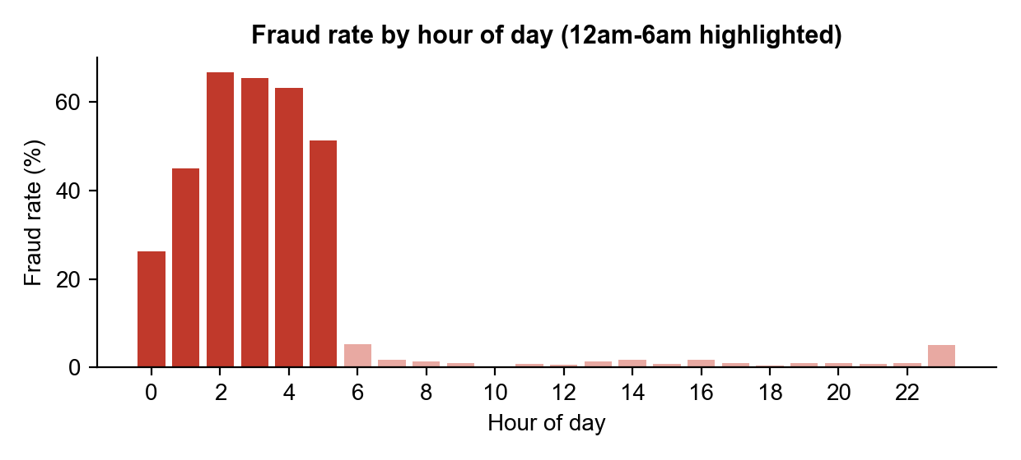
Figure 1 – Fraud rate by hour: fraud is concentrated between midnight and 6 am
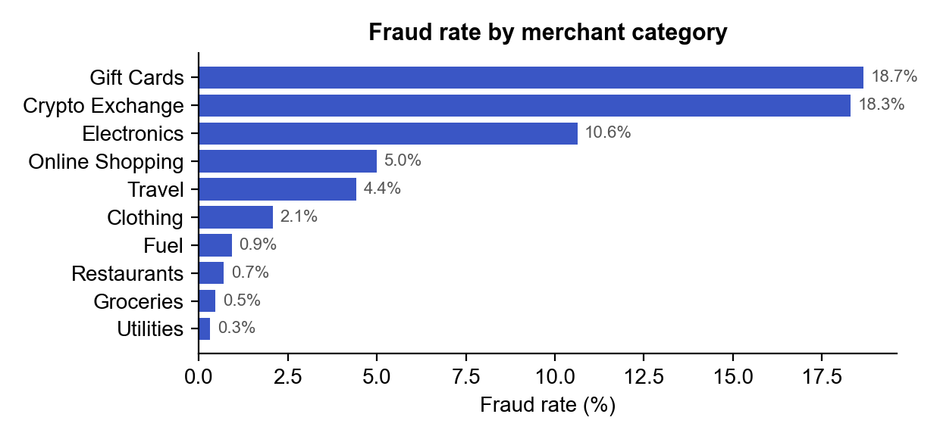
Figure 2 – Fraud rate by merchant category

✔ Output of this step
25,000 labelled transactions (750 fraud) + 1,000 new transactions for testing.

Step 4 – Feature engineering
AI models learn better from behavioural signals than from raw numbers. The key idea: compare each transaction with that customer's own normal behaviour, not with one fixed limit for everybody.
Engineered feature | How it is calculated | Why it helps
amount_to_avg_ratio | amount ÷ customer_avg_amount | ₹20,000 is normal for one customer and very suspicious for another
is_night | 1 if hour < 6 | Most fraud happens while the card owner is asleep
distance_from_home_km | From transaction location | Stolen card details are often used in another city or country
txn_count_24h | Count of the customer's transactions in 24 h | Fraudsters spend quickly before the card is blocked
merchant_category, channel | One-hot encoded (one column per value) | Some merchants and channels are much riskier

✔ Output of this step
10 input features per transaction, prepared by add_features() in fraud_model.py.

Step 5 – Train AI model 1: Random Forest (supervised learning)
- Split the data: 75% for training (18,750) and 25% for testing (6,250), keeping the 3% fraud share in both (stratified split).
- Inside the training part, kept 20% aside as a validation set for tuning (Step 7).
- Trained a Random Forest of 300 decision trees (max depth 14). Each tree learns rules such as "amount > 4× usual AND hour < 6 → fraud"; the trees vote and the share of fraud votes is the probability.
- Handled the rare fraud class with class_weight = balanced_subsample, so mistakes on fraud cases count more during training.

✔ Output of this step
A model that outputs a fraud probability (0–100%) for any transaction.

Step 6 – Train AI model 2: Isolation Forest (anomaly detection)
- Trained an Isolation Forest (300 trees) on genuine transactions only – it learns what normal behaviour looks like.
- It splits the data randomly; unusual transactions get separated ("isolated") in very few splits and receive a high anomaly score.
- Scaled the anomaly score to 0–1 so it can be combined with the Random Forest probability.
Why a second model? The Random Forest only knows fraud patterns it has seen. The Isolation Forest flags anything unusual, so it can catch new fraud patterns too.

✔ Output of this step
A model that outputs an anomaly score (0–100%) for any transaction.

Step 7 – Combine into a hybrid score and tune the threshold
risk_score = 0.75 × Random Forest probability + 0.25 × Isolation Forest anomaly score
- Calculated the hybrid risk score for every validation transaction.
- Tried every possible alert threshold and picked the one with the best F1 score (balance of catching fraud vs. false alarms): 52.4 out of 100.
- Defined three risk levels and the action for each:
Risk level | Risk score | Action
Low | below 26.2 | Approve automatically
Medium | 26.2 – 52.4 | Step-up verification: OTP or call to the customer
High | 52.4 and above | Block the transaction and alert the fraud team

✔ Output of this step
A single 0–100 risk score with a clear decision for every transaction.

Step 8 – Make the AI explainable
Banks must be able to explain why a payment was blocked. Two explanation methods were added:
- Red-flag reasons – simple checks that produce plain sentences, e.g. "Amount is 28.0× the customer's usual spend", "Unusual time (02:00)", "4,200 km from home", "New / unrecognised device".
- Shapley values (cooperative game theory, the idea behind SHAP) – the transaction is compared with a typical genuine transaction of the same customer. All 2⁸ = 256 combinations of the 8 factors are scored, and the change in fraud probability is shared fairly between the factors. The result shows exactly how many percentage points each factor added or removed.

✔ Output of this step
Every decision comes with reasons and an explanation chart.

Step 9 – Evaluate the model on unseen data
All results are on the 6,250 test transactions the models never saw during training or tuning.
Model | Precision | Recall | F1 score | ROC AUC
Random Forest alone | 0.901 | 0.872 | 0.886 | 0.998
Isolation Forest alone | 0.925 | 0.797 | 0.856 | 0.995
Hybrid (final system) | 0.906 | 0.877 | 0.891 | 0.998

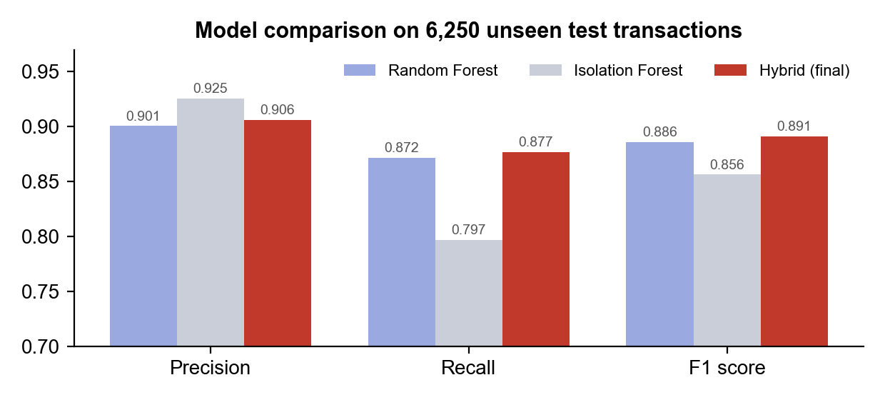
Figure 3 – The hybrid model has the best F1 score
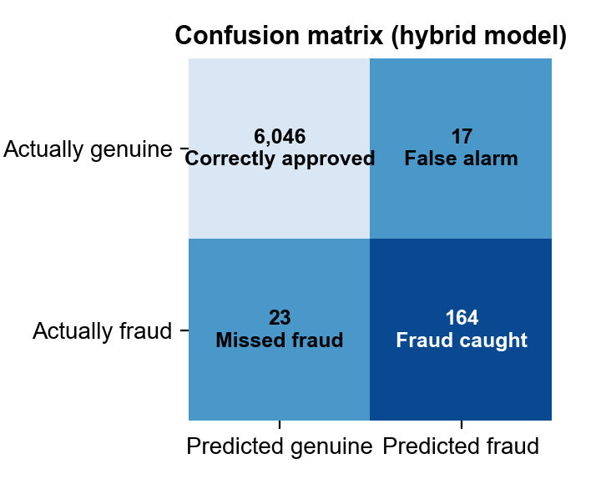
Figure 4 – Confusion matrix of the hybrid model
- Precision 90.6% – of all alerts, how many were real fraud.
- Recall 87.7% – of all real frauds, how many were caught (164 caught, 23 missed).
- False alarms – only 17 of 6,063 genuine transactions (0.3%).
- 96.5% of the fraud money was caught – the large frauds are the easiest to detect.
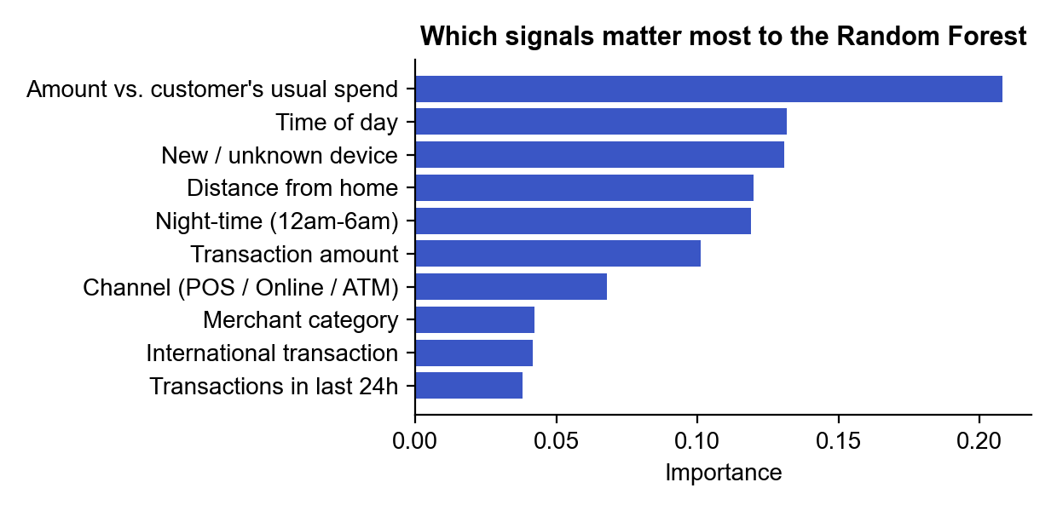
Figure 5 – Most important signals: amount vs. usual spend, time of day, new device

✔ Output of this step
Trained model saved to models/fraud_model.joblib, metrics to models/metrics.json.

Step 10 – Build the web application
The user interface was built with Streamlit in app.py. It has five pages, selected from the sidebar:
Page | Purpose
📊 Dashboard | KPIs and charts of the fraud patterns the AI learned from
🔍 Check a Transaction | Score one transaction in real time with a gauge, decision, red flags and Shapley chart
📁 Batch Scan (CSV / Excel) | Upload a file of transactions; get a ranked list of suspicious ones and download the results
📈 Model Performance | Confusion matrix, ROC curve, model comparison and feature importance
🤖 How the AI Works | Plain-language explanation of the approach and real-world uses

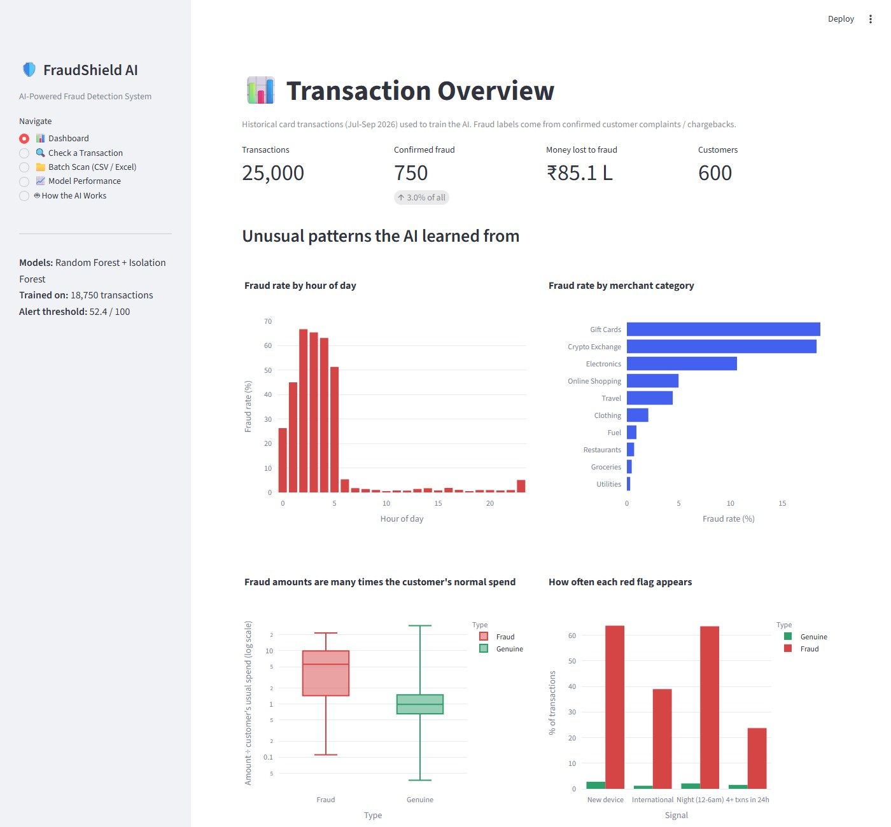
Figure 6 – Dashboard page

✔ Output of this step
A working, user-friendly web application: python -m streamlit run app.py.

Step 11 – Test the application with sample data

Test 1 – Three example transactions (Check a Transaction page)
Example | Key details | Expected | Result
Normal | ₹1,200 groceries, 6 pm, 4 km from home, known device | Low | 0.4 / 100 – Approve ✔
Borderline | ₹6,500 travel (usual ₹1,800), 11 pm, 900 km away | Medium | 34.7 / 100 – Verify ✔
Suspicious | ₹42,000 electronics (usual ₹1,500), 2 am, abroad, new device, 5 txns in 24 h | High | 100 / 100 – Block ✔

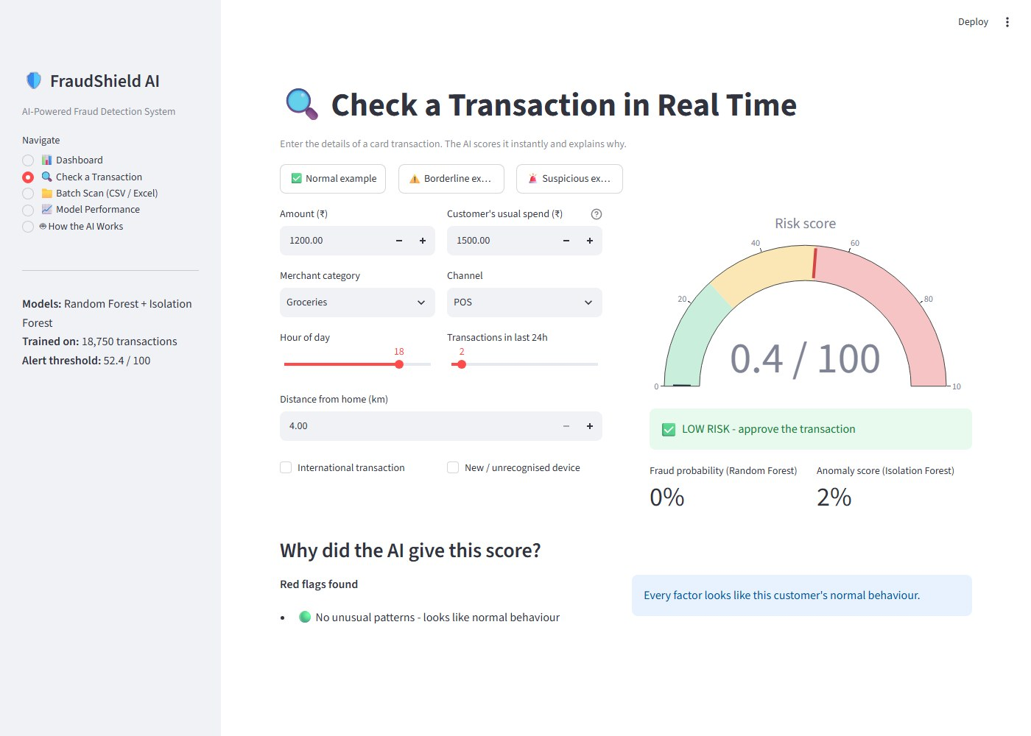
Figure 7 – Normal transaction: low risk, approve
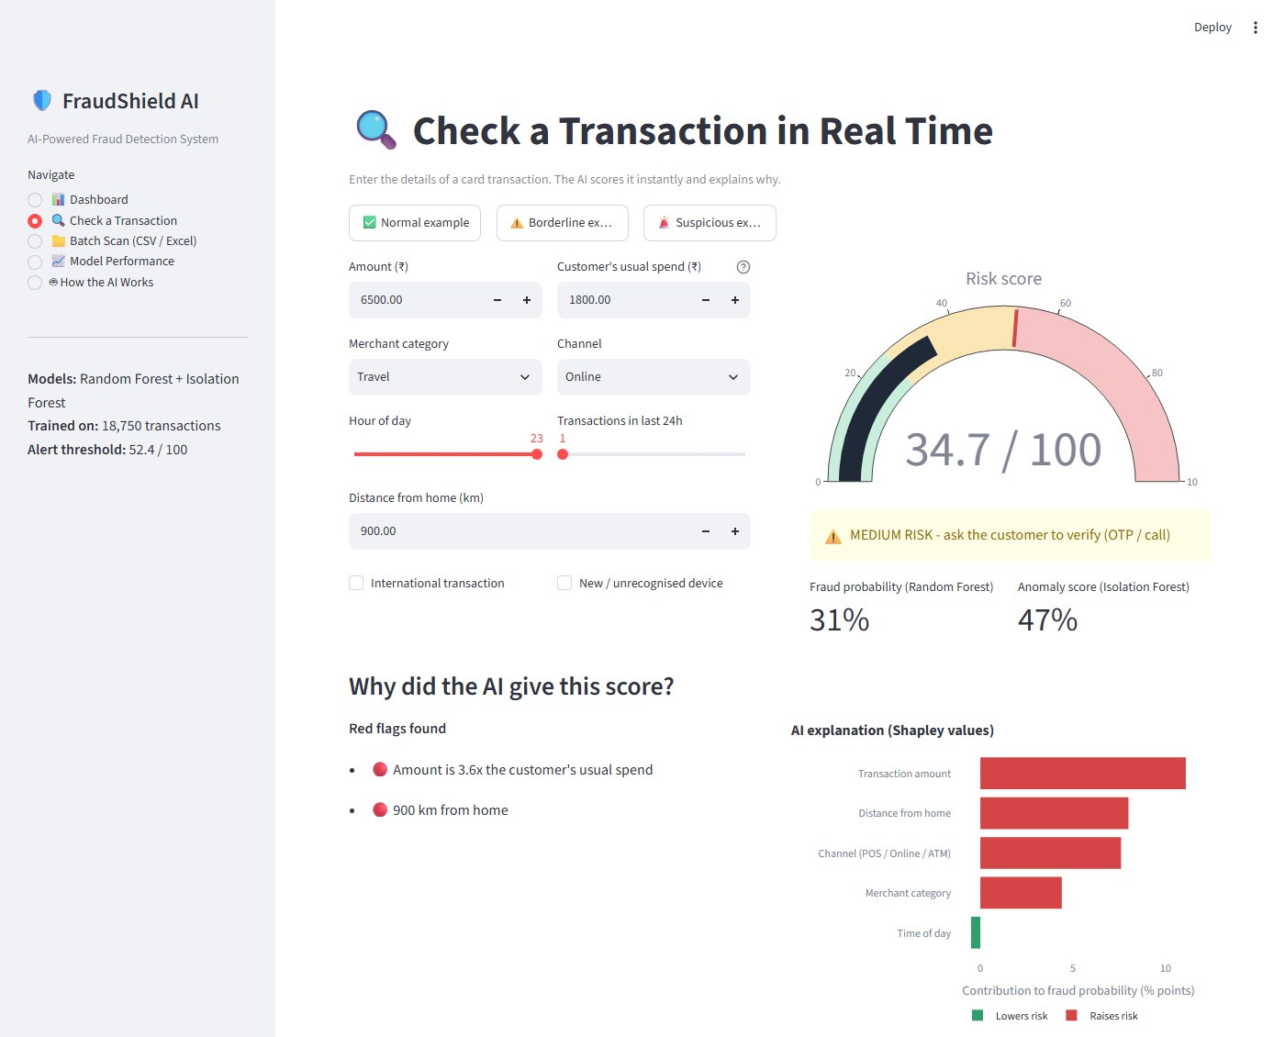
Figure 8 – Borderline transaction: medium risk, verify with OTP
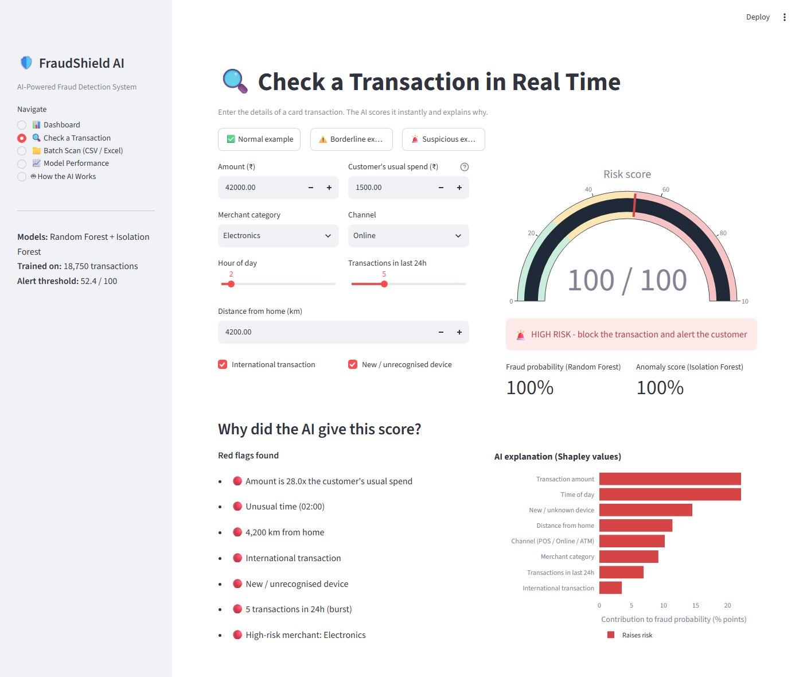
Figure 9 – Suspicious transaction: high risk, block – with red flags and Shapley explanation

Test 2 – 10-customer Excel file (Batch Scan page)
File data/test_10_customers.xlsx contains 10 customers with a mix of normal and suspicious transactions. Scanning it on the Batch Scan page gives:
Customer | Transaction | Risk score | Level
Ananya Rao | ₹1,850 groceries, 11 am | 0.1 | Low
Rahul Mehta | ₹950 restaurant, 8 pm | 1.7 | Low
Priya Nair | ₹3,200 fuel, 9 am | 2.8 | Low
Vikram Singh | ₹5,400 clothing online, 3 pm | 6.1 | Low
Kavya Reddy | ₹2,300 utilities online, 10 am | 5.5 | Low
Sneha Iyer | ₹9,500 travel (3.2× usual), 650 km away | 29.8 | Medium
Arjun Kapoor | ₹5,200 electronics (3.3× usual), new device | 41.6 | Medium
Rohit Sharma | ₹18,500 gift cards, 3 am, new device, 1,200 km | 100 | High
Meera Joshi | ₹46,000 electronics, 1 am, abroad, 5 txns in 24 h | 100 | High
Karan Patel | ₹25,000 crypto, 2 am, new device, 4 txns in 24 h | 100 | High

Result: 5 Low, 2 Medium, 3 High – exactly as expected; ₹89,500 at risk would be blocked.

Test 3 – 1,000 brand-new transactions
The built-in sample of 1,000 unseen transactions was scanned: 34 flagged as high risk, 25 medium. Checking against the true labels, the system caught 28 of the 30 real frauds (93%) and 82% of its alerts were correct.
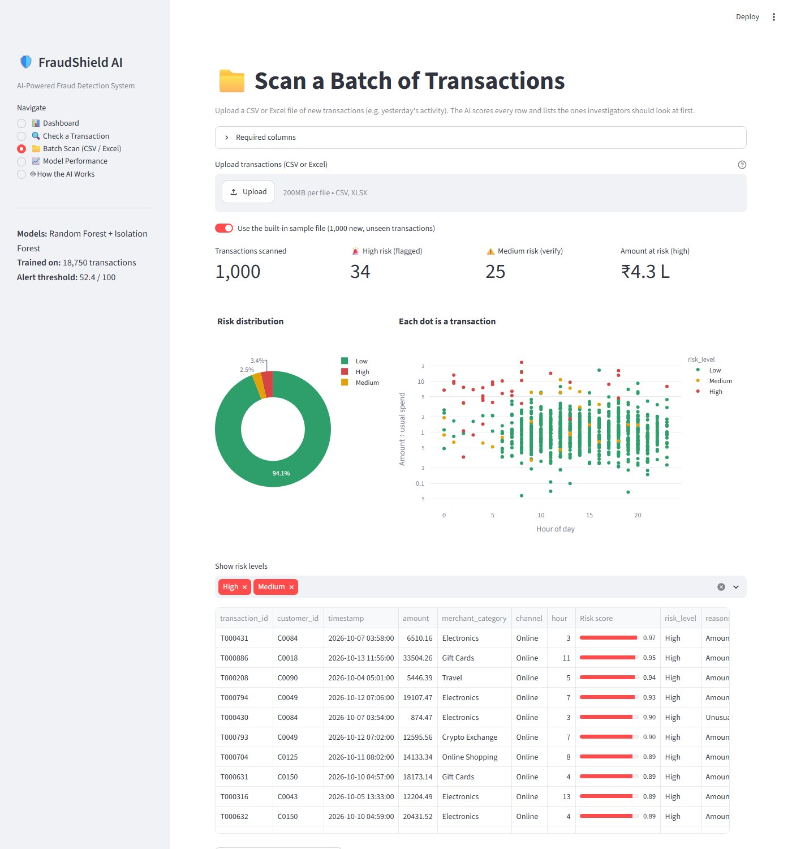
Figure 10 – Batch Scan page with the ranked list of risky transactions

✔ Output of this step
All features verified working with sample data.

Step 12 – Package and submit
- Wrote the documentation: README.md (how to run) and this project report.
- Created a private GitHub repository and pushed the code: https://github.com/Ramchandrappa/fraudshield-ai
- Created FraudShield_AI_Submission.zip containing the source code, data, trained model and reports, and tested that it runs on its own.
File | Purpose
app.py | Streamlit web application (user interface)
fraud_model.py | AI core – features, hybrid model, training, evaluation, explanations
data_generator.py | Builds the synthetic transaction dataset
data/transactions.csv | 25,000 labelled transactions
data/sample_new_transactions.csv | 1,000 new transactions for the batch demo
data/test_10_customers.xlsx | 10-customer Excel test file with expected results
models/ | Saved trained model and evaluation metrics
requirements.txt, README.md | Packages needed; how to run

✔ Output of this step
Source code, report and test data ready for submission.

Part C – Step-by-Step User Guide

C1. Start the application
- Install Python 3.10 or newer.
- Open a terminal in the project folder and install the packages:
pip install -r requirements.txt
- Start the app:
python -m streamlit run app.py
- The browser opens http://localhost:8501. Use the left sidebar to move between pages. Press Ctrl + C in the terminal to stop.

C2. Check a single transaction
- Open 🔍 Check a Transaction.
- Click ✅ Normal, ⚠️ Borderline or 🚨 Suspicious example – or type your own values: amount, customer's usual spend, merchant, channel, hour, transactions in 24 h, distance from home, and tick International / New device if they apply.
- Read the risk gauge and the decision: green = approve, yellow = verify, red = block.
- Read Red flags found and the Shapley chart to see why.

C3. Scan a batch of transactions
- Open 📁 Batch Scan (CSV / Excel).
- Keep "Use the built-in sample file" ON to scan 1,000 transactions, or switch it OFF and upload your own CSV / Excel file (e.g. data/test_10_customers.xlsx).
- Review the summary cards, the risk pie chart and the scatter plot.
- Use "Show risk levels" to filter; the table is sorted with the riskiest first and shows the reasons.
- Click Download scored results to save a CSV.
Your file must contain these columns: amount, customer_avg_amount, merchant_category, channel, hour, distance_from_home_km, is_foreign, is_new_device, txn_count_24h (is_foreign and is_new_device are 0 or 1).

C4. Other pages
- 📊 Dashboard – view fraud patterns by hour, merchant, amount and red flag.
- 📈 Model Performance – confusion matrix, ROC curve, model comparison, feature importance.
- 🤖 How the AI Works – plain-language summary for presentations.
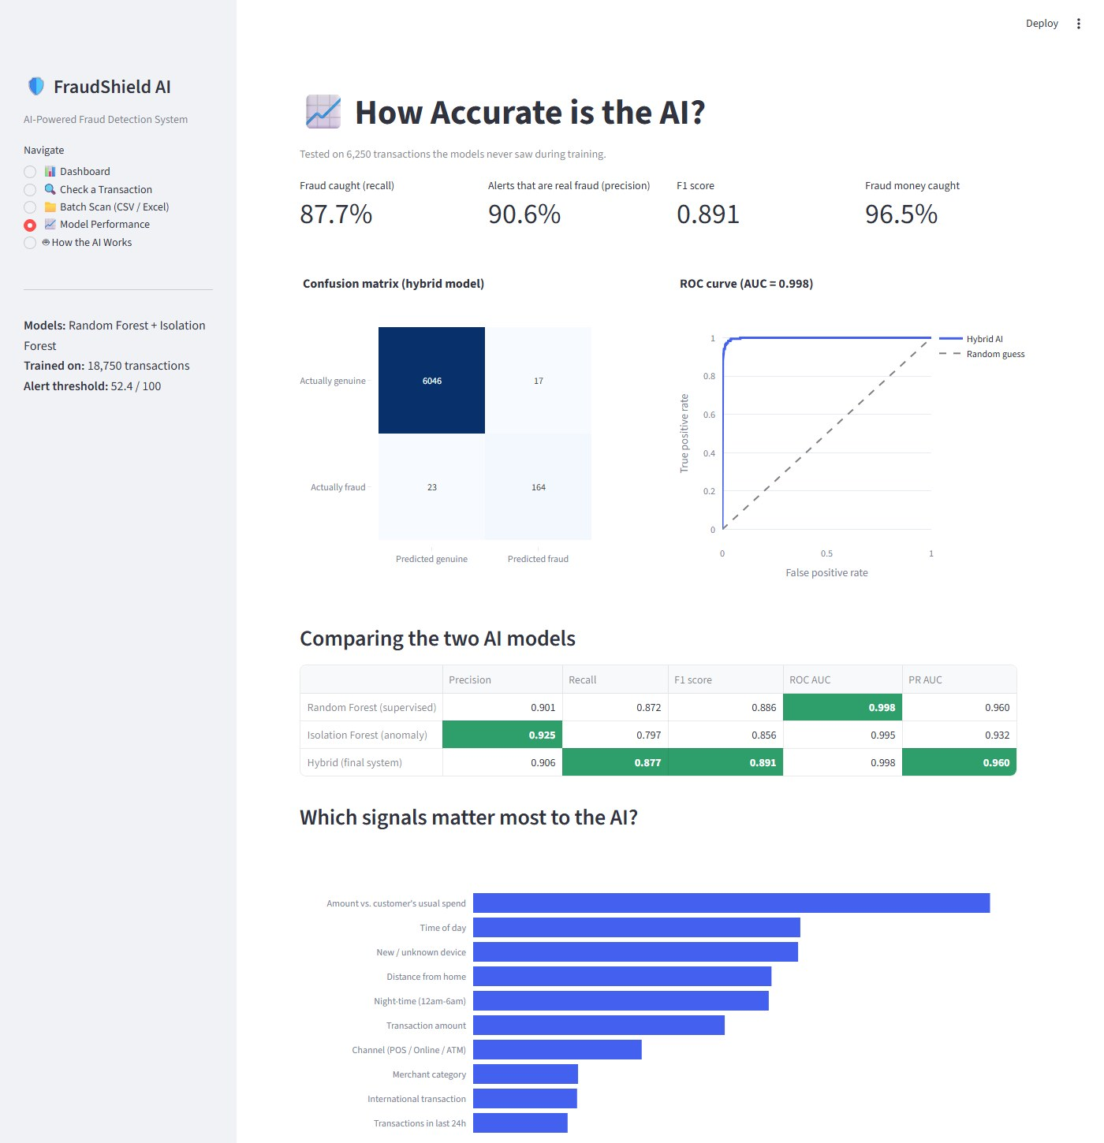
Figure 11 – Model Performance page

Part D – Applications, Limitations and Conclusion

D1. Benefits and practical applications
- Banks and card networks – score card payments in real time, before they are approved.
- UPI, wallet and e-commerce platforms – detect account takeover and payment fraud at checkout.
- Insurance and corporate finance – flag unusual claims or expense reimbursements for audit.
- Benefits – less money lost, fewer genuine customers blocked than with fixed rules, faster investigations (alerts are ranked and explained), easier compliance (every decision is explainable).

D2. Limitations
- The data is synthetic; real-world accuracy would be lower because real data is noisier and fraudsters actively try to look normal.
- The model is trained once; fraud patterns change, so it would need regular retraining.

D3. Future work
- Train on real, anonymised bank data and retrain regularly.
- Add richer signals – IP address, device fingerprint, merchant reputation, customer spending network.
- Try gradient boosting (XGBoost / LightGBM) and deep-learning sequence models.
- Learn from investigator feedback (active learning) and deploy as a real-time API.

D4. Conclusion
FraudShield AI shows how artificial intelligence can solve a real financial problem. By combining a supervised Random Forest with an unsupervised Isolation Forest, the system caught 87.7% of fraud and 96.5% of the fraud money, while wrongly flagging only 0.3% of genuine customers – and it explains every decision in plain language. The same approach is used by banks and payment companies to protect customers in real time.

Appendix A – How AI tools were used to build the project
Development activity | How the AI assistant helped
Planning | Suggested the hybrid Random Forest + Isolation Forest design and the app's page structure
Data | Wrote the synthetic data generator using documented real-world fraud patterns
Modelling | Wrote the training, threshold tuning and evaluation code; ensured tuning used validation data only
Explainability | Implemented red-flag reasons and exact Shapley values; fixed an explanation bug found during testing
User interface | Built the Streamlit app, then tested every page in a browser and fixed layout and readability issues
Documentation | Drafted the README, reports, test files and presentation notes

