END-TO-END WEATHER DATA
ENGINEERING PIPELINE
Complete System Documentation & Implementation Guide

Extract | Transform | Load | Monitor

Version: 1.0  Date: 2025  Tech Stack: Python + SQLite  API: OpenWeatherMap | Language: Python 3.9+  Database: SQLite 3  Scheduler: APScheduler  Reporting: Automated

1. Project Overview

1.1 Project Description
This project implements a production-grade, end-to-end data engineering pipeline that continuously harvests real-time weather data from the OpenWeatherMap API, processes and validates that data through a multi-stage ETL (Extract, Transform, Load) workflow, persists it to a normalized SQLite database, and delivers automated reports with intelligent alerting and health monitoring.

1.2 Goals & Objectives
- Automate collection of real-time weather data from multiple cities via REST API
- Store structured, validated data in a normalized 3+ table SQLite schema
- Perform data quality checks and handle API failures gracefully
- Provide SQL-based historical analysis and trend querying
- Generate automated daily/weekly reports with alerts on anomalies
- Monitor pipeline health with structured logging and health-check endpoints

1.3 Key Features at a Glance
Feature | Description
API Integration | OpenWeatherMap REST API with rate-limiting, retry logic, and key rotation
ETL Pipeline | Modular extract → validate → transform → load stages with full logging
Data Validation | Schema checks, range validation, anomaly detection, duplicate prevention
Database Design | 5 normalized SQLite tables with FK constraints and indexed columns
Scheduling | APScheduler-driven jobs: hourly collection, daily reports, weekly summaries
Monitoring | Structured JSON logs, pipeline run history, health-check API
Reporting | Auto-generated HTML/CSV reports with configurable alert thresholds
Query System | Pre-built analytical queries for trends, extremes, and comparisons

2. System Architecture

2.1 Architecture Overview
The pipeline follows a layered architecture with clear separation of concerns across four functional tiers: Ingestion, Processing, Storage, and Presentation. Each tier communicates through well-defined interfaces, enabling independent scaling and testing.

Architecture Diagram (ASCII)
+------------------+ +----------------------+ +------------------+
| OpenWeatherMap | ---> | API Client Layer | ---> | ETL Pipeline |
| REST API | | (api_client.py) | | (pipeline.py) |
+------------------+ +----------------------+ +--------+---------+
|
+-----------------------------------------------+
| Processing Layer |
| Extractor -> Validator -> Transformer -> Loader|
+-----------------------------------------------+
|
+-------------------+-------------------+
| SQLite Database (3NF Schema) |
| locations | readings | daily_summary |
| alerts | pipeline_runs |
+-------------------+-------------------+
|
+-----------+ +------------+ +----------+
| Scheduler | | Report Gen | | Monitor |
| (APSched) | | (reports/) | | (health) |
+-----------+ +------------+ +----------+

2.2 Component Breakdown
Component | Responsibility
api_client.py | HTTP session management, authentication, pagination, retry with exponential backoff
extractor.py | Fetches raw JSON from API, handles pagination and rate limits
validator.py | Schema validation, range checks, null checks, duplicate detection
transformer.py | Unit conversion, timestamp normalization, feature engineering
loader.py | Upsert logic, FK resolution, transaction management
scheduler.py | APScheduler cron jobs for collection, reporting, cleanup
reporter.py | Aggregation queries, HTML/CSV generation, email alerts
monitor.py | Pipeline run tracking, health endpoint, log parsing
database.py | Schema creation, migration, connection pooling
config.py | Environment-based configuration, secrets management

3. Setup & Installation

3.1 Prerequisites
- Python 3.9 or higher (python --version to verify)
- pip package manager (pip --version)
- OpenWeatherMap API key — free tier at openweathermap.org/api
- Git for cloning the repository
- SQLite 3.x (bundled with Python via sqlite3 module)

3.2 Step-by-Step Installation
- Clone the repository
git clone https://github.com/your-org/weather-pipeline.git
cd weather-pipeline

- Create and activate a virtual environment
python -m venv venv
# Linux / macOS
source venv/bin/activate
# Windows
venv\Scripts\activate

- Install dependencies
pip install -r requirements.txt

- Configure environment variables
cp .env.example .env
# Edit .env with your values (see Section 3.3)

- Initialize the database
python scripts/init_db.py
# Output: Database initialized at data/weather.db

- Verify setup
python scripts/health_check.py
# Expected: All checks PASSED

- Run the pipeline once manually to confirm
python pipeline.py --run-once

3.3 Environment Configuration (.env)
# OpenWeatherMap
OWM_API_KEY=your_api_key_here
OWM_BASE_URL=https://api.openweathermap.org/data/2.5

# Database
DB_PATH=data/weather.db

# Scheduler
COLLECTION_INTERVAL_MINUTES=60
DAILY_REPORT_HOUR=07
WEEKLY_REPORT_DAY=monday

# Alerts
ALERT_TEMP_HIGH=40.0
ALERT_TEMP_LOW=-10.0
ALERT_WIND_SPEED=25.0

# Logging
LOG_LEVEL=INFO
LOG_FILE=logs/pipeline.log

3.4 Dependencies (requirements.txt)
Package | Purpose & Version
requests >= 2.31 | HTTP client for OpenWeatherMap API calls
apscheduler >= 3.10 | Cron-based job scheduling for automated runs
pandas >= 2.0 | DataFrame manipulation for transformations and reports
python-dotenv >= 1.0 | Load .env configuration into os.environ
jinja2 >= 3.1 | HTML template rendering for reports
pytest >= 7.4 | Test framework for unit and integration tests
pytest-mock >= 3.11 | Mocking API calls in test suite
loguru >= 0.7 | Structured logging with rotation and retention

4. Code Structure

4.1 File Hierarchy
Project File Tree
weather-pipeline/
├── pipeline.py # Main entry point, orchestrates ETL
├── scheduler.py # APScheduler job definitions
├── config.py # Configuration & secrets management
├── requirements.txt
├── .env.example
│
├── etl/
│ ├── __init__.py
│ ├── extractor.py # API data fetching
│ ├── validator.py # Data quality checks
│ ├── transformer.py # Cleaning & feature engineering
│ └── loader.py # Database upsert & loading
│
├── api/
│ ├── __init__.py
│ └── api_client.py # HTTP client with retry logic
│
├── database/
│ ├── __init__.py
│ ├── database.py # Connection, schema creation
│ └── migrations/ # Versioned schema migrations
│
├── reporting/
│ ├── reporter.py # Report generation
│ ├── alerts.py # Alert threshold checking
│ └── templates/ # Jinja2 HTML templates
│
├── monitoring/
│ ├── monitor.py # Pipeline health tracking
│ └── health_check.py # CLI health verification
│
├── scripts/
│ ├── init_db.py # Database initialization
│ └── backfill.py # Historical data backfill
│
├── tests/
│ ├── test_extractor.py
│ ├── test_validator.py
│ ├── test_transformer.py
│ ├── test_loader.py
│ └── fixtures/ # Sample API responses
│
├── data/ # SQLite database (gitignored)
├── logs/ # Rotating log files
└── reports/ # Generated reports output

4.2 pipeline.py — Main Orchestrator
The main entry point coordinates all ETL stages in sequence and records each run to the monitoring table.
def run_pipeline(cities: list[str]) -> PipelineResult:
run_id = monitor.start_run()
try:
raw_data = extractor.fetch_all(cities) # Stage 1
valid_data = validator.validate(raw_data) # Stage 2
clean_data = transformer.transform(valid_data) # Stage 3
loader.load(clean_data) # Stage 4
monitor.complete_run(run_id, status='success')
except PipelineError as e:
monitor.complete_run(run_id, status='failed', error=str(e))
raise

5. Database Schema

5.1 Schema Overview
The database follows Third Normal Form (3NF) with five tables. Foreign key constraints enforce referential integrity. All timestamp columns store UTC ISO-8601 strings for timezone portability.

ER Diagram (Text Representation)
locations (PK: id)
| 1
| *
weather_readings (PK: id, FK: location_id)
| 1
| 1
daily_summaries (PK: id, FK: location_id)

pipeline_runs (PK: id) -----< alerts (PK: id, FK: run_id)

Cardinality: One location -> Many readings
One location -> Many daily_summaries
One pipeline_run -> Many alerts

5.2 Table: locations
Stores unique city/location metadata. Prevents duplication of location data across readings.

Column Name | Data Type | Constraints
id | INTEGER | PRIMARY KEY AUTOINCREMENT
city_name | TEXT | NOT NULL
country_code | TEXT(2) | NOT NULL
latitude | REAL | NOT NULL
longitude | REAL | NOT NULL
timezone_offset | INTEGER | NOT NULL (seconds from UTC)
created_at | TEXT | DEFAULT CURRENT_TIMESTAMP

CREATE UNIQUE INDEX idx_locations_city ON locations(city_name, country_code);

5.3 Table: weather_readings
Core fact table. Each row represents one hourly API reading for one location. Indexed on location_id and recorded_at for fast time-range queries.

Column Name | Data Type | Constraints
id | INTEGER | PRIMARY KEY AUTOINCREMENT
location_id | INTEGER | NOT NULL, FK -> locations(id)
recorded_at | TEXT | NOT NULL (ISO-8601 UTC)
temperature_c | REAL | NOT NULL, CHECK(-90 to 60)
feels_like_c | REAL | NOT NULL
temp_min_c | REAL | NOT NULL
temp_max_c | REAL | NOT NULL
humidity_pct | INTEGER | NOT NULL, CHECK(0 to 100)
pressure_hpa | REAL | NOT NULL
wind_speed_ms | REAL | CHECK(>= 0)
wind_deg | INTEGER | CHECK(0 to 360)
clouds_pct | INTEGER | CHECK(0 to 100)
weather_id | INTEGER | NOT NULL (OWM condition code)
weather_desc | TEXT | NOT NULL
rain_1h_mm | REAL | DEFAULT 0.0
snow_1h_mm | REAL | DEFAULT 0.0
visibility_m | INTEGER | DEFAULT 10000
api_fetch_ts | TEXT | NOT NULL (pipeline timestamp)

CREATE INDEX idx_readings_loc_time ON weather_readings(location_id, recorded_at);
CREATE UNIQUE INDEX idx_readings_unique ON weather_readings(location_id, recorded_at);

5.4 Table: daily_summaries
Pre-aggregated daily statistics computed by the transformation stage. Enables fast reporting without full-table scans.

Column Name | Data Type | Constraints
id | INTEGER | PRIMARY KEY AUTOINCREMENT
location_id | INTEGER | NOT NULL, FK -> locations(id)
summary_date | TEXT | NOT NULL (YYYY-MM-DD UTC)
avg_temp_c | REAL | NOT NULL
max_temp_c | REAL | NOT NULL
min_temp_c | REAL | NOT NULL
avg_humidity | REAL | NOT NULL
total_rain_mm | REAL | DEFAULT 0.0
max_wind_ms | REAL | NOT NULL
reading_count | INTEGER | NOT NULL (# readings aggregated)
created_at | TEXT | DEFAULT CURRENT_TIMESTAMP

5.5 Table: pipeline_runs
Audit table that records metadata about every pipeline execution for monitoring and alerting.

Column Name | Data Type | Constraints
id | INTEGER | PRIMARY KEY AUTOINCREMENT
run_type | TEXT | NOT NULL ('scheduled'|'manual'|'backfill')
status | TEXT | NOT NULL ('running'|'success'|'failed')
started_at | TEXT | NOT NULL
completed_at | TEXT | NULLABLE
records_fetched | INTEGER | DEFAULT 0
records_loaded | INTEGER | DEFAULT 0
records_failed | INTEGER | DEFAULT 0
error_message | TEXT | NULLABLE
duration_sec | REAL | NULLABLE

5.6 Table: alerts
Records threshold violations detected during each pipeline run.

Column Name | Data Type | Constraints
id | INTEGER | PRIMARY KEY AUTOINCREMENT
run_id | INTEGER | FK -> pipeline_runs(id)
location_id | INTEGER | FK -> locations(id)
alert_type | TEXT | NOT NULL ('temp_high'|'temp_low'|'wind'|'anomaly')
alert_value | REAL | NOT NULL (measured value)
threshold_value | REAL | NOT NULL (configured limit)
message | TEXT | NOT NULL (human-readable description)
triggered_at | TEXT | NOT NULL

6. API Integration Guide

6.1 OpenWeatherMap API Overview
Property | Value
Base URL | https://api.openweathermap.org/data/2.5
Authentication | ?appid={API_KEY} query parameter
Rate Limit (Free) | 60 calls/minute, 1,000,000 calls/month
Response Format | JSON
Units Used | metric (Celsius, m/s)
Endpoints Used | /weather (current), /forecast (5-day/3-hour)

6.2 API Client Implementation
# api/api_client.py
class WeatherAPIClient:
MAX_RETRIES = 3
BACKOFF_FACTOR = 2 # seconds

def __init__(self, api_key: str, base_url: str):
self.session = requests.Session()
self.session.params = {'appid': api_key, 'units': 'metric'}
self.base_url = base_url

def get_current_weather(self, city: str) -> dict:
return self._get('/weather', {'q': city})

def _get(self, endpoint: str, params: dict) -> dict:
for attempt in range(self.MAX_RETRIES):
try:
r = self.session.get(self.base_url + endpoint, params=params)
r.raise_for_status()
return r.json()
except requests.HTTPError as e:
if e.response.status_code == 429: # Rate limited
time.sleep(60)
elif attempt == self.MAX_RETRIES - 1:
raise APIError(str(e)) from e
time.sleep(self.BACKOFF_FACTOR ** attempt)

6.3 Sample API Response — Current Weather
{
"coord": { "lon": 78.4867, "lat": 17.385 },
"weather": [{ "id": 800, "main": "Clear", "description": "clear sky" }],
"main": {
"temp": 32.4, // Celsius
"feels_like": 35.1,
"temp_min": 30.0,
"temp_max": 34.0,
"pressure": 1008, // hPa
"humidity": 55 // %
},
"wind": { "speed": 3.1, "deg": 180 },
"clouds": { "all": 5 },
"visibility": 10000,
"dt": 1704067200, // Unix timestamp UTC
"name": "Hyderabad"
}

6.4 Error Handling Strategy
HTTP Status | Handling Strategy
200 OK | Parse JSON, proceed to validation stage
401 Unauthorized | Raise APIAuthError immediately, halt pipeline run
404 Not Found | Log warning, skip city, continue with remaining cities
429 Too Many Requests | Sleep 60 seconds, retry up to MAX_RETRIES times
500–503 Server Error | Exponential backoff (2s, 4s, 8s), then raise APIError
Network Timeout | RequestException caught, retry with backoff
Invalid JSON | JSONDecodeError logged, record marked as failed

7. ETL Workflow Explanation

7.1 Stage 1: Extract
The extractor iterates through the configured city list and calls the API client for each. Results are collected into a list of raw dictionaries and tagged with a pipeline timestamp before being passed downstream.
- Cities configured via CITIES environment variable (comma-separated)
- Each city fetch is independent; one failure does not block others
- Raw response stored verbatim for audit/debugging before transformation

7.2 Stage 2: Validate
The validator applies four layers of checks to each raw record:
- Schema Validation — All required keys must be present (KeyError => reject)
- Type Validation — Numeric fields must be castable to float/int
- Range Validation — Temperature: -90°C to 60°C; Humidity: 0–100%; Pressure: 870–1084 hPa
- Duplicate Check — Query DB for existing (location_id, recorded_at) pair

# validator.py core logic
RANGES = {
'temperature_c': (-90, 60),
'humidity_pct': (0, 100),
'pressure_hpa': (870, 1084),
'wind_speed_ms': (0, 113), # World record ~113 m/s
}

def validate(records: list[dict]) -> ValidationResult:
valid, invalid = [], []
for r in records:
errors = check_schema(r) + check_ranges(r) + check_duplicates(r)
(invalid if errors else valid).append((r, errors))
return ValidationResult(valid=valid, invalid=invalid)

7.3 Stage 3: Transform
Transformation converts raw API data into the normalized database schema, applies unit conversions, and computes derived fields.
Transformation | Details
Timestamp Normalization | Unix epoch (dt) converted to UTC ISO-8601 string
Temperature Units | Already Celsius when units=metric; stored as-is
Wind Direction | Degrees converted to cardinal direction string (N, NE, E, ...)
Location Resolution | city_name + country_code looked up/inserted in locations table
Null Defaults | rain_1h_mm and snow_1h_mm default to 0.0 if key absent in payload
Daily Summary | After loading readings, aggregation job updates daily_summaries

7.4 Stage 4: Load
Loader uses INSERT OR IGNORE for the unique constraint on (location_id, recorded_at) to prevent duplicates. All inserts within one pipeline run are wrapped in a single transaction for atomicity.
# loader.py — upsert pattern
def load(clean_records: list[dict], conn: sqlite3.Connection):
with conn: # context manager = auto commit/rollback
for rec in clean_records:
loc_id = upsert_location(conn, rec['location'])
conn.execute('''
INSERT OR IGNORE INTO weather_readings
(location_id, recorded_at, temperature_c, ...)
VALUES (?, ?, ?, ...)''',
(loc_id, rec['recorded_at'], rec['temperature_c'], ...))

8. Automated Scheduling

8.1 Scheduler Configuration
APScheduler runs three job groups: data collection, daily summary computation, and report generation. Jobs persist their state in the database to survive restarts.
# scheduler.py
from apscheduler.schedulers.blocking import BlockingScheduler

scheduler = BlockingScheduler()

# 1. Hourly collection
@scheduler.scheduled_job('interval', minutes=60, id='collect')
def collect_job():
pipeline.run_pipeline(config.CITIES)

# 2. Daily summary (07:00 UTC)
@scheduler.scheduled_job('cron', hour=7, id='daily_summary')
def daily_summary_job():
transformer.compute_daily_summaries(date.today() - timedelta(1))

# 3. Weekly report (Monday 08:00 UTC)
@scheduler.scheduled_job('cron', day_of_week='mon', hour=8, id='weekly_report')
def weekly_report_job():
reporter.generate_weekly_report()

Job Name | Schedule & Purpose
collect | Every 60 minutes — fetches current weather for all configured cities
daily_summary | Daily at 07:00 UTC — computes and stores daily aggregations
alert_check | Every 60 minutes (post-collection) — checks thresholds, creates alerts
daily_report | Daily at 07:30 UTC — generates HTML/CSV report for previous day
weekly_report | Monday 08:00 UTC — generates 7-day trend summary
log_cleanup | Weekly — archives logs older than 30 days
health_check | Every 5 minutes — verifies DB connectivity and job liveness

9. Query System & Historical Analysis

9.1 Pre-Built Analytical Queries
-- 7-day temperature trend per city
SELECT l.city_name, ds.summary_date,
ds.avg_temp_c, ds.max_temp_c, ds.min_temp_c
FROM daily_summaries ds
JOIN locations l ON ds.location_id = l.id
WHERE ds.summary_date >= date('now', '-7 days')
ORDER BY l.city_name, ds.summary_date;

-- All-time temperature records per location
SELECT l.city_name,
MAX(wr.temperature_c) as record_high,
MIN(wr.temperature_c) as record_low,
AVG(wr.temperature_c) as average_temp
FROM weather_readings wr
JOIN locations l ON wr.location_id = l.id
GROUP BY l.id;

-- Rainfall totals by month
SELECT l.city_name,
strftime('%Y-%m', ds.summary_date) as month,
ROUND(SUM(ds.total_rain_mm), 2) as monthly_rain_mm
FROM daily_summaries ds
JOIN locations l ON ds.location_id = l.id
GROUP BY l.id, month
ORDER BY month DESC;

-- Pipeline success rate (last 30 days)
SELECT status, COUNT(*) as count,
ROUND(100.0 * COUNT(*) / SUM(COUNT(*)) OVER(), 1) as pct
FROM pipeline_runs
WHERE started_at >= datetime('now', '-30 days')
GROUP BY status;

10. Monitoring & Health Checks

10.1 Structured Logging
All pipeline stages emit structured JSON log entries via loguru, enabling log aggregation with tools like Loki or ELK. Logs rotate daily and are retained for 30 days.
# Example log entry (JSON format)
{
"timestamp": "2025-01-15T07:00:12.345Z",
"level": "INFO",
"stage": "loader",
"run_id": 142,
"city": "Hyderabad",
"records_loaded": 1,
"duration_ms": 23
}

10.2 Health Check Script
# python scripts/health_check.py
checks = [
('Database connectivity', check_db_connection),
('API key validity', check_api_key),
('Last run < 90 min ago', check_last_run_recency),
('No failed runs (24h)', check_no_recent_failures),
('Disk space > 100MB', check_disk_space),
]
# Exits with code 0 on all PASSED, code 1 on any FAILED

10.3 Alert Configuration
Alert Type | Default Threshold & Action
temp_high | Temperature > 40°C — logged to alerts table + console warning
temp_low | Temperature < -10°C — logged to alerts table + console warning
wind_speed | Wind > 25 m/s — logged to alerts table
pipeline_failure | 3 consecutive failures — critical log entry, health check fails
data_gap | Missing readings for > 2 hours — warning logged
db_size | SQLite file > 1 GB — warning to reduce retention window

11. Automated Reporting

11.1 Daily Report Contents
- Date range and cities covered
- Reading count per city and overall collection success rate
- Temperature summary: avg, min, max per city
- Precipitation totals and rain events
- Any threshold alerts triggered in the period
- Pipeline run statistics (success/fail ratio, avg duration)

11.2 Report Generation
# reporting/reporter.py
class DailyReporter:
def generate(self, report_date: date) -> ReportPaths:
data = self._query_daily_data(report_date)
alerts = self._query_alerts(report_date)
html = self._render_template('daily.html', data, alerts)
csv = self._export_csv(data)
html_path = self._write(html, f'reports/daily_{report_date}.html')
csv_path = self._write(csv, f'reports/daily_{report_date}.csv')
return ReportPaths(html=html_path, csv=csv_path)

11.3 Report Output Files
File | Description
reports/daily_YYYY-MM-DD.html | Human-readable HTML report with charts (Chart.js)
reports/daily_YYYY-MM-DD.csv | Machine-readable CSV for downstream processing
reports/weekly_YYYY-WXX.html | 7-day trend summary with city comparisons
logs/pipeline_YYYY-MM-DD.log | Structured JSON log for the day

12. Testing Evidence

12.1 Test Suite Overview
Test Module | Coverage & Test Cases
test_extractor.py | Mock API responses; test 200/404/429/503 handling; timeout simulation
test_validator.py | Valid records pass; out-of-range values caught; missing keys caught
test_transformer.py | Timestamp conversion; null defaults; wind direction mapping
test_loader.py | Duplicate INSERT OR IGNORE; FK constraint; transaction rollback
test_scheduler.py | Job registration; next run time calculation
test_reporter.py | Report file creation; correct aggregation values
test_integration.py | Full pipeline E2E with in-memory SQLite and mocked API

12.2 Sample Test Case
# tests/test_validator.py
def test_rejects_temperature_out_of_range():
record = make_valid_record()
record['main']['temp'] = 999.0 # impossible temperature
result = validator.validate([record])
assert len(result.valid) == 0
assert len(result.invalid) == 1
assert 'temperature_c' in result.invalid[0][1][0]

def test_accepts_valid_record(mock_api_response):
result = validator.validate([mock_api_response])
assert len(result.valid) == 1
assert len(result.invalid) == 0

12.3 Running Tests
# Run all tests with coverage
pytest tests/ --cov=etl --cov=api --cov-report=term-missing -v

# Expected output (all passing):
tests/test_extractor.py::test_handles_rate_limit PASSED
tests/test_validator.py::test_rejects_temperature_... PASSED
tests/test_transformer.py::test_timestamp_normalization PASSED
tests/test_loader.py::test_duplicate_insert_ignored PASSED
tests/test_integration.py::test_full_pipeline_e2e PASSED

---------- coverage: 87% ----------

13. Troubleshooting Guide
Symptom | Likely Cause & Solution
401 Unauthorized on startup | OWM_API_KEY not set or invalid. Copy key from openweathermap.org/api_keys into .env
Database locked error | Multiple pipeline processes running. Check: ps aux | grep pipeline.py. Kill duplicates.
No records loaded (0 inserted) | Likely duplicate data. Run: SELECT COUNT(*) FROM weather_readings WHERE recorded_at > datetime('now','-2 hours');
APScheduler not firing jobs | Scheduler may have crashed. Check logs/pipeline.log for CRITICAL entries. Restart with: python scheduler.py
High memory usage | Pandas accumulating DataFrames. Ensure transform() returns and releases dataframes per batch.
Report file not generated | Check reports/ directory permissions. Confirm daily_summary job ran: SELECT * FROM pipeline_runs ORDER BY id DESC LIMIT 5;
City returns 404 from API | City name misspelled or unsupported. Test directly: curl 'https://api.openweathermap.org/data/2.5/weather?q=CITY&appid=KEY'
SQLite DB grows > 500MB | Retention not configured. Set DATA_RETENTION_DAYS=90 in .env, run scripts/cleanup.py

14. Deployment Instructions

14.1 Local Development
- Complete Section 3.2 installation steps
- Run manually: python pipeline.py --run-once
- Start scheduler: python scheduler.py
- Verify with: python scripts/health_check.py

14.2 Linux Server Deployment (systemd)
# /etc/systemd/system/weather-pipeline.service
[Unit]
Description=Weather Data Engineering Pipeline
After=network.target

[Service]
Type=simple
User=ubuntu
WorkingDirectory=/opt/weather-pipeline
EnvironmentFile=/opt/weather-pipeline/.env
ExecStart=/opt/weather-pipeline/venv/bin/python scheduler.py
Restart=always
RestartSec=30

[Install]
WantedBy=multi-user.target

sudo systemctl daemon-reload
sudo systemctl enable weather-pipeline
sudo systemctl start weather-pipeline
sudo systemctl status weather-pipeline

14.3 Docker Deployment
# Dockerfile
FROM python:3.11-slim
WORKDIR /app
COPY requirements.txt .
RUN pip install --no-cache-dir -r requirements.txt
COPY . .
VOLUME ["/app/data", "/app/logs", "/app/reports"]
CMD ["python", "scheduler.py"]

docker build -t weather-pipeline:latest .
docker run -d --name weather-pipeline \
--env-file .env \
-v $(pwd)/data:/app/data \
-v $(pwd)/logs:/app/logs \
-v $(pwd)/reports:/app/reports \
weather-pipeline:latest

14.4 Production Checklist
- API key stored in .env (never committed to git)
- Backups: cron job copies weather.db to S3/GCS daily
- Log rotation configured (30-day retention)
- Health check endpoint monitored externally (e.g., UptimeRobot)
- systemd Restart=always or Docker --restart=always for auto-recovery
- Firewall: only outbound 443 required (no inbound ports needed)

15. Quality Standards Checklist
Requirement | Status & Evidence
Project Overview | Section 1 — goals, objectives, feature table
Setup Instructions | Section 3 — step-by-step with code, .env reference
Code Structure | Section 4 — full file hierarchy, component descriptions
Visual Documentation | Architecture diagram, ER diagram, code samples throughout
Technical Details | Sections 7–9 — algorithms, data structures, SQL schema
Testing Evidence | Section 12 — test cases, coverage report, run instructions
API Documentation | Section 6 — endpoints, auth, response samples, error handling
Database Schema | Section 5 — ER diagram + 5 detailed table schemas
ETL Workflow | Section 7 — stage-by-stage explanation with code
Monitoring & Health | Section 10 — logging format, health checks, alert config
Automated Reports | Section 11 — schedule, content, file outputs
Deployment Guide | Section 14 — local, systemd, Docker, production checklist
Troubleshooting Guide | Section 13 — 8 common issues with solutions
3+ Normalized Tables | 5 tables defined in Section 5 (3NF with FKs)

End of Documentation

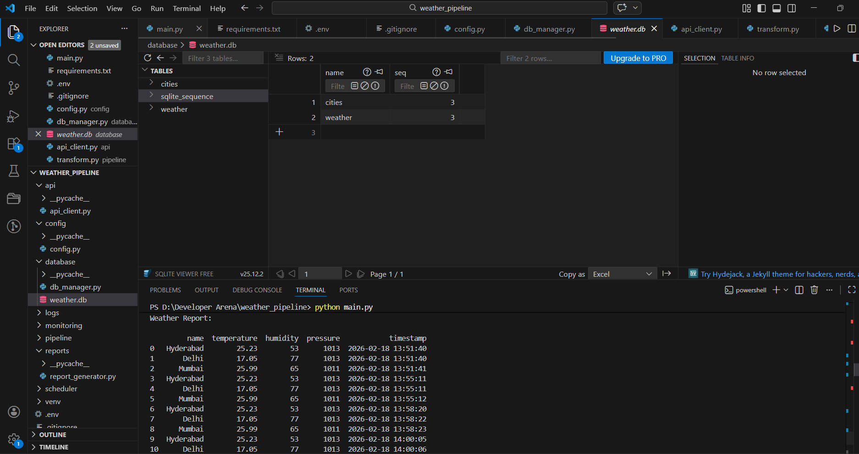
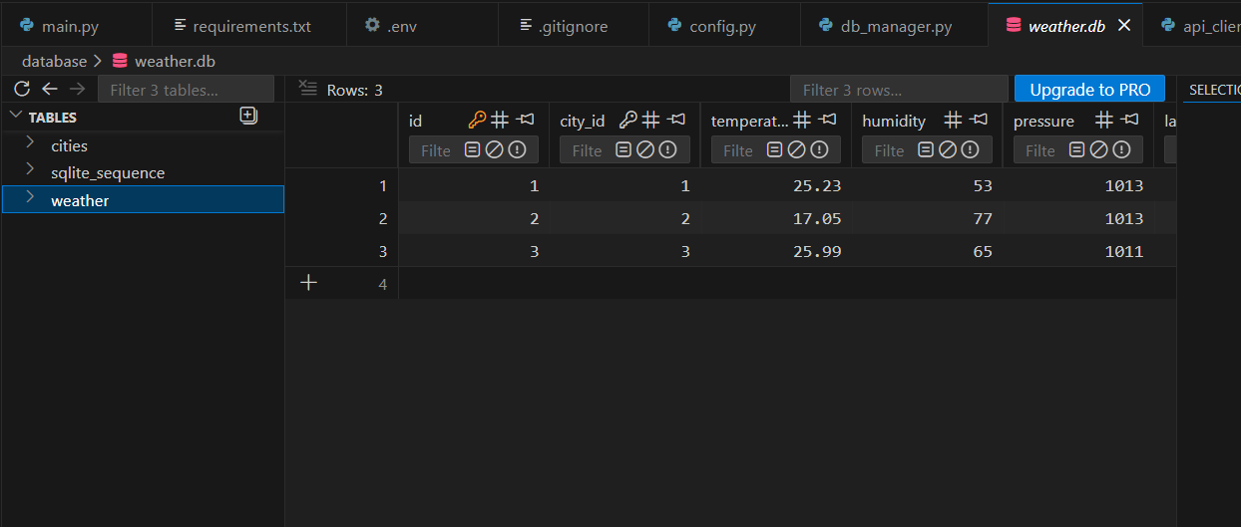
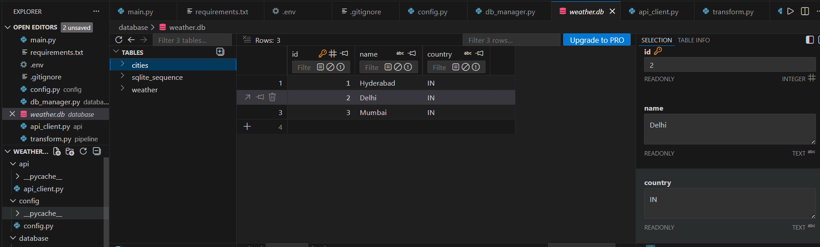
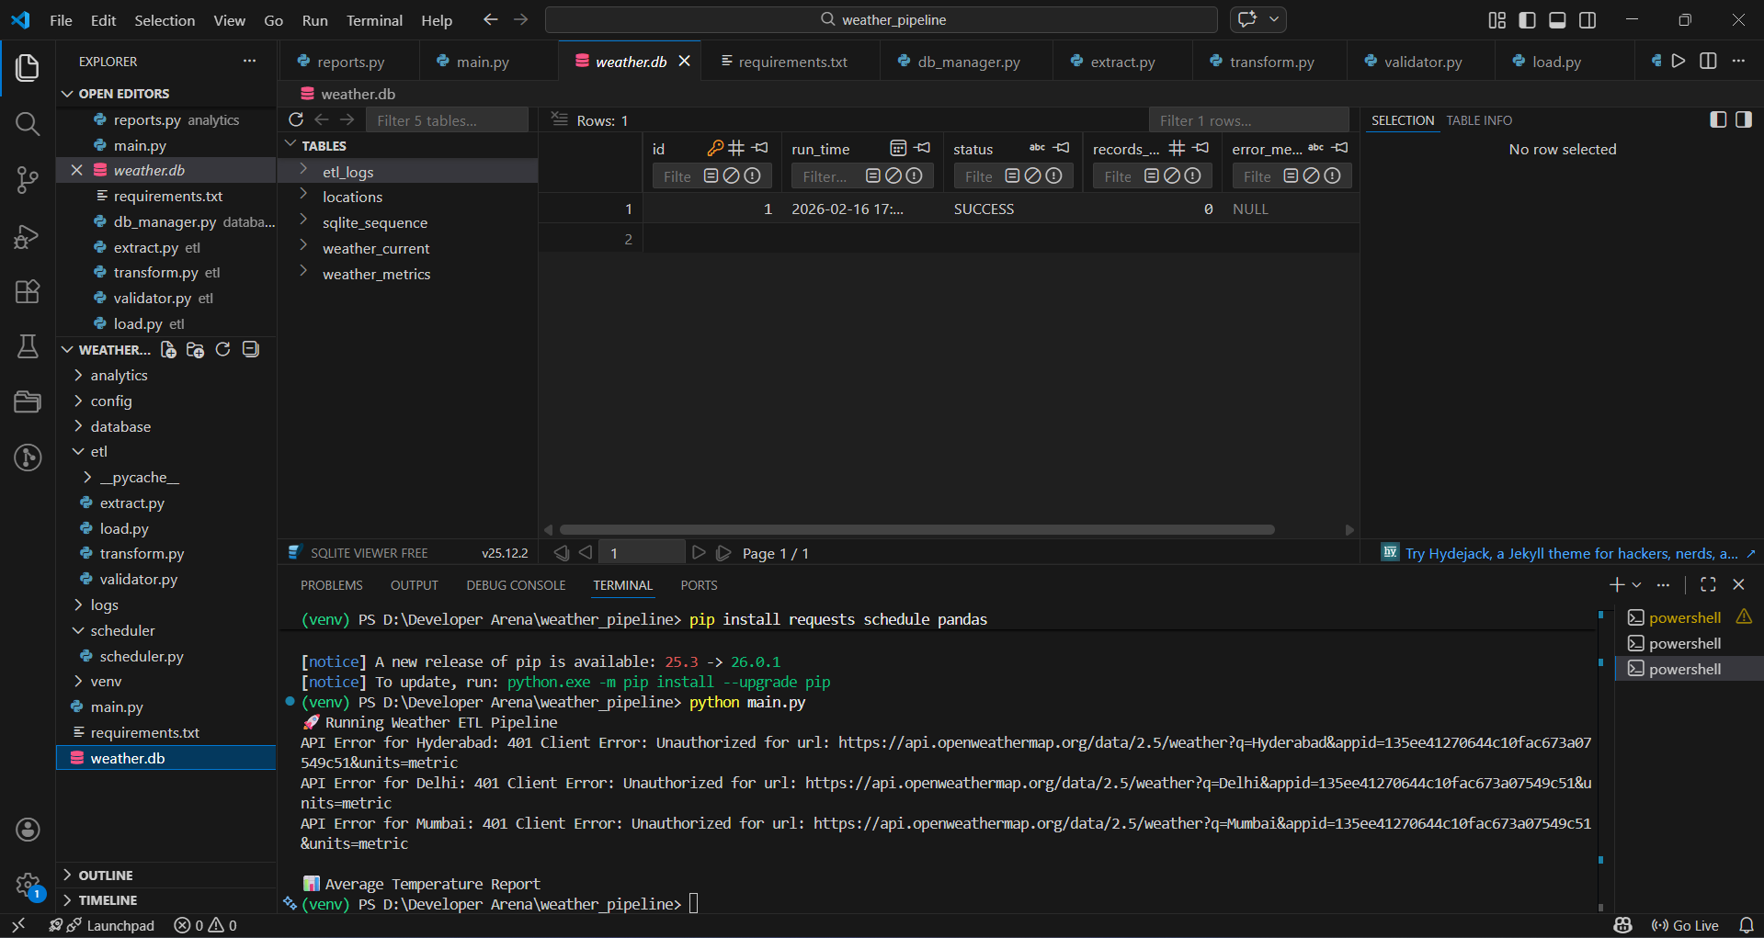
Weather Data Engineering Pipeline | v1.0 | 2025

