Phase 1 — Requirements & Architecture (Ram)
1. Executive Summary
The Risk Exposure Platform (REP) is designed as a tool-agnostic, modular platform that ingests heterogeneous security and business data, normalizes it into a canonical schema, computes business-relevant risk scores, and exports results for dashboards, reporting, and automation. The primary goal is to provide clear, actionable visibility into organizational risk while maintaining flexibility to incorporate new data sources, tools, and risk scoring methodologies.
Key objectives:
- Consolidate data from multiple security tools and business units
- Normalize data to a common schema
- Compute asset-based, threat-based, and business impact-based risk scores
- Provide configurable output formats for dashboards, reports, and automation workflows
- Support iterative improvements and integration of new data sources

2. High-Level Data Flow Diagram
Conceptual Flow:
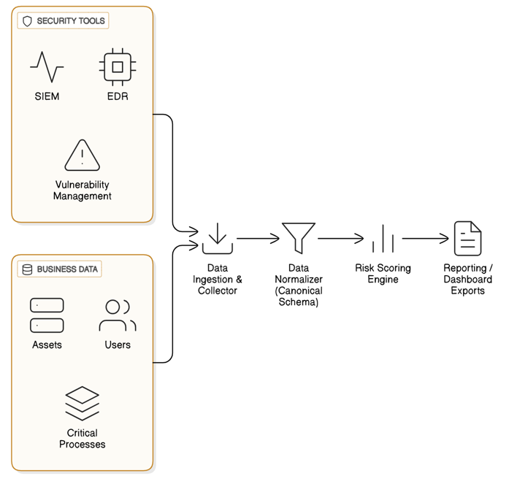

- Ingestion & Collector: Handles real-time and batch ingestion from multiple sources.
- Normalizer: Maps raw data to a canonical schema for consistency.
- Risk Scoring Engine: Calculates risk scores using configurable formulas.
- Reporting / Dashboard: Outputs risk insights for decision-making and automation.

3. Architecture Components & Description
Component | Description | Owner
Data Ingestion & Collector | Pulls data from SIEM, EDR, vulnerability scanners, and business applications. Supports streaming and batch ingestion. | Ram
Data Normalizer | Maps incoming data to a canonical schema to standardize fields such as asset type, vulnerability severity, and user privileges. | Ram
Risk Scoring Engine | Implements configurable risk models: threat-based, asset-based, business-impact-based. Supports aggregation and weighting. | Ram
Reporting & Export | Generates dashboards, CSV/JSON exports, and API endpoints for integration with external systems. | Ram
Configuration & Mapping | Centralized configuration files for normalization rules, scoring weights, and thresholds. | Ram

4. Risk Model Definition & Scoring
Risk Formula (Simplified):
- Risk Score=(Threat Likelihood × Vulnerability Severity ×Business Impact) to the power of Weight Factor
- Threat Likelihood: Probability of an exploit occurring (1–5 scale)
- Vulnerability Severity: Based on CVSS or internal scoring (1–10)
- Business Impact: Quantifies financial, operational, or reputational damage (1–5)
- Weight Factor: Adjustable per asset or business unit (0.8–1.2)

Example Scoring Table:
Asset | Vulnerability Severity | Threat Likelihood | Business Impact | Weighted Risk Score
Web Server | 8 | 4 | 5 | 160
Database | 7 | 3 | 5 | 105
User Workstation | 5 | 2 | 3 | 30

5. Canonical Data Schema
Field Name | Type | Description
asset_id | string | Unique asset identifier
asset_type | string | Server, Workstation, Network Device
vulnerability_id | string | Identifier of vulnerability (CVE or internal)
severity | int | CVSS or internal severity score (1–10)
threat_likelihood | int | Likelihood of exploit (1–5)
business_impact | int | Impact level (1–5)
last_detected | datetime | Timestamp of last detection
owner | string | Business owner or responsible team
normalized_risk | float | Computed risk score

6. Sample Output / Reports
- Dashboard Example: Heatmap showing asset risk vs business impact
- CSV Export: Risk score per asset, severity, and mitigation status
- JSON API Example: For integration into SOAR or ticketing systems

