Checkpoint

Done by Tashrif Radin Ali

The idea for this project is to make a star map where you can click on a star and view its planets. With this I can animate the background so it twinkles and when you hover on a star (glowing dot) you can view the star’s planetary system. If possible, I can try to zoom into the system to show the planetary system(keyframes can be used here) and move around the map, however that’s only after I finish something like the image below.

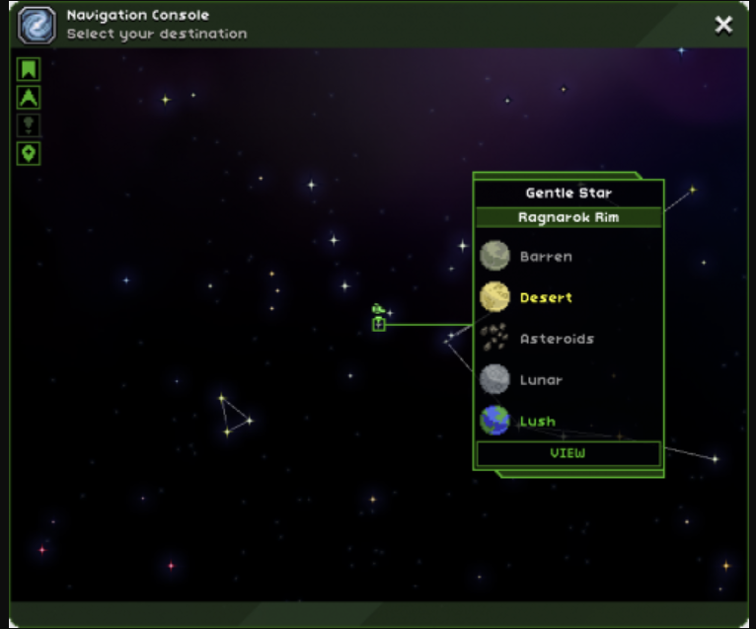

This is a screenshot from a game from a game named “Starbound”, I will use real stars with real planets in them.

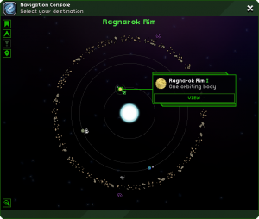

Only after I can finish the star map and have remaining time I can try doing a planetary system.