API returning teacher list

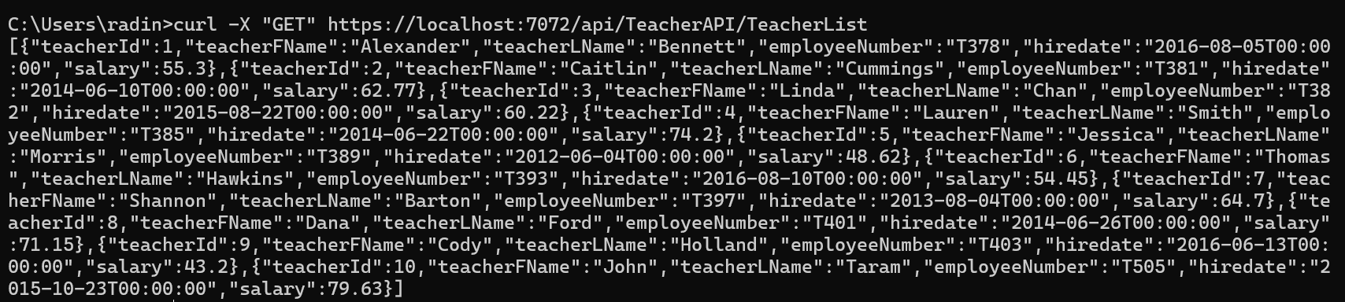

API returning a teacher

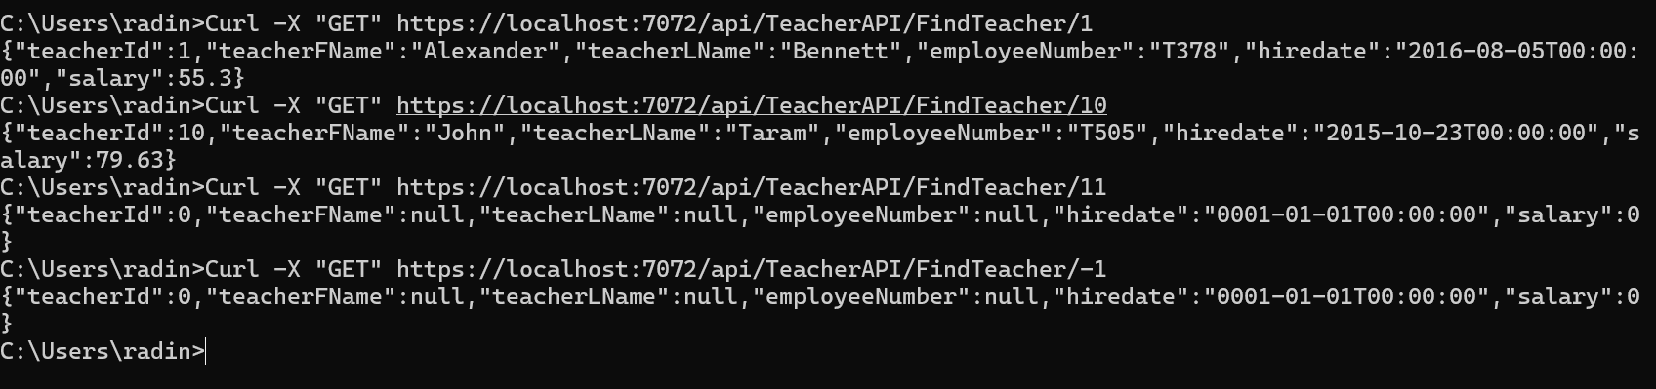

Web page displaying all Teachers

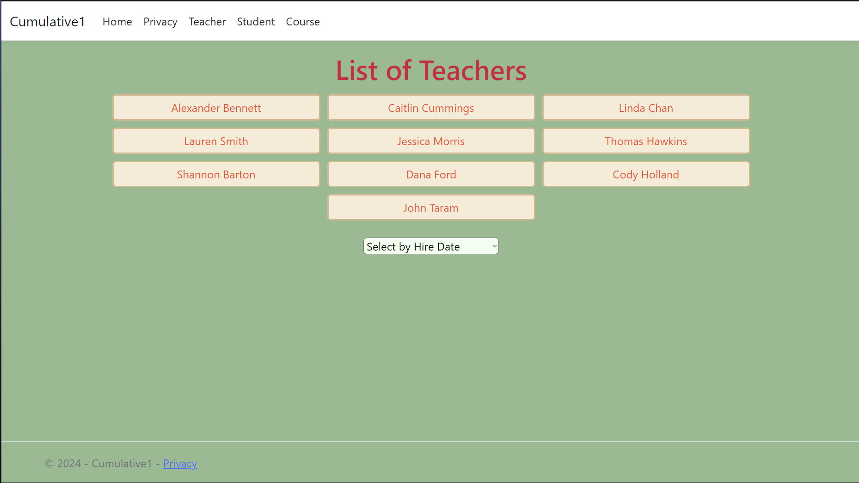

Web page displaying a teacher

