Ali Tashrif Radin

HTTP5126 Final Project Proposal

11/17/2024

**Planetary Database Proposal**

# Real World Scenario (2 marks)

Managing data about planetary systems and finding information about the planetary system and its celestial bodies.

# Problems & Features (6 marks)

## Problem 1: View data about solar systems in the universe

Space is a vast place with many stars with planets and moons. Researchers, instructors and students need to view information about different planetary systems and its layout. The required tables will be star, planet and moon.

## Problem 1 - Solution

Using views users can see the layout of different planetary systems. Users will be able to view the names of the star it’s, planets of that Planetary system and the moons of each of the planets.

## Problem 2: Make Calculations about body in the universe

Since space is so vast and we are constantly finding new stars, planets and moons we also need to find information like its gravitational strength. The required tables will be star, planet and moon.

## Problem 2 - Solution

Using functions users can get interesting information about a specific celestial body, like gravitational strength and escape velocity. The database stores values of mass and radius of each body which can be used with Newton’s law of universal gravitation to find values like gravitational strength.

# Architecture Description (16 marks)

Name of the database: Planetary

## Database Tools (3 marks) & Justification (3 marks)

View name(s): view_layout,

star_with_planets_view

Having this view can give us a nice summary of a specific planetary system. This includes the name of the star, its planets and the name of the moons of each planet.

Trigger name(s): trg_change_scientific_value_star,

trg_change_scientific_value_planet,

trg_change_scientific_value_moon

Since I am working with large data, this trigger will change the number to a scientific notation so that it is easier to read for a human.

Function name: fn_gravitaional_calculator

Since the database holds data about mass and radius, this can be used to find the gravitational force. This can be turned into a function for quick calculations.

## Database ERD Diagram (7 marks) & Justification (2 marks)

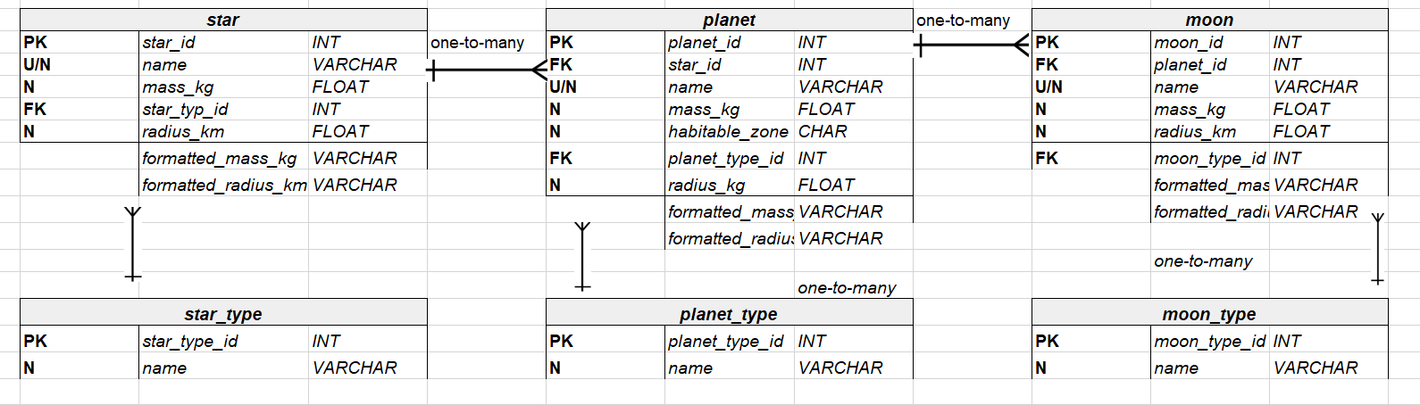

Justification about table structure: Each star will have a certain amount of planets, and each planet will have a certain amount of moons. Each celestial body will have mass and radius for various calculations. Each celestial body will have unique types giving a basic idea about the celestial body.