Data is a collection of information (datum is an individual piece of data)

databases are the solution for storing data, structured way to store data(e.g. relational database)

relational database organized collection data of one or more tables

tables data stored in columns and rows

SQL (structured query language) a programming language for storing and processing information in a relational database.

MySQL is a relational database management system it is a software used to manage rational database

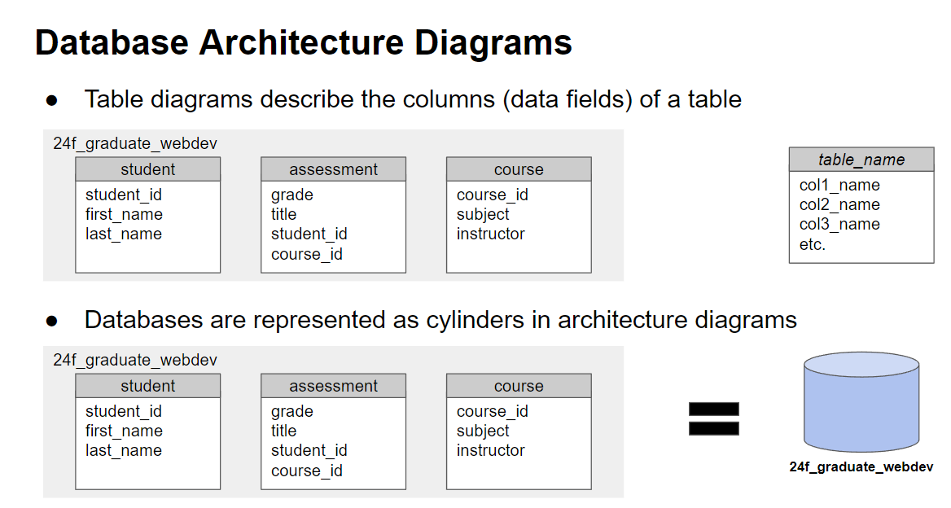

Naming conventions:

* Full words
* No prefixes
* Name has purpose
* Names in lowercase

Database:

* Singular name

Tables:

* Noun
* Either singular or plural

Things needed to work with DBs:

Web server -Apache web server

DBMS – MySQL

Database to store data

SELECT * FROM customers;

SELECT customer_name, city FROM customer;

SELECT DISTINCT column,1 column2 FROM table_name; (selects distinct values)

SELECT * FROM customer WHERE country = “Mexico”;

SELECT * FROM customer WHERE country <> “Mexico”;

SELECT * FROM customer WHERE countryGDP > 10;

SELECT * FROM customer WHERE country >= 10;

SELECT customer_id AS ‘ID’, name as ‘Customer’ from Customer;

SELECT name, CONCAT ( something1, ‘ , ‘ something2) AS ‘Address’ FROM customer; (puts something1 , something2 under address column)

SELECT * FROM movie LIMIT 5; (gives first 5);

SELECT * FROM movie LIMIT 5 OFFSET 5; (gives 5 after 5th row not including 5);

SELECT * FROM movie WHERE genre = ‘Drama’;

SELECT * FROM movie WHERE genre = ‘Drama’ or genre = ‘Comedy’;

SELECT * FROM movie WHERE genre = ‘Drama’ AND genre = ‘Comedy’;

SELECT * FROM movie WHERE runtime < 100;

SELECT * FROM movie WHERE NOT (genre = ‘Animation’ or genre = ‘Comedy);

SELECT * FROM movie WHERE title LIKE ‘The%’ ;(spaces matter)

SELECT * FROM movie WHERE title BETWEEN ‘A’ AND ‘J’

SELECT* FROM movie WHERE genre IN (‘Comedy’, ‘Drama’, ‘Romance’);

SELECT * FROM movie ORDER by title;

SELECT * FROM movie ORDER by title, runtime;

SELECT * FROM movie ORDER by title DESC;

SELECT * FROM movie ORDER by title DESC, runtime ASC;

SELECT * FROM movie WHERE release_year IS NULL