SELECT MAX (from row) FROM table;

SELECT MIN (from row) FROM table;

SELECT AVG (from row) FROM table;

SELECT SUM (from row) FROM table;

SELECT COUNT (from row) FROM table;

SELECT COUNT (movie_id), release_year FROM movie GROUP BY release_year;

SELECT COUNT (movie_id), release_year FROM movie GROUP BY release_yea HAVING COUNT (movie_id)>5;

Also look for LIMIT and OFFSET

SELECT movie.title, movie.director_id, director.name FROM movie INNER JOIN director

ON movie.director_id = director.director_id;

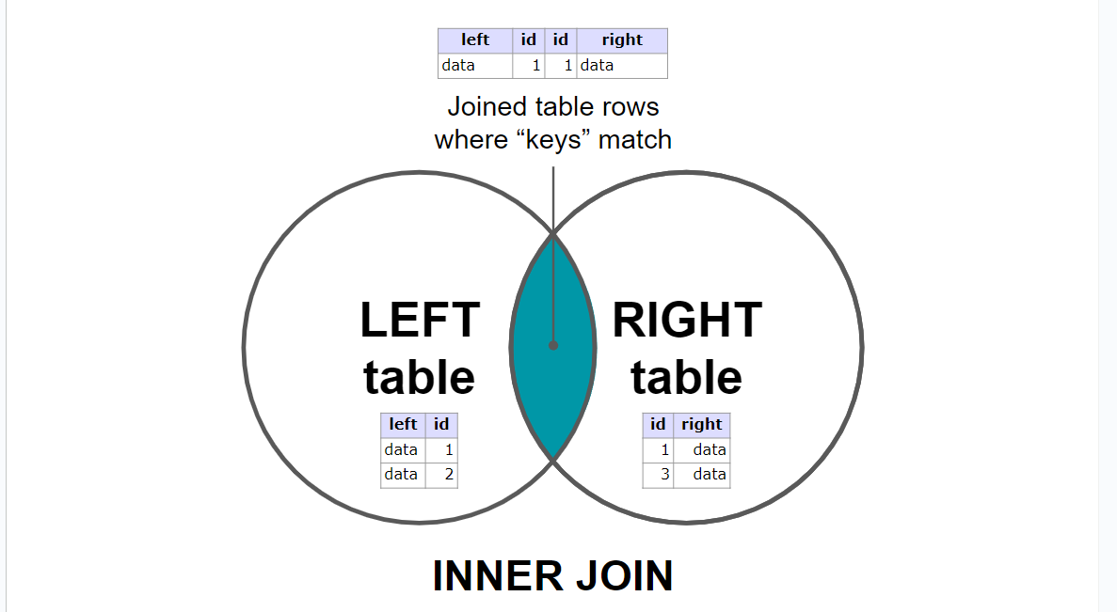

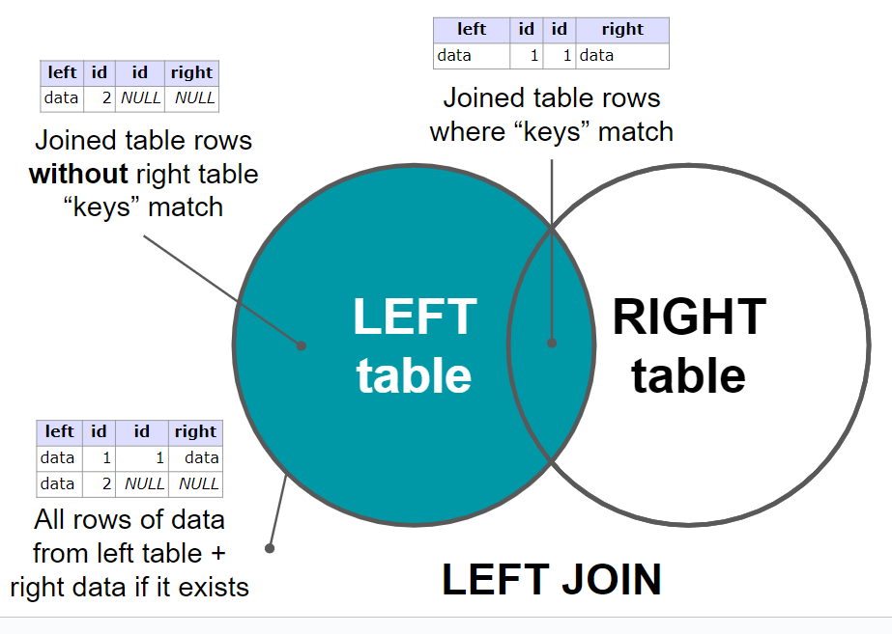

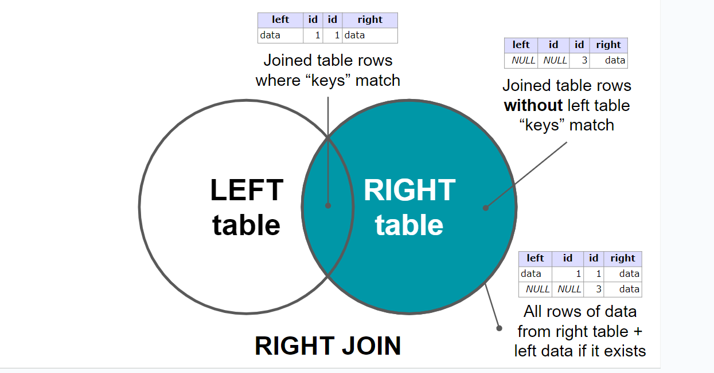

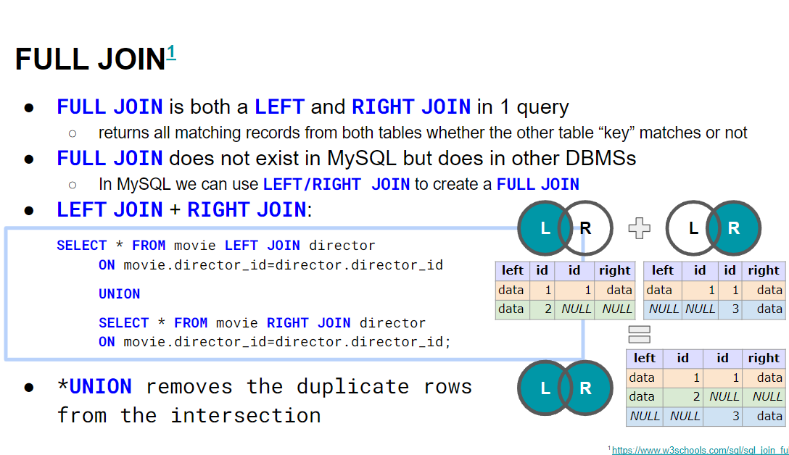

SELECT m.title, d.name FROM movie m INNER JOIN director d  
 ON m.director_id=d.director_id;

