Wireframing Relational Data

By Tashrif Radin Ali

Project idea

I would like to create a time capsule system which will store users’ pictures, messages, location and mood on a timeline. A user can come to the website and see all of their pictures, messages, location and mood as entries in a timeline, they can also edit these entries. They can also create a new timeline where they can add new entries to that timeline. A user can tag another user which would allow two users to share the same timeline where they can both on that timeline.

Relational Database

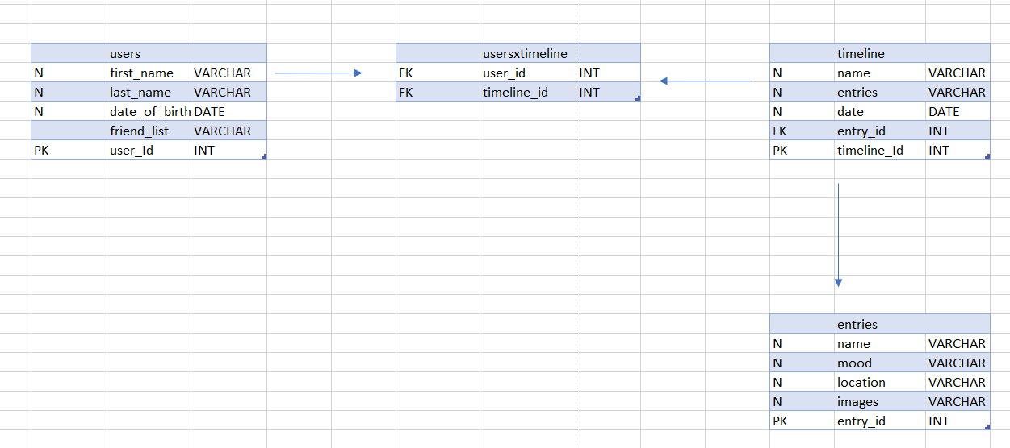

Fig 1: An entity relationship Users, Timelines and Entries

|  |  |  |  |
| --- | --- | --- | --- |
|  | User Entity | Timelines Entity | Entries Entity |
| User Entity | X | A user has many timelines | X |
| Timelines Entity | A timeline has many users | X | A timeline has may Entries |
| Entries Entity | X | An entry has one Timeline | X |

Fig 2: A table which verbalizes relationship between entities.

Wireframes

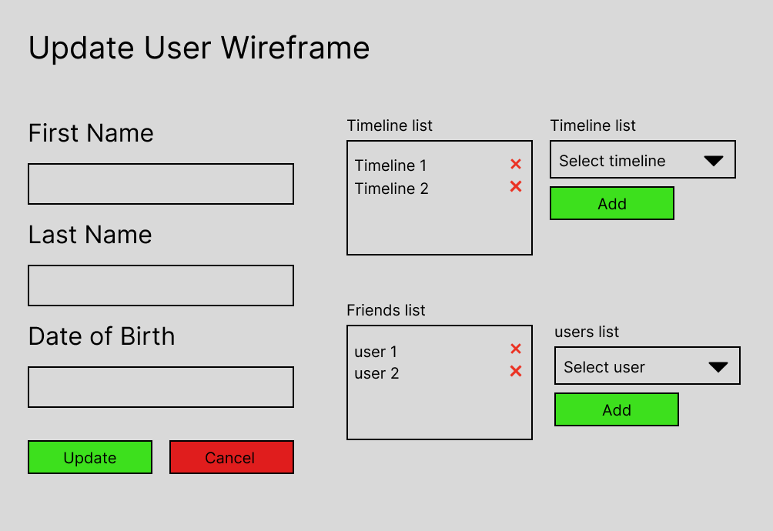

Fig 3: The figure above shows the wireframe to update user. A user can edit their first name, last name and date of birth. The user will be able to add new timelines and friends. When the user can select which friends can edit the timeline and its entries. To access the timeline double click on timeline you want to edit.

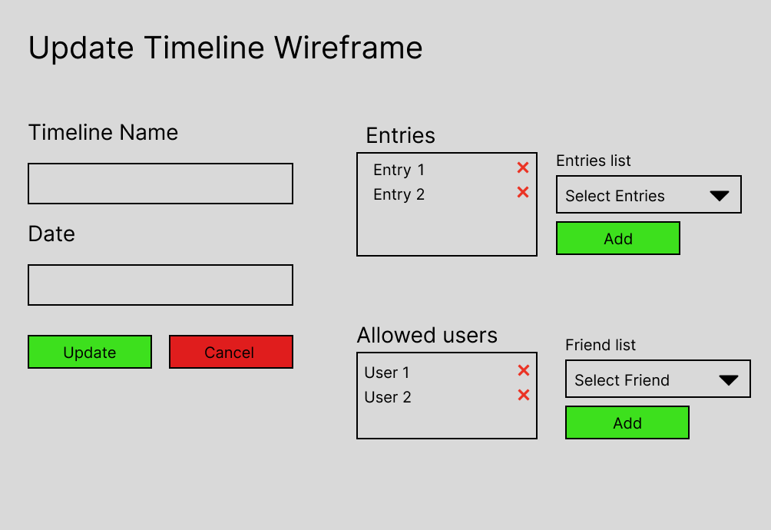

Fig 4: The figure above shows the wireframe to update the timeline. The user and allowed users can edit the timeline name, date and individual entries. The user can change who are allowed to edit on that timeline and its Entries. To access the entry double click on the entry to edit.

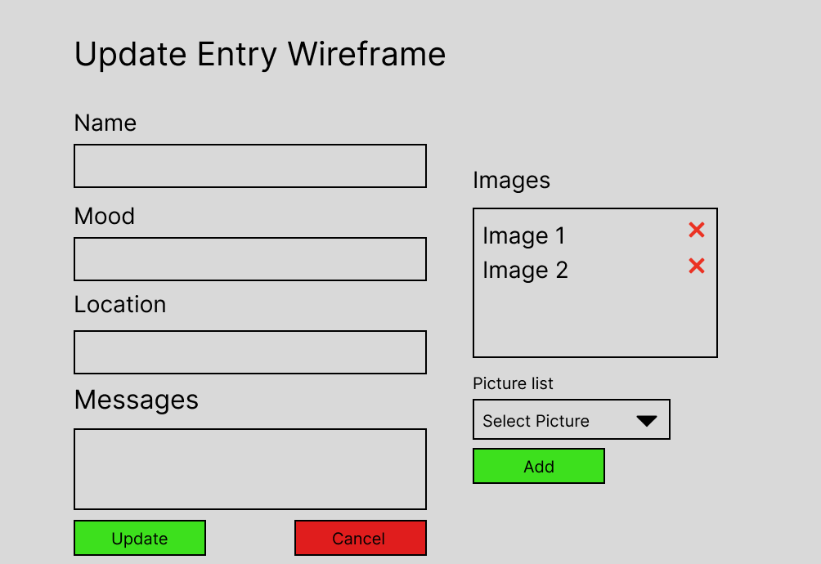

Fig 5: The figure above shows the wireframe to update Entry from timeline. Users can edit the name, mood, location, message and upload images of each entry.

Final notes on wireframes

These are the API methods could be used to implement the wireframes above

|  |  |  |
| --- | --- | --- |
| GET ListUsers | GET ListTimelines | GET ListEntries |
| GET FindUsers | GET FindTimelines | GET FindEntries |
| POST AddUsers | POST AddTimelines | POST AddEntries |
| DELETE DeleteUsers | DELETE DeleteTimelines | DELETE DeleteEntries |
| PUT UpdateUsers | PUT UpdateTimelines | PUT UpdateEntries |
| GET ListUsersForTimeline | GET ListTimelinesForEntries | GET ListEntriesForTimlines |
|  | GET ListTimelinesForUsers |  |
| POST AddTimlines | POST AddEntries | POST AddImages |
| POST AddFriends | POST AddAllowedUsers |  |
| DELETE RemoveTimlinesFromUser | DELETE DeleteEntriesFromTimelines | DELETE DeleteImagesFromEntries |
| DELETE RemoveFriendsFromUsers | DELETE DeleteAllowedUsersFromTimeline |  |