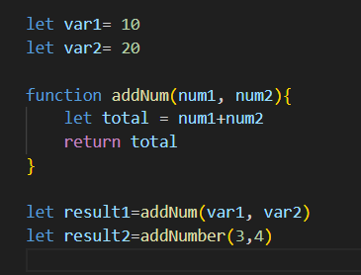

- Global Execution -> this
- Memory Phase
var1 => undefined
var2 => undefined
addNum =>definition
result1=> undefined
result2=>undefined
- Execution Phase
Var1 =>10
New variable environment
+ execution thread
Var2=>20
Add Num =>

