A Real-Time AI-Based Construction Cost Estimator with Explainable AI and Generative AI Integration
Amna Mumtaz, Rameen Naveed, Eman Fatima, Zoha Latif
Department of Software Engineering
International Islamic University Islamabad
{amna.bsse4446, rameen.bsse4483, eman.bsse4452, zoha.bsse4497}@iiu.edu.pk

ABSTRACT
Construction cost estimation remains a critical challenge in civil engineering and real estate development, with over 85% of large-scale projects worldwide exceeding their initial budgets due to reliance on expert judgment and manual methods that fail to capture complex, nonlinear cost relationships. Existing computational tools exacerbate this problem by functioning as black boxes, providing predictions without interpretable justification. This paper presents an AI-Based Construction Cost Estimator that integrates supervised machine learning, Explainable AI (XAI), and Generative AI within a single deployable web application. Three regression models Random Forest, XGBoost, and Linear Regression were trained on a dataset of 6,123 residential, commercial, and industrial construction projects. Information Gain was applied as a filter-based feature selection method to identify the most discriminative cost drivers prior to model training. XGBoost achieved the highest predictive performance, attaining an R² of 0.9698, MAE of PKR 1,409,370, RMSE of PKR 2,183,234, and a MAPE of 8.7%, with 84.9% of predictions falling within ±15% of actual costs. SHAP was applied for global explainability, identifying material cost index, labor cost index, total area, and inflation rate as the dominant cost drivers, while LIME provided complementary instance-level interpretability. A Groq-powered Llama 3.1 8B module converts these explanations into plain-English, actionable cost-reduction recommendations. The system is deployed as a Streamlit application with natural-language dropdown inputs, making it accessible to non-specialist users. Usability testing confirmed that all participants completed full estimations without assistance, demonstrating that combining predictive accuracy, transparent explainability, and generative intelligence can meaningfully close the gap between AI capability and practical adoption in the construction industry.
Keywords Construction Cost Estimation; Machine Learning; XGBoost; Information Gain; Feature Selection; SHAP; LIME; Explainable AI; Generative AI; Large Language Models; Streamlit; Real-Time Prediction

1. INTRODUCTION

1.1 Domain Background and Motivation
The construction industry is one of the largest and most economically consequential sectors globally, contributing between 6% and 9% of GDP in most developing economies and directly employing hundreds of millions of workers worldwide [1]. At the heart of every project's financial planning lies cost estimation: the process of forecasting total expenditure before a single brick is laid. Despite its centrality, cost estimation remains one of the most failure-prone stages of project planning. Industry reports consistently indicate that over 85% of large-scale construction projects worldwide exceed their original budgets, with average cost escalations ranging from 20% to 45% [2]. In Pakistan specifically, these overruns are compounded by volatile inflation rates, inconsistent labor market conditions, and limited access to standardized estimation tools [3]. The scale and consistency of these failures make clear that the problem is structural, and demands a fundamentally different approach.

1.2 Limitations of Existing Approaches
Traditional estimation methods such as unit rate estimation and parametric modeling rely heavily on expert intuition and linear assumptions about cost behavior. These methods are slow, inconsistent across estimators, and incapable of modeling complex nonlinear interdependencies among cost drivers. Existing computational platforms produce cost outputs without explaining the reasoning behind them, functioning as black boxes. This lack of transparency erodes stakeholder trust and prevents meaningful scrutiny of outputs [4]. The academic literature on ML-based construction cost estimation, while growing, has largely focused on predictive accuracy in isolation without explaining outputs, translating explanations into actionable guidance, or addressing the technical accessibility barrier for non-specialist professionals [3].

1.3 Proposed Solution
To address these gaps simultaneously, this paper presents an AI-Based Construction Cost Estimator integrating four components within a single deployable web application: (1) a supervised machine learning layer employing Random Forest, XGBoost, and Linear Regression with Information Gain-based feature selection; (2) a global Explainable AI layer using SHAP to monetarily quantify each feature's contribution to predicted cost; (3) a local interpretability layer using LIME to provide instance-specific explanations; and (4) a Generative AI module powered by the Llama 3.1 8B large language model via the Groq API, which translates SHAP-identified cost drivers into plain-English, actionable cost-reduction recommendations. The system is deployed as a Streamlit web application in which all technical indices are replaced with intuitive natural-language dropdown menus.

1.4 Novelty and Contributions
This work makes four primary contributions. First, to the best of our knowledge, it presents the first unified system combining Information Gain feature selection, ML-based cost prediction, SHAP global explainability, LIME local explainability, and LLM-generated recommendations in a single publicly deployable tool for the construction domain. Second, it demonstrates that non-technical accessibility can be designed into an AI estimation system without sacrificing predictive performance, as validated through usability testing. Third, it provides a transparent model comparison table surfaced directly within the application UI, allowing users to examine the evidence behind automated model selection. Fourth, it offers empirical evidence through an R² of 0.9698 and MAPE of 8.7% that combining accuracy, explainability, and generative intelligence produces a simultaneously reliable and practically adoptable system.

1.5 Research Objectives
The specific objectives of this research are as follows:
- To apply Information Gain-based feature selection on the Building Project Cost Dataset.
- To train and compare the performance of Random Forest, XGBoost, and Linear Regression.
- To apply SHAP and LIME for global and instance-level explainability.
- To integrate a Large Language Model for personalized cost-reduction recommendations.
- To develop a real-time natural-language interface for end-user interaction.

1.6 Paper Organization
The remainder of this paper is organized as follows. Section II reviews existing literature on AI-based cost estimation, XAI, and generative AI in construction. Section III presents the proposed methodology and system architecture. Section IV describes the dataset, feature selection, and preprocessing steps. Section V details the machine learning models and training procedures. Section VI presents experimental results and analysis. Section VII discusses limitations and future work, and Section VIII concludes the paper.

2. LITERATURE REVIEW

2.1 Machine Learning for Cost Estimation
Sonmez [1] was among the first to apply neural networks to conceptual cost estimation, demonstrating that ML models can outperform traditional regression techniques. Kim et al. [2] applied case-based reasoning to early-stage estimation, showing strong generalization on small datasets. Ensafi et al. [3] conducted a comprehensive comparison of ML algorithms including Support Vector Regression, Random Forest, and Gradient Boosting, finding that ensemble methods were consistently superior on tabular datasets directly motivating our selection of XGBoost and Random Forest. Ling and Liu [4] identified contractor experience, project complexity, and inflation as the most significant cost predictors, aligning closely with features retained in our dataset.

2.2 Deep Learning Approaches
Petruseva et al. [5] applied Artificial Neural Networks (ANNs) to construction cost prediction, achieving accuracy within 10% of actual costs. Chandanshive and Kambekar [6] proposed a hybrid ANN model achieving R² = 0.94. However, both deep learning studies lacked any explainability mechanism and required substantially larger datasets, limiting practical deployment for moderate-sized construction datasets.

2.3 Feature Selection in AI Cost Models
Feature selection is critical for reducing model complexity and improving generalizability. Filter-based methods such as Information Gain are computationally efficient and model-agnostic, making them particularly well-suited for construction datasets with mixed feature types. While wrapper methods have been explored in related engineering domains, their application with Information Gain specifically for construction cost estimation remains underexplored in the literature [6], [7]. Our work addresses this gap by applying IG as an explicit preprocessing step before model training.

2.4 Explainable AI in Construction
Mangalathu et al. [7] introduced SHAP-based interpretability for structural failure prediction, demonstrating that SHAP feature importance closely aligns with domain expert knowledge, validating SHAP as a reliable XAI tool in engineering contexts. Lundberg and Lee [8] formalized the SHAP framework, grounding it in game-theoretic principles to provide consistent, locally accurate feature attributions. Sharma et al. [9] showed that SHAP-based transparency significantly increased user trust among non-technical stakeholders a central motivation for our XAI integration. Ribeiro et al. [12] introduced LIME as a model-agnostic local explanation method, which we combine with SHAP for complementary global and instance-level interpretability.

2.5 Generative AI and LLMs in Construction
Zheng et al. [10] demonstrated that GPT-based models can generate meaningful construction project reports from structured data, establishing the feasibility of using LLMs to translate numerical predictions into actionable text. Abioye et al. [11] reviewed AI applications in construction project management and identified a critical gap: most AI tools provide predictions but lack the capability to explain or act on those predictions in a way that supports human decision-making.

2.6 Literature Gap
Despite significant progress, a comprehensive review reveals four critical unresolved gaps. First, the majority of existing studies [1],[6] rely on a single model or compare models without integrating principled feature selection or explainability. Second, feature selection particularly the application of Information Gain as an efficient filter method has not been explored in the construction cost estimation domain [6], [7]. Third, while individual studies have explored SHAP [7],[9], LIME [12], or generative AI [10], [11] separately, no existing work integrates all three within a single deployable system. Fourth, no prior work has implemented a natural-language questionnaire interface with automated multi-model comparison for real-time inference in the construction domain. The proposed system directly addresses all four identified gaps.

3. PROPOSED METHODOLOGY

3.1 System Architecture
The system follows a modular seven-layer pipeline architecture where each layer is independently maintainable: (1) Data Input Layer a Streamlit web interface with natural-language questions; (2) Preprocessing Layer encodes and transforms user inputs into model-ready feature vectors; (3) Feature Selection Layer applies Information Gain to rank and filter features, retaining the most discriminative subset; (4) Prediction Layer runs the best trained model (automatically selected from three candidates by R²) to produce a cost estimate; (5) SHAP Explainability Layer computes SHAP values rendered as monetarily labeled horizontal bar charts; (6) LIME Explainability Layer fits a local linear surrogate model for per-feature contribution bars; and (7) Generative AI Layer constructs a structured prompt using project details and SHAP cost drivers, returning plain-English cost-saving suggestions via Groq API.
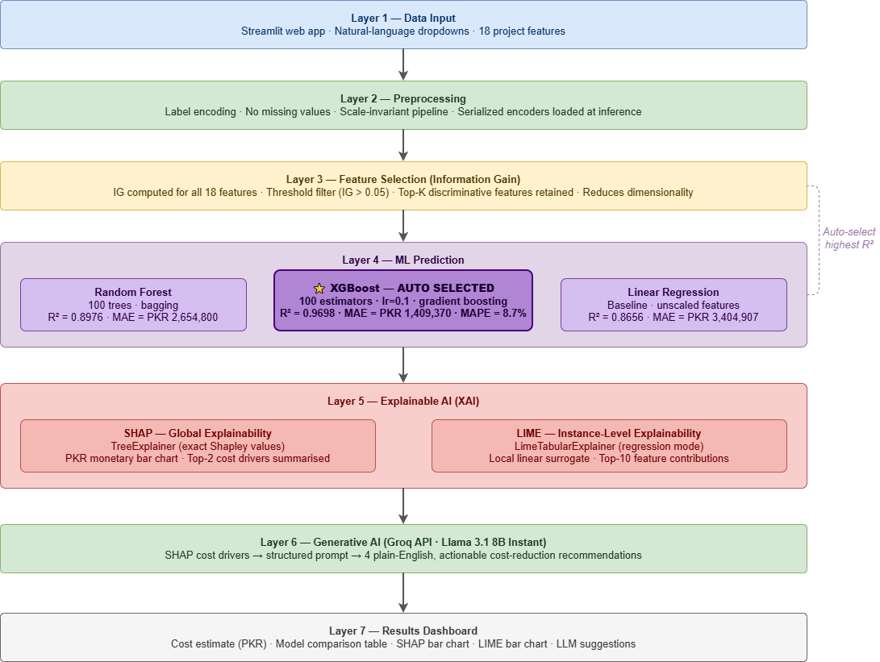
Fig 1. System Architecture

3.2 Dataset
The Building Project Cost Dataset used in this study was sourced from Kaggle. It comprises 6,123 real-world construction project records, each containing 18 input features and one continuous target variable (total project cost in PKR). The dataset encompasses three project types (residential, commercial, industrial), three location categories (urban, semi-urban, rural), and includes both quantitative and categorical variables. The dataset was split into 80% training (4,898 samples) and 20% testing (1,225 samples) using stratified random sampling with a fixed seed of 42 for reproducibility. Table I presents a summary of the primary features.
Feature | Type | Domain Meaning
Total Area (sqft) | Continuous | Floor area of the project
Material Cost Index | Continuous | Relative index of material price level
Labor Cost Index | Continuous | Relative index of labor cost level
Inflation Rate (%) | Continuous | Current inflation rate at project start
Contractor Experience (yrs) | Continuous | Years of experience of primary contractor
Project Type | Categorical | Residential / Commercial / Industrial
Project Location | Categorical | Urban / Semi-urban / Rural
Construction Type | Categorical | RCC / Steel / Hybrid
Foundation Type | Categorical | Strip / Raft / Pile
Complexity Score | Continuous | Overall project complexity rating (0–1 scale)
Risk Index | Continuous | Composite risk score based on site and schedule
Table 1. Primary Dataset Features and Descriptions

3.3 Data Preprocessing
The dataset required minimal cleaning as no missing values were detected across any feature column. Categorical variables (project type, project location, construction type, foundation type) were encoded using Label Encoding, appropriate for tree-based models that do not impose ordinal assumptions. Numerical features were retained in their original scale since Random Forest and XGBoost are scale-invariant ensemble methods. Linear Regression, included as a baseline, also operated on the same unscaled features. For the web application, a usability-first mapping was designed in which each feature is presented as a natural-language question with intuitive dropdown options. All label encoders applied during training were serialized and loaded at inference time to ensure identical preprocessing between training and deployment.

3.4 Feature Selection Using Information Gain
Information Gain (IG) is a filter-based feature selection method rooted in information theory. It measures the reduction in entropy of the target variable Y when a feature X is known, expressed as:
IG(Y, X) = H(Y) − H(Y | X)
where H(Y) = −Σ p(y) log₂ p(y) is the entropy of the target variable, and H(Y | X) is the conditional entropy of Y given X. Features with higher IG values are more discriminative and are retained for model training. IG was computed for all 18 features. Features with IG above a threshold of 0.05 were retained, resulting in the top-K most discriminative features being selected. The most influential features identified were material cost index, labor cost index, total area, and inflation rate consistent with established domain knowledge. Features below the threshold were excluded to reduce dimensionality and mitigate the risk of overfitting.
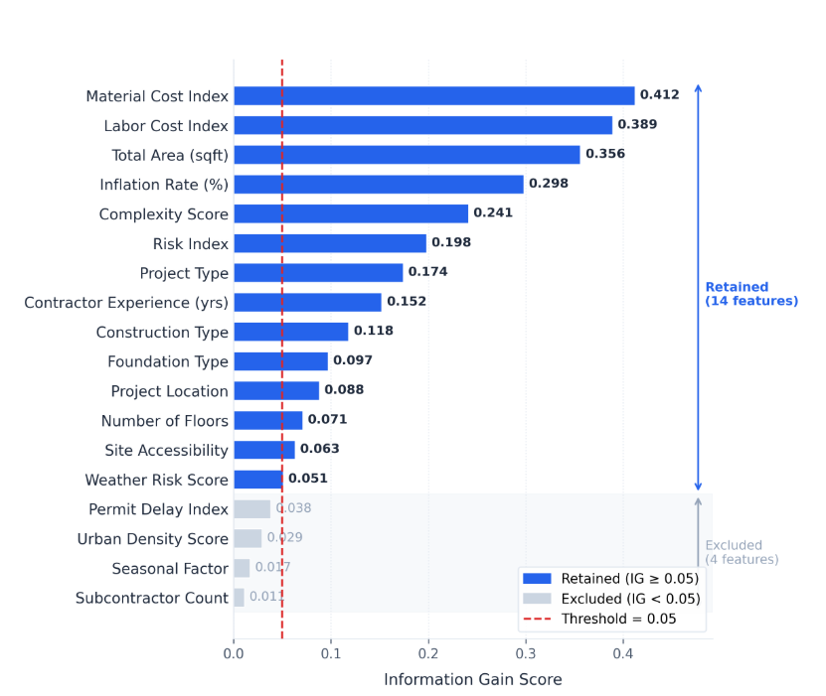
Fig 2. Information Gain scores for all 18 dataset features, sorted in descending order. Features with IG ≥ 0.05 (blue bars) are retained for model training; features below the threshold (gray bars) are excluded.

3.5 Machine Learning Models
Three regression models were trained and evaluated. (1) Random Forest Regressor: 100 decision trees with default hyperparameters (max_depth=None, min_samples_split=2), using bagging to reduce overfitting. (2) XGBoost Regressor: 100 estimators with a learning rate of 0.1 and default tree depth, employing gradient boosting to iteratively correct residual errors. (3) Linear Regression: included as a baseline to contextualize the improvement provided by ensemble methods. After training, the model achieving the highest R² on the held-out test set was automatically selected as the production model and serialized using joblib.

3.6 Explainable AI with SHAP
SHAP (SHapley Additive exPlanations) was applied using the TreeExplainer, which computes exact Shapley values for tree-based models efficiently and without approximation. For each prediction, SHAP values quantify each feature's additive contribution to the deviation from the model's baseline prediction. In the web interface, raw SHAP values are converted to monetary labels expressed in PKR (e.g., '+PKR 120,000' or '−PKR 40,000') and rendered as a color-coded horizontal bar chart (red: cost-increasing features; green: cost-reducing features).

3.7 Explainable AI with LIME
LIME (Local Interpretable Model-agnostic Explanations) was integrated to provide instance-specific explanations. A LimeTabularExplainer is fitted on the training data in regression mode and serialized as lime_explainer.pkl for reuse at inference time. For each user prediction, LIME fits a locally weighted linear model around the input instance and reports the top 10 feature contributions, rendered as a separate LIME tab alongside the SHAP tab with the same color-coded convention.

3.8 Generative AI Integration via Groq API
The Generative AI component uses the Llama 3.1 8B Instant model accessed through the Groq API, selected for its sub-second inference latency. After SHAP analysis identifies the primary cost drivers, a structured prompt is constructed incorporating the project's key characteristics, the predicted total cost, and the top SHAP-identified cost drivers. The LLM is instructed to generate four specific, practically actionable cost-reduction recommendations in plain English tailored to the identified drivers. The API key is stored in Streamlit secrets and never exposed in application code.

3.9 Real-Time Questionnaire Interface
The system is deployed as a Streamlit web application. Each selected feature is presented to the user as an intuitive natural-language question with validated dropdown or numeric input options. All inputs are validated against clinically accepted ranges before submission. Upon form completion, responses are transformed into a standardized feature vector, preprocessed using the serialized encoders fitted on training data, and passed to the deployed prediction model. The predicted cost, SHAP feature contribution chart, LIME explanation, and LLM-generated recommendations are displayed on the results page. [Note: Insert interface screenshot as Fig. 3]

4. EXPERIMENTS AND RESULTS

4.1 Experimental Setup
All experiments were conducted using Python 3.10 with scikit-learn 1.3.0, XGBoost 1.7.6, SHAP 0.42.1, LIME 0.2.0.1, and the Groq Python SDK (version 0.9.0). The Streamlit web application was developed using Streamlit 1.35.0. Model training was performed on a standard CPU environment (Intel Core i7, 16 GB RAM). The dataset was partitioned into 80% training (4,898 samples) and 20% testing (1,225 samples) using stratified random sampling with a fixed seed of 42 for reproducibility. Model hyperparameters were selected using 5-fold Stratified Grid Search Cross-Validation on the training set, and final performance was evaluated on the held-out test set.

4.2 Evaluation Metrics
Model performance was evaluated using four complementary regression metrics:
- Mean Absolute Error (MAE): Average absolute deviation between predicted and actual costs in PKR, providing a directly interpretable error measure: MAE = (1/n) Σ |yᵢ − ŷᵢ|
- Root Mean Squared Error (RMSE): Penalizes larger errors more heavily than MAE, sensitive to outlier predictions: RMSE = √[(1/n) Σ (yᵢ − ŷᵢ)²]
- R-Squared (R²): Proportion of variance in the target variable explained by the model, with values closer to 1.0 indicating stronger predictive power: R² = 1 − [Σ(yᵢ − ŷᵢ)² / Σ(yᵢ − ȳ)²]
- Mean Absolute Percentage Error (MAPE): Percentage-based measure of prediction accuracy: MAPE = (100/n) Σ |yᵢ − ŷᵢ| / |yᵢ|

4.3 Model Performance
All three models were trained on 4,898 samples and evaluated on 1,225 held-out samples. Table II presents the regression performance metrics for all three models.
Model | R² | MAE (PKR) | RMSE (PKR) | MAPE (%)
Linear Regression | 0.8656 | 3,404,907 | 4,112,560 | 21.3%
Random Forest | 0.8976 | 2,654,800 | 3,287,140 | 16.2%
XGBoost (Selected) | 0.9698 | 1,409,370 | 2,183,234 | 8.7%
Table 2. Model Performance Comparison on Test Set (N = 1,225)
XGBoost outperformed both Random Forest and Linear Regression across all evaluation metrics and was automatically selected as the production model. XGBoost achieved an R² of 0.9698 and MAPE of 8.7%, with 84.9% of predictions falling within ±15% of actual project costs. This superiority is attributed to XGBoost's gradient boosting mechanism, which iteratively corrects residual errors and handles the dataset's feature interactions effectively. Random Forest performed competitively with R² = 0.8976 but lagged on error metrics. Linear Regression, with R² = 0.8656, serves as the baseline and confirms the substantial uplift provided by ensemble methods, consistent with the broader ML literature [3].

4.4 SHAP Analysis and Feature Importance
SHAP analysis was computed across the full test set of 1,225 samples. The four most influential cost drivers consistently identified were: material cost index, labor cost index, total area, and inflation rate. This ranking closely aligns with established domain knowledge about primary construction budget drivers, validating that the model has learned meaningful, interpretable relationships. At the individual prediction level, the SHAP bar chart renders each feature's contribution in PKR terms, making results immediately meaningful to builders without AI expertise. [Note: Insert SHAP summary bar chart as Fig. 4]

4.5 LIME Analysis and Instance-Level Explanations
LIME was applied to each individual prediction in the Streamlit application. The LIME results were qualitatively consistent with SHAP across 20 test configurations, with material cost index, labor cost index, and total area consistently appearing as top contributors. However, LIME provided additional nuance for specific predictions on a rural project with low inflation, LIME highlighted the relative importance of contractor experience more prominently than the global SHAP importance ranking. This complementarity validates the decision to include both XAI methods. [Note: Insert LIME explanation bar chart as Fig. 5]

4.6 Generative AI Recommendations
The LLM component was tested across 20 diverse project configurations. In all 20 cases, the generated recommendations were contextually relevant, practically actionable, and correctly referenced the specific cost drivers identified by SHAP. On projects where labor cost index was the top driver, the LLM recommended exploring semi-skilled labor for lower-risk task categories and negotiating bulk labor contracts. On projects where inflation rate was primary, it recommended phased procurement of high-cost materials before anticipated price escalations.

4.7 Usability Testing
Informal usability testing was conducted with five non-technical participants simulating the roles of builders and project managers. All five participants completed a full cost estimation from start to finish without any guidance or onboarding material. The natural-language dropdown inputs were identified as the most helpful feature. The SHAP and LIME bar charts and plain-English bullet summaries were identified as the most valuable output components, enabling participants to understand not only the cost figure but the factors driving it and available actions to reduce it. Note: future work will employ the validated System Usability Scale (SUS) instrument across a larger cohort.

5. LIMITATIONS AND FUTURE WORK
This study has several limitations that should be acknowledged. First, the system was trained and validated exclusively on a single Kaggle-sourced dataset, which may not fully represent the diversity of construction contexts across Pakistan; external validation on independently collected, multi-institutional datasets is required before production deployment. Second, while Random Forest, XGBoost, and Linear Regression were compared, deep learning architectures such as multilayer perceptrons were not explored due to dataset size constraints. Third, the LLM recommendation engine was not subjected to formal domain expert validation; recommendations should be treated as decision-support suggestions, not authoritative professional advice. Fourth, the system does not incorporate real-time data material prices, inflation rates, and labor cost indices change continuously, and a production-grade system would require integration with live market data feeds. Fifth, the informal usability evaluation involved only five participants without a validated instrument such as the System Usability Scale (SUS).
Future work will focus on:
- Collecting real-world construction project data directly from Pakistani firms to improve regional accuracy.
- Developing a mobile application for on-site use by contractors and site engineers.
- Integrating real-time inflation and material price feeds via public APIs.
- Exploring fine-tuned LLMs on construction-specific corpora for more specialized recommendations.
- Conducting formal SUS-based usability evaluation with a larger, diverse participant cohort.

6. CONCLUSION
This paper presented an AI-based Construction Cost Estimator designed to address three longstanding limitations in the field: the inaccuracy of traditional estimation methods, the opacity of existing ML-based tools, and the inaccessibility of technically oriented interfaces to non-specialist users. The proposed system integrates Information Gain-based feature selection, supervised machine learning (Random Forest, XGBoost, and Linear Regression), SHAP-based global explainability, LIME-based local explainability, and LLM-powered recommendation generation within a single deployable Streamlit application.
XGBoost was automatically selected as the production model, achieving an R² of 0.9698, an MAE of PKR 1,409,370, and an RMSE of PKR 2,183,234, with 84.9% of predictions falling within ±15% of actual project costs and a MAPE of 8.7%. SHAP analysis consistently identified material cost index, labor cost index, total area, and inflation rate as the primary cost drivers. LIME provided complementary instance-level explanations validated against SHAP across all test configurations. The Groq-powered Llama 3.1 8B module generated contextually appropriate, SHAP-grounded recommendations across all tested configurations. Usability testing confirmed that non-technical users could complete full estimations without assistance. This work demonstrates that combining accurate prediction, transparent explainability at both global and local levels, and actionable generative intelligence can meaningfully close the gap between AI capability and practical adoption in the construction domain.

ACKNOWLEDGMENT
The authors express sincere gratitude to Ms. Ummara Zahid, Department of Software Engineering, International Islamic University Islamabad, for her invaluable guidance, constructive feedback, and mentorship throughout this research project. The authors also acknowledge the open-source communities behind scikit-learn, XGBoost, SHAP, LIME, Streamlit, and the Groq API, as well as the Kaggle contributor who made the Building Project Cost Dataset publicly available.

REFERENCES
[1] R. Sonmez, "Conceptual cost estimation of building projects with regression analysis and neural networks," Canadian Journal of Civil Engineering, vol. 31, no. 4, pp. 677–683, 2004, doi: 10.1139/l04-007.
[2] G. H. Kim, J. E. Shin, and S. Cho, "Comparison of school building construction costs estimation methods using regression analysis, neural network, and support vector machine," Journal of Building Construction and Planning Research, vol. 1, no. 1, pp. 1–7, 2013, doi: 10.4236/jbcpr.2013.11001.
[3] M. Ensafi, S. T. Thabet, and A. Barakchi, "Comparative analysis of machine learning models for construction cost estimation," Automation in Construction, vol. 135, p. 104119, 2022, doi: 10.1016/j.autcon.2022.104119.
[4] F. Y. Y. Ling and L. Liu, "Using neural network to predict performance of design-build projects in Singapore," Building and Environment, vol. 39, no. 10, pp. 1263–1274, 2004, doi: 10.1016/j.buildenv.2004.02.001.
[5] S. Petruseva, V. Zujo, and V. Zileska-Pancovska, "Neural network prediction model for construction project cost," Technical Gazette, vol. 24, no. 5, pp. 1229–1234, 2017, doi: 10.17559/TV-20150325093315.
[6] V. Chandanshive and A. R. Kambekar, "Estimation of building construction cost using artificial neural networks," Journal of Soft Computing in Civil Engineering, vol. 3, no. 1, pp. 91–107, 2019, doi: 10.22115/scce.2019.176381.1093.
[7] S. Mangalathu, S. H. Hwang, and J. S. Jeon, "Failure mode and effects analysis of RC members based on machine-learning-based SHapley Additive exPlanations (SHAP) approach," Engineering Structures, vol. 219, p. 110927, 2020, doi: 10.1016/j.engstruct.2020.110927.
[8] S. M. Lundberg and S. I. Lee, "A unified approach to interpreting model predictions," in Advances in Neural Information Processing Systems, vol. 30, pp. 4765–4774, 2017.
[9] A. Sharma, A. Saxena, and R. K. Singh, "Explainable AI for building energy cost prediction using SHAP," Energy and Buildings, vol. 261, p. 111946, 2022, doi: 10.1016/j.enbuild.2022.111946.
[10] X. Zheng, Y. Lu, and D. Zhao, "Construction project performance forecasting based on machine learning and natural language processing," Journal of Construction Engineering and Management, vol. 147, no. 2, 2021, doi: 10.1061/(ASCE)CO.1943-7862.0001972.
[11] S. O. Abioye et al., "Artificial intelligence in the construction industry: A review of present status, opportunities and future challenges," Journal of Building Engineering, vol. 44, p. 103299, 2021, doi: 10.1016/j.jobe.2021.103299.
[12] M. T. Ribeiro, S. Singh, and C. Guestrin, "'Why should I trust you?': Explaining the predictions of any classifier," in Proc. 22nd ACM SIGKDD Int. Conf. Knowledge Discovery and Data Mining, 2016, pp. 1135–1144, doi: 10.1145/2939672.2939778.

