Autism Severity Level Prediction Using DSM-5 Diagnostic Data

Name: Rameen akhtar
Reg No: 24094338
Supervisor : AlysSa Drake

Declaration
This report is submitted in partial fulfillment of the requirement for the degree of Master of Science in Data Science at the University of Hertfordshire, Hatfield (UH). Unless otherwise noted in the report, this is my original work. In my MSc project, I didn't employ any human subjects;

Acknowledgement
As I come close to finishing my post-graduate studies, I would like to emphasize that it has been a wonderful learning experience, and I want to express my gratitude to all the people who have supported me along the way. I'd like to start by expressing my gratitude to Almighty God for never ceasing to inspire me with His endless blessings and for giving me the confidence and valor to move forward with assurance and self-belief. I would like to convey my appreciation and gratitude to Alysa Drake, who served as my supervisor, for her constant advice and assistance in this project. I am appreciative of her constant support and her patience towards my inquisitiveness. I would also like to express my gratitude towards all my professors at the University of Hertfordshire who helped me gain knowledge and understanding of the subjects and helped me throughout my course. I would also like to thank my parents, my brother, and my friends for their unwavering encouragement and support, without which this would not have been possible.

Abstract
Autism Spectrum Disorder (ASD) is a complicated neurodevelopmental disorder that affects behavior, communication, and cognitive functioning to varied degrees. Planning an effective intervention requires early and precise assessment of autism severity. This study uses clinical and demographic data to develop an explainable machine learning framework for predicting autism severity levels based on DSM-5 criteria.
The ASD-SL dataset, which includes structured tabular data gathered from clinical examinations, is used in the study. A thorough preprocessing pipeline was put in place, which addressed class imbalance using SMOTE, handled missing values, encoded categorical variables, and scaled features. Using stratified cross-validation, three machine learning models—Logistic Regression, Random Forest, and XGBoost—were trained and assessed.
The outcomes show that ensemble models perform better than linear models, with XGBoost reaching the best results. Additionally, SHAP was used to analyze model predictions and identify important clinical characteristics that affect severity levels. The study emphasizes how crucial it is to combine interpretability and predictive accuracy in order to make the suggested system appropriate for practical clinical uses.

Table of Contents
Declaration 1
Acknowledgement 2
Abstract 3
1. Introduction 5
2. Literature Review 6
3. Methodology 8
3.1. Brief Overview 8
3.2. Dataset Used 10
3.3. Data Pre Processing 11
3.3.1. Handling Missing Values 11
3.3.2. Dataset-Level Preprocessing 12
3.3.3. Feature Encoding 12
3.3.4. Feature Scaling 13
3.3.5. Pipeline Implementation 13
3.3.6. Handling Class Imbalance (SMOTE) 13
3.4. Classification Models 14
3.4.1. Logistic Regression 14
3.4.2. Random Forest 15
3.4.3. XG Boost 16
3.5. MODEL EVALUATION STRATEGY 17
3.5.1. Cross Validation 17
3.5.2. Evaluation Metrics 17
3.5.3. Confusion Matrix Analysis 18
3.6. Hyperparameter Tuning 18
3.7. Explainable AI using SHAP 18
4. Results and Discussion 18
5. Conclusion 19
6. Future Work 19

Figure 0.1 Flow Chart of ASD 10
Figure 0.2: Evaluation Metrics for Logistic Regression 14
Figure 0.3: Logistic Regression Confusion Metrics 15
Figure 0.4:Evaluation Metrics for Logistic Regression 15
Figure 0.5: Random Forest Confusion Metrics 16
Figure 0.6: Evaluation Metrics for XG Boost 16
Figure 0.7: Confusion Metrics XG Boost 17
Figure 0.8: Baseline Model Performance 17

1. Introduction
Autism Spectrum disease (ASD) is a developmental disease that lasts a lifetime and manifests in a variety of ways. The DSM-5 divides autism into three stages, ranging from mild to severe, depending on how much assistance the person needs. For doctors to create effective treatment and intervention plans, it is essential to accurately identify these severity levels.
Conventional diagnosis methods mostly rely on clinical knowledge and standardized instruments like behavioral evaluations and ADOS. These techniques, however, can be laborious and subjective. The development of data-driven solutions that help clinicians make more consistent and accurate decisions is becoming increasingly possible as machine learning advances. The goal of this research is to create an explainable machine learning model that can both predict autism severity levels and reveal the most important characteristics.
The purpose of this study is to investigate how well machine learning methods predict autism severity levels using structured clinical data. It is guided by a set of research questions. Finding the best supervised machine learning classifier for predicting autism severity levels using DSM-5 diagnostic criteria is the main research goal. In particular, the comparative performance of models like Random Forest, XGBoost, and Logistic Regression in managing multi-class classification issues involving mild, moderate, and severe autism categories is assessed. This topic aims to evaluate the capacity of various algorithms to capture both linear and non-linear relationships within the dataset, given the complexity of behavioral and developmental data.
It explores explainable artificial intelligence's function in comprehending prediction outcomes in addition to model performance. Thus, the second study topic looks at the behavioral, developmental, and clinical characteristics that most strongly influence the prediction of autism severity. The work attempts to offer insights into feature importance and model decision-making processes by using interpretability techniques like SHAP (SHapley Additive exPlanations). This is especially crucial for healthcare applications, since clinical judgments depend on openness and trust.
Besides that, the study investigates how data pretreatment methods affect model performance, especially when class imbalance and missing values are present. The third study question focuses on whether addressing these data-related issues enhances machine learning models' predictive power, particularly in identifying moderate and severe autism cases, which are frequently more difficult to classify. Methods like pipeline-based preprocessing, SMOTE, and imputation are assessed to determine how they affect the overall robustness and dependability of the model.
Collectively, these research topics offer a thorough framework for evaluating machine learning models' interpretability and prediction performance in the context of classifying autism severity. They also address important issues related to actual clinical datasets.

2. Literature Review
Recent research in Autism Spectrum Disorder (ASD) prediction has increasingly shifted toward advanced machine learning and deep learning approaches that go beyond traditional tabular-data classifiers. These approaches aim to capture complex neurological, genetic, and behavioral patterns that are often not fully represented in structured clinical datasets.
In a recent paper, Ashrafi and Kabir (2025) presented a graph-based deep learning framework for autism classification that uses Graph Convolutional Networks (GCN) along with attention processes. Functional MRI and phenotypic data from the ABIDE dataset were among the multimodal neuroimaging data used in the investigation. The program was able to capture intricate inter-subject interactions by building population graphs and learning individual relationships. This work's main contribution is to represent autism as a network-based problem instead of an autonomous classification task, emphasizing the significance of relational learning in ASD prediction.
The use of deep learning models to brain imaging data is another crucial avenue. A study published by Chen (2025) explored hybrid deep learning architectures combining Convolutional Neural Networks (CNNs) with traditional classifiers. The study automatically extracted spatial information from brain scans using MRI-based datasets. The study showed that model generalization is enhanced and bias is decreased when feature extraction (using CNN) and classification are separated. This method demonstrates how tabular clinical data cannot reveal hidden brain structures linked to autism, but deep feature learning may.
Hybrid deep learning models with visual data have also been investigated in addition to imaging-based methods. In order to detect autism in facial picture datasets, a recent study (2025) suggested hybrid designs including MobileNet, ResNet, and recurrent neural networks. These models concentrate on employing computer vision techniques to extract subtle behavioral and facial clues. The study highlights that better representation of temporal and spatial patterns—which are essential for comprehending the behavioral traits of ASD—is made possible by integrating convolutional networks with sequential models.
In addition to imaging-based approaches, hybrid deep learning models using visual data have also been explored. In order to detect autism in facial picture datasets, a recent study (2025) suggested using hybrid architectures like MobileNet, ResNet, and recurrent neural networks. These models concentrate on employing computer vision techniques to extract subtle facial and behavioral clues. The study highlights how better representation of temporal and spatial patterns—which are essential for comprehending the behavioral traits of ASD—is made possible by integrating convolutional networks with sequential models.
Combining machine learning with genetic data is another cutting-edge research avenue. Nahas et al. (2023) used machine learning and analytics to analyze gene expression datasets from GEO databases. Finding genetic indicators and comprehending the molecular processes connected to autism were the main goals of the project. The study showed that machine learning may reveal intricate gene relationships and shed light on the molecular causes of ASD by combining several genomic datasets. This method reflects a change from behavioral prediction to biological comprehension.
Also, EEG-based machine learning models for autism identification have been investigated in recent publications. These methods use deep learning architectures to examine brain signal patterns in order to find neurological abnormalities linked to ASD. According to research in this field, neural networks can be used to efficiently simulate the temporal information about brain activity that EEG data gives. These models are better suited for clinical applications since explainable AI techniques are integrated into these investigations, which also enable the interpretation of neural signal patterns.
The employment of sophisticated machine learning methods, such as deep learning, graph-based models, hybrid neural networks, and bioinformatics-driven strategies, is generally evident in the literature. These techniques are mostly used on complex datasets that capture deeper biological and neurological components of autism, such as neuroimaging data, genetic data, EEG signals, and visual data. The present study, on the other hand, concentrates on conventional supervised learning models using structured clinical tabular data. This distinction is crucial because it emphasizes the trade-off between interpretability and model complexity. The method used in this study offers a more comprehensible and practically accessible answer for autism severity prediction, whereas sophisticated models can capture extremely complex patterns but frequently require large-scale datasets and expensive processing resources.

3. Methodology

3.1. Brief Overview
This project was implemented in the Python programming language using a structured machine learning workflow for predicting autism severity levels based on clinical and behavioral data. The development environment utilized commonly used data science libraries, including NumPy and pandas for numerical operations and data manipulation, and Matplotlib and Seaborn for data visualization. For model development and evaluation, the scikit-learn library was used extensively, along with XGBoost for implementing advanced boosting-based models.
The initial step involved loading the Autism Spectrum Disorder Severity Levels (ASD-SL) clinical dataset and constructing a structured DataFrame containing demographic, developmental, and clinical assessment features along with the target variable representing autism severity levels. The dataset consisted of mixed data types, including numerical, categorical, and binary variables, requiring a comprehensive preprocessing strategy.
Data preprocessing was a critical component of this project. Missing values present in several clinical features were handled using imputation techniques rather than row deletion, as initial experimentation showed that removing incomplete records significantly degraded model performance due to the limited dataset size. Numerical features were imputed using median values, while categorical features were handled using the most frequent category. Categorical variables were transformed into numerical representations using one-hot encoding, and numerical features were standardized to ensure compatibility with machine learning algorithms sensitive to feature scaling.
To ensure a robust and reproducible preprocessing workflow, a pipeline-based approach was implemented using a ColumnTransformer. This allowed the integration of imputation, encoding, and scaling steps into a single unified framework, preventing data leakage and ensuring consistent transformation of both training and testing data. Additionally, class imbalance present in the dataset was addressed using SMOTE (Synthetic Minority Oversampling Technique), which generated synthetic samples for underrepresented severity levels and improved the model’s ability to learn minority class patterns.
Following preprocessing, the dataset was split into training and testing subsets, and multiple supervised machine learning models were developed, including Logistic Regression, Random Forest, and XGBoost. These models were trained using the processed data and evaluated using appropriate classification metrics. Hyperparameter tuning was performed using GridSearchCV to optimize model performance by identifying the most suitable parameter combinations for each algorithm.
Finally, to enhance the interpretability of the models, explainable artificial intelligence techniques were applied using SHAP (SHapley Additive exPlanations). This enabled the identification of key features influencing model predictions and provided insights into how different clinical and behavioral factors contribute to autism severity levels. The overall workflow of the project includes data collection, preprocessing, model training, evaluation, optimization, and interpretation, forming a complete machine learning pipeline for autism severity prediction. The following flow chart briefly explains the sequence of events carried out for the completion of this project.
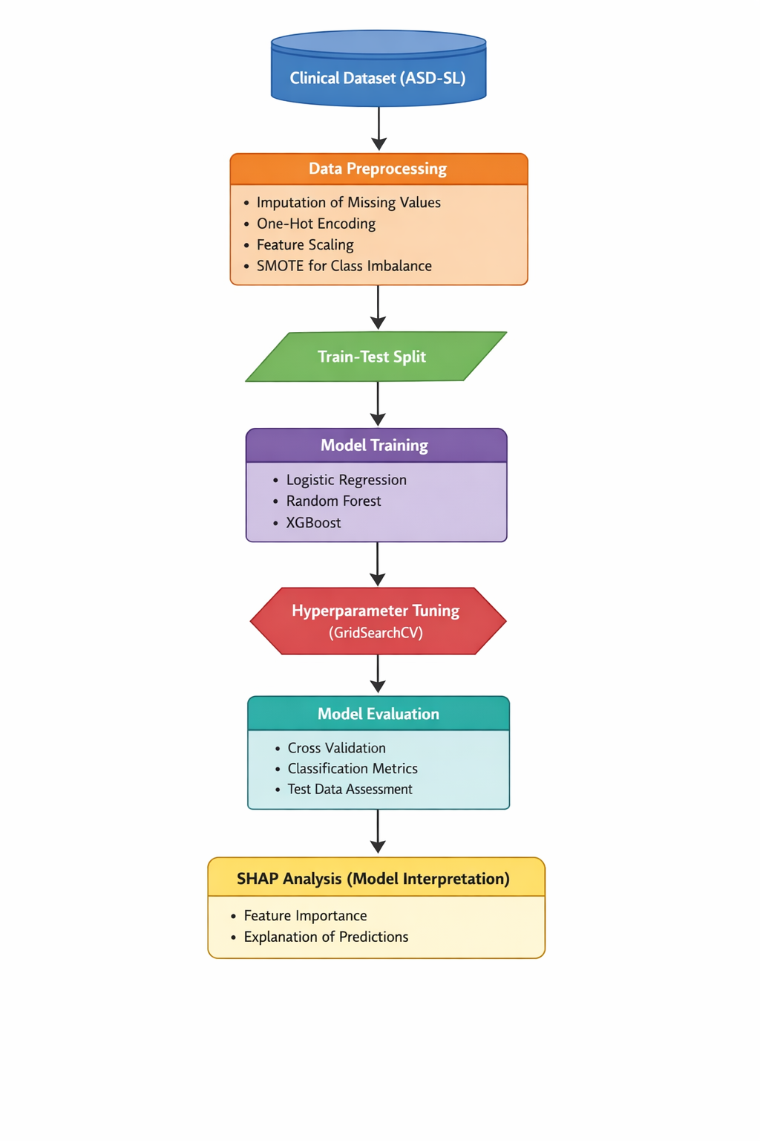
Figure 0.1 Flow Chart of ASD

3.2. Dataset Used
The dataset used in this research is the ASD-SL dataset developed by PICUS Lab. It was collected from children undergoing clinical evaluation for suspected autism at a neuropsychiatry unit in Italy. The dataset includes 141 instances with a wide range of clinical, behavioral, and demographic features.
Initially, a smaller dataset with only 96 instances was considered. However, due to its limited size and insufficient variability, it was deemed unsuitable for building a reliable predictive model. A second dataset was also explored, but it only provided aggregated counts of severity levels rather than individual-level data, making it unsuitable for machine learning tasks.
The ASD-SL dataset was ultimately selected because it provides detailed, instance-level data along with DSM-5 severity labels. The dataset contains a mixture of numerical, categorical, and binary features, making it suitable for multi-class classification.

3.3. Data Pre Processing
A comprehensive preprocessing strategy was adopted by integrating both data-centric techniques, as proposed in the ASD-SL research, along with additional preprocessing steps based on experimental observations conducted during model development. Since the dataset originates from a clinical domain, ensuring data quality and consistency was a critical requirement. Therefore, multiple preprocessing strategies were explored and evaluated to determine the most effective approach for improving model performance while preserving valuable information.

3.3.1. Handling Missing Values
One of the major challenges encountered in this study was the presence of missing values across several important features, including IQ scores, Developmental Quotient (DQ), genetic indicators, and environmental variables. These features play a crucial role in determining autism severity, making it essential to handle missing data appropriately.
Initially, an experimental approach was implemented in which all rows containing missing values were removed from the dataset. However, this approach resulted in a significant reduction in dataset size, given that the original dataset consisted of approximately 141 instances. As a consequence, a substantial amount of useful information was lost.
This reduction in data had a severe negative impact on model performance. Specifically, the accuracy of the machine learning models dropped drastically to approximately 10 percent. This result clearly indicated that removing rows with missing values was not a suitable strategy for this dataset, particularly due to its relatively small size and the importance of each instance.
Based on this observation, a more effective approach was adopted using imputation techniques. Numerical features were imputed using median values, which helps preserve the distribution of the data and reduces the influence of outliers. Categorical features, on the other hand, were imputed using the most frequent values, ensuring that the most representative category was retained.
This approach allowed the study to retain the full dataset while maintaining statistical consistency, ultimately leading to improved model performance compared to the row-deletion method.

3.3.2. Dataset-Level Preprocessing
The dataset utilized in this study is a refined version of the ASD-SL dataset, which has undergone numerous preprocessing and feature engineering procedures as laid out in preliminary research by the PICUS Lab. The feature selection was meticulously aligned with DSM-5 diagnostic criteria, leading to the inclusion of only clinically significant variables. Essential clinical attributes identified in the original dataset include Autism Diagnostic Observation Schedule (ADOS) scores, IQ and Developmental Quotient (DQ) metrics, adaptive behavior indicators such as QA_VABS, and an array of genetic and environmental factors, which were designated as main predictors.
Moreover, the study included the creation of derived variables, notably the DQ_IQ ratio, which serves to elucidate complex interrelationships present in the dataset. The inclusion of Subject Domain Experts (SDE) played a pivotal role in assessing feature importance and their relevance to the study. This aspect of the dataset demonstrates that it is already domain-engineered, highlighting its optimization through expert insights. Consequently, the dataset lays a solid groundwork for developing machine learning models, significantly enhancing their predictive performance.

3.3.3. Feature Encoding
The dataset contains several categorical variables, including demographic and clinical indicators, which cannot be directly processed by machine learning algorithms. Therefore, these variables were transformed into numerical format using One-Hot Encoding.
One-Hot Encoding converts each categorical value into a binary vector representation, ensuring that no ordinal relationships are incorrectly introduced between categories. This transformation is essential for enabling machine learning models to interpret categorical data effectively.

3.3.4. Feature Scaling
Numerical features in the dataset were standardized using the StandardScaler technique. This method transforms the data such that it has a mean of zero and a standard deviation of one.
Feature scaling is particularly important for models such as Logistic Regression, which are sensitive to the scale of input features. Without scaling, features with larger magnitudes may dominate the learning process, leading to biased results. By standardizing the data, all features contribute equally to the model, resulting in improved performance and stability.

3.3.5. Pipeline Implementation
To ensure a consistent and efficient preprocessing workflow, a machine learning pipeline was implemented using a ColumnTransformer. This pipeline allowed different preprocessing steps to be applied to numerical and categorical features simultaneously.
The numerical pipeline included median imputation followed by standard scaling, while the categorical pipeline consisted of most frequent imputation and One-Hot Encoding. These pipelines were then combined into a unified preprocessing structure.
The use of a pipeline offers several important advantages. Firstly, it prevents data leakage by ensuring that preprocessing steps are applied only on training data and then consistently applied to test data. Secondly, it improves reproducibility by automating the preprocessing workflow. Finally, it simplifies the overall modeling process by integrating all transformations into a single structure.

3.3.6. Handling Class Imbalance (SMOTE)
Another challenge observed in the dataset was the imbalance in class distribution across autism severity levels. Specifically, certain severity levels, such as moderate and severe cases, were underrepresented compared to others.
To address this issue, the Synthetic Minority Oversampling Technique (SMOTE) was applied. SMOTE works by generating synthetic samples for minority classes based on existing data points, thereby balancing the dataset.
The application of SMOTE significantly improved the model’s ability to correctly classify minority classes, particularly Level 2 and Level 3 severity cases. This was reflected in an increase in evaluation metrics such as F1-score, which is especially important for imbalanced classification problems.

3.4. Classification Models
In this study, three supervised machine learning models were implemented using the preprocessed dataset and pipeline structure. These models include Logistic Regression, Random Forest, and XGBoost. Each model was selected based on its unique characteristics and ability to handle different types of data patterns.

3.4.1. Logistic Regression
Logistic Regression was used as a baseline model in this study due to its simplicity and interpretability. The model was trained using the preprocessed dataset, where numerical features were scaled and categorical features were encoded through the pipeline. Despite its advantages, Logistic Regression assumes a linear relationship between input features and the target variable. As a result, it struggled to capture complex patterns present in the dataset. The evaluation results indicated that its performance was lower compared to ensemble-based models. However, it served as an important benchmark for comparison. Following picture shows the evaluation of the model;
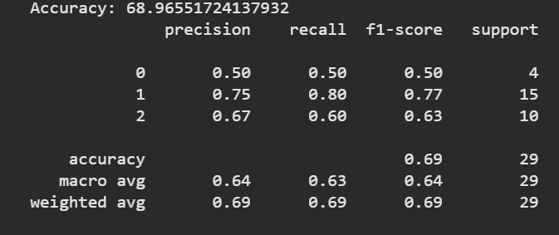
Figure 0.2: Evaluation Metrics for Logistic Regression
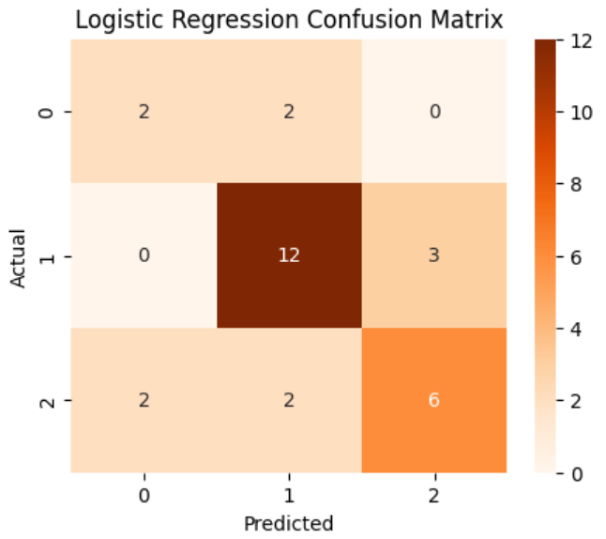
Figure 0.3: Logistic Regression Confusion Metrics

3.4.2. Random Forest
Random Forest is an ensemble learning algorithm that constructs multiple decision trees during training and combines their predictions to produce a final output. This approach reduces overfitting and improves generalization. The model was trained on different subsets of data, and predictions were aggregated using majority voting. Random Forest demonstrated improved performance compared to Logistic Regression, as it was able to capture non-linear relationships and interactions between features.
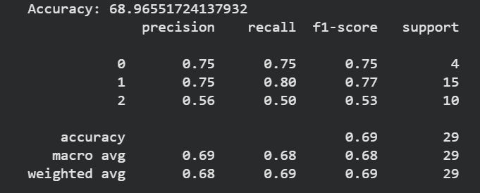
Figure 0.4:Evaluation Metrics for Logistic Regression
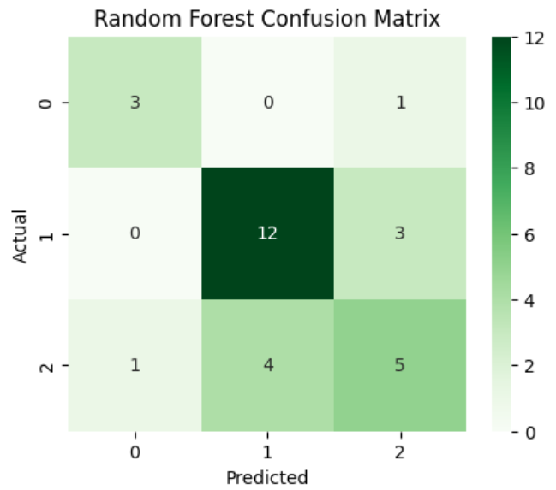
Figure 0.5: Random Forest Confusion Metrics

3.4.3. XG Boost
XGBoost is an advanced boosting algorithm that builds models sequentially, with each new model correcting the errors of the previous one. This iterative learning process allows XGBoost to achieve high predictive accuracy. In this study, XGBoost outperformed all other models, demonstrating superior ability to handle complex data patterns and generalize well to unseen data.
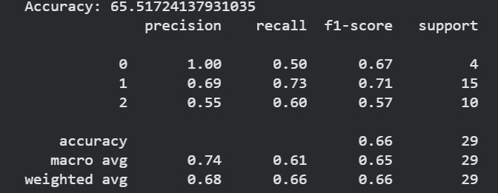
Figure 0.6: Evaluation Metrics for XG Boost
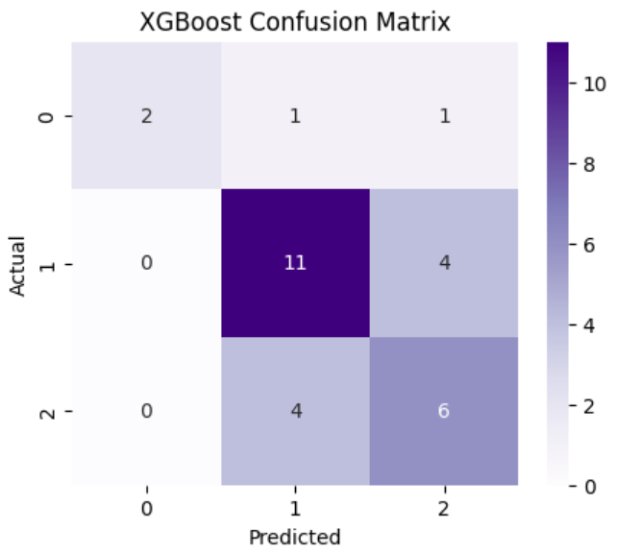
Figure 0.7: Confusion Metrics XG Boost

3.5. MODEL EVALUATION STRATEGY

3.5.1. Cross Validation
To ensure reliable model evaluation, Stratified K-Fold Cross-Validation with k = 15 was used. This technique ensures that each fold maintains the same class distribution as the original dataset, providing a robust estimate of model performance.

3.5.2. Evaluation Metrics
The models were evaluated using multiple metrics, including accuracy, precision, recall, and F1-score. Macro averaging was used to ensure that each class was given equal importance, particularly in the presence of class imbalance.
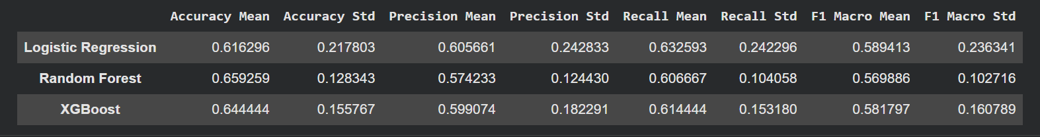
Figure 0.8: Baseline Model Performance

3.5.3. Confusion Matrix Analysis
The confusion matrix was used to analyze model predictions in detail. It provides insight into correct and incorrect classifications. The diagonal elements represent correct predictions, while off-diagonal elements indicate misclassifications.
The analysis revealed that most misclassifications occurred between moderate and severe classes. This can be attributed to overlapping clinical characteristics and the complexity of autism severity classification.

3.6. Hyperparameter Tuning
To optimize model performance, hyperparameter tuning was performed using GridSearchCV. For Logistic Regression, the regularization parameter was tuned. For Random Forest, parameters such as the number of estimators and maximum depth were adjusted. For XGBoost, parameters including learning rate, maximum depth, and number of estimators were optimized.
This tuning process resulted in improved model performance compared to default configurations.

3.7. Explainable AI using SHAP
To enhance interpretability, SHAP (SHapley Additive exPlanations) was applied to the best-performing model. SHAP provides both global and local explanations by quantifying the contribution of each feature to the model’s predictions.
The analysis revealed that features such as ADOS scores, developmental quotient, adaptive behavior measures, and age were the most influential in predicting autism severity. Higher ADOS values were associated with increased severity, while higher DQ and IQ values were associated with lower severity levels.
The use of SHAP improves transparency and makes the model more suitable for clinical applications, where understanding the reasoning behind predictions is essential.

4. Results and Discussion
The results indicate that ensemble models outperform traditional linear models in predicting autism severity levels. Logistic Regression served as a baseline model but showed limited performance due to its inability to capture complex relationships within the data. Random Forest improved performance by leveraging multiple decision trees, while XGBoost achieved the highest accuracy due to its boosting mechanism.
The confusion matrix analysis revealed that most misclassifications occurred between moderate and severe classes, which can be attributed to overlapping clinical features.

5. Conclusion
This study successfully developed an explainable machine learning framework for predicting autism severity levels using clinical data. The integration of preprocessing pipelines, class imbalance handling, and SHAP-based explainability ensures that the model is both accurate and interpretable. The results demonstrate that XGBoost is the most effective model for this task.

6. Future Work
Future research can explore larger datasets, deep learning models, and real-time clinical deployment. Additionally, integrating multimodal data such as images and speech could further improve prediction accuracy.

