

Name : rameen Akhtar
Reg no : bse193107
Section : 02
Date : April 4, 2022
Course : WEB ENGINEERING

Assignment # 01

Submitted to :
SIR MUHAMMAD HAMMAD

Capital university of science
And technology

LAYOUT PAGE:
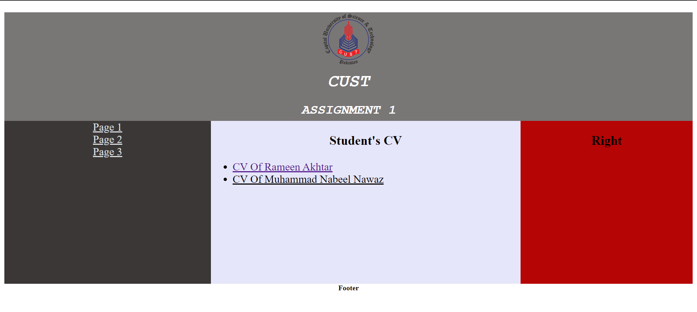
PAGE 1:

PAGE 2:

PAGE 3:


CV OF RAMEEN AKHTAR:
