Submitted By:
Rameen Ezwa Janjua F2024376149
Noor Sidra F2024376144
Submitted To:
Prof. Muhammad Maaz Waseem
Project:
(Milestone 2)
Smart Parking Management System

Query Suite:

- FILTERING QUERIES:
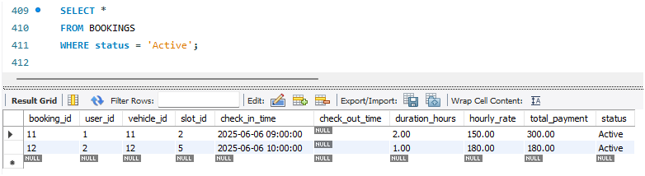

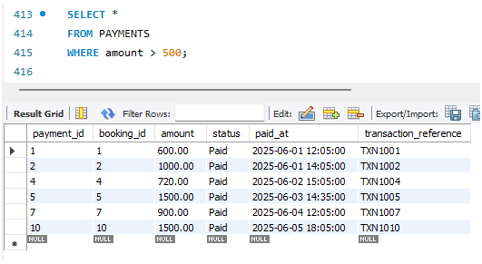
Brief Description:
  - Shows all booking records where status is Active.
Works by filtering rows using WHERE condition.
  - Shows only those payments where amount is greater than 500.
Filters data based on condition.

- AGGREGATION QUERIES:
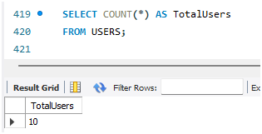

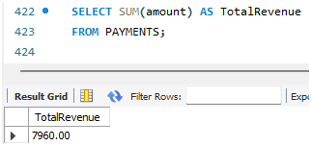

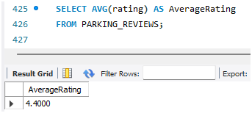

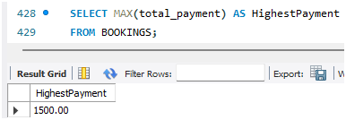
Brief Description:
  - Counts total number of users in the table.
Uses COUNT() to calculate total rows.
  - Calculates total revenue from all payments.
Adds all values using SUM().
  - Finds average rating given by users.
Uses AVG() to compute mean value.
  - Shows highest booking payment.
Uses MAX() to find largest value.

- GROUP BY / HAVING:
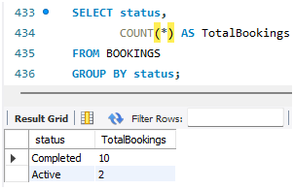

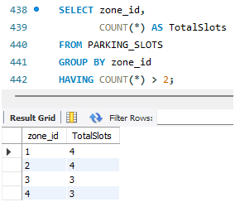

Brief Description:
  - Shows number of bookings for each status (Active/Completed).
Groups rows based on status.
  - Shows zones that have more than 2 parking slots.
Groups data and filters grouped results using HAVING.

- JOIN QUERIES:
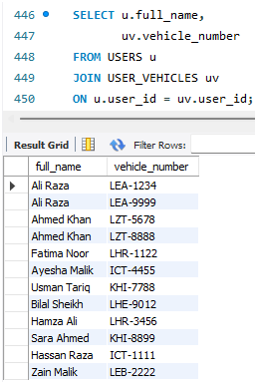

Brief Description:
Shows each user with their vehicle number.
Combines USERS and USER_VEHICLES using common user_id.
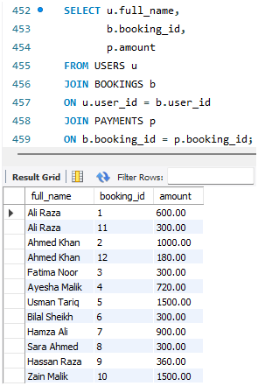

Brief Description:
Shows user name, booking ID, and payment amount together.
Joins 3 tables using foreign key relationships.

- SUBQUERIES:
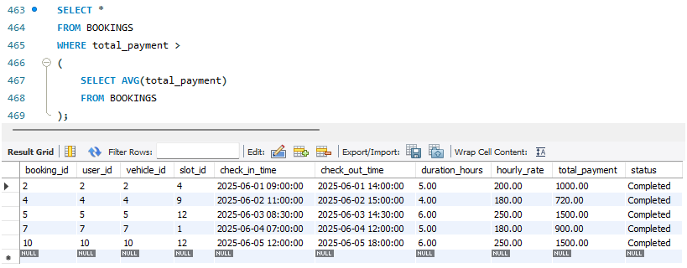
Brief Description:
Shows bookings that are higher than average payment.
Subquery first calculates average, outer query compares values.

