

ASSIGNMENT 1

NAME:Rameen Fatima

CLASS:ME-15(c)

CMS:453962

DATE OF SUBMISSION:Thursday,23rd November, 2023

**TASK 1:**

Write a C++ program to display factors of a number using for loops.

**CODE:**

#include <iostream>

using namespace std;

int main(){

int num;

cout << "Enter a number:";

cin >> num;

for (int i=1;i<=num;i++)

{

int rem = num%i;

if(rem == 0){

cout << i << endl;

}

}

}

**OUTPUT**:

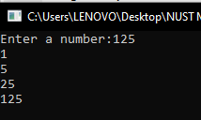

**TASK 2**:

**OUTPUT:**

x is 5 and y is 10

**TASK 3:**

Write a C++ program, take an integer value from user and check if it’s greater than 10 and less thanequal to 20. Print 1 if yes and print 0 if no. Use appropriate datatype for output.

**CODE:**

#include <iostream>

using namespace std;

int main(){

int num;

bool result;

cout << "Enter your number:";

cin >> num;

if (num>10 && num<=20){

result = true;

}

else {

result = false;

}

cout << result;

}

**OUTPUT**:

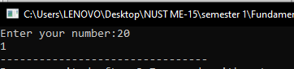

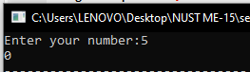

**TASK 4:**

Write a C++ program that uses a while loop to find the largest prime number less than a given positive integer N. Your program should take the value of N as input from the user and then find the largest prime number less than or equal to N. You are not allowed to use any library or pre-existing functions to check for prime numbers.

**CODE:**

#include <iostream>

using namespace std;

int main(){

int num,i=1,prime;

cout<< "Enter your number:";

cin>> num;

while(i<num){

for(int j =2;j<=i/2;j++){

int rem = i%j;

if (rem == 0){

break;

}

else if (j == i/2){

prime = i;

}

}

i++;

}

cout << "The largest prime number less than your number is:"<<prime;

}

**OUTPUT**:

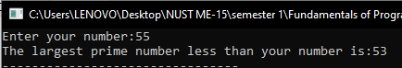

**TASK 5:**

Write a C++ program, take two string as input from user and check if both strings are equal or not. If they are equal make them unequal by rotating string. e.g., Hello is turned into olleH etc

**CODE:**

#include<iostream>

using namespace std;

int main(){

int n;

cout << "Enter the length of your strings:";

cin>> n;

char a[n],b[n];

cout << "Enter the first string:"<<endl;

for(int i=0;i<=n-1;i++){

cin>> a[i];

}

cout << "Enter the second string:"<<endl;

for(int i=0;i<=n-1;i++){

cin>> b[i];

}

for(int i=0;i<=n-1;i++) {

if(a[i]!=b[i]){

cout << "The strings are not equal";

break;

}

else if (i == n-1){

for(int j=n-1;j>=0;j--){

b[(n-1)-j] = a[j];

}

cout << "Your new strings are:"<<endl;

for(int j = 0;j<=n-1;j++){

cout << b[j];

}

cout << endl;

for(int j = 0;j<=n-1;j++){

cout << a[j];

}

for(int i=0;i<=n-1;i++) {

if(a[i]!=b[i]){

cout <<endl<< "The strings are not equal";

break;

}

}

}

}

}

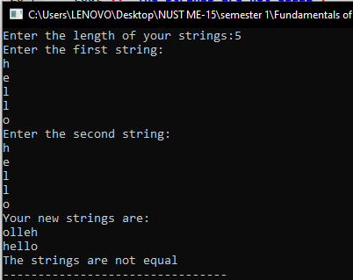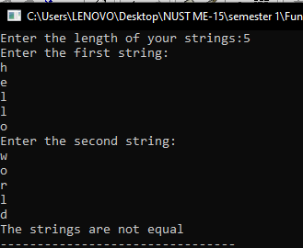**OUTPUT**:

**TASK 6:**

Perform division in C++ without / using for loops. You can use / only to display the final results. Your dividend must be greater than divisor.

**CODE;**

#include<iostream>

using namespace std;

int main(){

int dividend = 342, divisor = 6,quotient;

cout << dividend;

while(dividend >divisor){

dividend = dividend - divisor;

quotient++;

}

cout << "/"<< divisor<< " = "<< quotient;

}

**OUTPUT**:



**TASK 7:**

Write a C++program for a string which may contain lowercase and uppercase characters. The task is to remove all duplicate characters from the string and find the resultant string.

**CODE:**

#include<iostream>

using namespace std;

int main(){

int k=0;

char arr[]={'M','i','s','s','i','s','s','i','p','p','i'},arr2[100];

cout<< "The initial array is:";

for(int i = 0;i<=11;i++){

cout << arr[i];

}

cout << endl;

for (int i=0;i<=11;i++){

arr[i];

for(int j=i+1;j<=11;j++){

if(arr[i]==arr[j]){

break;

}

else if(j == 11){

arr2[k]= arr[i];

k++;

}

}

}

cout << "Array after deleting duplicate characters is:";

for(int i=0;i<=k;i++){

cout<<arr2[i];

}

}

**OUTPUT**:

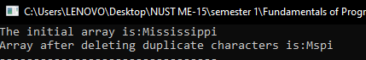

**TASK 8:**

Suppose an integer array a[5] = {1,2,3,4,5}. Add more elements to it and display them in C++.

**CODE:**

#include<iostream>

using namespace std;

int main(){

int a[5] = {1,2,3,4,5},b[8];

for(int i=0;i<=4;i++){

b[i]=a[i];

}

for(int i=0;i<=2;i++){

b[5+i]= 6+i;

}

cout << "The array before addition is:";

for(int i=0;i<=4;i++){

cout << a[i]<<",";

}

cout <<endl<< "The array after addition is:";

for(int i=0;i<=7;i++){

cout << b[i]<<",";

}

}

**OUTPUT**:

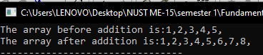

**TASK 9:**

Given an integer array and an integer X. Find if there’s a triplet in the array which sums up to the given integer X.

**CODE:**

#include<iostream>

using namespace std;

int main(){

int a[10]={1,2,3,4,5,6,7,8,9,0},x=10,sum = 0;

for(int i = 0; i<=9;i++){

for(int j=0;j<=10;j++){

for(int k=0;k<=10;k++){

sum = a[i] + a[j] + a[k];

if(sum == x){

cout<< "("<<a[i]<<","<<a[j]<<","<<a[k]<<")"<<endl;

}

}

}

}

}

**OUTPUT**:

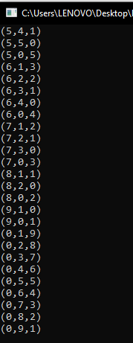

**TASK 10:**

Implement Bubble Sort on an array of 6 integers.

**CODE:**

#include<iostream>

using namespace std;

int main(){

int a[6] = {4,6,8,1,7,9},temp;

cout << "Ascending order:"<<endl;

for(int i=0;i<=5;i++){

for(int j=0;j<=i;j++){

if(a[i]<a[j]){

temp = a[j];

a[j] = a[i];

a[i] = temp;

}

}

}

for( int i = 0;i<=5;i++){

cout << a[i]<< ",";

}

cout<<endl<<"Descending order:"<< endl;

for(int i=0;i<=5;i++){

for(int j=0;j<=i;j++){

if(a[i]>a[j]){

temp = a[j];

a[j] = a[i];

a[i] = temp;

}

}

}

for( int i = 0;i<=5;i++){

cout << a[i]<< ",";

}

}

**OUTPUT:**

