LABTASK1:

#include <iostream>

using namespace std;

//lab task1

int main()

{

int x,sum;

for(int i = 0;i < 10;i++)

{

cout << "Enter your number:"<< endl;

cin >> x;

sum = sum + x;

}

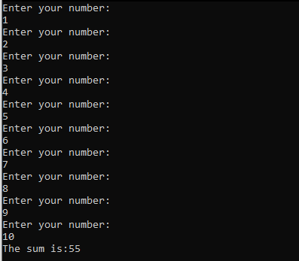cout << "The sum is:"<< sum;

return 0;

}

LABTASK2:

#include <iostream>

using namespace std;

//labtask2

int main(){

int prod,num;

cout << "Enter a number:";

cin >> num;

for (int i = 0;i<10;++i){

prod = num\*i;

cout << num << " x " << i << " = "<<prod<< endl;

}

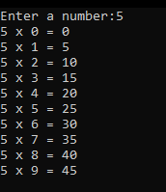

LABTASK3:

#include <iostream>

using namespace std;

//labtask3

int main(){

int x,factorial = 1;

cout << "Enter your number:";

cin >> x;

if (x >0){

for (int i = 1;i<11;i++){

factorial = factorial\*i;

if( i == x)

break;

}

}

else if (x < 0){

cout << "Invalid Input";

}

else

 factorial = 1;

cout << factorial;

return 0;

}

LABTASK4:

#include <iostream>

using namespace std;

int main(){

int n,n1,n2,sum = 0;

cout << "Enter length of sequence:";

cin >> n;

cout << "Enter your first digit:";

cin >> n1;

cout << "Enter your second digit:";

cin >> n2;

cout << n1 << "," << n2;

for (int i=0;i < n-2;i++){

sum = n1 + n2;

cout << "," << sum ;

n1 = n2;

n2 = sum;

}

return 0;

}

