

LAB MANUAL 10

NAME:Rameen Fatima

CLASS:ME-15C

CMS:453962

**LABTASK 1:**

**CODE:**

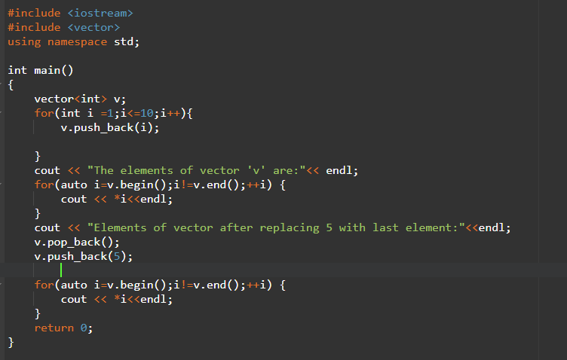

**OUTPUT:  
**

**LABTASK 2:**

**CODE:**

**OUTPUT:**



