

Manual 7 - LabTasks

NAME:Rameen Fatima

CMS:453962

CLASS:ME-15C

**LABTASK3:**

#include<iostream>

using namespace std;

int main (){

int c=5,r=5;

char arr[r];

//upper triangle

for (int i=0;i<=r/2;i++){

arr[i]=' ';

}

for(int j=0;j<=c/2;j++){

arr[c/2-j]='*',arr[c/2+j]='*';

cout << arr << endl;

}

//lower triangle

for (int i=r/2+1;i<r;i++){

arr[i]='*';

}

for(int j=c/2+1;j<c;j++){

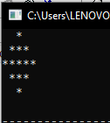

arr[j-4]=' ',arr[j-3]=' ';

arr[7-j]=' ',arr[9-j] = ' ';

cout << arr << endl;

}

}

**LABTASK2:**

#include<iostream>

using namespace std;

int main(){

int arr[5] = {5,10,15,20,25},sum= 0,product = 1;

for(int i=0;i<=4;i++){

sum = sum + arr[i];

product = product*arr[i];

}

cout<< "The sum is:"<< sum<<endl;

cout << "The product is:"<< product;

}

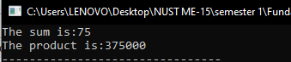

**LABTASK1:**

#include<iostream>

using namespace std;

int main(){

int arr[10];

for(int i=0;i<=9;i++){

cout<<"Enter your number:";

cin>> arr[i];

}

for(int i=0;i<=9;i++){

cout<< arr[i]<<",";

}

}