

LABMANUAL - 6

NAME:Rameen Fatima

CLASS:ME-15(c)

CMS:453962

DATE OF SUBMISSION:Thursday,23rd November, 2023

**LABTASK 1:**

**CODE:**

**#include<iostream>**

**using namespace std;**

**int main(){**

**cout << "Enter the range of your sequence:";**

**int n,a = 1,b=1,sum;**

**cin>>n;**

**cout << a<<","<<b;**

**for(int i=2;i<=n;i++){**

**sum = a+b;**

**cout << ","<< sum;**

**a=b;**

**b=sum;**

**}**

**}**

**OUTPUT:**

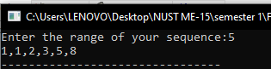

**LABTASK 2:**

**CODE:**

#include<iostream>

using namespace std;

//floyd's triangle

int main(){

int sum=0;

for (int i=0;i<=4;i++){

for(int j=1;j<=i+1;j++){

++sum;

cout << " "<<sum;

}

cout << endl;

}

}

**OUTPUT:**

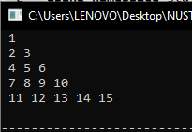

**HOMETASK 1:**

**CODE:**

#include<iostream>

using namespace std;

int main(){

int sum;

for (int i=1;i<=50;i++){

for(int j=1;j<=i/2;j++){

int rem = i%j;

if(j==1){

if(i == 2 || i==3){

cout << i<<" + ";

sum = sum +i;

}

else{

continue;

}

}

else if(rem == 0){

break;

}

else if(j==i/2){

sum = sum + i;

cout << i<< " + ";

}

}

}

cout << "="<<sum; }

**OUTPUT:**



**HOMETASK 2:**

**CODE:**

#include<iostream>

using namespace std;

int main(){

for (int i=0;i<=4;i++){

for(int j=1;j<=i+1;j++){

cout <<j<<" ";

}

cout << endl;

}

}

**OUTPUT:**

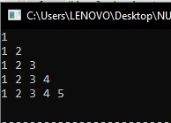

**HOMETASK 3:**

**CODE:**

#include<iostream>

using namespace std;

int main(){

int i =1;

cout <<i;

while(i<=4){

for(int j=1;j<=2*i-2;j++){

cout << 2*i-2<<" ";

}

i++;

cout << endl;

}

}

**OUTPUT:**

