Problem#1

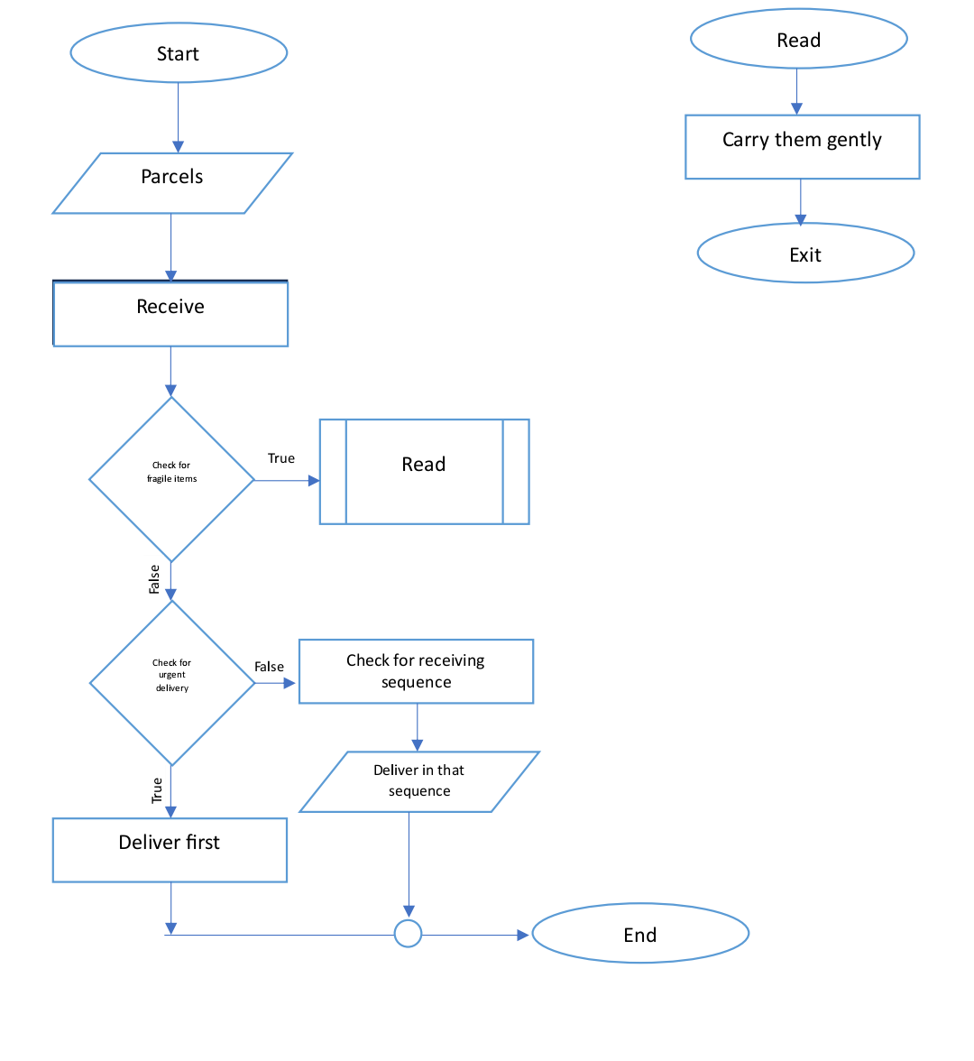

Problem#2

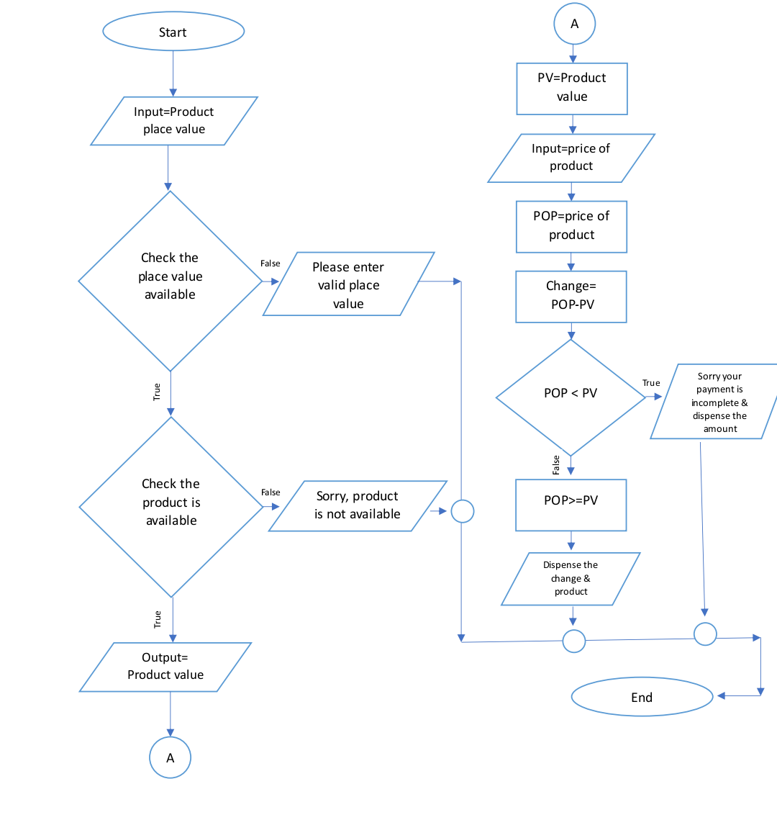

Problem#3

START

// Input/

INPUT num1

INPUT num2

INPUT num3

// Conditional Statements

IF

num1<num2<num3

THEN

PRINT "num1 is the smallest number"

IF

num2<num3<num1

THEN

PRINT "num2 is the smallest number"

ELSE

PRINT "num3 is the smallest number"

END

Problem#4

START

// Input

Input num1

Input num2

// Output

Select the operation

1 Multiplication

2 Division

// Conditional Statements

IF

user select Multiplication

THEN

PRINT num1\*num2

ELSE

PRINT num1/num2

END

Problem#5

* Ask user to enter the number
* Set num to number
* Set I to 2
* If num is equal to 2 or 3
* Display it’s a prime number
* Else
* While (num is greater than 3)
* Do (set I to i+1 then divide the num by I until num)
* If num is divisible by I then display its not a prime number
* Else
* Display it’s a prime number

Problem#6

* Ask user to enter the number between 1-365
* Divide the number by 7
* If the remainder is 0 then print Monday
* If remainder is 1 then print Tuesday
* If remainder is 2 then print Wednesday
* If remainder is 3 then print Thursday
* If remainder is 4 then print Friday
* If remainder is 5 then print Saturday
* Else print Sunday