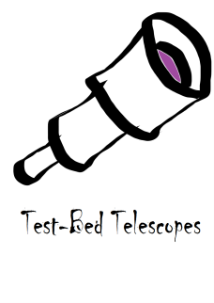
Test-Bed Telescopes

Reference: | TBT-SW-ICD-0002
Issue/Rev.: | 0.1

Demonstration Test-Bed for the Remote Control of an
Automated Follow-Up Telescope

SSA-TBT
TBT HMI SW Interface Control Document

 | Name & Function | Signature | Date
Prepared by: | J.M. Puerta, QA Manager |  | 2014-04-04
Checked by: | A. Ibarra, SW Architect |  | 2014-XX-XX
Authorised by: | A. Torres,TechnicalManager |  | 2014-XX-XX
Approved by: | V. Ruiz, Project Manager |  | 2014-XX-XX

File: TBT-SW-ICD-0002

Doc. Classification | [ ] Class A | [ ] Class R | [ X ] Class I
ESA Signature: |  |  | Not needed

DOCUMENT INFORMATION

Contract data
Contract Number | 4000107726/13/D/JR
Contract Issuer | ESA - ESOC

Distribution List
Internal | TBT Consortium
External | I. Zayer (HSO/GSS)  T. Flohrer  J. Reinhardt  D. Koschny  G.M. Pinna  E. Fletcher

Document Change Record
Iss./Rev. | Date | Section/Page | Change Description
0.1 | 2014-04-04 | all | Initial Draft

Table of Contents

1.INTRODUCTION 6
1.1 Scope 6
1.2 Applicable Documents 6
1.3 Reference Documents 7
1.4 Acronyms 7
2.TBT HMI OVERVIEW 9
3.INTERFACE DESIGN 11
1.5 Interface to Control SW module 11
1.6 Interface to Processing SW module 14
4.MIMICS DESIGN 15
1.7 Web Pages Definition 16
5.ANNEX I: TBT HMI PARAMETERS TABLE 28

Index of Figures

Figure 1. RTS-2 and WGMMI Architecture 10
Figure 2. TOTAS and WGMMI Architecture 10
Figure 3 Login Web Page 17
Figure 4. WGMMI Framework and Main Monitoring screen 18
Figure 5. Main WGMMI information frame 18
Figure 6. Alarms buffer 19
Figure 7. Navigation tree 19
Figure 8. Management frame 19
Figure 9. Main Monitoring Monitoring mimic 20
Figure 10. RTS2 Control Mimic 21
Figure 11. Quicklook 22
Figure 12. RTS2 Poiting Model and Pointing Error Mimic 23
Figure 13. Local Weather mimic 24
Figure 14. Encapsulated Scheduling mimic 25
Figure 15. Processing Monitoring Mimic 27

Index of Tables

Table 1. WGMMI and RTS2 Data Type Matching 14
Table 2. TBT HMI Parameter list 35

INTRODUCTION

Scope
This Interface Control Document (ICD) is part of the deliverable “DD-0008: System Architecture” for the ESA/GSTP study “Demonstration Test-Bed for the Remote Control of an Automated Follow-Up Telescope” (ref: G532-004GR), with abbreviated code name SSA-TBT.

The document gathers the mimics’ design of the WGMMI for the SSA-TBT as well as the information matching between the data displayed and the monitored RTS-2 parameters. The document will be updated along the life of the project to include valuable feedback from internal actors, ESA and tests results.

Applicable Documents
The following documents contain requirements and references, which are applicable to the work:

- [AD1] Statement of Work: Demonstration Test-Bed for the Remote Control of an Automated Follow-Up Telescope. GSTP Activity Reference G532-004GR.
Reference: GRST-SYST-GST-SOW-1004-HSO-GSS, Issue: 1.1, Date: 05/05/2011
ESA/ESOC
- [AD2] Volume 2: Technical Proposal to ESA for the “Demonstration Test-Bed for the Remote Control of an Automated Follow-Up Telescope"
Reference: OFE-11-0020, Issue 1, Revision 08, Date: 20/07/2011
INSA, IXION, IGUASSU, CAB, IAC, ROA, FABRA
- [AD3] SSA-TBT Software Market Survey Report
Reference: TBT-SW-DD-0005, Issue 1.0, Date: 03/05/2013
- [AD4] SSA-TBT Project Management Plan
Reference: TBT-MAN-PMP-0001, Issue 0.3, Date: 11/12/2012
- [AD5] SSA-TBT Software Development Plan
Reference: TBT-SW-SDP-0001, Issue 1.0, Date: 10/06/2013
- [AD6] SSA-TBT Safe operation Control Concept.
Reference: TBT-HW-DD-0001, Issue 0.2, Date: 07/05/2013
- [AD7] SSA-TBT Software Requirements and Acceptance Document
Reference: TBT-SW-SRAD-0001, Issue 1.0, Date: 13/06/2013
- [AD8] SSA-TBT Control Software Requirements Specification
Reference: TBT-SW-SRS-CONTROL-00001, Issue 0.3, Date: 09/06/2013
- [AD9] SSA-TBT Processing Software Requirements Specification
Reference: TBT-SW-SRS-PROCESSING-00001, Issue 0.3, Date: 31/05/2013

Reference Documents
The following documents contain useful references

- [RD1] RTS2 JSON API Documentation
Date: 15/02/3013, Petr Kubánek
- [RD2] Evolus Pencil SW: http://pencil.evolus.vn/
- [RD3] Hypertext Transfer Protocol -- HTTP/1.1
Date: June 1999, W3C/MIT

Acronyms
AD Applicable Document
AMCSF Automatic Meridian Circle of San Fernando
APS Active Pixel Sensor (also called CMOS-detector)
AR Acceptance Review
ATC Automatic Transit Circle
BNC Baker-Nunn Camera
BSSC Board for Software Standardization and Control
CAB Centro de Astrobiología
CCD Charge Coupled Device
CDR Critical Design Review
CESAR Cooperation through Education in Science and Astronomy Research
COTS Commercial Off The Shelf
ENO European Northern Observatory
ECSS European Co-operation for Space Standardization
ESA European Space Agency
ESTRACK ESa TRACKing network (of ground stations)
FA Final Acceptance
FITS Flexible Image Transport System
FPA Focal Plane Assembly
FoV Field of View
GEO GEo-stationary Orbit
GSTP General Support and Technology Program
HMI Human-Machine Interface
HW HardWare
IAC Instituto Astrofísico de Canarias
ISDEFE Ingeniería y Sistemas Aeroespaciales
INDI Instrument Neutral Distributed Interface
ITRF International Terrestrial Reference Frame
JVM Java Virtual Machine
LEO Low Earth Orbit
M&C Monitoring and Control
MEO Medium Earth Obit
NEO Near-Earth Object(s)
NNO New NOrcia
OGS (ESA’s) Optical Ground Station in Tenerife
PDR Preliminary Design Review
PM Progress Meeting
QMS Quality Management System
RD Reference Document
RDM Requirements Definition and Management
RF Radio Frequency
RGO Royal Greenwich Observatory
ROA Real Observatorio de la Armada
RTS2 Remote Telescope System. Version 2.
SETG Software Engineering Tailoring for Ground Segments
SCMP Software Configuration Management Plan
SDP Software Development Plan
SOA Service Oriented Architecture
SoW Statement Of Work
SRAD Systems Requirements and Architecture Document
SRS Software Requirements Specification
SSA Space Situational Awareness
SW SoftWare
TBC To Be Confirmed
TBD To Be Determined
TBS To Be Specified
TBT Demonstration Test-Bed for the Remote Control of an Automated Follow-Up Telescope
TBW To Be Worked
ToO Target of Opportunity
TRB Test Review Board
TRFM Telescope Fabra / ROA / Montsec
TRR Test Readiness Review
URD User Requirements Document
WCS World Coordinate System
WP Work Package
VO Virtual Observatory

TBT HMI OVERVIEW
In the context of the SSATBT project, the WGMMI has been selected as the better solution after a SW survey phase, presented to and approved by ESA, to provide an advanced HMI that will monitor the Control SW and the Processing SW modules (for more detail refer to [AD7], [AD8] and [AD9]). This SW module is named as TBT HMI. On the other hand, the TBT HMI does not monitor the TBT Scheduling as it presents a dedicated HMI.

With regard to internal interfaces, the TBT HMI will interface the Control SW (RTS2) to retrieve information and send commands, and the Processing SW (TOTAS) only for monitoring purposes. The two communication interfaces are described hereafter.

Concerning the external interfaces, the document presents the graphical interface to the users and the communication interface (based on the communication structure described in [AD6]).

The WGMMI is an independet SW package consisting of an application that provides the remote and local user an interface module of the M&C system for ESA’s Ground Station equipment. MMI (Man-Machine Interfaces) modules are generic and can be tailored for a specific device through an XML tailoring file.

WGMMI main functions and capabilities can be summarised in the following list:
- Real-time monitoring (configurable polling, on changed supported) and commanding
- Structured Information displaying
- Control capability
- Existing graphical elements for Telescope environment
- Users and Roles Management
- Plugins as add-ons
- Fully configurable (based on XML files)
- Multi-platform (running code based on Java)
- Multiple clients management with no extra impact on controlled subsystems
- Client-Server Communication channel optimization

The main WGMMI architecture considering the WGMMI SW and the Control SW modules is presented in the following figures:

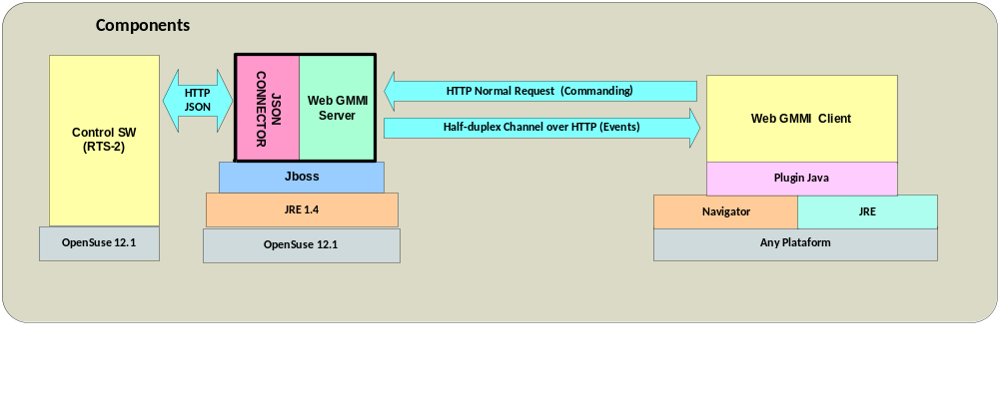
Figure 1. RTS-2 and WGMMI Architecture
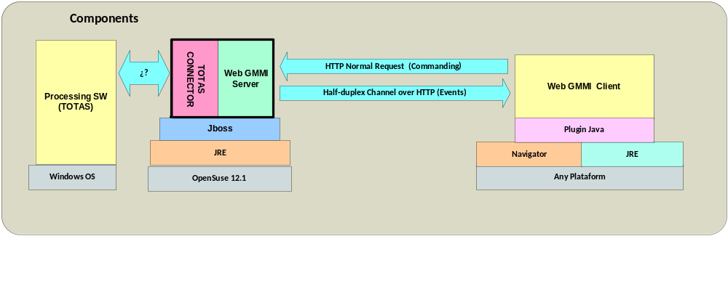
Figure 2. TOTAS and WGMMI Architecture

Mainly, the WGMMI is composed of a server and a client. The server can run locally or remotely as long as it has a direct connection channel to the subsystem to be monitored and controlled. The client runs in the operator HW platform in a regular web browser as an applet. Since the whole SW is developed under java it is considered fully multi-platform, just needing a JVM running, and a Jboss application server in case of the WGMMI server.

WGMMI server is running indefinitely on the web server, sending monitoring events to the clients. The WGMMI client will receive monitoring events that will be visualized on the screen. Only those monitored parameters that have changed are sent, and only those being displayed in the active mimic in the client side, so the communication channel is optimised at its maximum.

The TBT HMI will use the communication channel described in [A8]. Due to stringent channel bandwidth the WGMMI tailoring is focused on the necessary data for a user under special conditions such as maintenance activities.

INTERFACE DESIGN
Since there are two different subsystems that WGMMI server will communicate to, two interfaces are considered hereafter: interface with control SW module (RTS-2) and interface with processing SW module (TOTAS).

Interface to Control SW module
According to [AD8], the MMI shall allow conduction of several test campaigns, exploiting the full range of observing capabilities and simulating contingencies (TBT-CON-M-MMI-0050). In the particular case of the TBT HMI it is conceived to provide full capability to users for contingency situations and maintenance activities, as well as for supervision. Thus, the WGMMI is tailored to monitor all the available variables from the two already referred SW modules and present those that the operators need to be shown. Furthermore, some of them are transformed to present more valuable information to operators than the pure monitored data. In addition, WGMMI is designed to be an independent SW module with a unique communication point to Control SW module not to interfere the latest in their telescope devices control activities.

This subchapter describes the interface that the RTS-2 offers and how the WGMMI is using it to acquire information from the RTS-2 and send commands at low-level.

RTS-2 Interface Description
The RTS-2 provides two main interfaces: json API interface and RTS-2 protocol interface. After a thorough assessment on both, the json API interface was selected due to its standarisation and better accessibility.

According to RTS2 documentation ([R1]), the JSON API is provided by RTS2 to allow external programs controlling observatories subsystems. Calls are realized over HTTP as GET/POST requests, with arguments used to parametrize the call. Calls are handled by RTS2 rts2-xmlrpcd component. Data returned through HTTP are JSON encoded data. It is a synchronous communication relying on the HTTP protocol. Regular HTTP communication is extensively explained in [R3].

The WGMMI Server opens a connection to the rts-2xmlrpcd component, and issues GET requests according to JSON API description ([R1]).

Currently, the monitoring process is driven by quering the xmlrpc daemon by means of the following API call:
http://rts2ipaddress:8889/api/getall

where the rts2ipaddress is the IP of the machine where the RTS2 is running. The IP address is fully configurable and will be the same as that set in the final system deployment.

The result of that call is the whole set of variables that the RTS2 drivers expose in a JSON API format. Refer to [R1] for more details.

The monitoring polling cycle is fully configurable, and set to 3 seconds by default.

With regard to the “set variable” commanding, the WGMMI composes the following API call accordingly:

http://rts2apiaddress:8889/api/set?d=DEVICE&n=VARIABLE&v=VALUE

where
- DEVICE is a valid device name within the RTS2 database (for example, in dummy driver T0 stands for Telescope)
- VARIABLE is a valid variable name within the specified DEVICE
- VALUE is a valid value for the VARIABLE

It is worth mention that “variable” denomination will be used for RTS2 data since “parameter” denomination will be used for WGMMI data.

Data Elements
There are two main data elements concerning the communication between the WGMMI and the Control SW: acquired variables and commands.

The existing devices monitored and controlled by Control SW are:
- T0, Telescope
- C0, Camera
- CUP, cupola or dome
- EXEC, executor of the active observation (active queue)
- SEL, selector that gets the following observation from the active or higher priority queue
- DAVIS, Weather station

The table in Annex I summarises the acquired variables including the following fields:
- TBT HMI Parameter identifier.
- Description of the parameter
- Type of the parameter. WGMMI types are:
  - Integer
  - Unsigned Integer
  - Real
  - String
  - Enumerated
- Feasible values. Depending on the type of the parameter, the suitable values are as follows:
  - Integer, Unsigned Integer, Real: This field defines the numeric range
  - String: This field defines the maximum number of characters
  - Enumerated: This field defines the list of suitable values for the parameter
- Monitoring (MON): it states if the parameter is monitored or not
- Commanding (CMD): it states if the parameter is commandable or not
- RTS2/TOTAS variable. The RTS2 variable or TOTAS variable name as it comes in the JSON API monitoring response. With regard to RTS2, the variable name is composed of device_name,variable_name. With regard to Processing SW, is TBD.

The following list gathers those commands available from the TBT HMI:
- move RA DEC, where
where
  - RA stands for Right Ascension. An integer variable which Range is …TBD
  - DEC stands for Declination. An integer variable which Range is…TBD
- …TBC

Message Description
The response coming from RTS2 presents the following structure, as it is described in [R1]:

“device”: {
"d":
{ "variable name":value,... }, device variables and their values
"minmax": list of variables with minimal/maximal allowed value
{ "variable name":[min, max],... },
"idle":0 or 1, idle state. 1 if device is idle
"state":device state, full device state
“sstart”: ,
“send”: ,
"f":time actual time. Can be used in next get query as from parameter
}

As an example the output by using dummy drivers is:

"T0":{"d":{"infotime":1397028631.16275906562805175781,"LATITUDE":20.00000000000000000000,"LONGITUD":10.00000000000000000000,"ALTITUDE":700.00000000000000000000,"ORI":{"ra":20.00000000000000000000,"dec":30.00000000000000000000},"OFFS":{"ra":0.00000000000000000000,"dec":0.00000000000000000000},"woffs":{"ra":0.00000000000000000000,"dec":0.00000000000000000000},"OBJ":{"ra":20.00000000000000000000,"dec":30.00000000000000000000},"TAR":{"ra":20.00000000000000000000,"dec":30.00000000000000000000},"CORR_":{"ra":0.00000000000000000000,"dec":0.00000000000000000000},"wcorr":{"ra":0.00000000000000000000,"dec":0.00000000000000000000},…
,"minmax":{},"idle":1,"state":0,"sstart":null,"send":null,"f":null}

The first field is the device name. In the example, it corresponds to T0. Then, by foillowing the JSON structure “d” contains the device variables and values.

For monitoring purposes, only “d” and “state” fields are used.

Concerning the “d” main field, the variables appears as a name/value pair, so WGMMI parses this info to get the variable value and update the internal value of the corresponding WGMMI parameter.

The RTS2 handles just three variable types: boolean, numeric and string. WGMMI handles five types: Real, Integer, Unsigned Integer, String and Enumerated.

The conversion table of parameter types is as follows:
WGMMI type | RTS2 type
Real | Numeric
Integer | Numeric
Unsigned Integer | Numeric
String | String
Enumerated* | Numeric/String
Boolean | Boolean
Table 1. WGMMI and RTS2 Data Type Matching
- Enumerated values are parameters with a particular set of values, corresponding to labels. They are set in the WGMMI side and the source for the conversion can be a numeric variable or a string variable.

Communication Protocol
Communication protocol is base on RTS2 JSON API. AS stated in the documentation, “The JSON is a lightweight data-interchange format. RTS2 provides JSON API which allows external programs to control the observatories and other systems running RTS2. Calls are realized over HTTP as GET/POST requests, with arguments used to parametrize call. Calls are handled by rts2-xmlrpcd component of the RTS2. Data returned through HTTP are JSON encoded data”.

Details are found in official documentation of RTS2, [R1].

Interface to Processing SW module
TBW when protocol and parameters are defined at TOTAS side.

TOTAS Interface Description
TBW

Data Elements
TBW

Message Description
TBW

Communication Protocol
TBW

MIMICS DESIGN
In this chapter every mimic design is presented. Furthermore, the matching between mimics elements and monitored parameters or commands is described.

It is worth reminded that the TBT HMI will monitor two subsystems:
- Control SW, which monitors and controls the HW devices composing the observation system (telescope, camera, dome, filter, weather station)
- Processing SW, which processes the captured images
In addition, the TBT HMI will control just one subsystem: Control SW. Pocessing SW will not be monitored to not interfere with the highly demmanding processing activities.

The TBT HMI definition is based on several documents:
- Operational Concept. Official document with reference ([AD6])
- SRAD, ([AD7])
- Control SW SRS, ([AD8])
- Processing SW SRS, ([AD9])
- JSON API documentation ([RD1])
- Several emails exchanged between IXION and RTS2 experts (Petr Kubánek, and Stanislav Vitek).

The mimics design is supported by the web pages design performed by means of the pencil SW tool ([RD2]).

In order to unambiguously identify each TBT HMI parameter (based on WGMMI), the following WGMMI parameter name convention is adopted:

SWM_DEVICE_VARNAME

where

- SWM stands for the SW Module the variable is monitored from. It can get only two values: CO for Control or PR for Processing.
- DEVICE stands for device. It is a string specifying the device the parameter belongs to. In case of the Control SW, it is a direct device name acronym (for complete device list refer to 1.5.2). In case of the Processing SW, is TBD.
REMARK: The devices names are set by Control SW and Processing SW. If there is no a specific device, the GE acronym is used to specify it is a GENERIC variable.
- VARNAME stands for the monitored variable name. It is a free string, with no maximum length. It is a meaningful string, which may be the whole variable name or just a reduction of it.

Web Pages Definition

Overall Monitoring Web Page
This web page is the first the operator opens when addressing the specific URL (TBD). In the Web Page a collection of parameters from both sites (Cebreros and NNO) are presented, and a button per site to access the whole site monitoring and control web pages.

This web page is conceived with no security since it will present only a small set of parameters and no control at all.

The design of this web page is TBD.

Login Web Page
The first page is the login page:

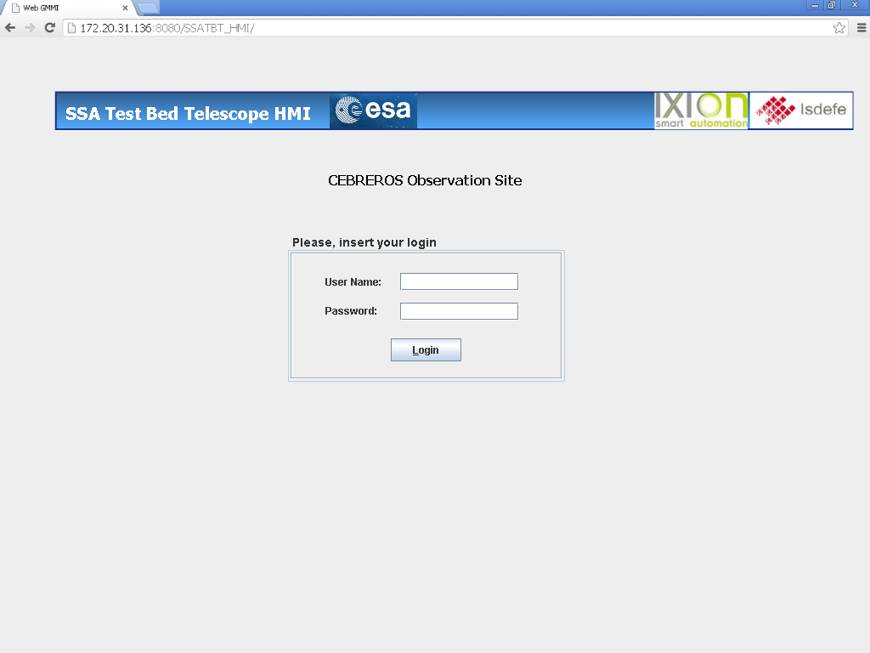
Figure 3 Login Web Page

- It is the first page when addressing the TBT-SSA URL for the WGMMI
- The operator must introduce a valid user and password to login in the specific site HMI.

Main TBT Control SW User IF Mimic
Once the user is logged in, this web page is presented. It collects all the monitoring data from the Control SW subsystem.
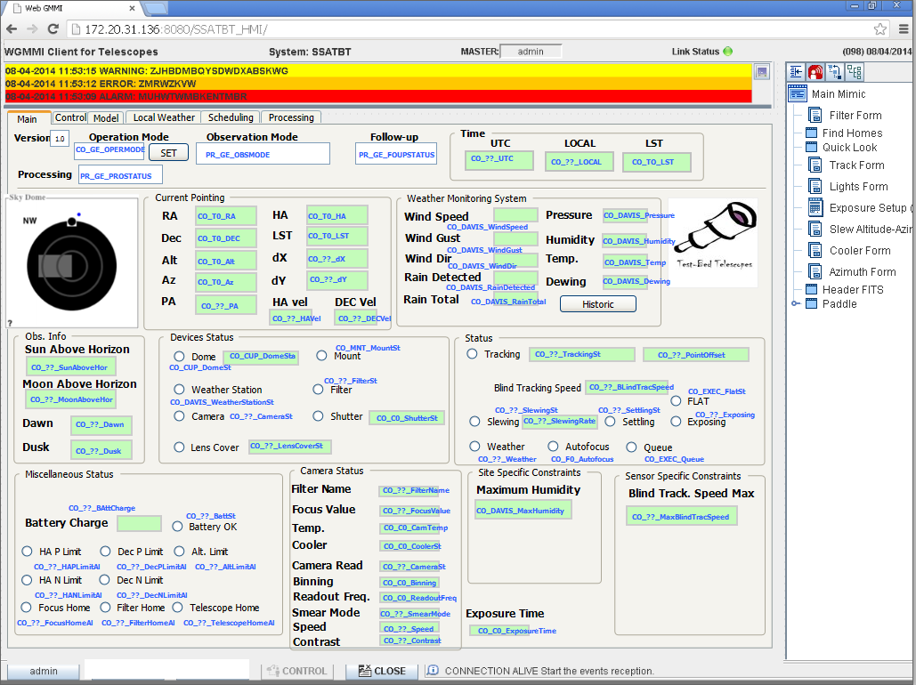
Figure 4. WGMMI Framework and Main Monitoring screen

The screen is divided into 5 subframes:
- Main WGMMI information:

Figure 5. Main WGMMI information frame
Where it presents the following information:
  - Client information as static text string
  - System information. It will be the static string SSATBT
  - User logged in
  - Link status between WGMMI server and WGMMI client, displaying a linking led with the following convention:
    - Blinking between light and dark green: communication OK
    - Blinking between red and yellow: communication NOK
  - Current date and time at WGMMI Server.
- Alarm buffer
Figure 6. Alarms buffer
It presents the active alarms in the system. There are four levels:
  - Alarm: background in red
  - Warning: background in yellow
  - Error: background in orange
  - Info: background in gray
- Navigation tree frame:
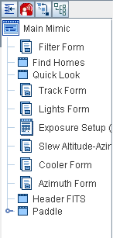
Figure 7. Navigation tree

The menu is a tree presenting quick way to execute the available commands (opening forms) in the open mimic.
- Lower-screened management frame:

Figure 8. Management frame
Where buttons mean:
  - Logged user roles (labelled as admin in the snapshot): it presents a list of roles related to the logged user
  - Control: it requests the control if the user has priviledges to do it so
  - Close: it closes the current connection going back to login web page
  - Last logged event presentation
- Main (monitoring/commanding) mimic
It presents different tabs where operator can select to show different information. In this particular case, the monitored RTS2 data is shown:
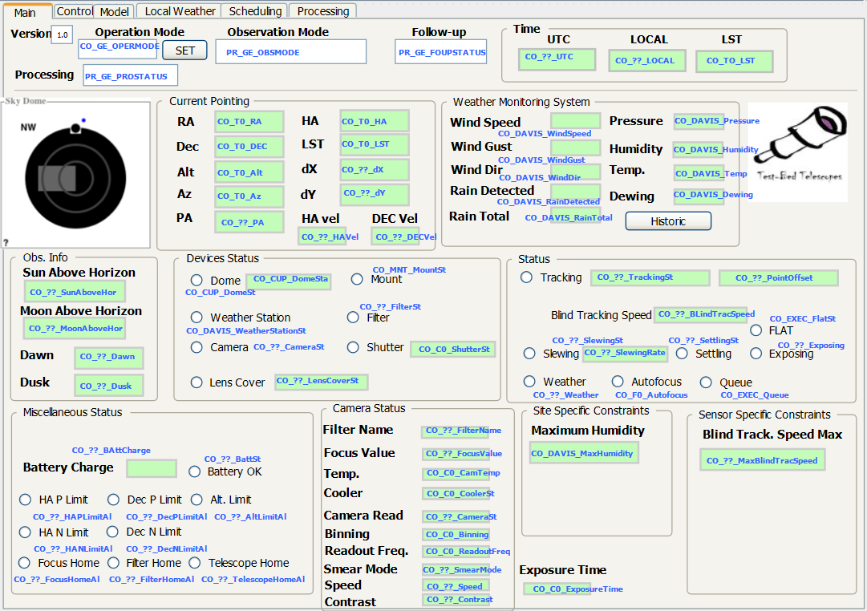
Figure 9. Main Monitoring Monitoring mimic

- Each WGMMI parameter corresponds to a Control SW or Processing SW parameter according to the table in Annex I. Each WGMMI parameter is presented in blue.
  - The Historic button opens the Historic Local Weather page.

TBT ControL SW Control Mimic
The information of this web page is presented by selecting the Control tab, so only the main mimic changes:
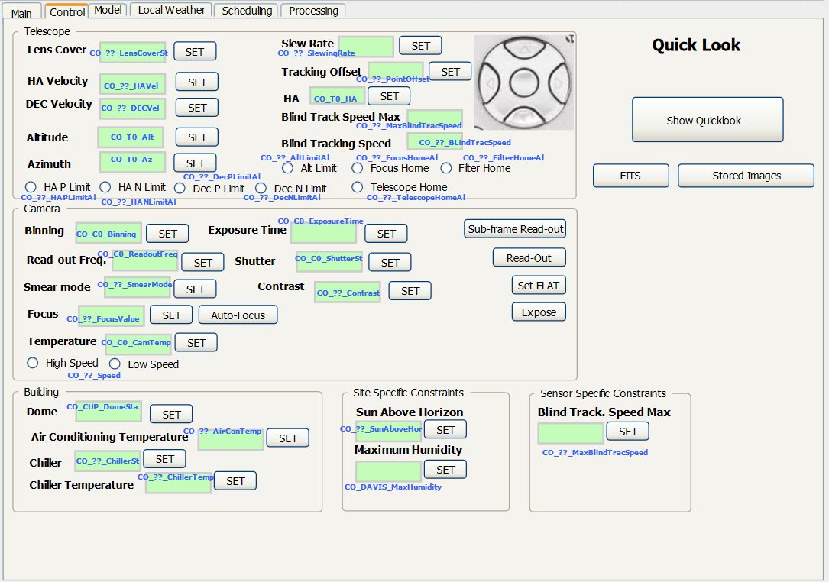
Figure 10. RTS2 Control Mimic

- Each mimic element presents the current monitored value and a SET button that opens a form to command a new value. Each WGMMI parameter corresponds to a Control SW or Processing SW parameter according to the table in Annex I. Each WGMMI parameter is presented in blue.

- The Show Quick look button opens an independent window presenting the last image taken by the telescope camera. This feature will be disabled for remote users due to the stringent channel bandwidth.
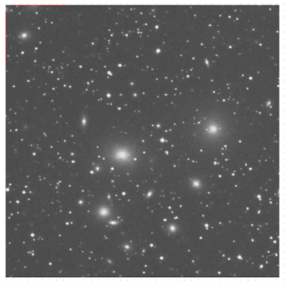
Figure 11. Quicklook

- The Stored Images button opens an independent window presenting the collection of small images. This feature will be disabled for remote users due to the stringent channel bandwidth.
- FITS button opens a independent window showing the FITS header of the quicklook image
- The pad graphical mimic is used to move the telescope in the desired direction step by step.
- The Auto-focus button executes the auto-focus command.
- The Sub-frame Read-out button executes the RTS2 subframe readout command.
- The readout button executes the RTS2 readout command.
- The set FLAT button sets the current telescope position coordinaates internally for a flat command.
- The Expose button executes the RTS2 Expose command

Control SW Model Mimic
The information of this web page is presented by selecting the Model tab, so only the main mimic changes:

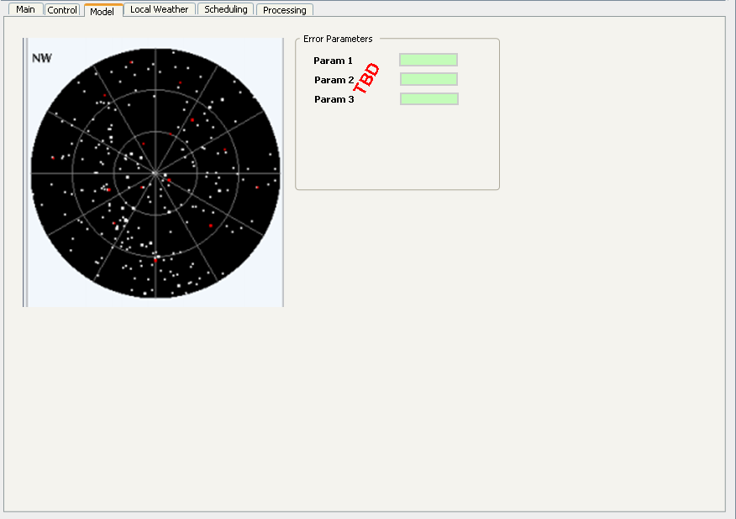
Figure 12. RTS2 Poiting Model and Pointing Error Mimic
The mimic will present the poiting model as a static bipmap image, and a set of parameters corresponding to the poiting error. The parameters collection is outstanding still.

Historical Local Weather Mimic
The information of this web page is presented by selecting the Local Weather tab, so only the main mimic changes
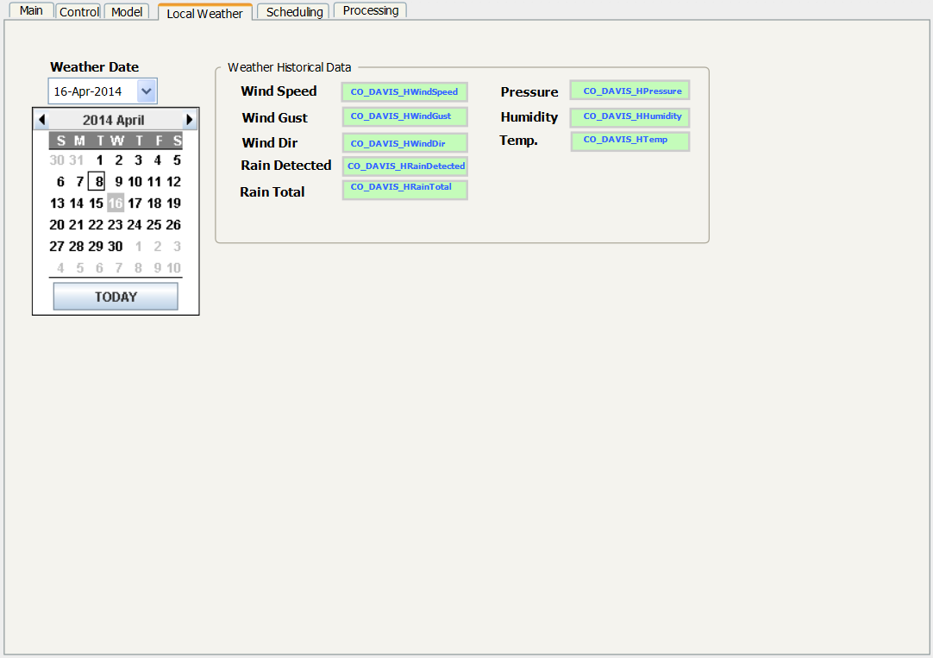
Figure 13. Local Weather mimic

It presents the following information:
- The Weather Date combo box opens a calendar built-in application to select the day for the historical weather data.
- The mimic elements within the “Weather Historical Data” block display the data corresponding to the selected day. Each WGMMI parameter corresponds to a Control SW or Processing SW parameter according to the table in Annex I. Each WGMMI parameter is presented in blue.

Control SW Encapsulated Scheduling Mimic
The information of this web page is presented by selecting the Scheduling tab, so only the main mimic changes
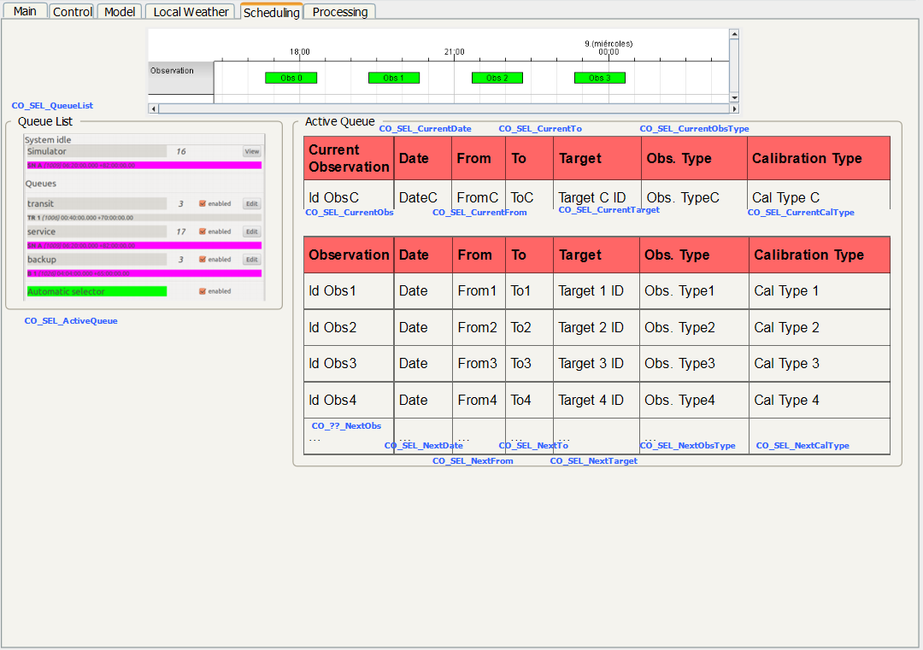
Figure 14. Encapsulated Scheduling mimic

- The timeline graphic element displayes the observation of the current queue in a time basis. It presents a green block with the exact starting and final time within the whole day.
- The Queues list is monitored from the RTS2. Presents information about every existing queue in the RTS2.
- The Active queue presents a list of scheduled observations. It is divided into the current observation and the upcoming observations. For each observation a list of parameters are displayed:
  - Observation Identifier
  - Date (maybe not needed since the observation is for the current night)
  - From Time: when the observation begins
  - To Time: when the observation ends
  - Target: target of the observation (in case of follow-ups).
  - Observation type: follow-up or survey of uMEO/GEO/NEO, or Calibration.
  - Calibration type: BIAS, FLAT or DARK, only in case the observation type is “Calibration”
- Each WGMMI parameter corresponds to a Control SW or Processing SW parameter according to the table in Annex I. Each WGMMI parameter is presented in blue.

Processing SW Mimic
The information of this web page is presented by selecting the Processing tab, so only the main mimic changes
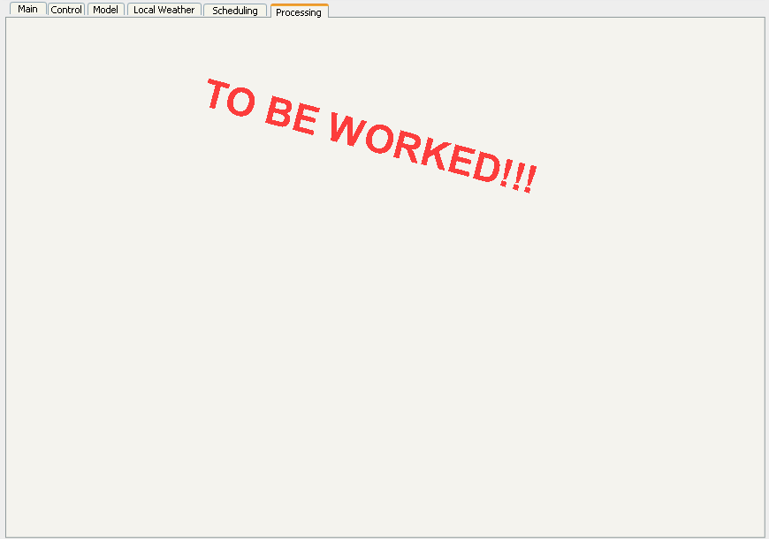
Figure 15. Processing Monitoring Mimic

This web page is TBW once the Processing SW data to be displayed is defined.

ANNEX I: TBT HMI PARAMETERS TABLE
The following table presents the correspondence between the TBT HMI (WGMMI) parameters and the RTS-2 or TOTAS parameters.

It is worth mention that some Parameters IDs present ?? within their names, which means that the device name is missing. Furthermore, every missing correspondence from RTS-2 or TOTAS is presented in red background.

The reader can notice that currently there is a high level of uncertanbility according to the parameters names montored from RTS-2 or TOTAS, which must be provided by the RTS-2 and TOTAS developing responsibles.

Parameter ID | Parameter Description | Type | Values | MON | CMD | RTS-2/TOTAS Parameter Matching
CO_GE_OPERMODE | Operation Mode | Enumerated | TBD | YES | YES | TBD
PR_GE_OBSMODE | Observation Mode | Enumerated | TBD | YES | NO | TOTAS?? TBD
PR_GE_PROSTATUS | Processing | Enumerated | ON  OFF | YES | NO | TOTAS?? TBD
PR_GE_FOUPSTATUS | Follow-up | Enumerated | YES  NO | YES | NO | TOTAS?? TBD
CO_??_UTC | UTC | String | TBD | YES | NO | TBD
CO_??_LOCAL | Local time as it is in RTS2 | String | Current Date+Time | YES | NO | T0 ,?? TBC
CO_T0_LST | LST | String | TBD | YES | NO | T0,LST
CO_T0_RA | Right Ascension | Real | TBD | YES | NO | T0, ORI -> ra ?? TBC
CO_T0_DEC | Declination | Real | TBD | YES | NO | T0, ORI -> dec ?? TBC
CO_T0_Alt | Altitude | Real | TBD | YES | NO | T0, TEL_ -> alt
CO_T0_Az | Azimuth | Real | TBD | YES | NO | T0, TEL_ -> az
CO_??_PA | Polar Angle | Real | TBD | YES | NO | TBD
CO_T0_HA | Hour Angle | Real | TBD | YES | NO | T0 ,HA
CO_T0_CurLST | Current Point Local Sidereal time | String | TBD | YES | NO | TBD
CO_??_dX | Delta Altitude (formal error) | Real | degrees | YES | NO | TBD
CO_??_dY | Delta Azimuth (formal error) | Real | degrees | YES | NO | TBD
CO_??_HAVel | Mount Hour Angle speed | Real | deg/sec | YES | NO | TBD
CO_??_DECVel | Mount Declination speed | Real | deg/sec | YES | NO | TBD
CO_DAVIS_WindSpeed | Wind Speed | Real | m/s | YES | NO | DAVIS,AVGWIND?? TBC
CO_DAVIS_WindGust | Wind Gust | Enumerated | YES  NO | YES | NO | DAVIS,AVGWINDS??  TBC
CO_DAVIS_WindDir | Wind Dir | String?  Numeric? TBC | degrees | YES | NO | DAVIS,WINDDIR
CO_DAVIS_RainDetected | Rain Detected | Enumerated | YES  NO | YES | NO | DAVIS,RAIN
CO_DAVIS_RainTotal | Rain Total | Real | mm to sqm | YES | NO | DAVIS,rain_rate
CO_DAVIS_Pressure | Pressure | Real | hPa | YES | NO | DAVIS,BAR_PRESS
CO_DAVIS_Humidity | Humidity | Real | % | YES | NO | DAVIS,DOME_HUM
CO_DAVIS_Temp | Outdoor Temperature | Real | degrees | YES | NO | DAVIS,DOME_TMP
CO_DAVIS_Dewing | Dewing | Enumerated | YES  NO | YES | NO | DAVIS,WETNESS?? TBC
CO_??_SunAboveHor | Position of sun above horizon | Real | degrees | YES | NO | TBD
CO_??_MoonAboveHor | Position of moon above horizon | Real | degrees | YES | NO | TBD
CO_??_Dawn | Daily dawn time | String | time | YES | NO | TBD
CO_??_Dusk | Daily dusk time | String | time | YES | NO | TBD
CO_CUP_DomeSt | Status of the Dome (aka Housing or Roof) | Enumerated | OK  ERROR | YES | NO | CUP,state
CO_CUP_DomeSta | State of the Dome | string | OPEN  CLOSED  ERROR | YES | NO | CUP,TBD
CO_DAVIS_WeatherStationSt | Weather Station Status | Enumerated | OK  ERROR | YES | NO | DAVIS,state
CO_??_CameraSt | Camera Readout status | Enumerated | READOUT ON  READOUT OFF  EXPOSING | YES | NO | TBD
CO_??_LensCoverSt | Lens cover status | Enumerated | ON  OFF | YES | NO | TBD
CO_MNT_MountSt | Mount status | Enumerated | OK  ERROR | YES | NO | MOUNT,state
CO_??_FilterSt | Filter status | Enumerated | OK  ERROR | YES | NO | TBD
CO_C0_ShutterSt | Shutter Status | Enumerated | OPEN  CLOSED | YES | NO | C0,SHUTTER
CO_??_TrackingSt | Tracking Status of Telescope | Enumerated | None  Blind  Ephemerids  Sidereal | YES | NO | TBD
CO_??_PointOffset | Pointing offset when tracking | Real | degrees | YES | NO | TBD
CO_??_BlindTracSpeed | Current Blind Tracking Speed | Real | deg/sec | YES | NO | TBD
CO_??_SlewingSt | Slewing Status | Enumerated | YES  NO | YES | NO | TBD
CO_??_SlewingRate | Mount Mount slew rate | Numeric | deg/sec | YES | NO | TBD
CO_??_SettlingSt | Settling Status | Enumerated | YES  NO |  | NO | TBD
CO_EXEC_FlatSt | Flat Status | Enumerated | TBD | YES | NO | EXEC,flats_done??
CO_??_Exposing | System is exposing | Enumerated | ON  OFF | YES | NO | TBD
CO_??_Weather | (bad) weather | Enumerated | YES  NO | YES | NO | TBD
CO_F0_Autofocus | Autofocus status monitoring and immediate command | Enumerated | ON  OFF | YES | NO | F0,TBD
CO_EXEC_Queue | Queue running status | Enumerated | YES  NO | YES | NO | EXEC,enabled?
CO_??_BattCharge | Battery Charge | Real | TBD | YES | NO | TBD
CO_??_BattSt | Battery status | Enumerated | OK  ERROR | YES | NO | TBD
CO_??_HAPLimitAl | HA P Limit | Boolean | ALARM ON  ALARM OFF | YES | NO | TBD
CO_??_HANLimitAl | HA N Limit | Boolean | ALARM ON  ALARM OFF | YES | NO | TBD
CO_??_FocusHomeAl | Focus Home | Boolean | ALARM ON  ALARM OFF | YES | NO | TBD
CO_??_DecPLimitAl | Dec P Limit | Boolean | ALARM ON  ALARM OFF | YES | NO | TBD
CO_??_DecNLimitAl | Dec N Limit | Boolean | ALARM ON  ALARM OFF | YES | NO | TBD
CO_??_FilterHomeAl | Filter Home | Boolean | ALARM ON  ALARM OFF | YES | NO | TBD
CO_??_AltLimitAl | Alt. Limit | Boolean | ALARM ON  ALARM OFF | YES | NO | TBD
CO_??_TelescopeHomeAL | Telescope Home | Boolean | ALARM ON  ALARM OFF | YES | NO | TBD
CO_??_FilterName | Filter Name | String | name of filter | YES | NO | TBD
CO_??_FocusValue | Focus Value | Real | position | YES | NO | TBD
CO_C0_CamTemp | Camera Temperature | Real | degrees | YES | NO | C0.CCD_TEMP
CO_C0_CoolerSt | Cooler status | Enumerated | ON  OFF ?? TBC | YES | NO | C0,COOLING
CO_??_CameraRdSt | Camera Readout status | Enumerated | READOUT ON  READOUT OFF  EXPOSING | YES | NO | TBD
CO_C0_Binning | Binning | Unsigned Integer | TBD | YES | NO | C0,binning
CO_C0_ReadoutFreq | Readout Frequency | REal | MHz | YES | NO | C0,pixels_second?? TBC
CO_??_SmearMode | Smear mode | Enumerated | ON  OFF | YES | YES | TBD
CO_??_Speed | Speed (High/Low) | Enumerated | HIGH  LOW | YES | NO | TBD
CO_??_Contrast | Contrast | Real | TBD | YES | YES | TBD
CO_C0_ExposureTime | Exposure Time | Unsigned Integer | seconds | YES | YES | C0,exposure
CO_DAVIS_MaxHumidity | Maximum Humidity | Real | % | YES | YES | DAVIS,max_humidity
CO_??_MaxBlindTracSpeed | Maximum Blind Tracking Speed | Real | deg/sec | YES | NO | TBD
CO_??_AirConTemp | Air Conditioning Temperature | Real | degrees | YES | YES | TBD
CO_??_ChillerSt | Chiller Status | Enumerated | ON  OFF | YES | YES | TBD
CO_??_ChillerTemp | Chiller Temperature | Real | degrees | YES | YES | TBD
CO_DAVIS_HWindSpeed | Historical Wind Speed | Real | m/s | YES | NO | DAVIS,AVGWIND TBC
CO_DAVIS_HWindGust | Historical Wind Gust | Enumerated | YES  NO | YES | NO | DAVIS,AVGWINDS TBC
CO_DAVIS_HWindDir | Historical Wind Dir | String  Numeric  TBC | degrees | YES | NO | DAVIS,WINDDIR  TBC
CO_DAVIS_HRainDetected | Historical Rain Detected | Enumerated | YES  NO | YES | NO | DAVIS,RAIN  TBC
CO_DAVIS_HRainTotal | Historical Rain Total | Real | mm to sqm | YES | NO | DAVIS,rain_rate  TBC
CO_DAVIS_HPressure | Historical Pressure | Real | hPa | YES | NO | DAVIS,BAR_PRESS  TBC
CO_DAVIS_HHumidity | Historical Humidity | Real | % | YES | NO | DAVIS,DOME_HUM  TBC
CO_DAVIS_HTemp | Historical Outdoor Temperature | Real | degrees | YES | NO | DAVIS,DOME_TMP  TBC
CO_SEL_QueueList | List of Queues | Array of strings | list of queues | YES | NO | SEL, queue_names
CO_SEL_ActiveQueue | Queue that is currently operative | string | name of queue | YES | NO | SEL,current_qid
CO_SEL_CurrentObsType | Current Observation ID | Integer |  | YES | NO | SEL,current_obs
CO_SEL_CurrentDate | Current Observation Date | string |  | YES | NO | T0 ,infotime ?? TBC
CO_SEL_CurrentFrom | Current Observation From | string |  | YES | NO | SEL,current_start
CO_SEL_CurrentTo | Current Observation To | string |  | YES | NO | SEL,current_end
CO_SEL_CurrentTarget | Current target observation | Integer | ID of target | YES | NO | SEL,current_target
CO_SEL_CurrentObsType | Current Observation Type | String | Calibration | YES | NO | SEL,TBD
CO_SEL_CurrentCalType | Current Calibration Type | Enumerated | BIAS  FLAT  DARK | YES | NO | SEL,TBD
CO_??_NextObs | Next Observation ID | Integer |  | YES | NO | TBD
CO_SEL_NextDate | Next Observation Date | string |  | YES | NO | T0 ,infotime ?? TBC
CO_SEL_NextFrom | Next Observation From | string |  | YES | NO | SEL,plan_start?? TBC
CO_SEL_NextTo | Next Observation To | string |  | YES | NO | SEL,plan_end?? TBC
CO_SEL_NextTarget | Next Observation Target | Integer | ID of target | YES | NO | SEL,next_planned_id TBC
CO_SEL_NextObsType | Next Observation Type | String | Calibration | YES | NO | SEL,TBD
CO_SEL_NextCalType | Next Observation Calibration Type | Enumerated | BIAS  FLAT  DARK | YES | NO | SEL,TBD

Table 2. TBT HMI Parameter list

