PROJECT REPORT TEMPLATE

1. INTRODUCTION :

1.1 OVERVIEW :

1. Appointment scheduling: The application can help businesses schedule appointments for customers to apply for visas. This feature may include the ability to select a date and time, set reminders, and manage multiple appointments simultaneously.
2. Customer database management: The application can store and manage customer information, including their contact details, visa type, and appointment history. This feature can help businesses provide personalized service and improve customer retention.

1.2 PURPOSE :

The purpose of a CRM (Customer Relationship Management) application that helps to book a visa slot is to provide businesses with an efficient and effective way to manage their customer interactions and bookings related to visa appointments. By automating the booking process and providing a centralized platform for managing customer data,

2. PROBLBM DEFINITION & DESIGN THINKING

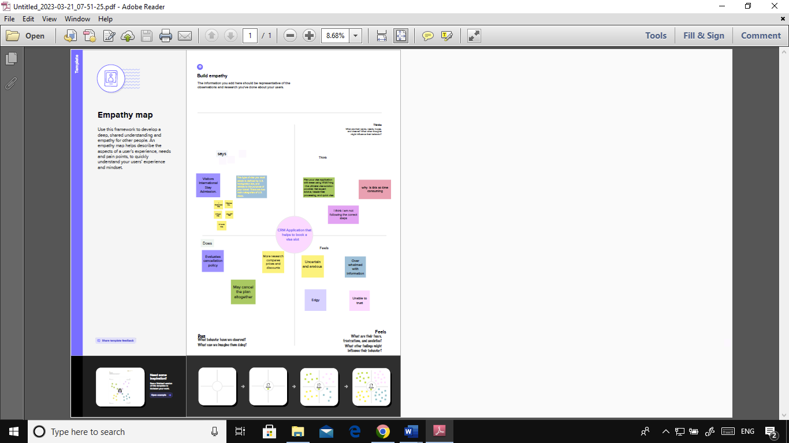 2.1 EMPATHY MAP :

2.2 IDEATION & BRAINSTORMING MAP

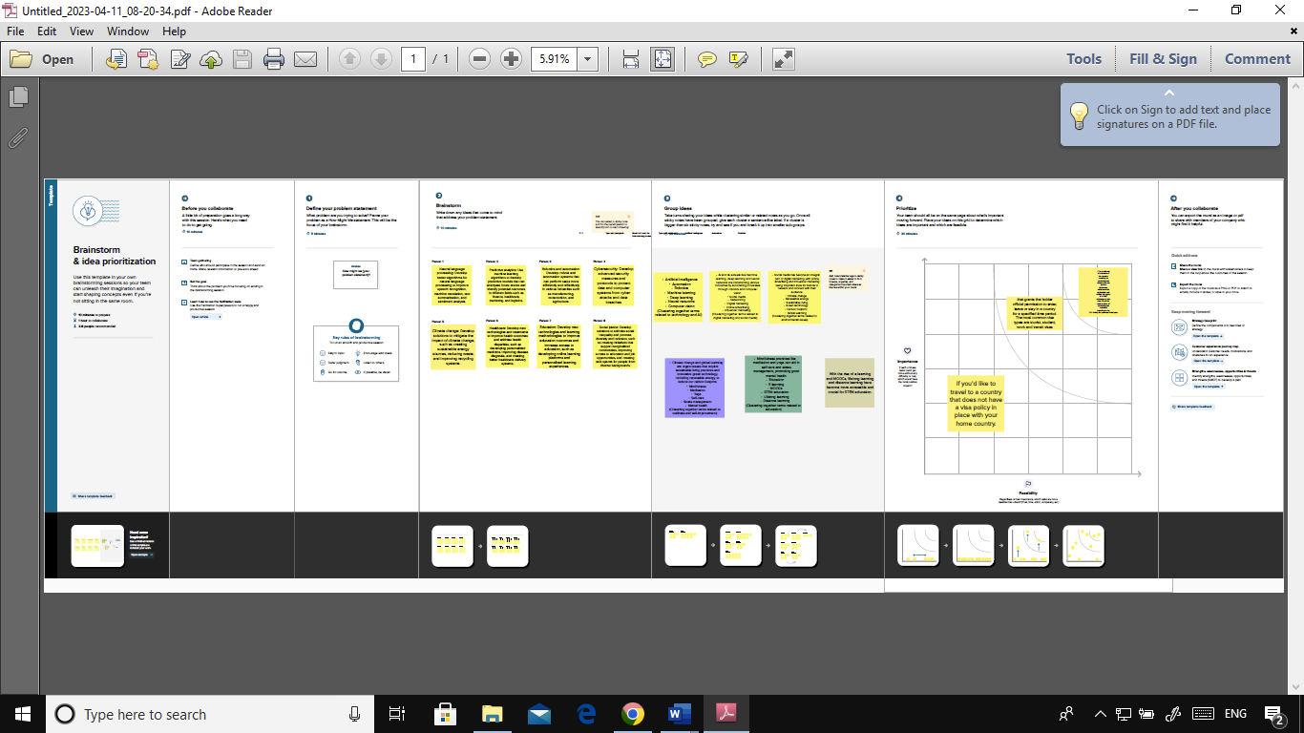

3. RESULT

3.1 DATA MODEL :

|  |  |
| --- | --- |
| OBJECT NAME | FIELD IN THE OBJECT |
| OBJECT 1 | |  |  | | --- | --- | | FIELD LABLE | DATA TYPE | | PASSPORT | NUMBER | | VISA SLOT | MASTER DETAIL  RELATIONSHIP | |
| OBJECT 2 | |  |  | | --- | --- | | FIELD LABLE | DATA TYPE | | PAYMENT | TEXT | | RESCHEDULE  /CANCEL | TEXT | |

3.2 : ACTIVITY & SCREENSHOT ;

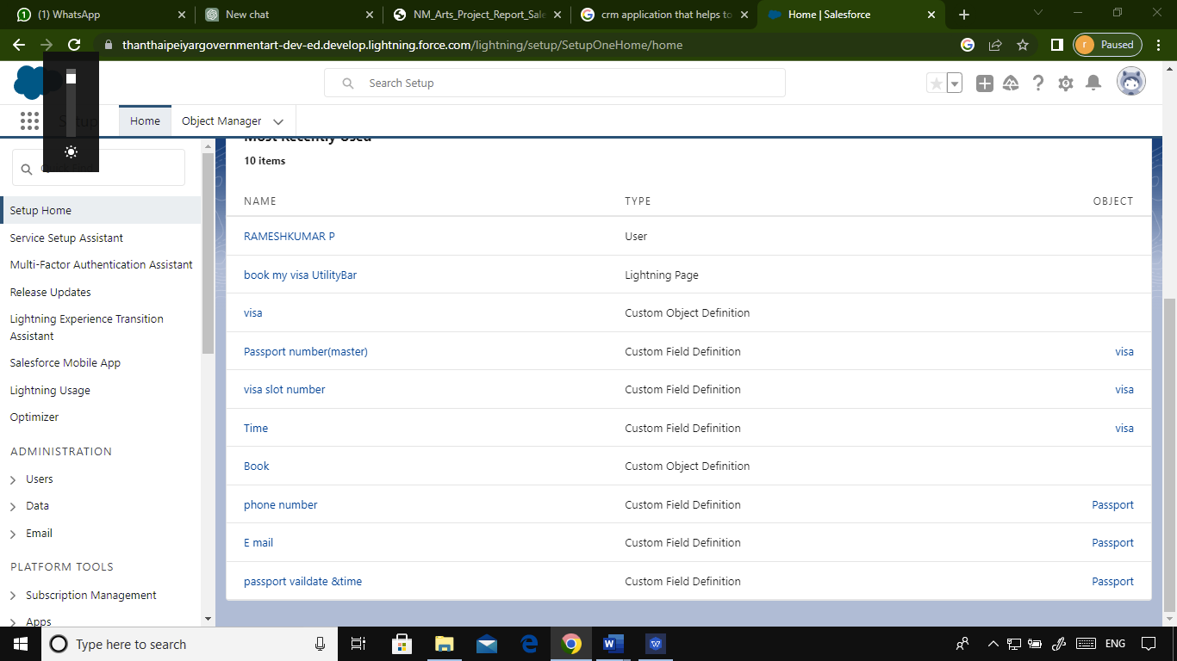

4. TRAILHEAD PROFILE PUBLIC URL ;

TEAM LEADER - <https://trailblazer.me/id/rperiyasamy8>

TEAM MEMBER 1 - <https://trailblazer.me/id/svellaisamy2>

TEAM MEMBER 2 - <https://trailblazer.me/id/sponnaiyan>

TEAM MEMBER 3 - <https://trailblazer.me/id/surij4>

5. ADVANTAGES & DISADVANTAGE :

ADVANTAGES :

1. Improved customer experience: By automating the visa appointment booking process, businesses can provide a more convenient and streamlined experience for their customers.
2. Increased operational efficiency: The application can help businesses manage their customer data and appointments more efficiently, reducing the need for manual processes and improving overall productivity.
3. Better data management: The application can store and manage customer data in a centralized location, making it easier for businesses to access and analyze their customer information.

DISADVANTAGE :

1. Technical issues: The application may experience technical issues, such as system crashes or bugs, which can disrupt the booking process and negatively impact customer experience.
2. Implementation challenges: Implementing a CRM application can be a complex process that requires significant time and resources, and businesses may face challenges in integrating the application with their existing systems.
3. Data security concerns: Storing and managing customer data carries risks, such as data breaches or cyber attacks, which can compromise the security and privacy of customer information.

6. APPLICATION :

1. User registration and login: Customers can create an account with their personal information and login to the application to manage their visa appointment bookings.
2. Visa appointment booking: Customers can search for available appointment slots based on their preferred date, time, and visa type, and book appointments accordingly.
3. Automated notifications: Customers can receive automated notifications about their appointment status, reminders, and any changes to the appointment schedule.
4. Payment processing: The application can facilitate payment processing for visa application fees and other charges associated with the appointment.

7. CONCLUSION :

In conclusion, a CRM (Customer Relationship Management) application that helps to book a visa slot can be a valuable tool for businesses that want to improve their customer service and operational efficiency. The application can automate the visa appointment booking process, provide a convenient and streamlined experience for customers, and store and manage customer data in a centralized location.

However, businesses need to consider the potential advantages and disadvantages of implementing a CRM application for visa slot booking. While the application can provide significant benefits such as improved customer experience, increased efficiency, and enhanced data management and analytics, it may also come with challenges such as technical issues, implementation challenges, data security concerns, cost, and dependency on technology.

8. FUTURE SCOPE :

1. Integration with other systems: As businesses continue to digitize their operations, there may be a need to integrate the visa slot booking application with other systems such as travel management systems, customer relationship management systems, or payment processing systems.
2. Advanced analytics and AI: The application may leverage advanced analytics and artificial intelligence (AI) technologies to provide more personalized service to customers, optimize appointment scheduling, and identify patterns in customer behavior.
3. Mobile-first approach: With the rise of mobile devices and mobile-first users, the visa slot booking application may become increasingly mobile-friendly, with a focus on mobile app development and user experience optimization.