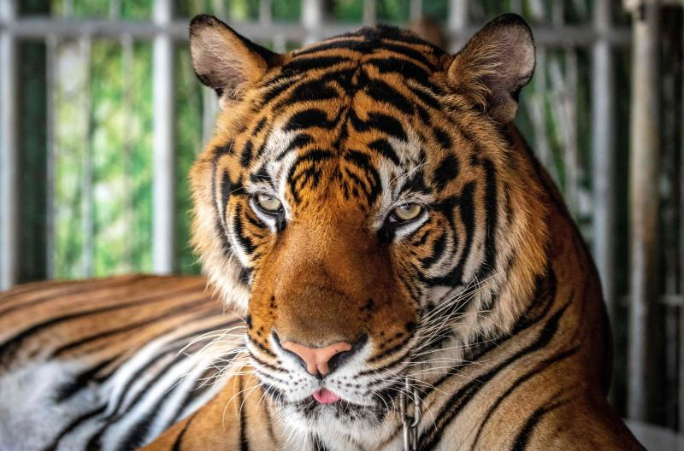

<https://www.bangkokpost.com/opinion/opinion/1860789/tiger-industry-continues-to-profit>