Project Report
On
Student Record managment System

Created By
Jaydip jadav Bscit-6

Under The Guidance of

Submitted To
GEETANAJALI COLLEGE OF COMPUTER SCIENCE & COMMERCE



Affiliated To
SAURASTRA UNIVERSITY

For Academic Year
2025-2026
Acknowledgement

The project on STUDENT RECORD MANAGEMENT SYSTEM is developed in PHP Language at GEETANJALI COLLEGE OF COMPUTER SCIENCE & COMMERCE.
I would like to acknowledge that my project has been completed and I am ensuring that, in this accomplishment, I would like to express my special gratitude to all my teachers and specially to PROF. BRIJESH MARU without their guidance and feedback it is not possible to complete this assignment.

Index

PERTICULARS | PAGE NO
- Introduction
  - Abstract 1
  - Purpose 1
- Project Profile 2
- System Requiment 3
- models 3
- software resources 4
- list of model 4

- Data dictonary 5
- System designe&Diagram 10
- DED 1 diyagram 11
- DFD 2 vel diagram 12
- Er diyagram 13
- Use case diagram 14
- Table of contant 15
- images 19
- conclusion 29

INTRODUCTION

Abstract
Student Record System is a web-based technology that manages student databases and provides rights to update the details. In this web application, Students must be registered by admin. This web application provides a way to effectively control records & track student details.
Student Record System is a web-based technology that manages student record.

Purpose
- student deatailles recording
- Easy add student information
- Admin register student information easyly
- Easy monitoring
- Admin can add,delete,update information
- Add course,subject any time
- Admin easyli add student

Project Profile

Project Title: Student Record management System
Development Software: Visual code
Front End Tool: PHP
Back End Tool: SQL Server
Academic Year: 2025-26
Developed By: jadav jaydip
Submitted To: GEETANJALI COLLEGE

System Requirements
- Server: Apache or any PHP-enabled web server
- Language: PHP (backend), HTML/CSS/JS (frontend)
- Database: MySQL/MariaDB
- Browser: Modern web browser

Modules
Admin Module: Manage Student details, Cours, subject, admin register student name.

Cours Module: Add cours, view cours name, select subject.

Subject Module: Add cours, view cours name, select subject.

Ragestor module: select course,select subject,personal information,contact information.

Session Module: Select session of year.

Authentication Module: Login, logout, session, role-based access control.

- Software Resources

Frontend Design Tool: Microsoft Visual Studio 2010
Backend Design Tool: Microsoft SQL server
Code-Behind Language: PHP

- Functionality:
- Login/logout
- Add subject
- Add course
- Register
- View student
- session

List Of Modules
- Login
- Student Module
- Fees Module
- Course Module
- Attendance Module

Data Dictionary

User Login Table
columns | Datatype | Constraints
UserId | int | -
UserName | char (10) | Not null
Password | varchar (20) | Not null

Course Table
columns | Datatype | Constraints
Id | Int(11) | -
course id | varchar(250) | Not null
cshort | varchar(250) | Not null
cfull | varchar(250) | Not null
cdate | varchar(250) | Not null
update_date | varchar(250) | Not null

Subject Table
columns | Datatype | Constraints
Id | int | -
Course short | varchar(50) | Not null
cfull | varchar (250) | Not null
sub1 | varchar(250) | Not null
Sub2 | varchar(250) | Not null
Sub3 | varchar(250) | Not null
Sub4 | varchar(250) | Not null

session Table
columns | Datatype | Constraints
Id | int | PK
session | varchar(250) | Not null
Posting date | date | Not null
status | Int(11) | Not null

Register Table

columns | Datatype | Constraints
Id | int (11) | -
course | Varcher(150) | Not null
subject | varchar (150) | Not null
fname | Varcher(255) | Not null
mname | enum | Not null
lname | Int(11) | Not null
gender | Int(11) | Not null
gname | timestamp | Not null
ocp | Varcher(255) | Not null
income | Varcher(255) | Not null
category | Varcher(255) | Not null
pchal | Varcher(255) | Not null
nationality | Varcher(255) | Not null
mobno | Varcher(255) | Not null
emailid | Varcher(255) | Not null
country | Varcher(255) | Not null
state | Varcher(255) | Not null
dist | Varcher(255) | Not null
padd | text | Not null
cadd | text | Not null
bord | Varcher(255) | Not null
roll | Varcher(255) | Not null
pyear | Varcher(255) | Not null
sub | Varcher(255) | Not null
marks | Bigint(100) | Not null
fmarks | Bigint(100) | Not null
Board1 | Varcher(255) | Not null
Roll1 | Varcher(255) | Not null
Yop1 | Varcher(255) | Not null
Sub1 | Varcher(255) | Not null
session | Varcher(255) | Not null
Marks1 | Varcher(255) | Not null
Fmarks1 | Varcher(255) | Not null
regno | Varcher(255) | Not null

City Table

columns | Datatype | Constraints
id | int (11) | -
name | Varcher(30) | NOT null
City id | Int(11) | Not null

state Table:

columns | Datatype | Constraints
id | int (11) | -
name | Varcher(30) | NOT null
State_id | Int(11) | Not null

country Table:

columns | Datatype | Constraints
id | int (11) | -
name | Varcher(30) | NOT null
country_id | Int(11) | Not null

- 0 level DFD (Context Diagram):

System Design & Diagrams

- 1 DFD (Context Diagram):

DFD:2 managing student redord

Admin

*ER diyagram:

*Use case diyagram overview:

Table of Contents
- Authentication
- Register managment
- Course
- subject
- session
- state
- Country
- City

1.Authentication:
Test ID | Test Scenario | Expected Result | Status
TC_001 | Verify module main page loads successfully | Page should load without errors
TC_002 | Verify user input validations | System should validate and show proper messages
TC_003 | Verify authorized access control | Unauthorized users should not access restricted pages
TC_004 | Verify CRUD operations work correctly | Create, Update, Delete actions should function properly
TC_005 | Verify UI and layout responsiveness | Page layout should be responsive on all devices

2.Register managment:

Test ID | Test Scenario | Expected Result | Status
TC_001 | Verify module main page loads successfully | Page should load without errors
TC_002 | Verify user input validations | System should validate and show proper messages
TC_003 | Verify authorized access control | Unauthorized users should not access restricted pages
TC_004 | Verify CRUD operations work correctly | Create, Update, Delete actions should function properly
TC_005 | Verify UI and layout responsiveness | Page layout should be responsive on all devices

3.Course:
Test ID | Test Scenario | Expected Result | Status
TC_001 | Verify module main page loads successfully | Page should load without errors
TC_002 | Verify user input validations | System should validate and show proper messages
TC_003 | Verify authorized access control | Unauthorized users should not access restricted pages
TC_004 | Verify CRUD operations work correctly | Create, Update, Delete actions should function properly
TC_005 | Verify UI and layout responsiveness | Page layout should be responsive on all devices

4.subject:
Test ID | Test Scenario | Expected Result | Status
TC_001 | Verify module main page loads successfully | Page should load without errors
TC_002 | Verify user input validations | System should validate and show proper messages
TC_003 | Verify authorized access control | Unauthorized users should not access restricted pages
TC_004 | Verify CRUD operations work correctly | Create, Update, Delete actions should function properly
TC_005 | Verify UI and layout responsiveness | Page layout should be responsive on all devices

5.session:
Test ID | Test Scenario | Expected Result | Status
TC_001 | Verify module main page loads successfully | Page should load without errors
TC_002 | Verify user input validations | System should validate and show proper messages
TC_003 | Verify authorized access control | Unauthorized users should not access restricted pages
TC_004 | Verify CRUD operations work correctly | Create, Update, Delete actions should function properly
TC_005 | Verify UI and layout responsiveness | Page layout should be responsive on all devices

6.state:
Test ID | Test Scenario | Expected Result | Status
TC_001 | Verify module main page loads successfully | Page should load without errors
TC_002 | Verify user input validations | System should validate and show proper messages
TC_003 | Verify authorized access control | Unauthorized users should not access restricted pages
TC_004 | Verify CRUD operations work correctly | Create, Update, Delete actions should function properly
TC_005 | Verify UI and layout responsiveness | Page layout should be responsive on all devices

7:Country:
Test ID | Test Scenario | Expected Result | Status
TC_001 | Verify module main page loads successfully | Page should load without errors
TC_002 | Verify user input validations | System should validate and show proper messages
TC_003 | Verify authorized access control | Unauthorized users should not access restricted pages
TC_004 | Verify CRUD operations work correctly | Create, Update, Delete actions should function properly
TC_005 | Verify UI and layout responsiveness | Page layout should be responsive on all devices

8.City:
Test ID | Test Scenario | Expected Result | Status
TC_001 | Verify module main page loads successfully | Page should load without errors
TC_002 | Verify user input validations | System should validate and show proper messages
TC_003 | Verify authorized access control | Unauthorized users should not access restricted pages
TC_004 | Verify CRUD operations work correctly | Create, Update, Delete actions should function properly
TC_005 | Verify UI and layout responsiveness | Page layout should be responsive on all devices

- Login Screen:
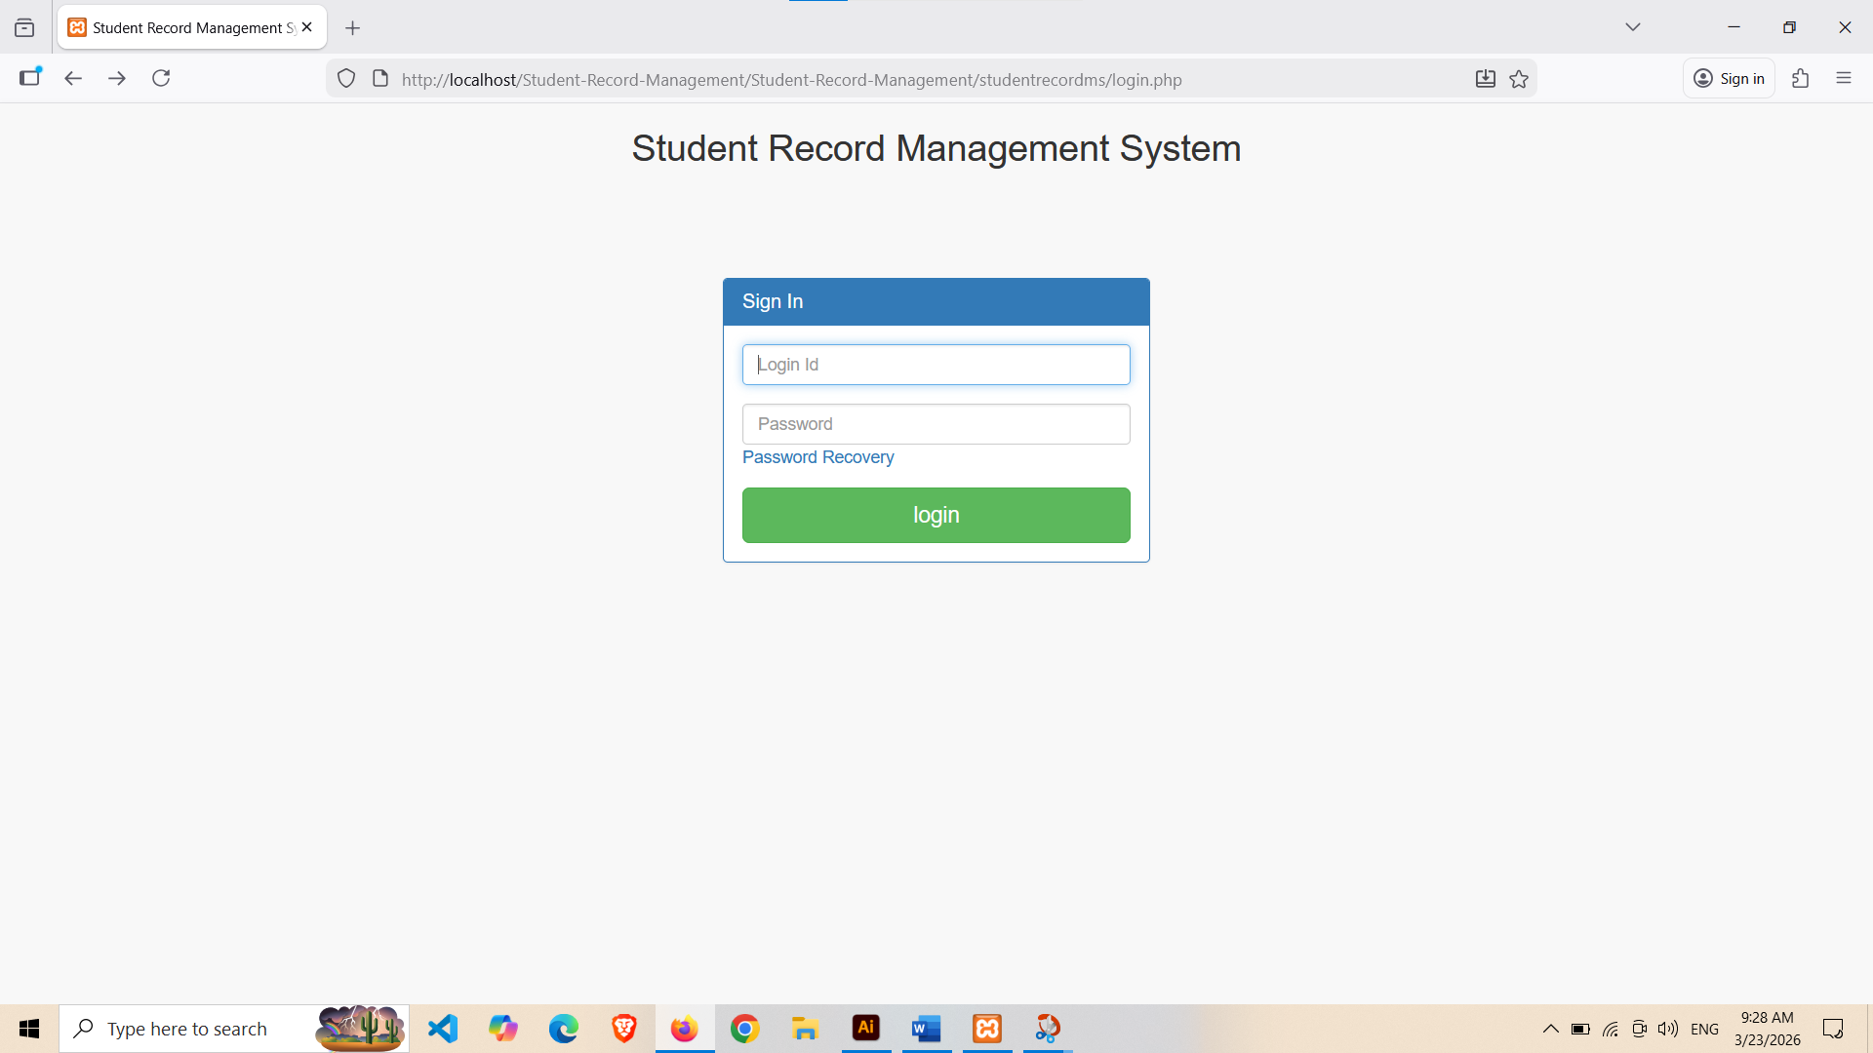

→ In this page user must give username & password.
→ If the password is correct, then he will be redirect to home page else he gets the prompt.
→ Admin can only login.

- Admin Dashbord page:

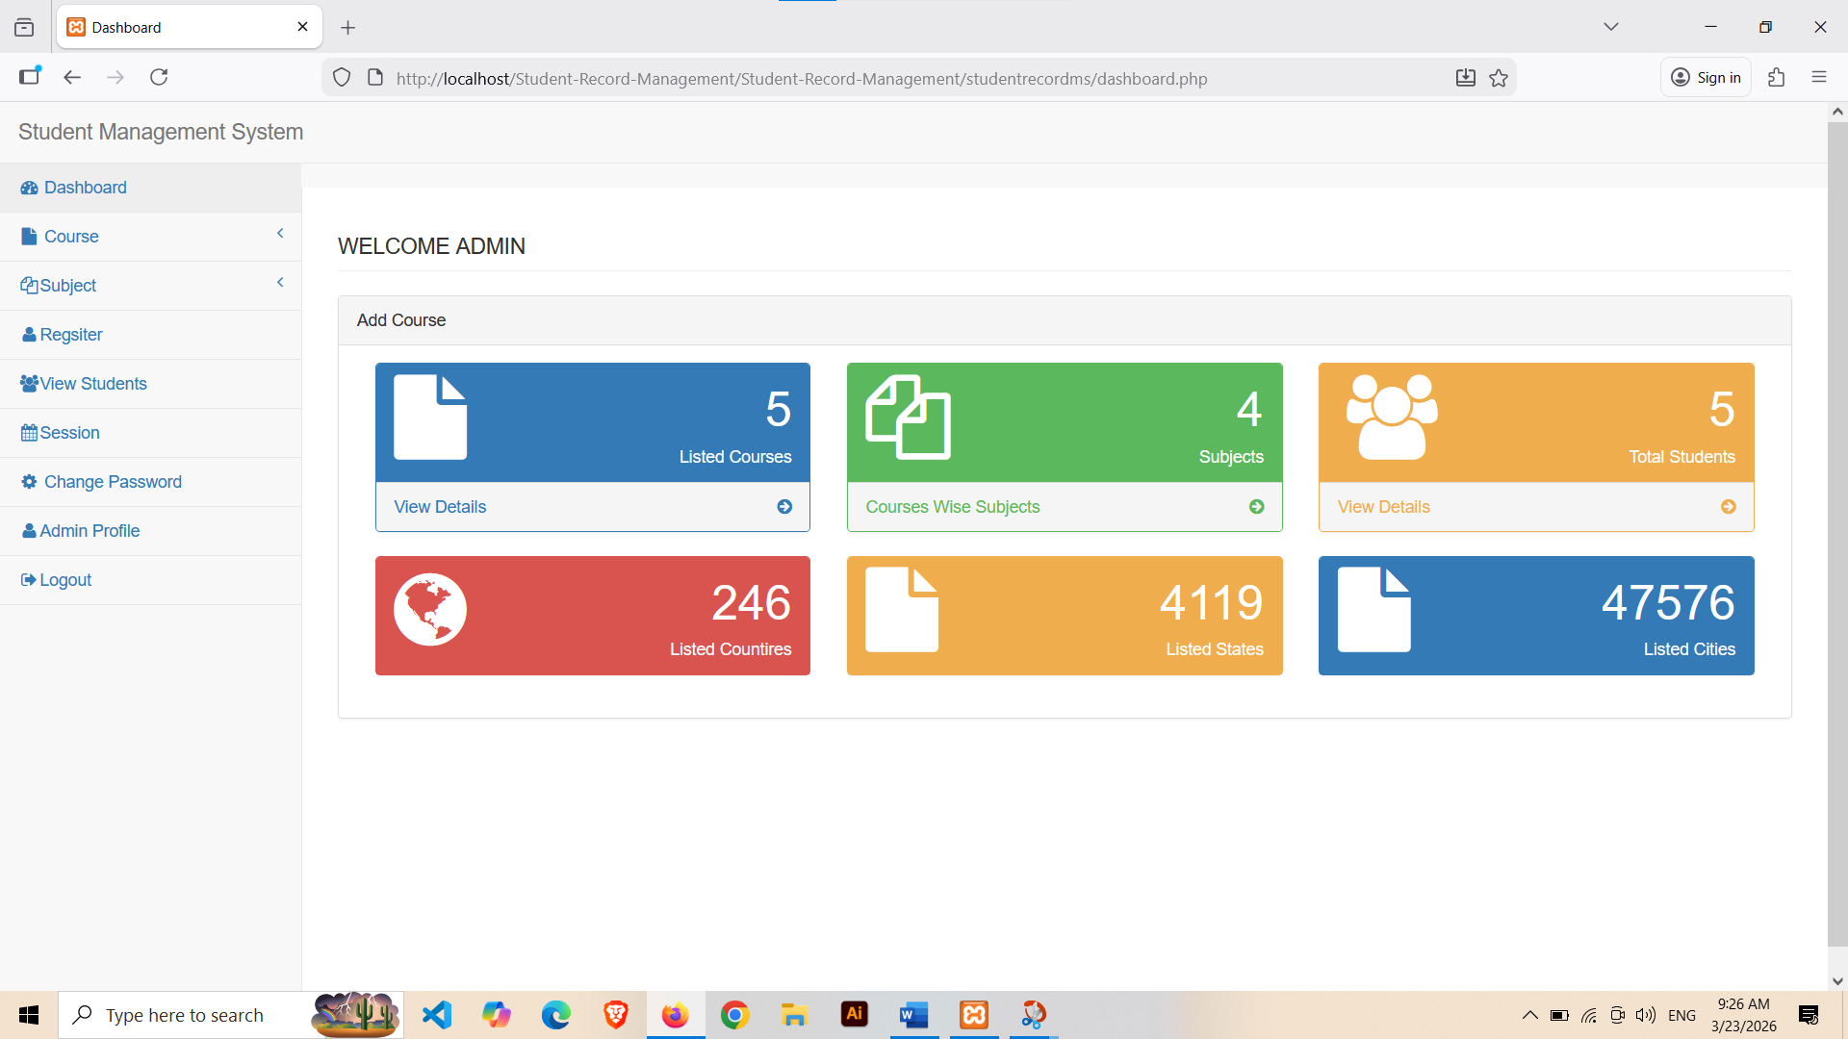

- Hear is a admin dashboard to show all data and information.
- Admin can add a cours and managing all Student and Activity.
- Hear is admin can handal all student,Course,student register.
- Admin can add course,subject or student.
- Admin can register student details and informantion.

- Add course Page:
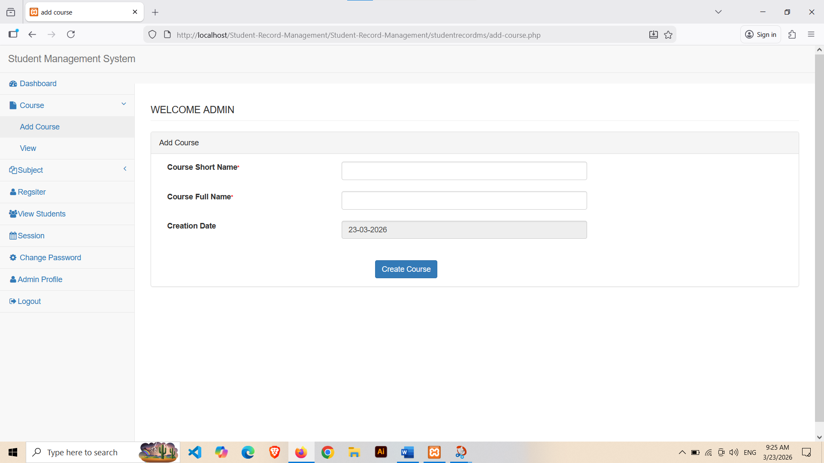

- Hear is a Course ,admin can add course.
- Admin can add couse and view.
- Admin creat course.
- View coure.

- Add Subject Page:

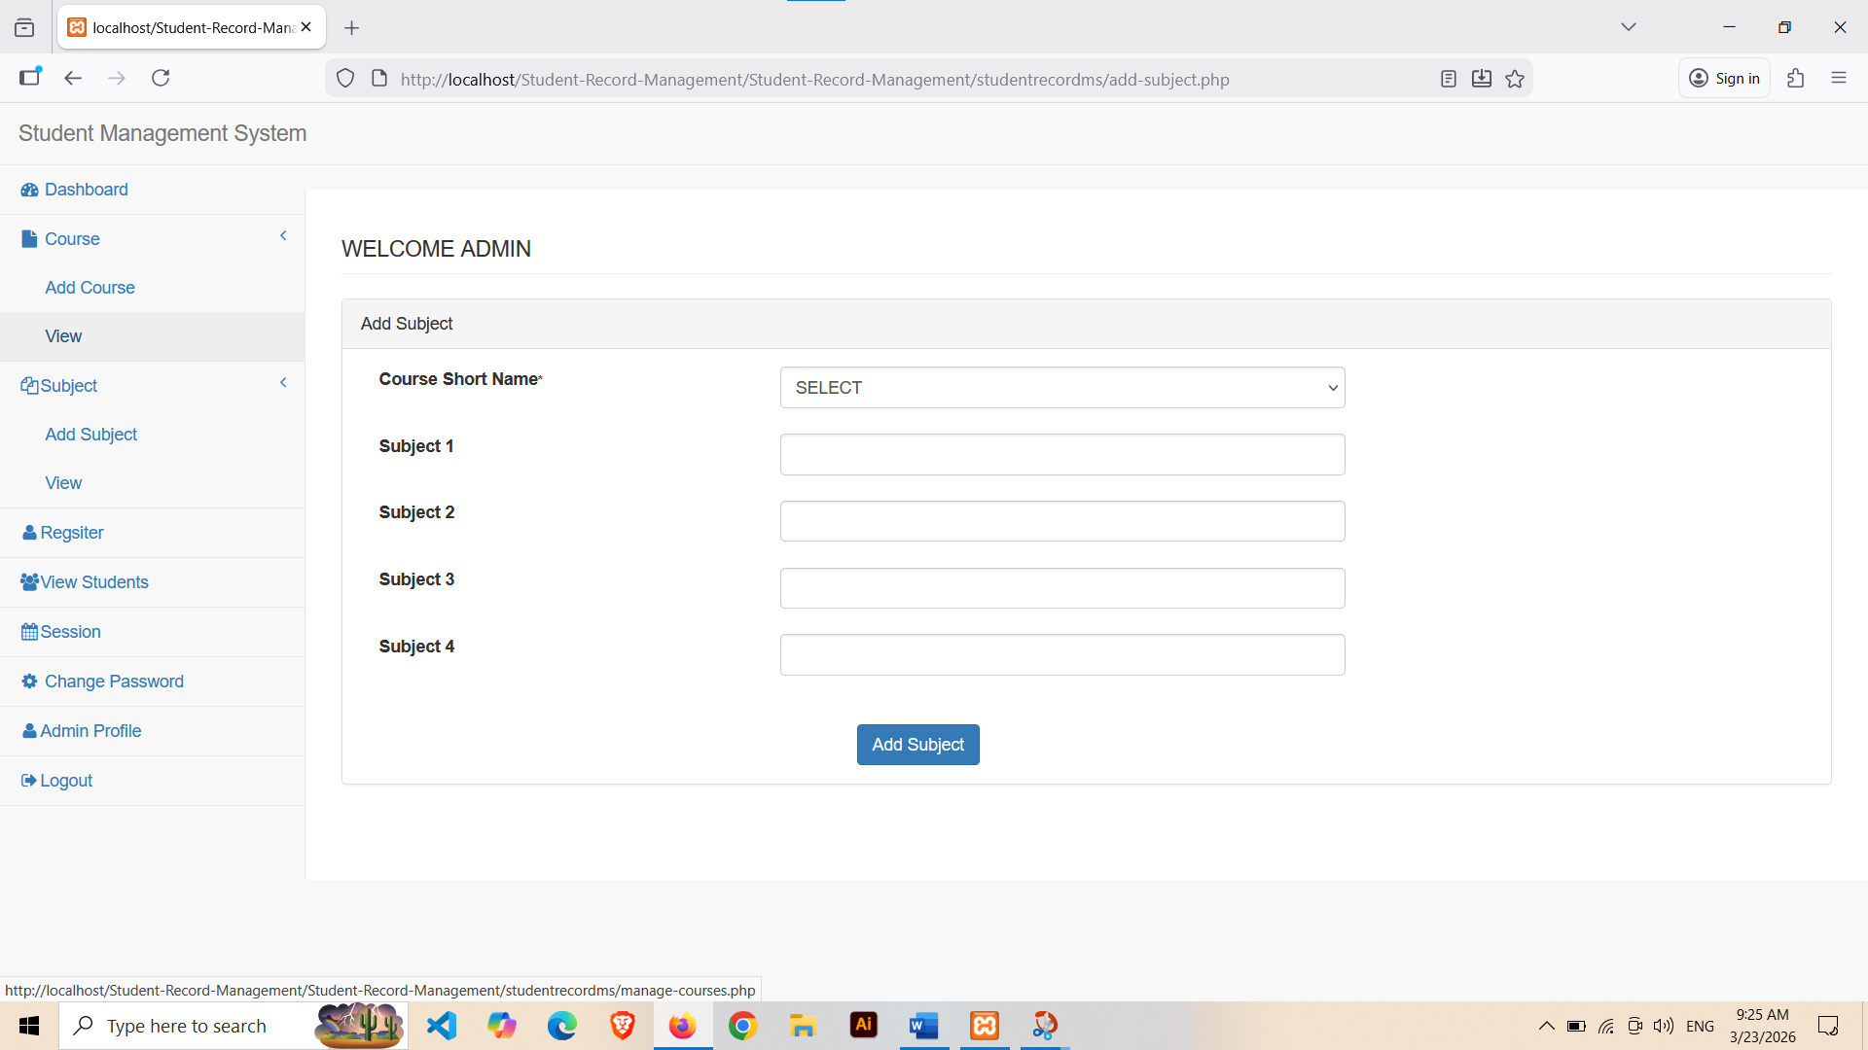

- Hear is a page to add subject.
- Admin can add subject details.
- Select course name add subject add.
- Admin can view subject.
- This page is use to add subject.

- Register Page:
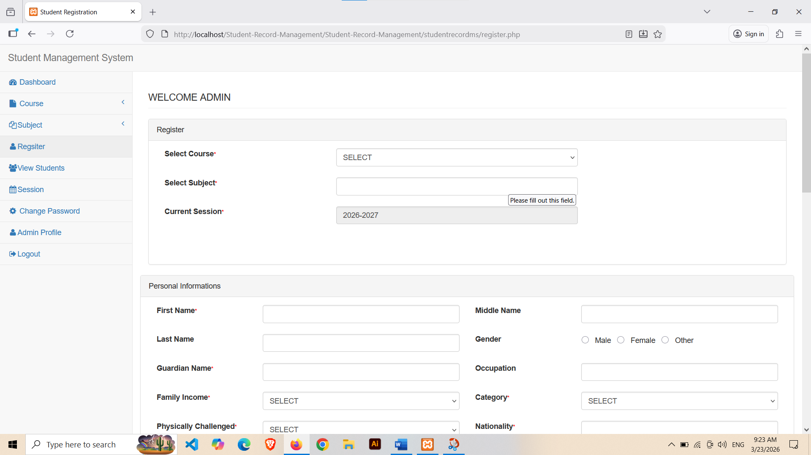

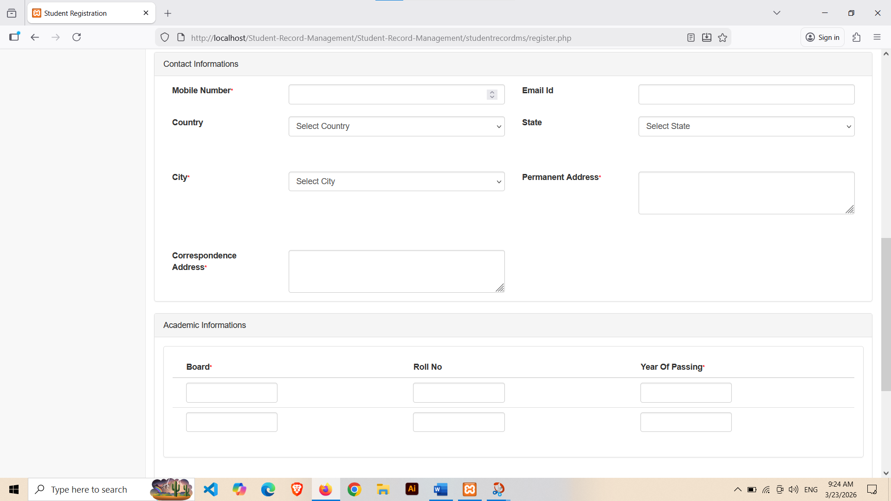
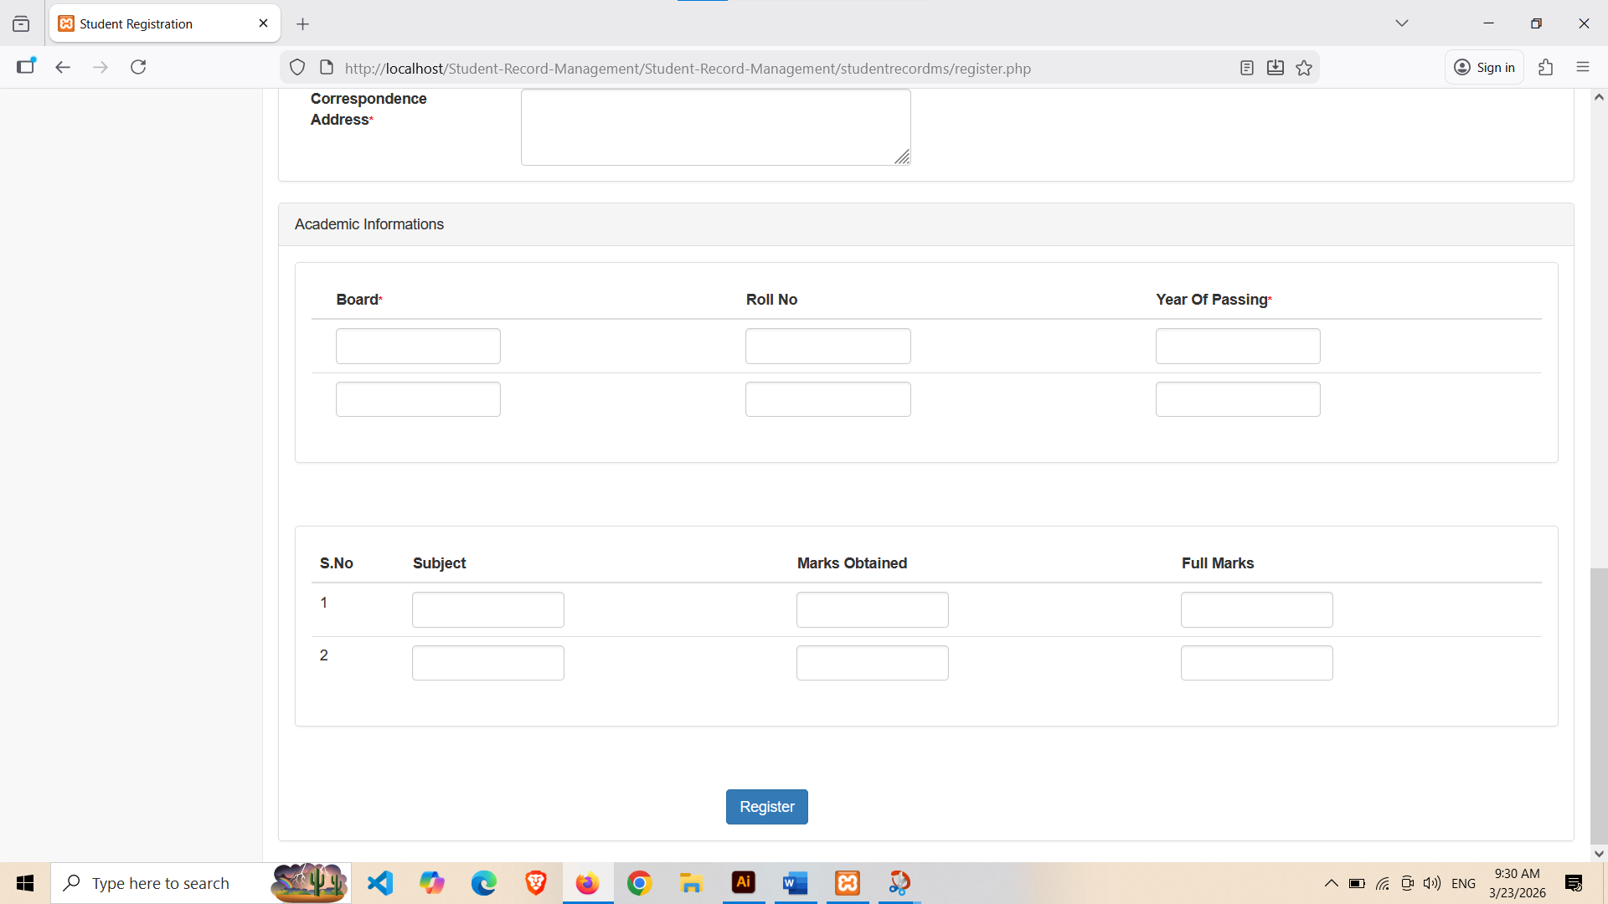
- Hear is a page to admin can register Student.
- First step is select subject,course.
- After select subject,course select personal information.
- Filip student personal infromatiom like name,gender,occupation,nationality,category,income etc.
- After personal information add.
- Contact information filip like Gmail,phone number,address etc.
- Academic information filip.

⮚ View Student page:
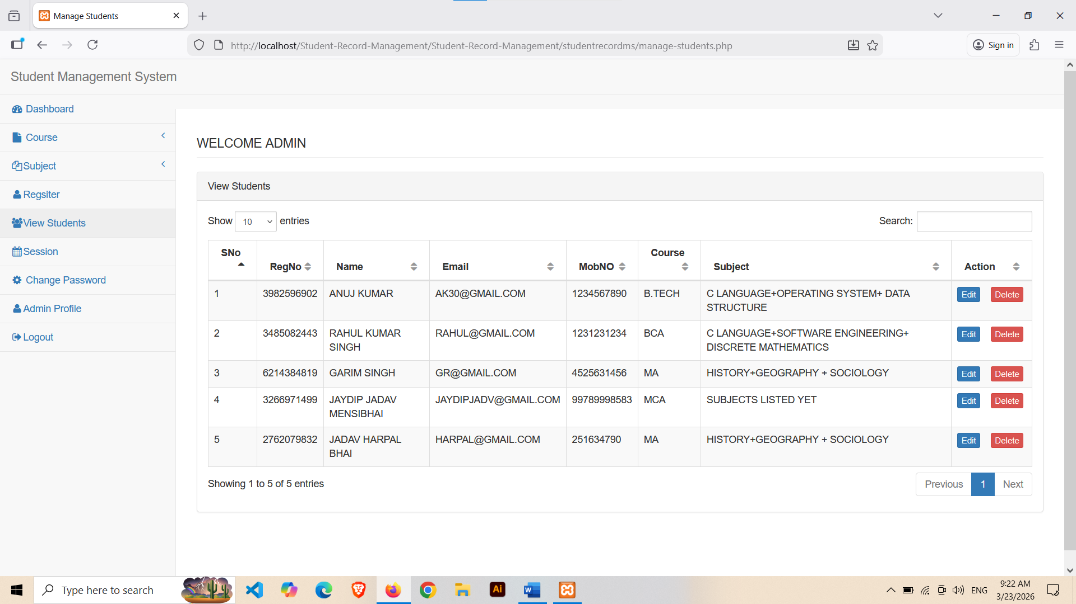

- Hear is a page to student.
- Aadmin can view thair student.
- Admin can edit,delete student.
- Heare show student all information.

- Session page:
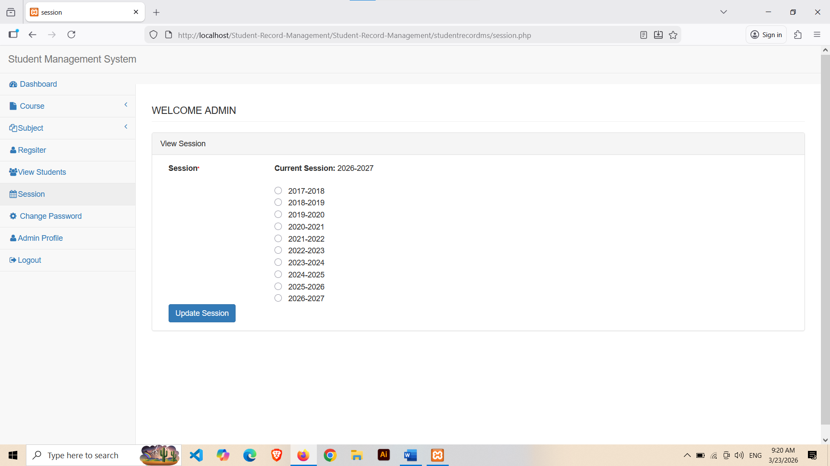

- In this page Session.
- Select session year.
- Admin can update session and select session

Conclusion :
- The Student record Management System developed using PHP and MySQL provides an efficient, reliable, and user-friendly solution for managing student information.
- The system allows administrators to manage Student records, monitor daily student details.

- The project entitled as Student record system is the system that deals with the issues related to a particular institution.
- This project is successfully implemented with all the features mentioned in system requirements specification.
- The project is designed to management a Student record managment.

