SELECT * FROM CAR_SALES_TRANSACTION

WHERE OWNER = 'First Owner' AND

YEAR BETWEEN 2016 AND 2020

AND KM_DRIVEN < 80000

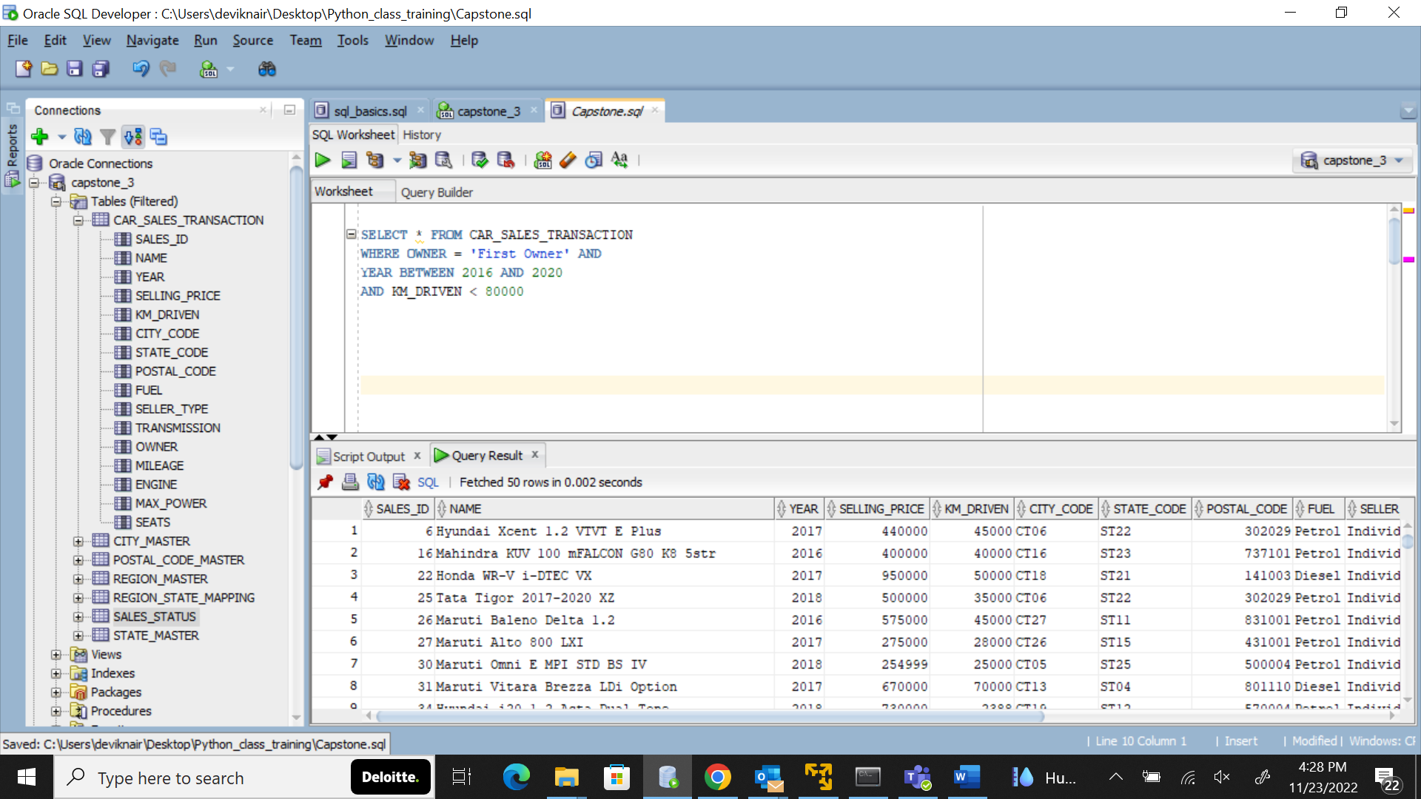

SELECT * FROM CAR_SALES_TRANSACTION

WHERE MILEAGE BETWEEN '24' AND '26' AND

SEATS IN ('4','5')AND

FUEL = 'Diesel' AND

YEAR BETWEEN 2018 AND 2020

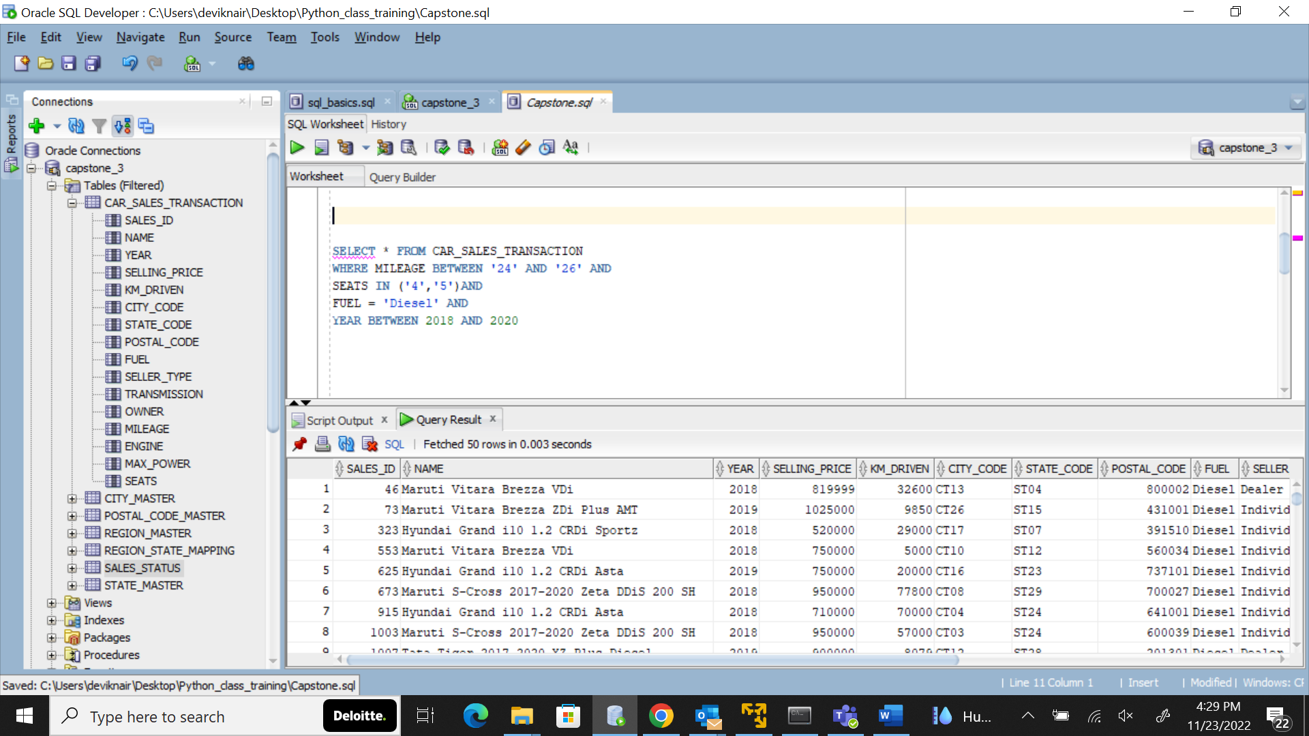

SELECT * FROM CAR_SALES_TRANSACTION

JOIN SALES_STATUS USING (SALES_ID)

WHERE SOLD = 'N' AND

SELLER_TYPE IN ('Individual','Dealer') AND

KM_DRIVEN <60000 AND

YEAR BETWEEN 2014 AND 2020

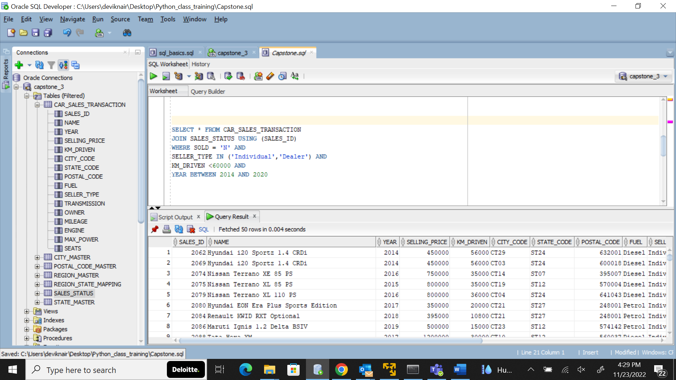

SELECT * FROM CAR_SALES_TRANSACTION JOIN CITY_MASTER

USING (CITY_CODE)

WHERE MILEAGE BETWEEN '20' AND '25' AND

CITY_NAME IN('Mumbai', 'Kochi', 'Chennai', 'Delhi')

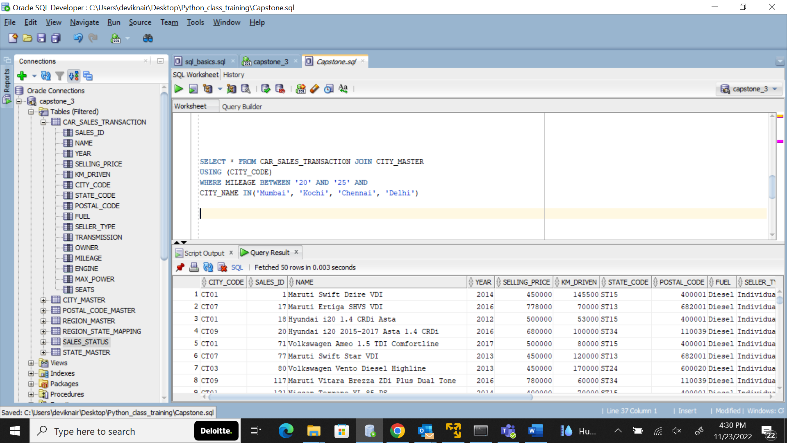

SELECT * FROM CAR_SALES_TRANSACTION JOIN SALES_STATUS

USING (SALES_ID)

WHERE NAME LIKE '%Honda%' AND

OWNER IN ('First Owner','Second Owner') AND

FUEL = 'Petrol' AND

MILEAGE = '25' AND

SOLD = 'N' AND

SEATS > 4

