|  |  |
| --- | --- |
| **Ex. No : 4**  **Date:** | **Create a web form that accepts a user’s name and age.Write a servlet to process the form data and display it back on the browser** |

**AIM:**

To write a Java Servlet program to process the form of data to accepts user’ name and age,and displaying it back on the browser.

**PROGRAM:**

**HTML Code:**

<!DOCTYPE html>

<html>

<head>

<meta charset="ISO-8859-1">

<title>forms</title>

</head>

<body>

<form action="/Ramesh_134/DisplayUser">

<h1><i>Form validation</i></h1>

<p>

<label for="user">Username: </label>

<input type="text" name="user" placeholder="Enter your name"><br><br>

</p>

<p>

<label for="age">Age: </label>

<input type="number" name="age" placeholder="Enter your age" required><br><br>

</p>

<input type="submit" name="Accept">

</form>

</body>

</html>

**Servlet Code:**

package com.ramesh.servlet;

import java.io.IOException;

import java.io.PrintWriter;

import javax.servlet.ServletException;

import javax.servlet.annotation.WebServlet;

import javax.servlet.http.HttpServlet;

import javax.servlet.http.HttpServletRequest;

import javax.servlet.http.HttpServletResponse;

/**

* Servlet implementation class DisplayUser 231801134

*/

@WebServlet("/DisplayUser")

public class DisplayUser extends HttpServlet {

private static final long serialVersionUID = 1L;

/**

* @see HttpServlet#HttpServlet()

*/

public DisplayUser() {

super();

// TODO Auto-generated constructor stub

}

/**

* @see HttpServlet#doGet(HttpServletRequest request, HttpServletResponse response)

*/

protected void doGet(HttpServletRequest request, HttpServletResponse response) throws ServletException, IOException {

String a=request.getParameter("user");

String b=request.getParameter("age");

int c=Integer.parseInt(b);

PrintWriter p=response.getWriter();

if(a.isEmpty()) {

p.println("Username name should not be Empty");

}

else if(c<=0){

p.println("Age should not less than 1.");

}

else {

p.println("Username: " +a+"<br>");

p.println("age: " +c+"<br>");

}

}

/**

* @see HttpServlet#doPost(HttpServletRequest request, HttpServletResponse response)

*/

protected void doPost(HttpServletRequest request, HttpServletResponse response) throws ServletException, IOException {

// TODO Auto-generated method stub

doGet(request, response);

}

}

231801134

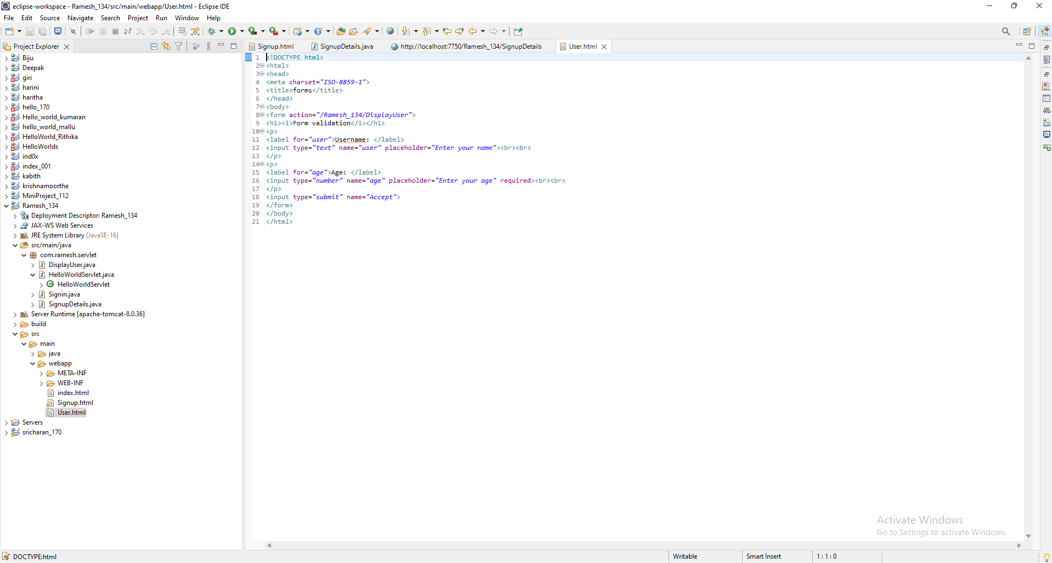

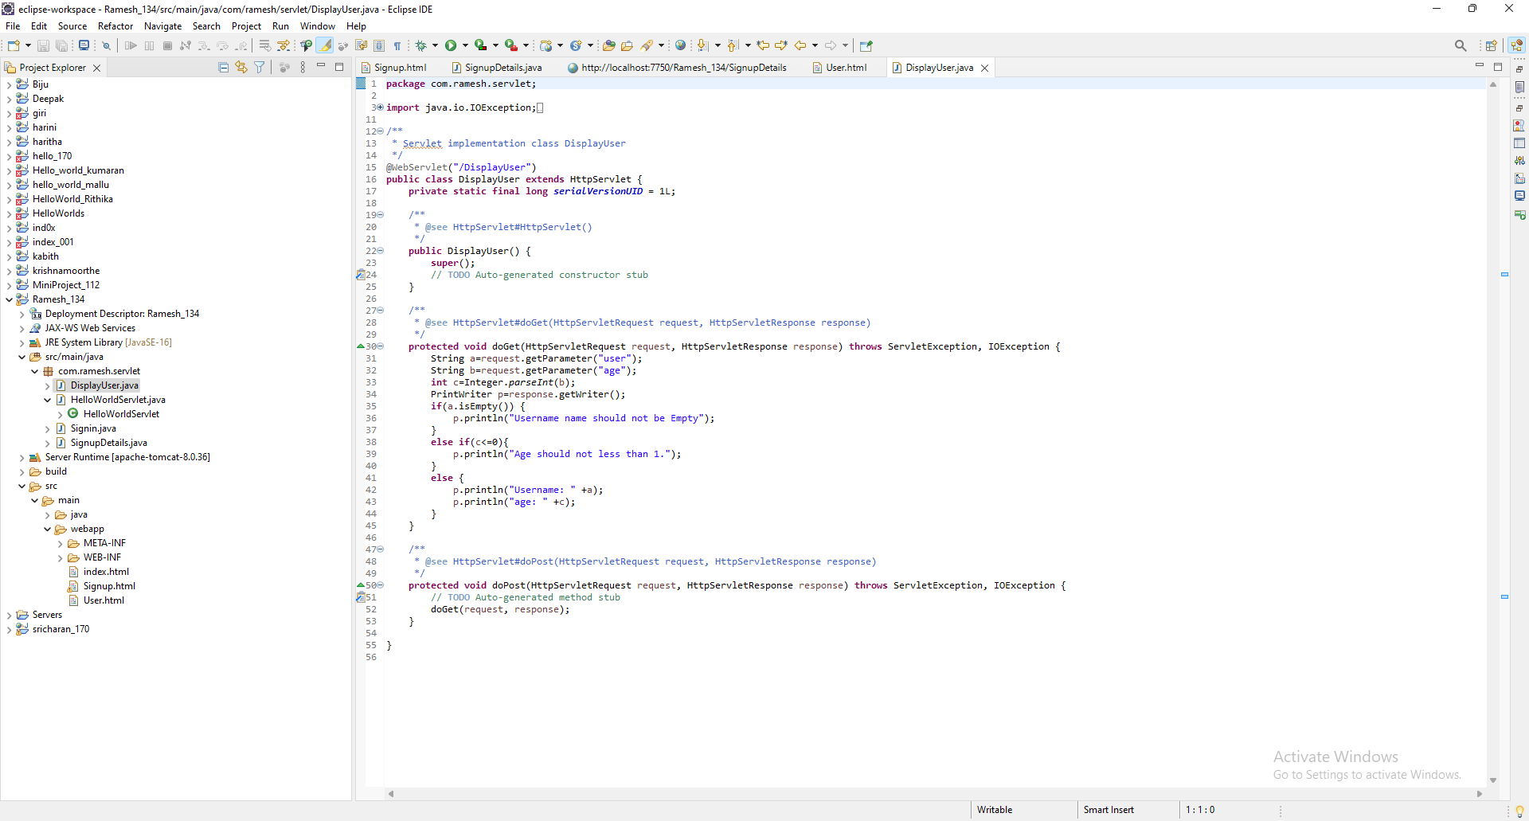

231801134

**OUTPUT:**

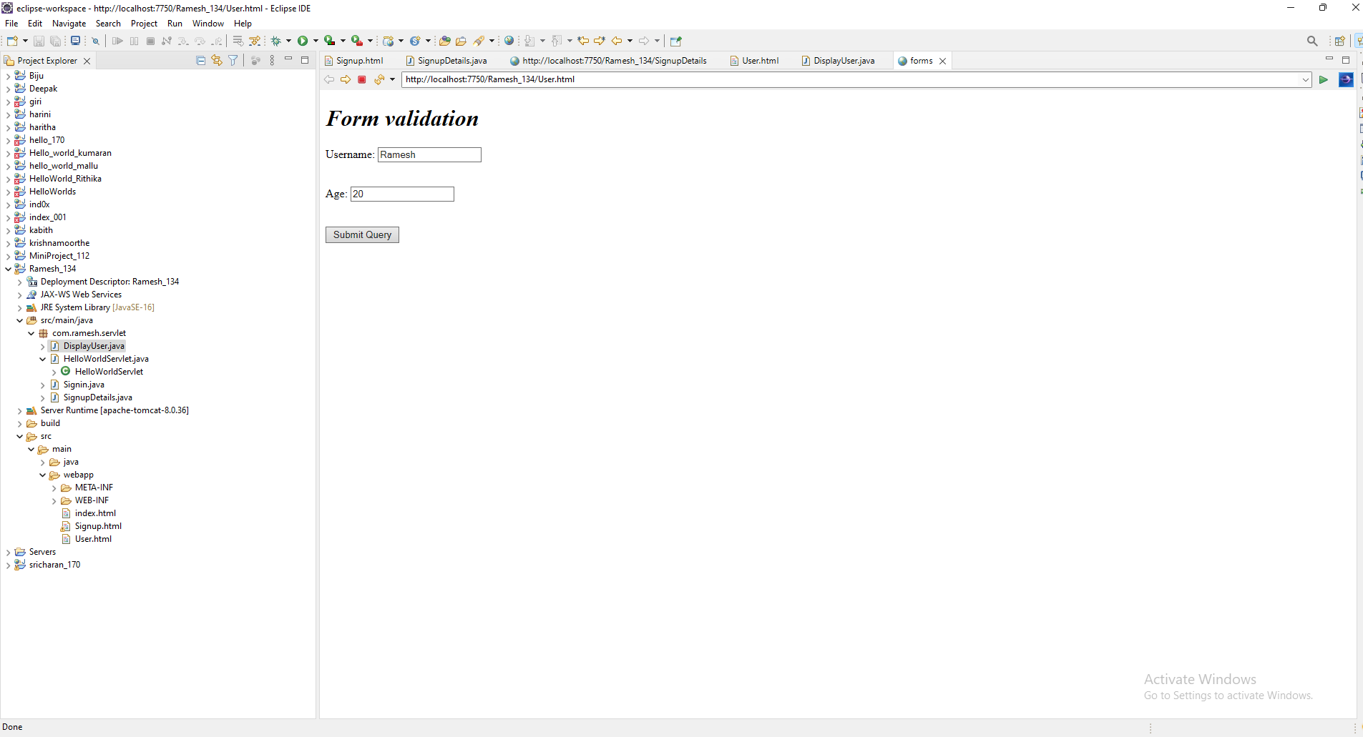

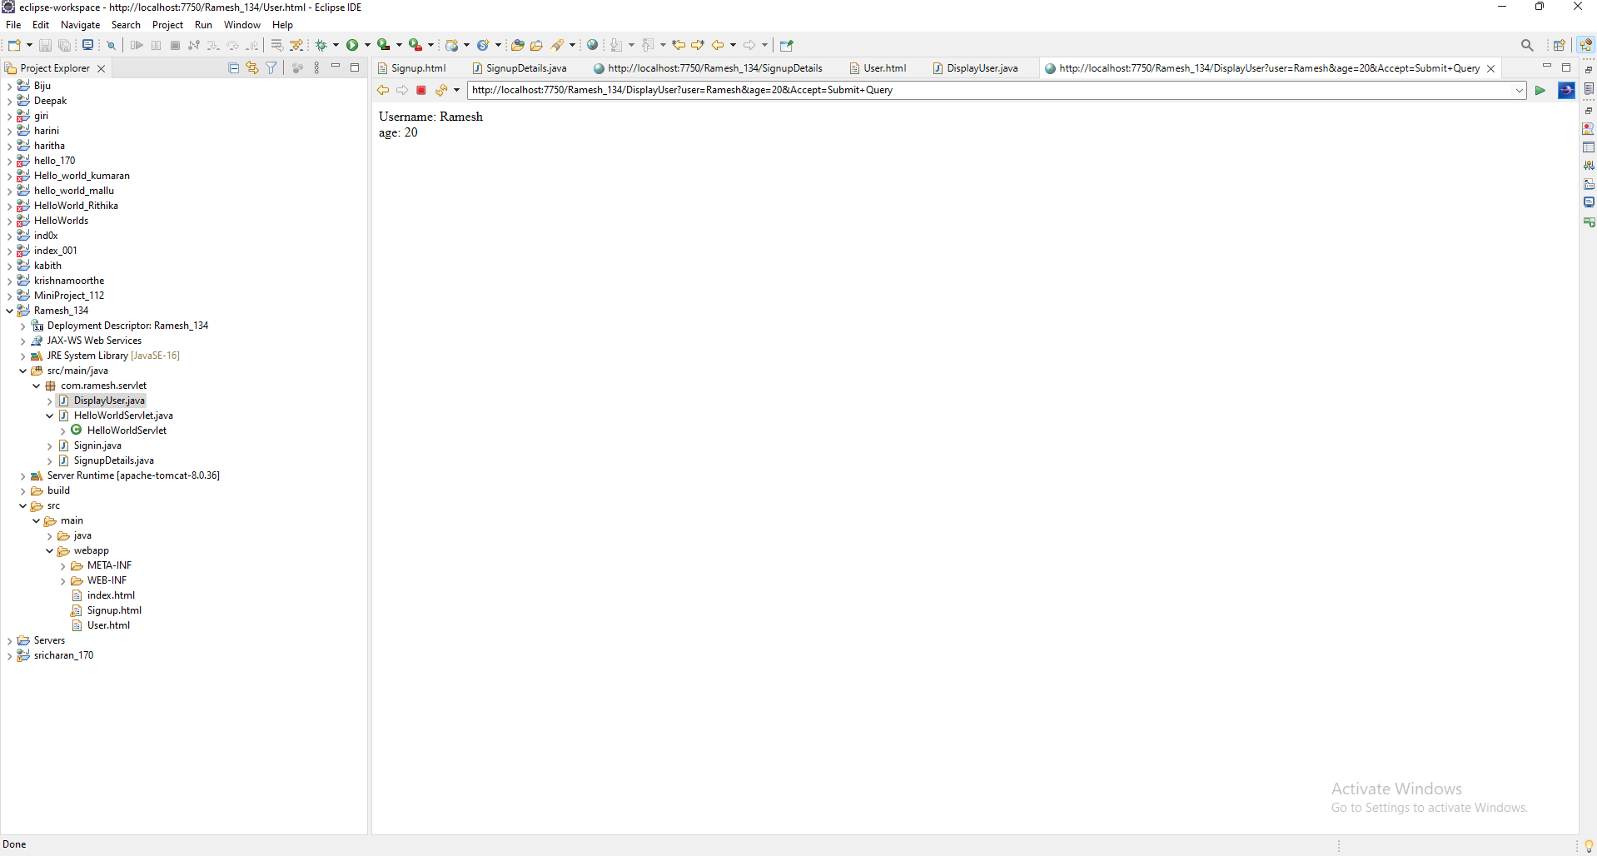

**RESULT:**

The output of user name and age was successfully displayed in the browser when the servlet was accessed.

231801134