|  |  |
| --- | --- |
| **Ex. No : 5**  **Date:** | **Write a servlet to demonstrate the difference betwwen HTTP GET and POST methods by creating a form and handling requests accordingly** |

**AIM:**

To write a Java Servlet program to tell difference between HTTP GET and POST methods by creating form and handling requests

**PROGRAM:**

**HTML Code:**

<!DOCTYPE html>

<html>

<head>

<meta charset="ISO-8859-1">

<title>Insert title here</title>

</head>

<body>

<center>

<h1 style="color:blue">SIGNUP FORM</h1>

<form method="post" action="/Ramesh_134/SignupDetails">

<label for="fname">First Name:</label>

<input type="text" id="fname" name="fname" placeholder="Enter your first name" required><br><br>

<label for="lname">Last Name:</label>

<input type="text" id="lname" name="lname" placeholder="Enter your last name" required><br><br>

<label for="dob">Date of Birth:</label>

<input type="date" id="dob" name="dob" required><br><br>

<p>

<label for="gender">Gender: </label>

<label for="male">Male </label>

<input type="radio" id="male" name="gender" value="Male">

<label for="female">Female </label>

<input type="radio" id="male" name="gender" value="Female"><br><br>

</p>

<label for="address">Address</label> 231801134

<textarea type="text" name="address"></textarea><br><br>

<input type="submit" value="SignUp">

</form>

</center>

</body>

</html>

**Servlet Code:**

package com.ramesh.servlet;

import java.io.IOException;

import java.io.PrintWriter;

import javax.servlet.ServletException;

import javax.servlet.annotation.WebServlet;

import javax.servlet.http.HttpServlet;

import javax.servlet.http.HttpServletRequest;

import javax.servlet.http.HttpServletResponse;

/**

* Servlet implementation class SignupDetails

*/

@WebServlet("/SignupDetails")

public class SignupDetails extends HttpServlet {

private static final long serialVersionUID = 1L;

/**

* @see HttpServlet#HttpServlet()

*/

public SignupDetails() {

super();

// TODO Auto-generated constructor stub

}

/**

* @see HttpServlet#doGet(HttpServletRequest request, HttpServletResponse response)

*/

protected void doGet(HttpServletRequest request, HttpServletResponse response) throws ServletException, IOException {

// TODO Auto-generated method stub

response.getWriter().append("Served at: ").append(request.getContextPath());

}

/**

* @see HttpServlet#doPost(HttpServletRequest request, HttpServletResponse response)

*/

protected void doPost(HttpServletRequest request, HttpServletResponse response) throws ServletException, IOException {

String f_name=request.getParameter("fname"); 231801134

String l_name=request.getParameter("lname");

String DOB=request.getParameter("dob");

String gen=request.getParameter("gender");

String add=request.getParameter("address");

PrintWriter p = response.getWriter();

p.println("First Name: "+f_name+"<br>");

p.println("Last Name: "+l_name+"<br>");

p.print("Age: "+DOB+"<br>");

p.print("Gender: "+gen+"<br>");

p.print("Address: "+add+"<br>");

}

}

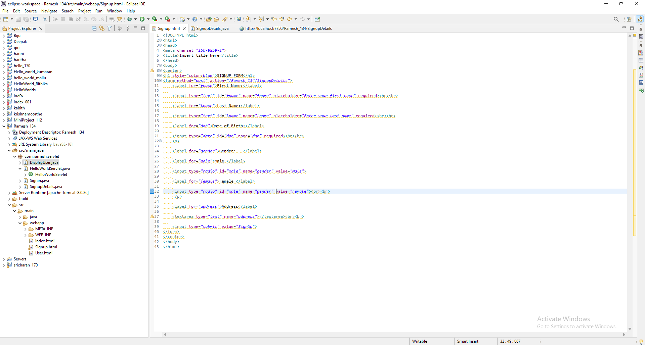

231801134

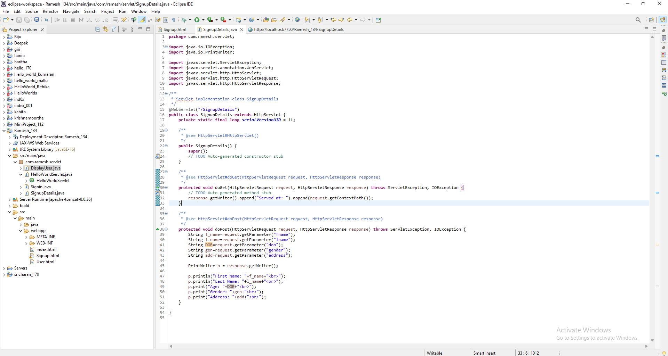

**OUTPUT:**

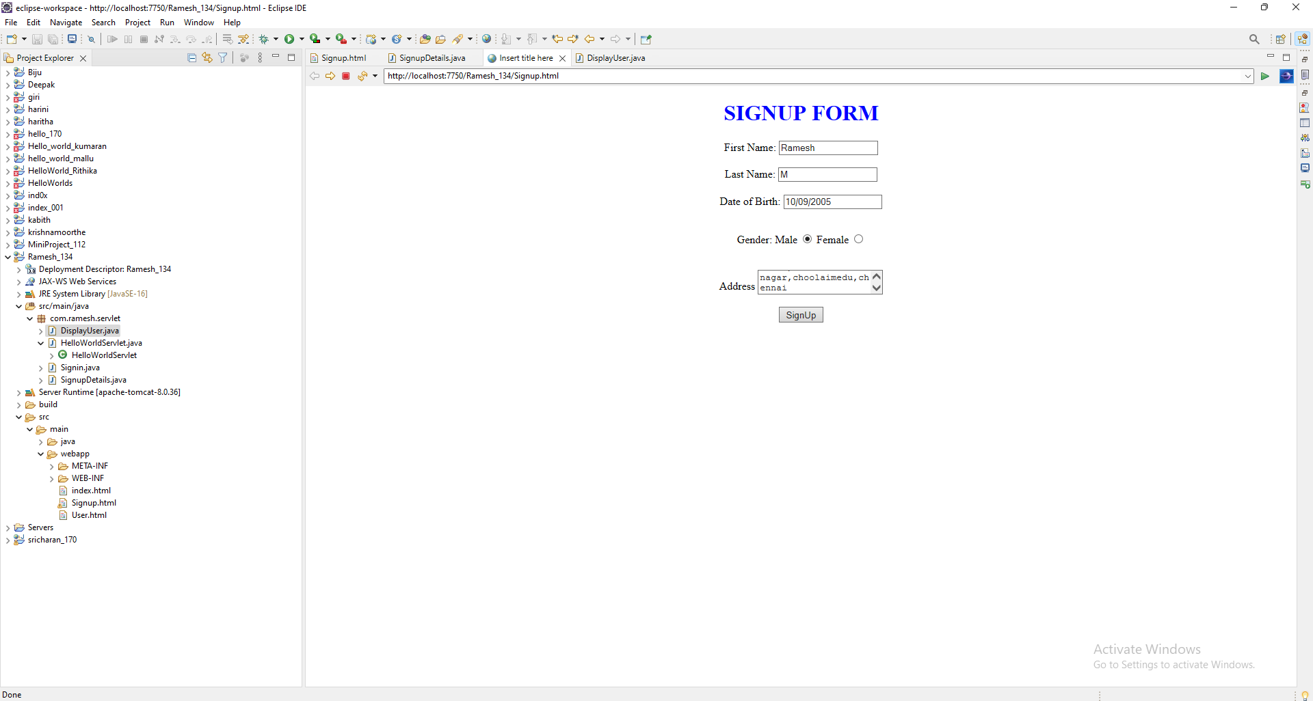

231801134

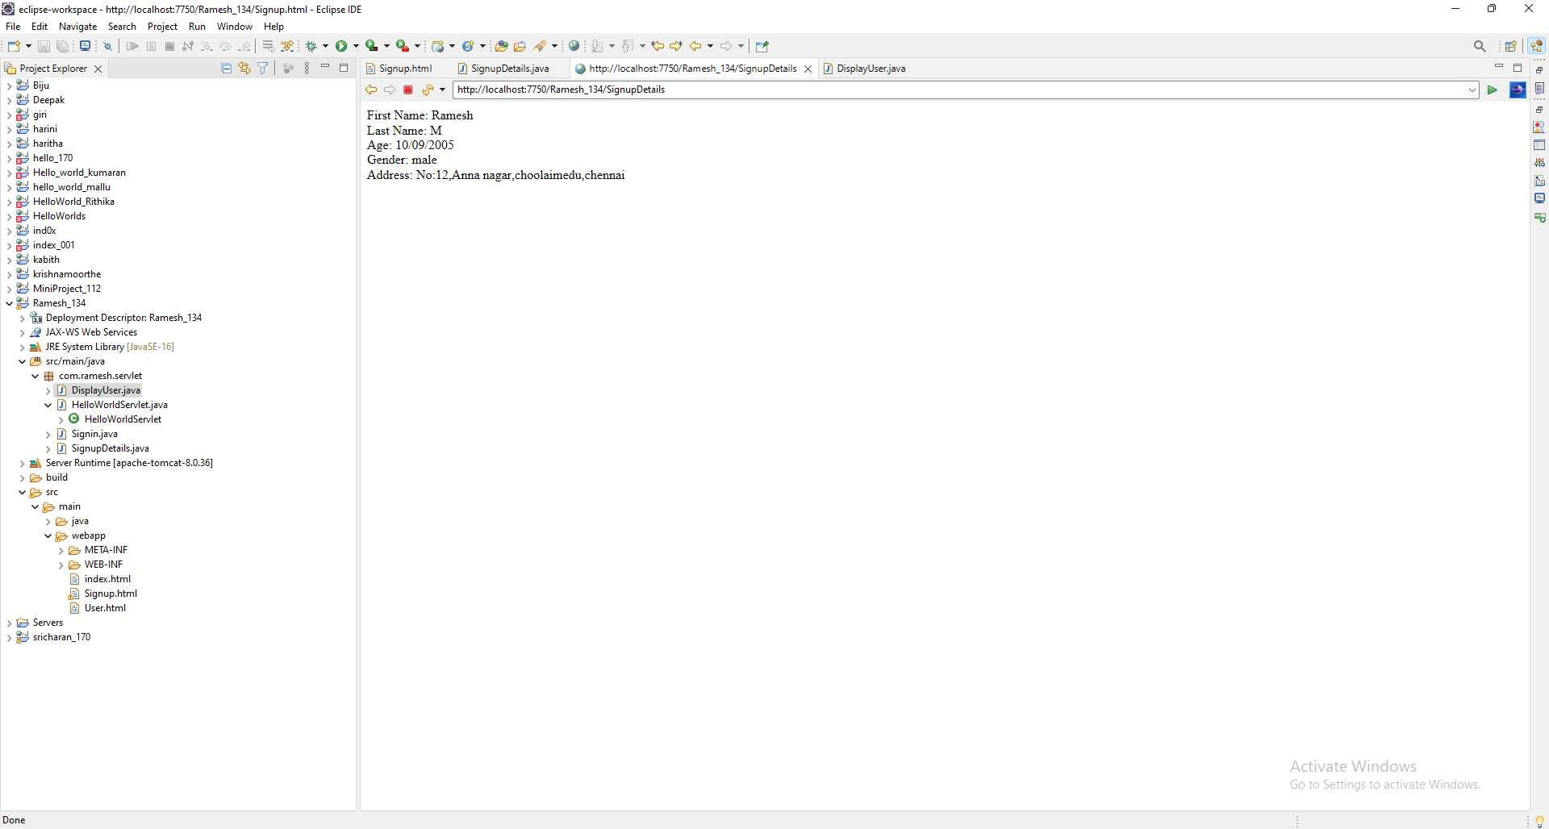

**RESULT:**

The output of creating a from using GET and POST methods was successfully displayed in the browser and assessed by servlet.

231801134