|  |  |
| --- | --- |
| **Ex. No : 8**  **Date:** | **Write a JS program to validate a the controls of the form of library management system,access database using servlet/JSP** |

**AIM:**

To write a JS program to validate the form of library management system and access the database using servlet/JSP

**PROGRAM:**

<%@ page import="java.sql.*" %>

<%@ page contentType="text/html;charset=UTF-8" language="java" %>

<html>

<head>

<title>Library Management - Add Book</title>

<style>

body {

font-family: Arial, sans-serif;

background-color: #f3f3f3;

margin: 20px;

padding: 20px;

}

h2 {

color: #333;

}

form {

background-color: #fff;

padding: 20px;

border-radius: 8px;

box-shadow: 0 2px 5px rgba(0,0,0,0.1);

width: 400px;

}

input[type="text"],

input[type="number"],

select {

width: 100%;

padding: 8px;

margin: 6px 0 12px 0;

border: 1px solid #ccc;

border-radius: 4px;

}

input[type="submit"] {

background-color: #4CAF50;

color: white;

border: none; 231801134

padding: 10px 16px;

cursor: pointer;

border-radius: 4px;

}

input[type="submit"]:hover {

background-color: #45a049;

}

p {

font-size: 16px;

}

a {

color: #007BFF;

text-decoration: none;

}

a:hover {

text-decoration: underline;

}

</style>

<script>

function validateForm() {

const bookId = document.getElementById("bookId").value.trim();

const title = document.getElementById("title").value.trim();

const author = document.getElementById("author").value.trim();

const year = document.getElementById("year").value.trim();

const category = document.getElementById("category").value;

const copies = document.getElementById("copies").value.trim();

const currentYear = new Date().getFullYear();

if (!/^[a-zA-Z0-9]+$/.test(bookId)) {

alert("Book ID must be alphanumeric.");

return false;

}

if (!/^[A-Za-z ]+$/.test(title)) {

alert("Title must contain only letters.");

return false;

}

if (!/^[A-Za-z ]+$/.test(author)) {

alert("Author name must contain only letters.");

return false;

}

if (!/^\d{4}$/.test(year) || parseInt(year) > currentYear) {

alert("Year must be a valid 4-digit year.");

return false;

}

if (category === "") {

alert("Please select a category.");

return false; 231801134

}

if (isNaN(copies) || parseInt(copies) <= 0) {

alert("Copies must be a positive number.");

return false;

}

return true;

}

</script>

</head>

<body>

<h2>Add Book to Library</h2>

<form method="post" onsubmit="return validateForm()">

Book ID: <input type="text" name="bookId" id="bookId"/><br/>

Title: <input type="text" name="title" id="title"/><br/>

Author: <input type="text" name="author" id="author"/><br/>

Year: <input type="text" name="year" id="year"/><br/>

Category:

<select name="category" id="category">

<option value="">--Select--</option>

<option value="Science">Science</option>

<option value="Fiction">Fiction</option>

<option value="History">History</option>

</select><br/>

Copies: <input type="number" name="copies" id="copies"/><br/><br/>

<input type="submit" value="Add Book"/>

<p>

<label>Book Details:-</label>

<a href="./display_books.jsp">Click Here</a>

</p>

</form>

<%

// JSP Database logic

// TODO:Change password before run the code

// TODO: CREATE THE TABLE IN MYSQL

/**

CREATE TABLE books (

book_id VARCHAR(20) PRIMARY KEY,

title VARCHAR(100),

author VARCHAR(100),

year INT,

category VARCHAR(50),

copies INT

);

**/

String bookId = request.getParameter("bookId");

if (bookId != null) {

String title = request.getParameter("title");

String author = request.getParameter("author"); 231801134

String year = request.getParameter("year");

String isbn = request.getParameter("isbn");

String category = request.getParameter("category");

String copies = request.getParameter("copies");

try {

Class.forName("com.mysql.cj.jdbc.Driver");

Connection conn = DriverManager.getConnection(

"jdbc:mysql://localhost:3306/library_management_ramesh", "root", "");

PreparedStatement ps = conn.prepareStatement(

"INSERT INTO books (book_id, title, author, year, category, copies) VALUES (?, ?, ?, ?, ?, ?)");

ps.setString(1, bookId);

ps.setString(2, title);

ps.setString(3, author);

ps.setInt(4, Integer.parseInt(year));

ps.setString(5, category);

ps.setInt(6, Integer.parseInt(copies));

int result = ps.executeUpdate();

if (result > 0) {

%>

<script>alert("Book Added Successfully!!")</script>

<%

} else {

%>

<script>alert("Failed to add book!!")</script>

<%

out.println("<p style='color:red;'>Failed to add book.</p>");

}

ps.close();

conn.close();

} catch (Exception e) {

out.println("<p style='color:red;'>Error: " + e.getMessage() + "</p>");

}

}

%>

</body>

</html>

**HTML Code:**

<%@ page import="java.sql.*" %>

<%@ page contentType="text/html;charset=UTF-8" language="java" %>

<html>

<head>

<title>Library Books List</title>

<style>

231801134

table {

border-collapse: collapse;

width: 90%;

margin: 20px auto;

}

th, td {

border: 1px solid #333;

padding: 10px;

text-align: center;

}

th {

background-color: #f2f2f2;

}

h2 {

text-align: center;

}

</style>

</head>

<body>

<h2>All Books in Library</h2>

<%

try {

Class.forName("com.mysql.cj.jdbc.Driver");

Connection conn = DriverManager.getConnection(

"jdbc:mysql://localhost:3306/library_management_ramesh", "root", "");

Statement stmt = conn.createStatement();

231801134

ResultSet rs = stmt.executeQuery("SELECT * FROM books");

out.println("<table>");

out.println("<tr><th>Book ID</th><th>Title</th><th>Author</th><th>Year</th><th>Category</th><th>Copies</th></tr>");

while (rs.next()) {

out.println("<tr>");

out.println("<td>" + rs.getString("book_id") + "</td>");

out.println("<td>" + rs.getString("title") + "</td>");

out.println("<td>" + rs.getString("author") + "</td>");

out.println("<td>" + rs.getInt("year") + "</td>");

out.println("<td>" + rs.getString("category") + "</td>");

out.println("<td>" + rs.getInt("copies") + "</td>");

out.println("</tr>");

}

out.println("</table>");

rs.close();

stmt.close();

conn.close();

} catch (Exception e) {

out.println("<p style='color:red;text-align:center;'>Error: " + e.getMessage() + "</p>");

}

%>

</body>

</html>

231801134

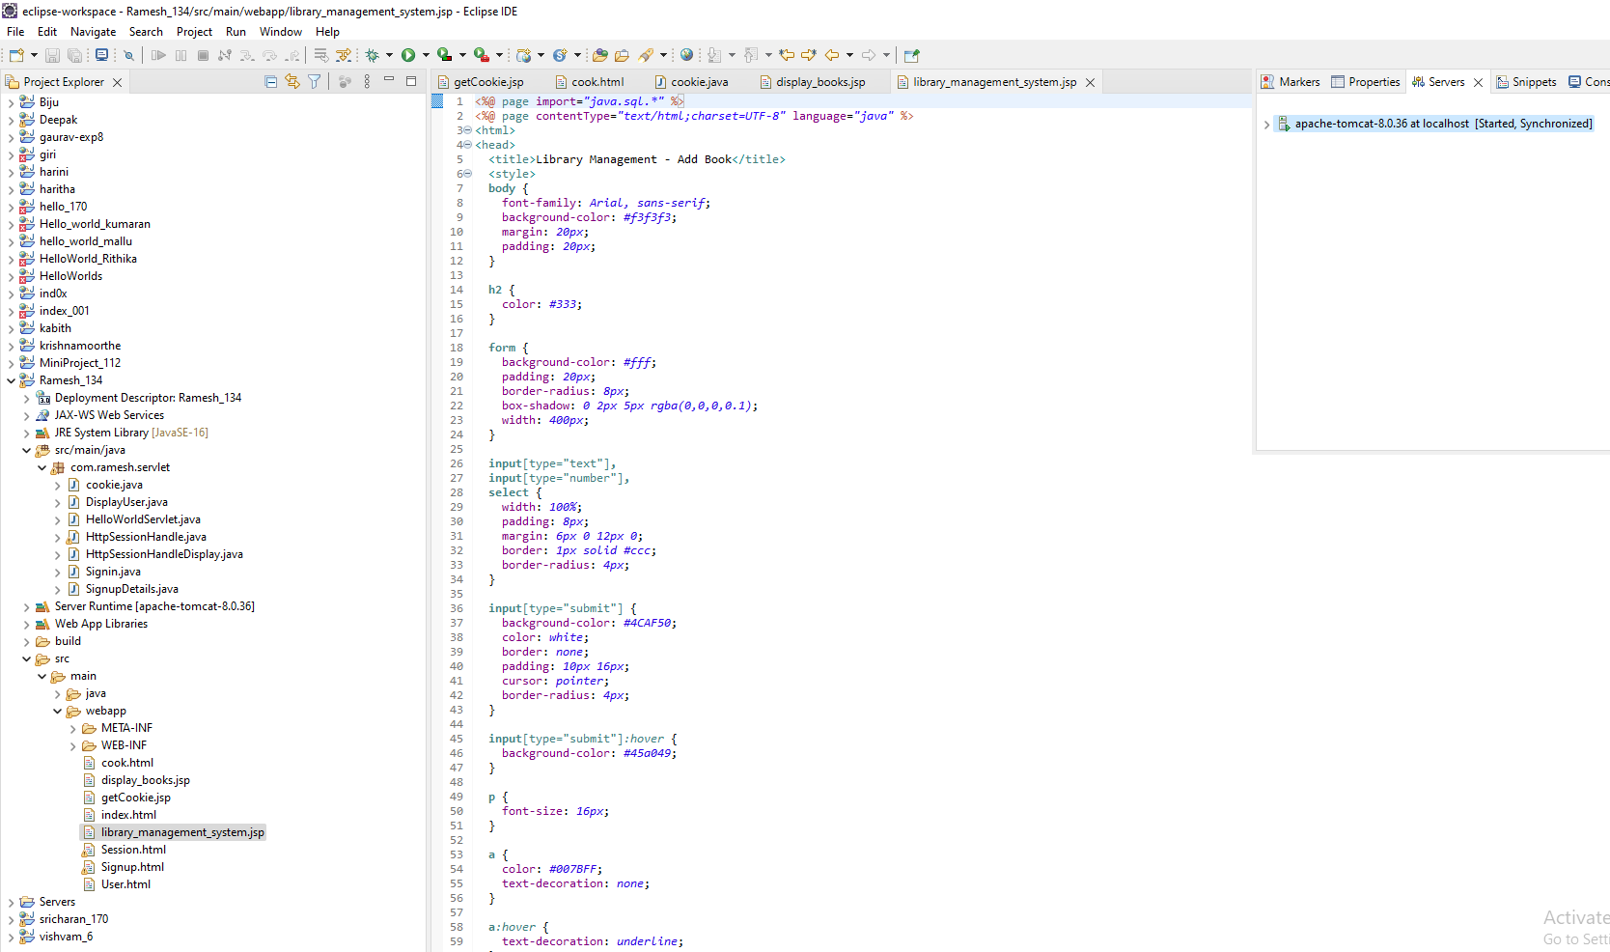

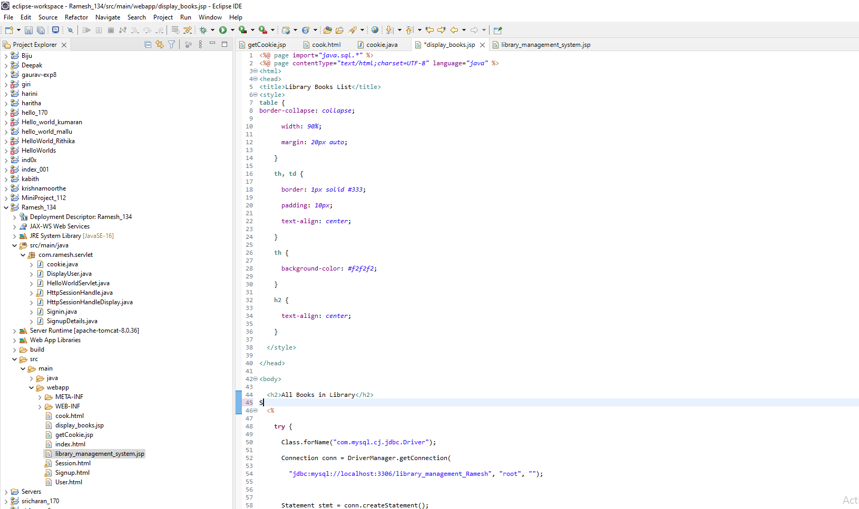

231801134

**OUTPUT:**

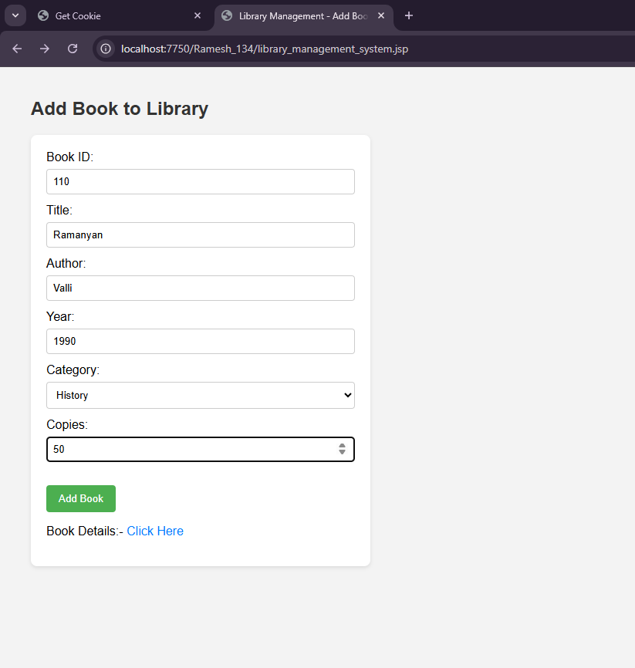

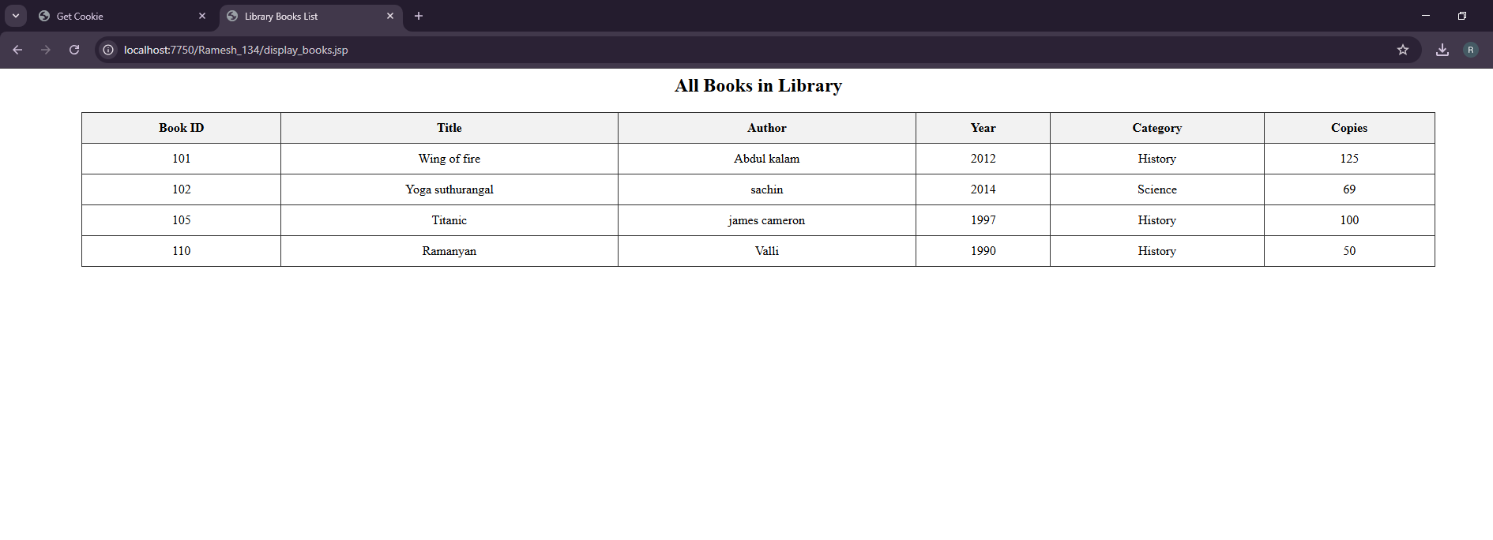

231801134

**RESULT:**

Thus , to validate the form of library management system and access using database was successfully executed

231801134