Supplementary Material
Apparent machine-learning performance in a metal-oxide nanoparticle cytotoxicity benchmark is driven by validation strategy and duplicate records
Figure S1a. Permutation null distribution of the leave-one-oxide-out MCC for the XGBoost model (1,000 label permutations). The observed value (solid line) lies within the 95% interval of the null distribution (dashed lines), consistent with the two-sided permutation p = 0.062.
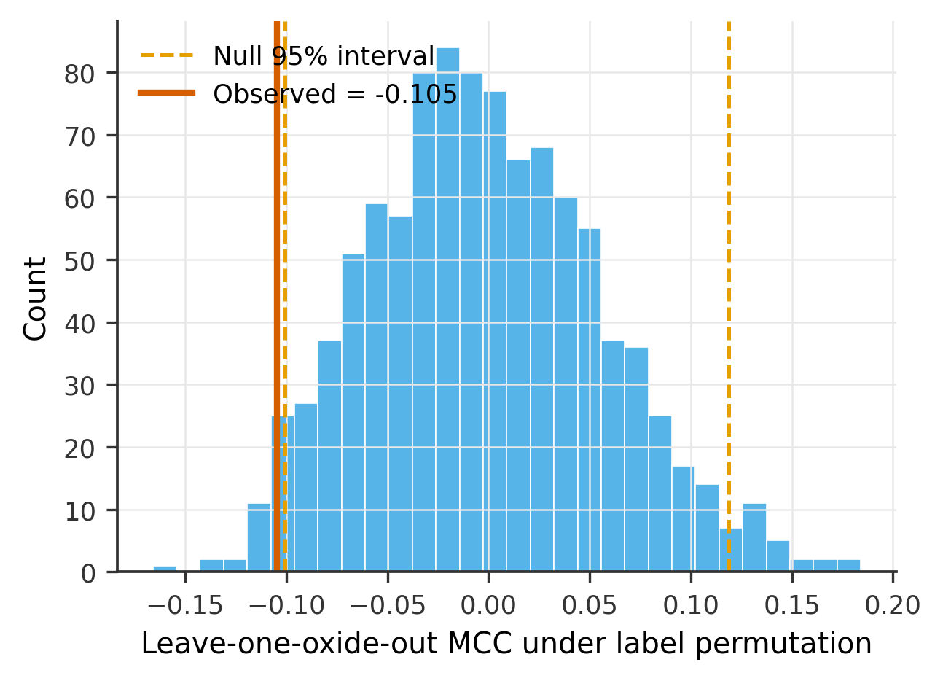
Figure S1b. Permutation null distribution of the leave-one-oxide-out MCC for the multilayer perceptron (1,000 label permutations). The observed value (solid line, +0.166) lies well outside the 95% interval of the null distribution (dashed lines), consistent with the two-sided permutation p = 0.004. Unlike the XGBoost case (Figure S1a), the multilayer perceptron's observed score is clearly distinguishable from chance.
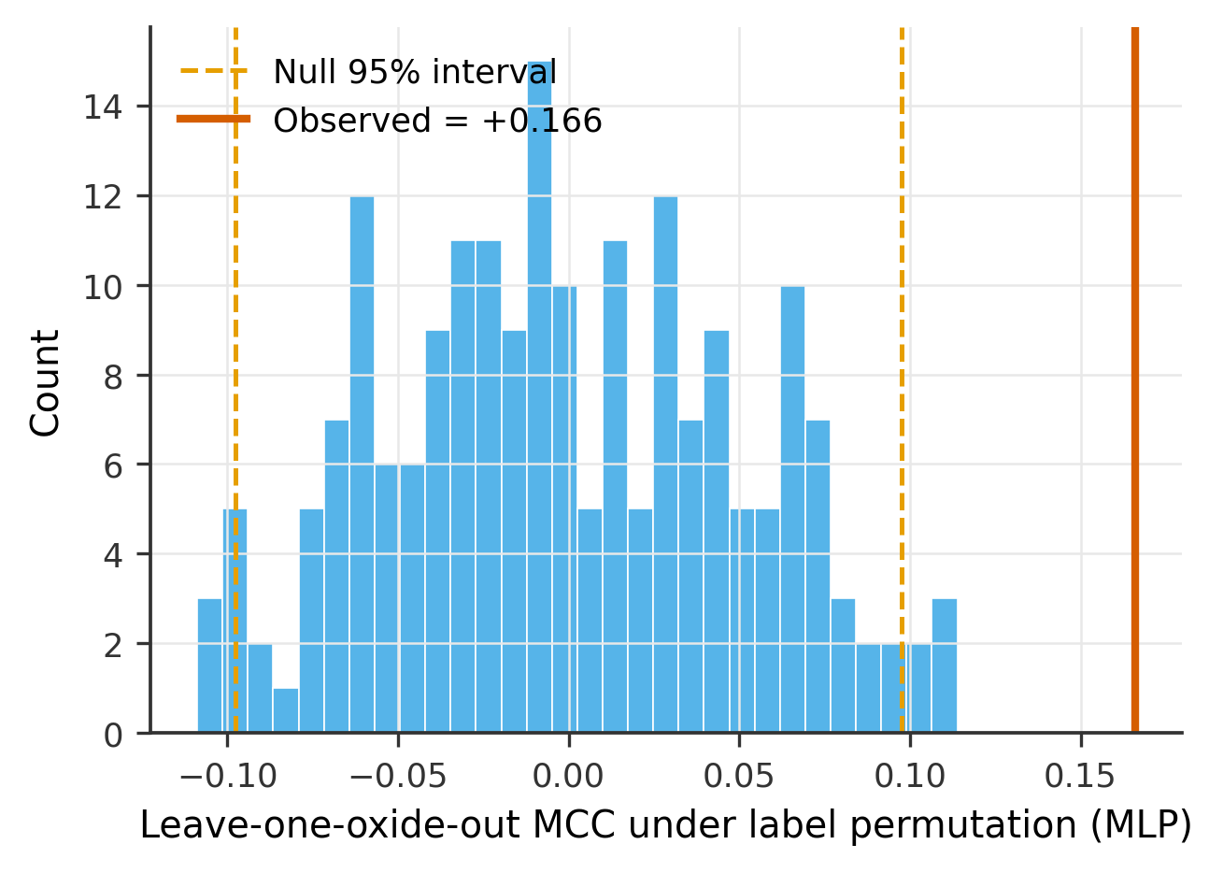

Figure S2. Per-oxide leave-one-oxide-out performance (full XGBoost model), with sample size (n) and number of cytotoxic instances annotated for each held-out oxide. Al₂O₃ and Fe₂O₃ folds are undefined (hatched) because the held-out set contains no cytotoxic instances. Per-oxide fold values are shown for transparency and are not interpreted or ranked against one another.
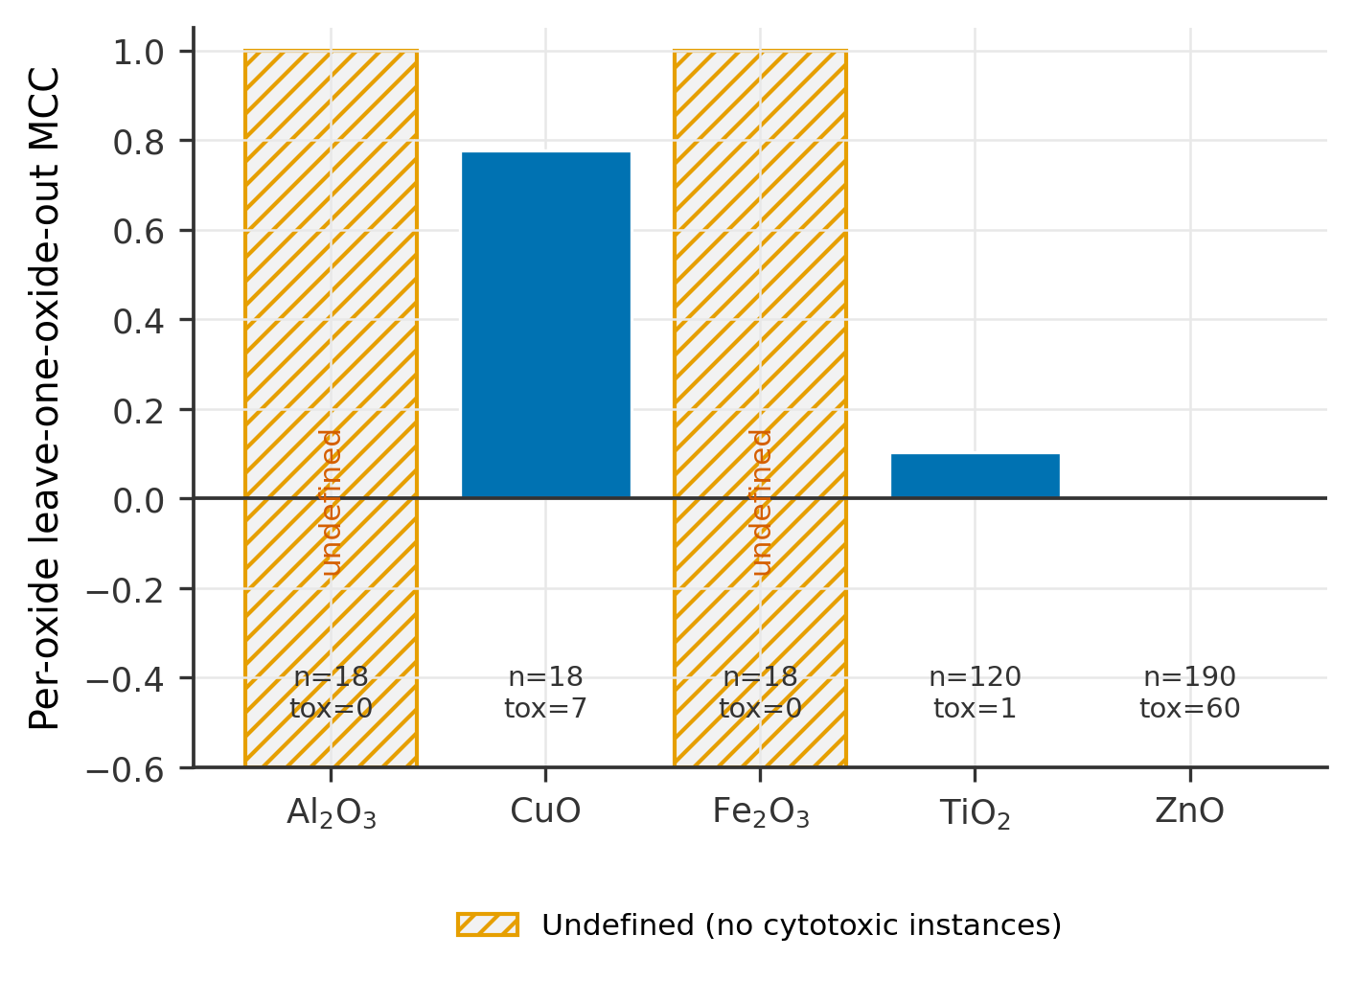
Figure S3. Effect of training-set material diversity on leave-one-oxide-out (LOMO) performance. Mean MCC is shown for the random forest and XGBoost as a function of the number of oxide classes included in the training set (2, 3, or 4 of the remaining oxides); shaded regions indicate variability across different oxide-class combinations (±1 SD). Although increasing material diversity was associated with improved mean performance, substantial variability remained—the bands span zero and rest on few combinations (only three oxides, ZnO, TiO₂, and CuO, provide defined test folds)—so this trend should be regarded as suggestive rather than statistically established, indicating that benchmark composition strongly influences apparent cross-material generalization.
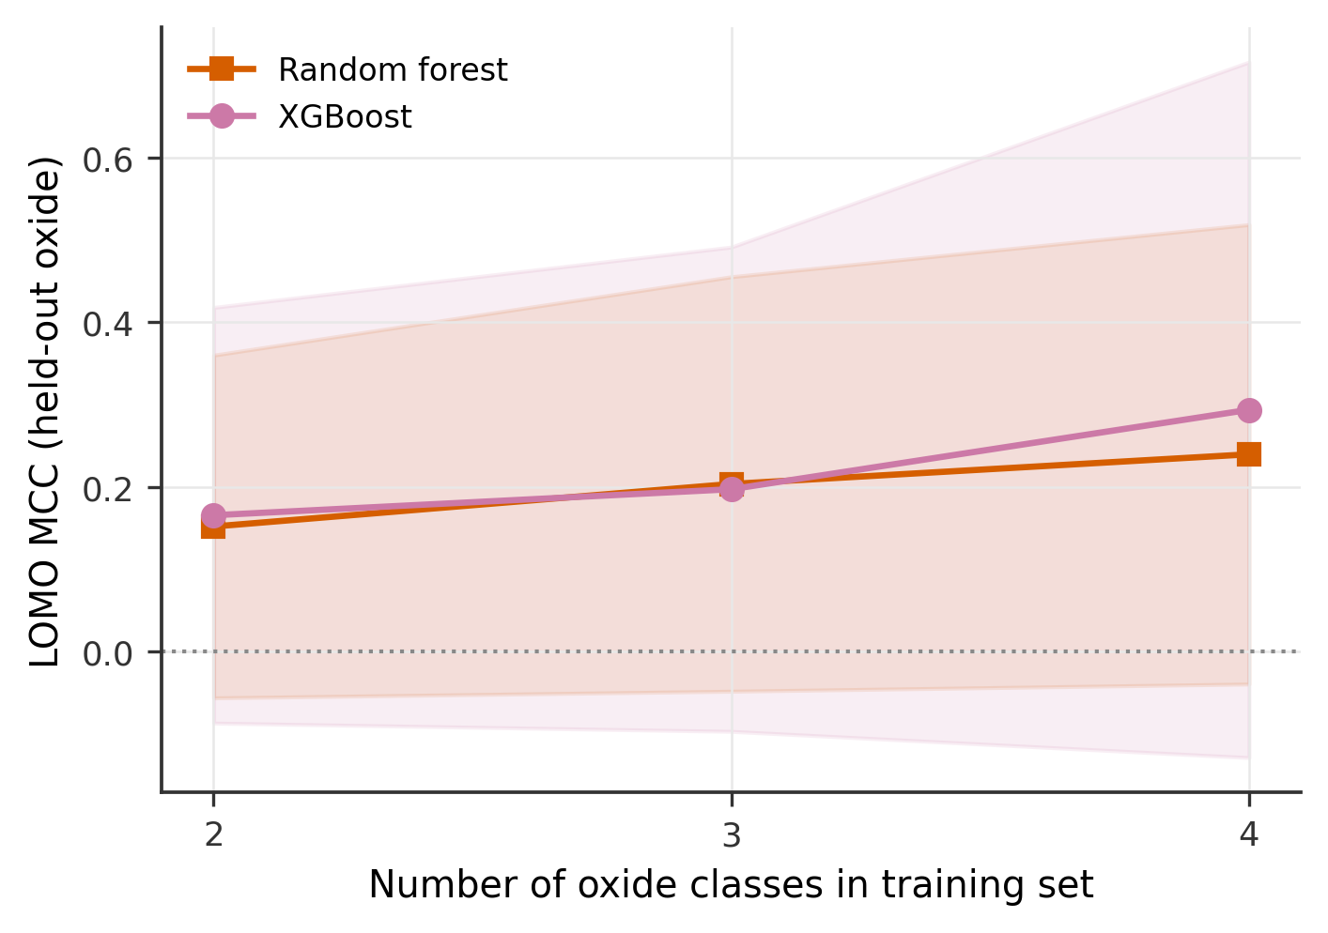

Table S1. Leakage curve. Random five-fold and leave-one-oxide-out (LOMO) MCC at nine duplication levels, with the leakage gap (k-fold minus LOMO). Underlies Figure 1.
Duplicated fraction | Rows (n) | k-fold MCC | LOMO MCC | Leakage gap
0.00 | 364 | 0.612 | −0.116 | 0.727
0.10 | 400 | 0.674 | −0.109 | 0.783
0.20 | 437 | 0.736 | −0.117 | 0.853
0.25 | 455 | 0.707 | −0.133 | 0.839
0.30 | 473 | 0.702 | −0.096 | 0.798
0.40 | 510 | 0.746 | −0.123 | 0.869
0.50 | 546 | 0.757 | −0.142 | 0.899
0.55 | 564 | 0.796 | −0.081 | 0.877
0.60 | 582 | 0.807 | −0.103 | 0.910
Regression of leakage gap on duplicated fraction: slope 0.261, intercept 0.755, R² = 0.817 (n = 9 points). Because the duplication levels are generated from the same deduplicated dataset and are not independent, this regression is a descriptive summary rather than an inferential test.

Table S2. Multi-seed stability. LOMO MCC for each classifier across eight random seeds, with per-model standard deviation (SD). Underlies Figure 2.
Seed | LogReg | Random forest | SVM (RBF) | XGBoost | MLP
42 | 0.034 | −0.116 | −0.103 | −0.105 | 0.166
0 | 0.034 | −0.058 | −0.103 | −0.105 | 0.204
1 | 0.034 | 0.147 | −0.103 | −0.105 | 0.277
2 | 0.034 | −0.048 | −0.103 | −0.105 | 0.064
3 | 0.034 | −0.046 | −0.103 | −0.105 | 0.130
7 | 0.034 | −0.036 | −0.103 | −0.105 | 0.083
13 | 0.034 | 0.228 | −0.103 | −0.105 | 0.130
99 | 0.034 | −0.031 | −0.103 | −0.105 | 0.125
SD | 0.000 | 0.110 | 0.000 | 0.000 | 0.064
Three classifiers (logistic regression, SVM, XGBoost) are seed-invariant (SD ≈ 0). The multilayer perceptron remains positive at every seed (+0.064 to +0.277) but varies more than fourfold in magnitude (SD 0.064). The random forest changes sign across seeds (−0.116 to +0.228, SD 0.110), centring near zero.

Table S3. Per-oxide leave-one-oxide-out folds (full XGBoost model). Each oxide is held out in turn; n and number cytotoxic are for the held-out oxide.
Held-out oxide | n | Cytotoxic (n) | Fold MCC
ZnO | 190 | 60 | 0.000
TiO₂ | 120 | 1 | 0.103
CuO | 18 | 7 | 0.777
Al₂O₃ | 18 | 0 | NA (single-class)
Fe₂O₃ | 18 | 0 | NA (single-class)
Pooled | 364 | 68 | −0.105
Folds for Al₂O₃ and Fe₂O₃ are undefined (single class). Pooled MCC [95% CI −0.182, −0.009]. The high CuO and TiO₂ folds rest on only 7 and 1 cytotoxic instances and are shown for transparency only.

Table S4. Feature-set decomposition under LOMO (XGBoost). MCC with 95% bootstrap CIs for the full descriptor set, dose only, and descriptors excluding dose.
Feature set | LOMO MCC | 95% CI | ≈ chance
Full descriptor set | −0.104 | [−0.182, −0.009] | No
Dose only | −0.164 | [−0.221, −0.084] | No
Descriptors excluding dose | −0.146 | [−0.178, −0.114] | No
All subsets produce below-chance MCCs; no subset of the available descriptors supported above-chance cross-material generalization. The dose-only row refers to XGBoost fitted on the dose descriptor alone, which is not the same as the single-variable dose-threshold baseline of Section 3.2: that baseline selects a cut maximizing training-partition MCC and applies it directly, rather than fitting a flexible model to one feature. The two are therefore not comparable, and the threshold rule's higher performance reflects the estimator rather than additional information.

Table S5. Class frequencies within each leave-one-oxide-out fold. For each held-out oxide, the number of cytotoxic and non-cytotoxic held-out instances and the cytotoxic fraction.
Held-out oxide | n (held out) | Cytotoxic | Non-cytotoxic | Cytotoxic fraction
ZnO | 190 | 60 | 130 | 0.316
TiO₂ | 120 | 1 | 119 | 0.008
CuO | 18 | 7 | 11 | 0.389
Al₂O₃ | 18 | 0 | 18 | 0.000
Fe₂O₃ | 18 | 0 | 18 | 0.000
Total | 364 | 68 | 296 | 0.187
Cytotoxic instances are heavily concentrated in ZnO (60 of 68). Two oxides (Al₂O₃, Fe₂O₃) contain no cytotoxic instances, leaving their folds single-class and their fold MCC undefined.

Table S6. Hyperparameter sensitivity. LOMO MCC (with 95% percentile-bootstrap CI) across a small grid of reasonable settings for the random forest, support vector machine, and multilayer perceptron.
Model | Setting | LOMO MCC | 95% CI | CI excludes 0
Random forest | n_estimators=100, max_depth=None | −0.116 | [−0.192, −0.033] | Yes (below 0)
Random forest | n_estimators=300, max_depth=None | −0.055 | [−0.148, +0.045] | No
Random forest | n_estimators=300, max_depth=5 | −0.055 | [−0.146, +0.046] | No
Random forest | n_estimators=500, max_depth=10 | −0.089 | [−0.172, +0.003] | No
Random forest | n_estimators=300, min_samples_leaf=5 | −0.070 | [−0.141, +0.021] | No
SVM (RBF) | C=0.1, gamma=scale | 0.000 | [0.000, 0.000] | No
SVM (RBF) | C=1, gamma=scale | −0.103 | [−0.133, −0.075] | Yes (below 0)
SVM (RBF) | C=10, gamma=scale | −0.017 | [−0.106, +0.081] | No
SVM (RBF) | C=1, gamma=0.1 | −0.103 | [−0.135, −0.075] | Yes (below 0)
SVM (RBF) | C=10, gamma=0.01 | −0.014 | [−0.105, +0.088] | No
MLP | hidden=(50,), alpha=1e-4 | +0.205 | [+0.087, +0.318] | Yes (above 0)
MLP | hidden=(100,), alpha=1e-4 | +0.166 | [+0.052, +0.279] | Yes (above 0)
MLP | hidden=(100,50), alpha=1e-4 | +0.277 | [+0.167, +0.391] | Yes (above 0)
MLP | hidden=(100,), alpha=1e-2 | +0.170 | [+0.054, +0.285] | Yes (above 0)
MLP | hidden=(100,), alpha=1.0 | +0.210 | [+0.089, +0.336] | Yes (above 0)
Random forest and SVM are at or below chance across all settings. The multilayer perceptron is above chance with an interval excluding zero in every setting (MCC +0.166 to +0.277). No configuration of any model reaches the dose-threshold baseline of 0.410. This is a descriptive robustness check, not a model-selection procedure; nested material-level tuning would be required to select hyperparameters without leakage.

Table S7. Permutation test results. Observed leave-one-oxide-out (LOMO) MCC against the label-permutation null distribution (1,000 permutations) for the two models selected for permutation testing: XGBoost (a representative high-capacity model whose point estimate sat below zero) and the multilayer perceptron (the only model with an interval above zero). Underlies Figures S1a and S1b.
Model | Observed LOMO MCC | Null mean | Null 95% interval | Two-sided p | Permutations
XGBoost | −0.105 | −0.002 | [−0.101, +0.119] | 0.062 | 1,000
MLP | +0.166 | −0.003 | [−0.102, +0.102] | 0.004 | 1,000
The XGBoost observed score lies within its null 95% interval (p = 0.062), indistinguishable from chance. The multilayer perceptron observed score lies outside its null 95% interval (p = 0.004), distinguishable from chance. This is the statistical basis for treating the multilayer perceptron signal as real but narrow (see main text); it remains below the dose-threshold baseline of 0.410. As in the main text (Section 2.6), the permutation p-values and interval-based statements here are descriptive heuristics rather than formal tests of statistical significance.

Table S8. Software environment. Python and package versions used for all analyses. A fixed random seed (42) was used for the primary analysis, with eight seeds {0, 1, 2, 3, 7, 13, 42, 99} for the stability assessment.
Software | Version
Python | 3.12.9
scikit-learn | 1.8.0
XGBoost | 3.2.0
NumPy | 2.4.5
pandas | 3.0.3
SciPy | 1.17.1
matplotlib | 3.10.9
Versions are pinned in requirements.txt in the analysis code repository. Deterministic results reproduce exactly on this environment; the random forest and multilayer perceptron use internal randomness and reproduce on the pinned environment.

All values are reproducible from the analysis code (https://github.com/Ramesh2217/MONP-nanotox-audit; fixed seed 42, pinned software versions in requirements.txt). Deterministic results reproduce exactly; the random forest and multilayer perceptron use internal randomness and reproduce on the pinned environment. The MLP permutation test used 1,000 label permutations (observed MCC +0.166; null mean −0.003; two-sided p = 0.004).

