**Ability to understand Cloud Networking**

**KO1 – Able to create Virtual Private Cloud**

1. Steps for Creating a Virtual Network using Azure Portal
   1. Sign in to Azure
   2. Create a virtual network
   3. Create virtual machines (VM1 and VM2)
   4. Connect to myVM1 (Virtual Machine 1)
   5. Communicate between VMs
2. Implementation
   1. First of all, we require an Azure account with active subscription.
   2. Sign in to the Azure Portal
   3. Create a Virtual Network
      1. Select Create a resource in the upper left-hand corner of the portal.
      2. In the search box, enter Virtual Network. Select Virtual Network in the search results.
      3. In the Virtual Network page, select Create.
      4. In Create virtual network, enter or select this information in the Basics tab:

|  |  |
| --- | --- |
| Setting | Value |
| Project details |  |
| Subscription | Select your subscription |
| Resource group | Select Create new |
|  | Enter myResourceGroup |
| Select OK |
| Instance details |  |
| Name | Enter myVNet |
| Region | Select whichever is correct |

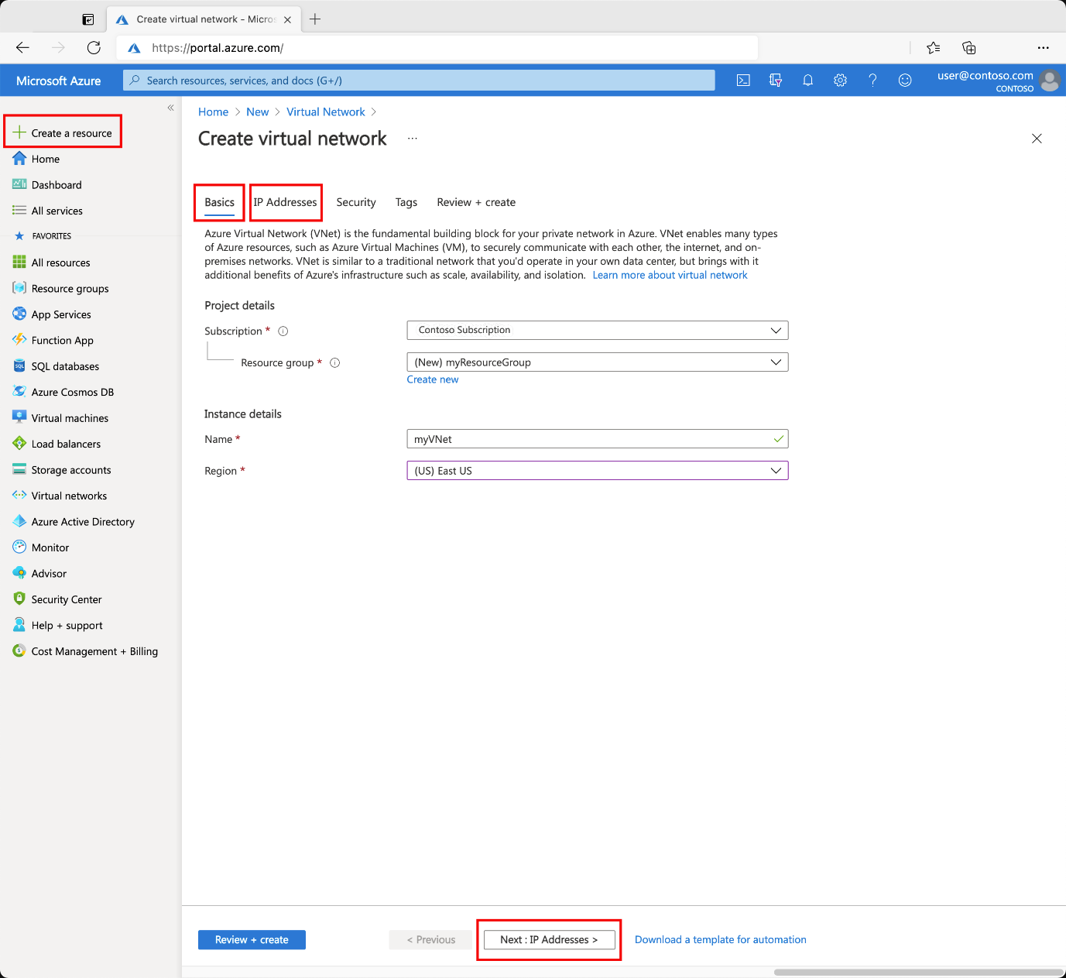

* + 1. Select the IP Addresses tab, or select the Next: IP Addresses button at the bottom of the page.
    2. In IPv4 address space, select the existing address space and change it to 10.1.0.0/16.
    3. Select + Add subnet, then enter MySubnet for Subnet name and 10.1.0.0/24 for Subnet address range.
    4. Select Add.
    5. Select the Security tab, or select the Next: Security button at the bottom of the page.
    6. Under BastionHost, select Enable. Enter this information:

|  |  |
| --- | --- |
| Setting | Value |
| Bastion name | Enter myBastionHost |
| AzureBastionSubnet address space | Enter 10.1.1.0/24 |
| Public IP Address | Select Create new  For Name, enter myBastionIP  Select OK |

* + 1. Select the Review + create tab or select the Review + create button.
    2. Select Create.
  1. Create virtual machine
     1. Create two VMs in a virtual network by following the procedure given:
        1. On the upper-left side of the portal, select Create a resource > Compute > Virtual machine.
        2. In Create a virtual machine, type or select the values in the Basics tab:

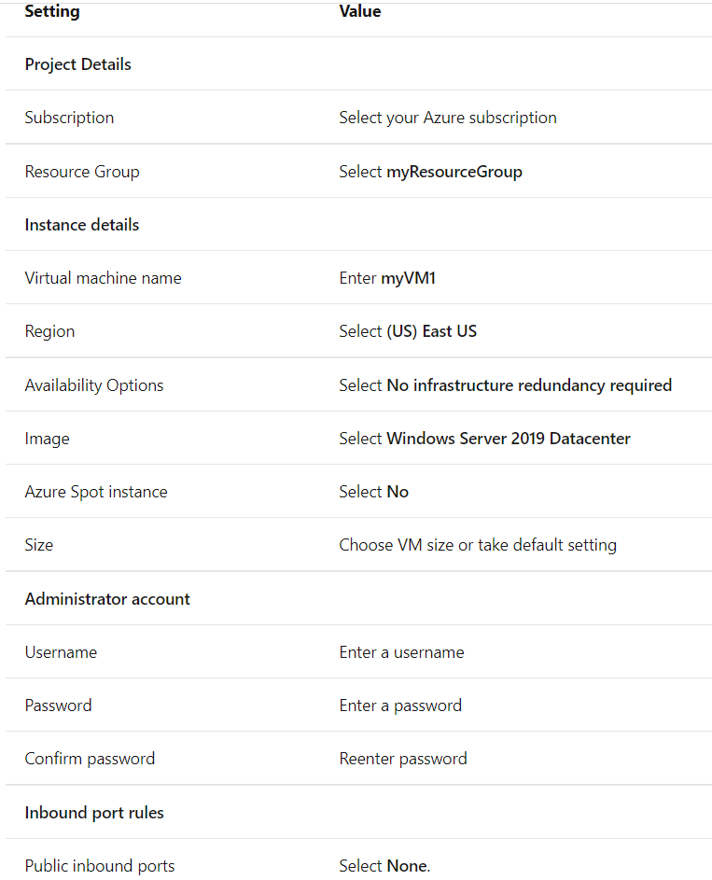

* + - 1. Select the Networking tab, or select Next: Disks, then Next: Networking.
      2. In the Networking tab, select or enter:

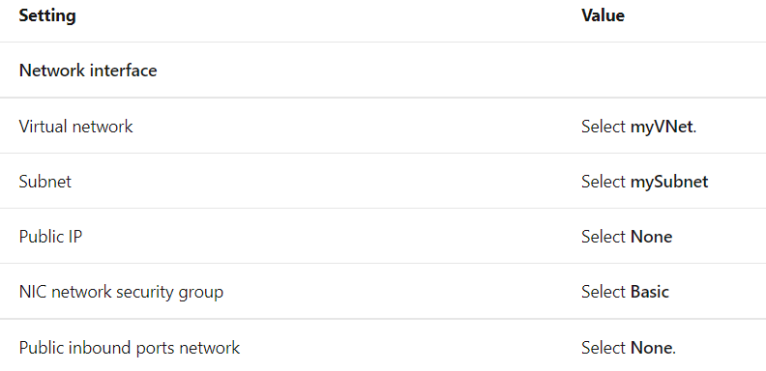

* + - 1. Select the Review + create tab, or select the blue Review + create button at the bottom of the page.
      2. Review the settings, and then select Create.

Work similarly to create second virtual machine.

* 1. Connect to myVM1 (Virtual Machine 1)
     1. Go to Azure Portal to manage your private VM. Search for and select Virtual machines.
     2. Pick the name of your private virtual machine myVM1.
     3. In the VM menu bar, select Connect, then select Bastion.

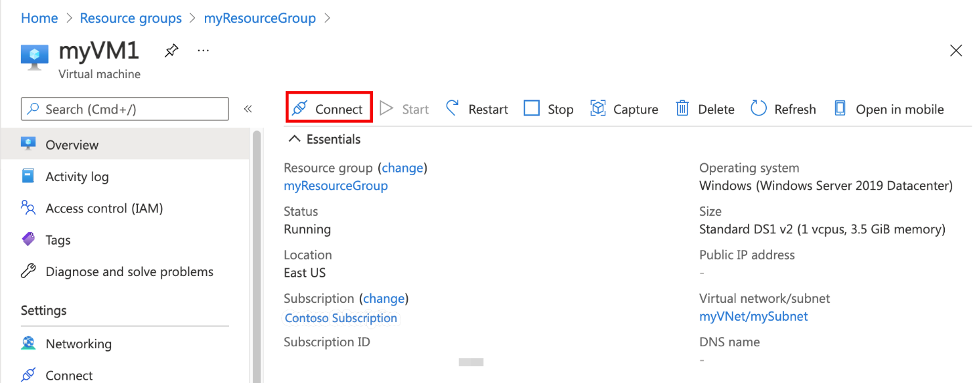

* + 1. In the Connect page, select the blue Use Bastion button.
    2. In the Bastion page, enter the username and password you created for the virtual machine previously.
    3. Select Connect.
  1. Communicate between two virtual machines
     1. In the bastion connection of myVM1, open PowerShell.
     2. Enter ping myvm2.
     3. You'll receive a message similar to this output:

Pinging myvm2.cs4wv3rxdjgedggsfghkjrxuqf.bx.internal.cloudapp.net [10.1.0.5] with 32 bytes of data:

Reply from 10.1.0.5: bytes=32 time=3ms TTL=128

Reply from 10.1.0.5: bytes=32 time=1ms TTL=128

Reply from 10.1.0.5: bytes=32 time=1ms TTL=128

Reply from 10.1.0.5: bytes=32 time=1ms TTL=128

Ping statistics for 10.1.0.5:

Packets: Sent = 4, Received = 4, Lost = 0 (0% loss),

Approximate round trip times in milli-seconds:

Minimum = 1ms, Maximum = 3ms, Average = 1ms

* + 1. Close the bastion connection to myVM2.