**KO2 - Able to create Internet Gateway and attach to VPC**

* In this step, you create the virtual network gateway (VPN gateway) for your VNet. Creating a gateway can often take 45 minutes or more, depending on the selected gateway SKU.
* Create a virtual network gateway using the following values
  + Name: VNet1GW
  + Region: East US
  + Gateway type: VPN
  + VPN type: Route-based
  + SKU: VpnGw2
  + Generation: Generation 2
  + Virtual network: VNet1
  + Gateway subnet address range: 10.1.255.0/27
  + Public IP address: Create new
  + Public IP address name: VNet1GWpip
* In Search resources, services, and docs (G+/) type virtual network gateway. Locate Virtual network gateway in the search results and select it.

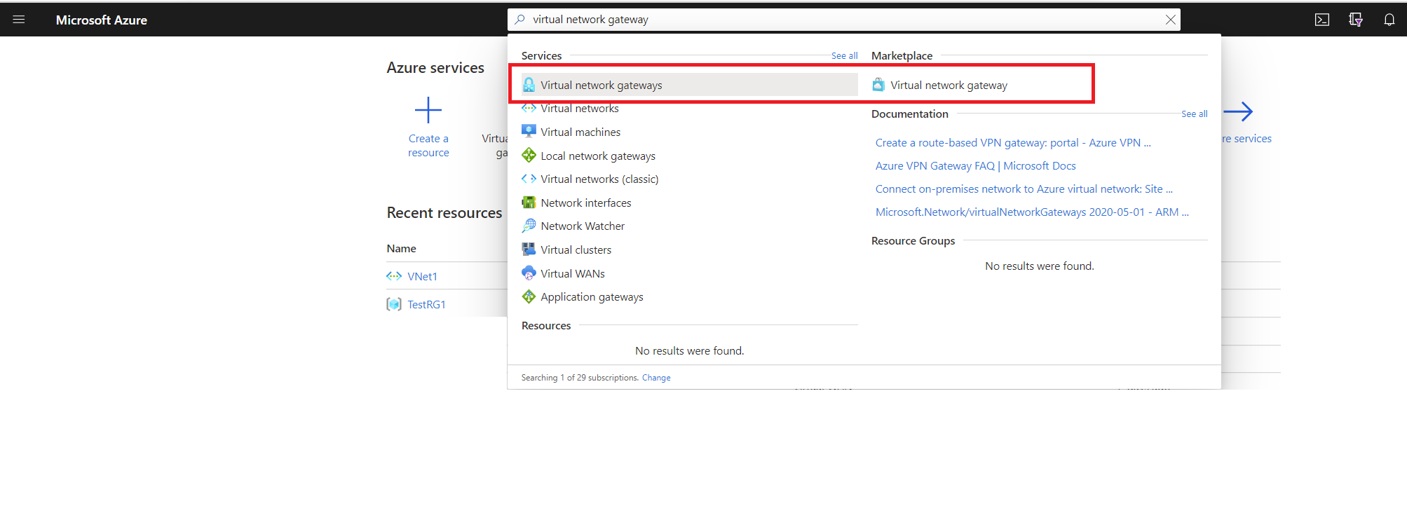

* On the Virtual network gateways page, select + Create. This opens the Create virtual network gateway page.

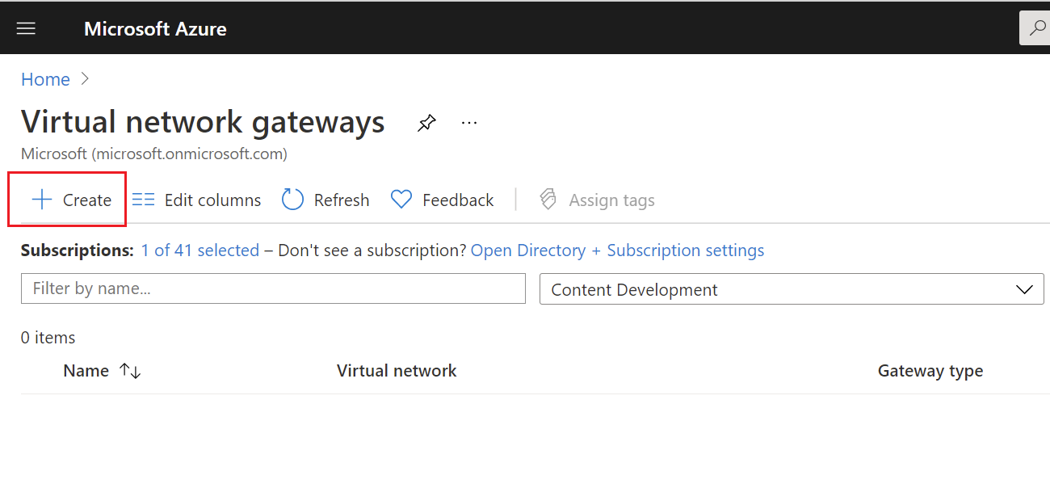

* On the **Basics** tab, fill in the values for **Project details** and **Instance details**.

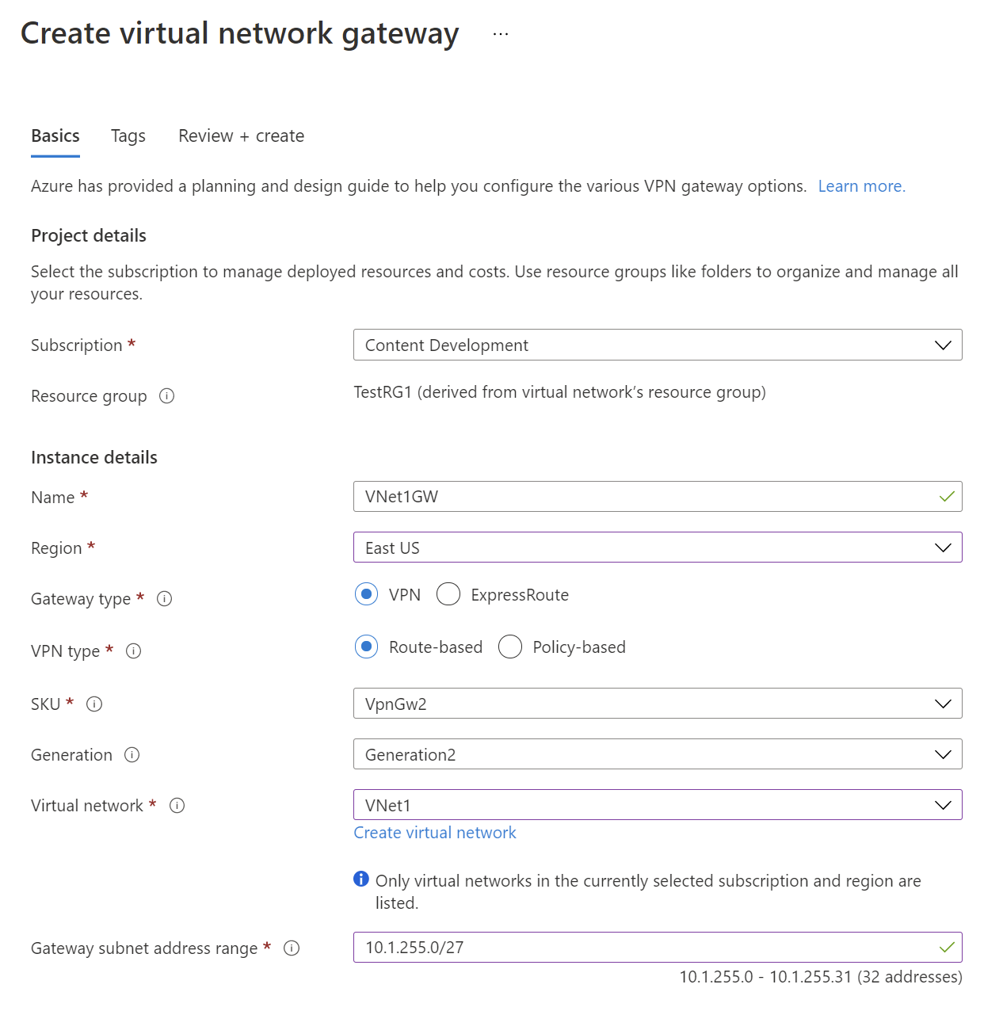

* Specify in the values for **Public IP address**. These settings specify the public IP address object that gets associated to the VPN gateway. The public IP address is dynamically assigned to this object when the VPN gateway is created. The only time the Public IP address changes is when the gateway is deleted and re-created. It doesn't change across resizing, resetting, or other internal maintenance/upgrades of your VPN gateway.

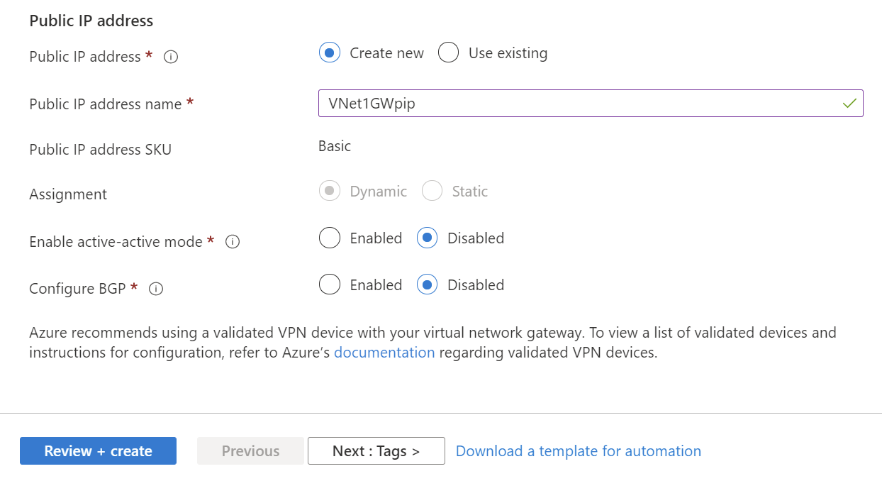

* + Public IP address: Leave Create new selected.
  + Public IP address name: In the text box, type a name for your public IP address instance.
  + Assignment: VPN gateway supports only Dynamic.
  + Enable active-active mode: Only select Enable active-active mode if you are creating an active-active gateway configuration. Otherwise, leave this setting Disabled.
  + Leave Configure BGP as Disabled, unless your configuration specifically requires this setting. If you do require this setting, the default ASN is 65515, although this can be changed.
* Select **Review + create** to run validation.
* Once validation passes, select **Create** to deploy the VPN gateway.

View the public IP address

* You can view the gateway public IP address on the Overview page for your gateway.

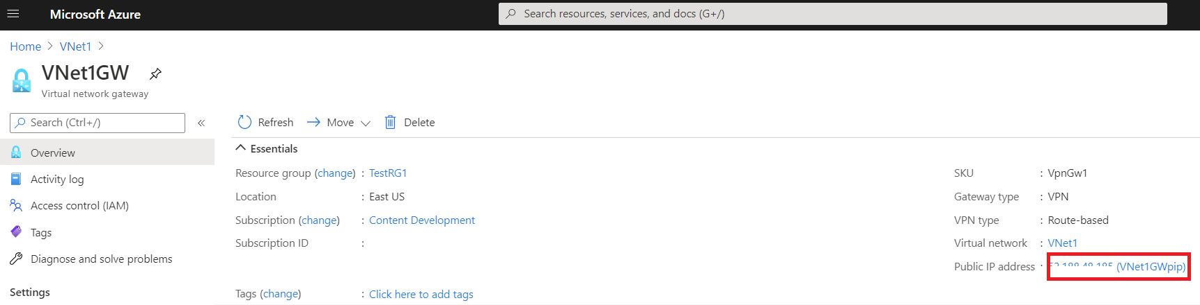

* To see additional information about the public IP address object, click the name/IP address link next to Public IP address.

Resize a gateway SKU

* Go to the Configuration page for your virtual network gateway.
* Select the arrows for the dropdown.

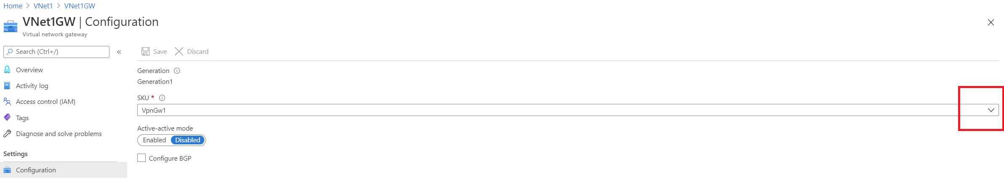

* Select the SKU from the dropdown.

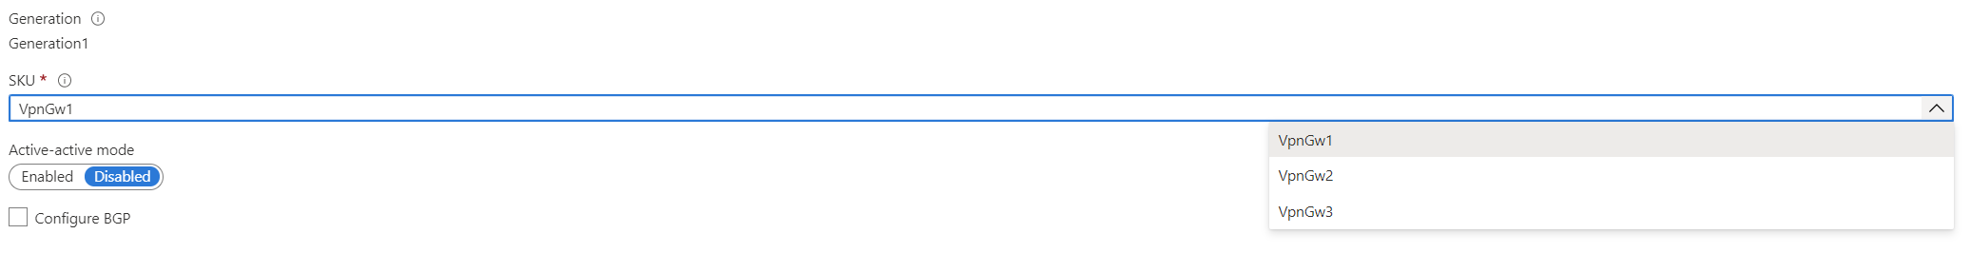

Reset a gateway

* In the portal, navigate to the virtual network gateway that you want to reset.
* On the page for the virtual network gateway, select Reset.

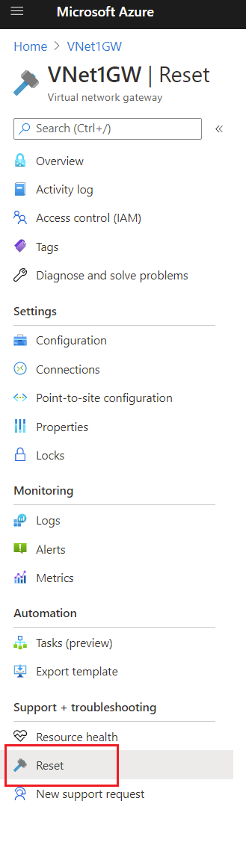

* On the Reset page, click Reset. Once the command is issued, the current active instance of the Azure VPN gateway is rebooted immediately. Resetting the gateway will cause a gap in VPN connectivity, and may limit future root cause analysis of the issue.