**KO4 - Ability to create a NAT Gateway**

1. Steps for Creating a NAT gateway using Azure Portal
   1. Sign in to Azure
   2. Create a virtual network
   3. Create virtual machines
   4. Create a NAT gateway and associate with the virtual network.
   5. Connect to virtual machine and verify NAT IP address.
2. Implementation
   1. First of all, we require an Azure account with active subscription.
   2. Sign in to the Azure Portal
   3. Create a Virtual Network
      1. Select Create a resource in the upper left-hand corner of the portal.
      2. In the search box, enter Virtual Network. Select Virtual Network in the search results.
      3. In the Virtual Network page, select Create.
      4. In Create virtual network, enter or select this information in the Basics tab:

|  |  |
| --- | --- |
| Setting | Value |
| Project details |  |
| Subscription | Select your subscription |
| Resource group | Select Create new |
|  | Enter myResourceGroup |
| Select OK |
| Instance details |  |
| Name | Enter myVNet |
| Region | Select whichever is correct |

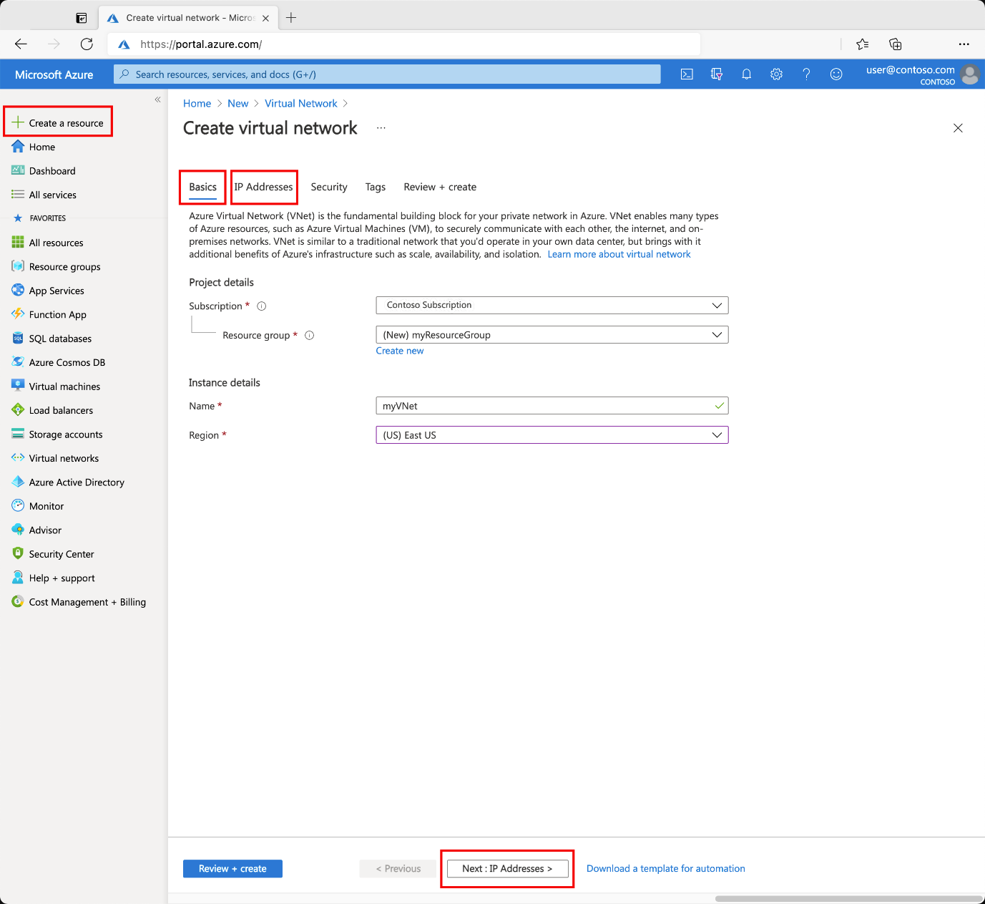

* + 1. Select the IP Addresses tab, or select the Next: IP Addresses button at the bottom of the page.
    2. In IPv4 address space, select the existing address space and change it to 10.1.0.0/16.
    3. Select + Add subnet, then enter MySubnet for Subnet name and 10.1.0.0/24 for Subnet address range.
    4. Select Add.
    5. Select the Security tab, or select the Next: Security button at the bottom of the page.
    6. Under BastionHost, select Enable. Enter this information:

|  |  |
| --- | --- |
| Setting | Value |
| Bastion name | Enter myBastionHost |
| AzureBastionSubnet address space | Enter 10.1.1.0/24 |
| Public IP Address | Select Create new  For Name, enter myBastionIP  Select OK |

* + 1. Select the Review + create tab or select the Review + create button.
    2. Select Create.
  1. NAT Gateway: You can use one or more public IP address resources, public IP prefixes, or both. We'll add a public IP resource and a NAT gateway resource.
     1. On the upper-left side of the screen, select Create a resource > Networking > NAT gateway or search for NAT gateway in the search box.
     2. Select Create.
     3. In Create network address translation (NAT) gateway, enter or select this information in the Basics tab:

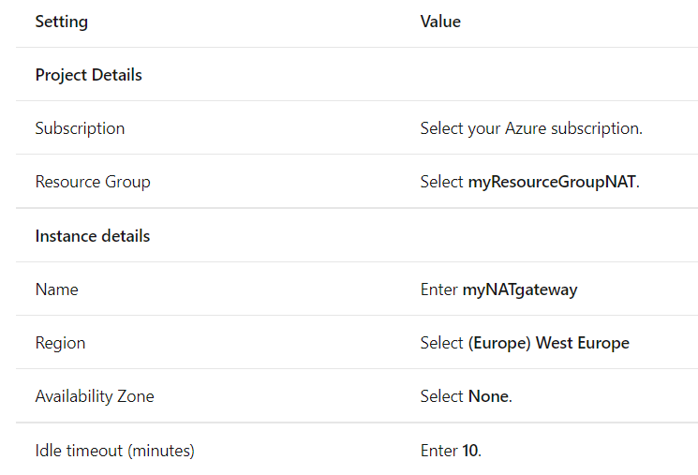

* + 1. Select the Outbound IP tab, or select the Next: Outbound IP button at the bottom of the page.
    2. In the Outbound IP tab, enter or select the following information:

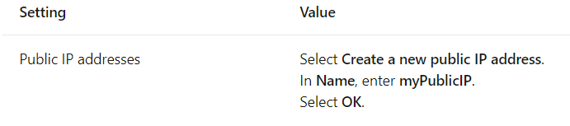

* + 1. Select the Subnet tab, or select the Next: Subnet button at the bottom of the page.
    2. In the Subnet tab, select myVNet in the Virtual network pull-down.
    3. Check the box next to mySubnet.
    4. Select the Review + create tab, or select the blue Review + create button at the bottom of the page.
    5. Select Create.
  1. Create virtual machine
     1. Create two VMs in a virtual network by following the procedure given:
        1. On the upper-left side of the portal, select Create a resource > Compute > Virtual machine.
        2. In Create a virtual machine, type or select the values in the Basics tab:

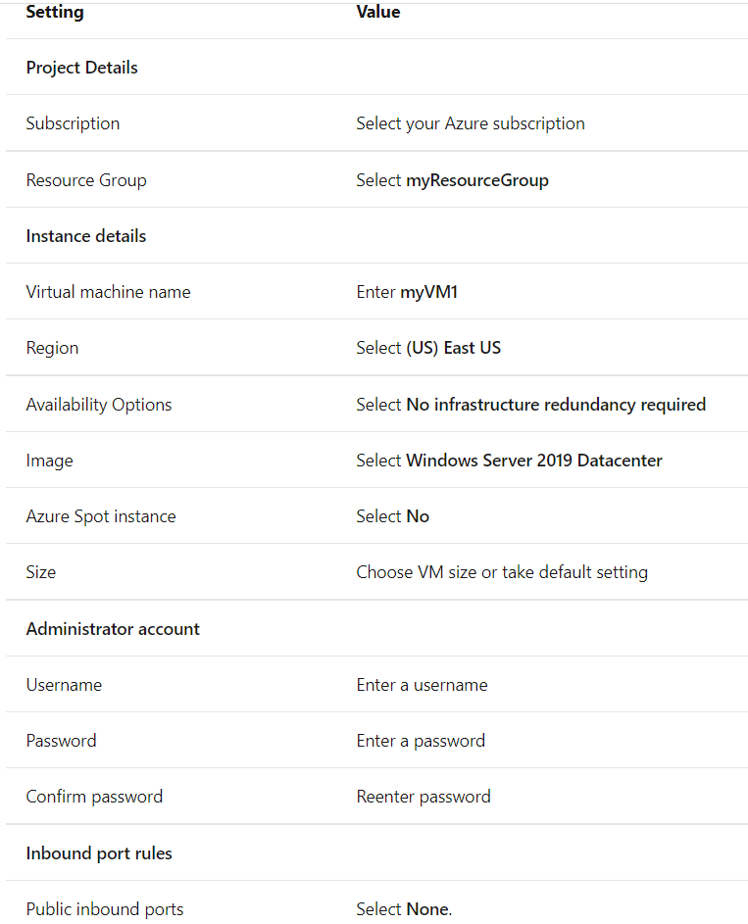

* + - 1. Select the Networking tab, or select Next: Disks, then Next: Networking.
      2. In the Networking tab, select or enter:

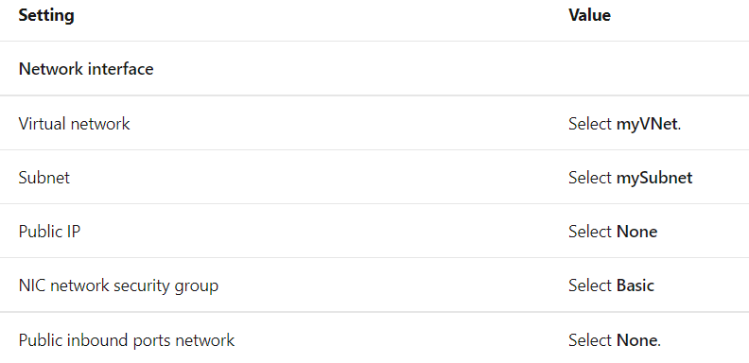

* + - 1. Select the Review + create tab, or select the blue Review + create button at the bottom of the page.
      2. Review the settings, and then select Create.

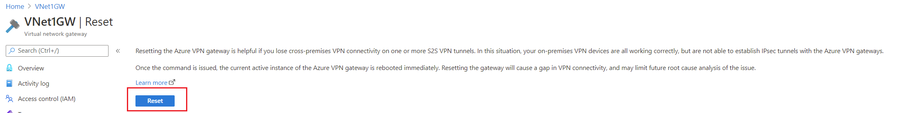

* 1. Test NAT Gateway
     1. Find the public IP address for the NAT gateway on the Overview screen. Select All services in the left-hand menu, select All resources, and then select myPublicIP.
     2. Make note of the public IP address:

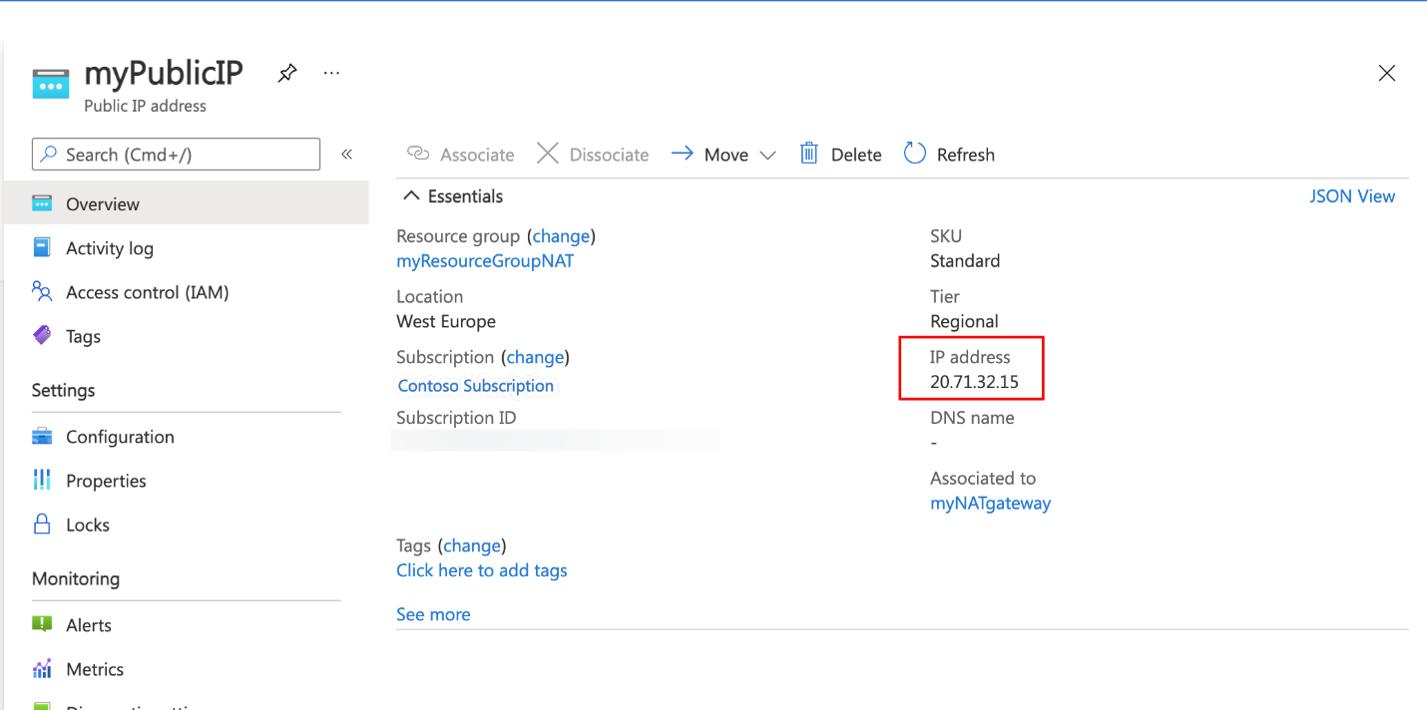

* + 1. Select All services in the left-hand menu, select All resources, and then from the resources list, select myVM that is located in the myResourceGroupNAT resource group.
    2. On the Overview page, select Connect, then Bastion.
    3. Select the blue Use Bastion button.
    4. Enter the username and password entered during VM creation.
    5. Open Internet Explorer on myTestVM.
    6. Enter https://whatsmyip.com in the address bar.
    7. Verify the IP address displayed matches the NAT gateway address you noted in the previous step:

