**KO2 - Able to create an Azure Storage account**

An Azure storage account contains all of your Azure Storage data objects: blobs, files, queues, and tables

To create an Azure storage account with the Azure portal, follow these steps:

Step 1: Log into your Azure Portal

Click **New**, **Data + Storage**, **Storage Account**

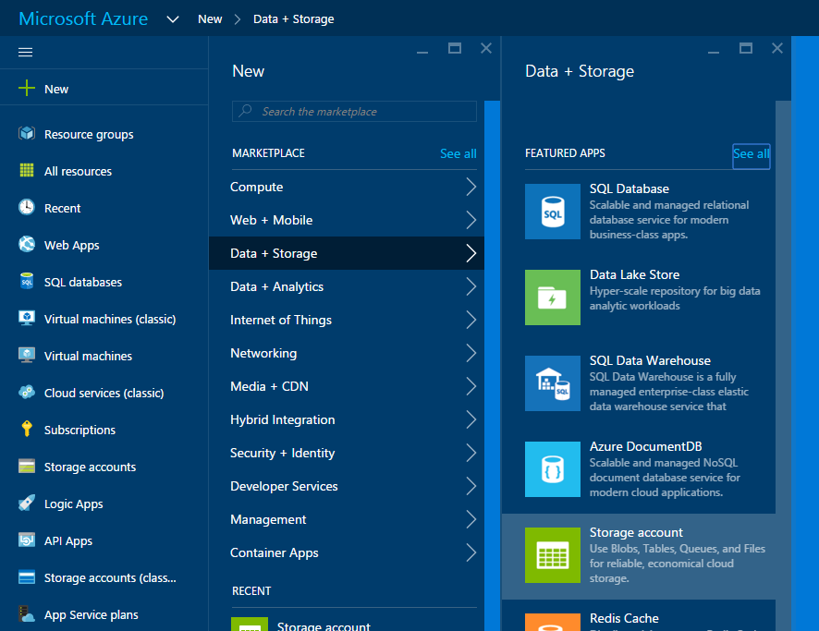

**Step** 3: Choose **Create**

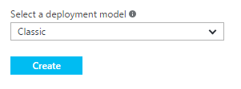

#### Step 4: Type a name for your storage account.

This will be the storage account name that you’ll use to access your storage.

* + - **Choose a pricing tier:**

This is the replication level of your storage across Azure’s physical data center locations.

* + - **Choose a Resource Group,**

This groups your related services together in Azure. If you don’t have any other services running yet, click Create a new resource group

* + - **Choose the subscription**

This will add the storage account under the chosen subscription, you may only have one.

* + - **Choose the location of the data**

This is the physical location of the data centres that will hold your storage account

* + - **Choose whether you want to use Diagnostics**

Diagnostics will disable the regular monitoring charts and alerts for your storage resource, though will send diagnostic data into a storage account for your own monitoring.

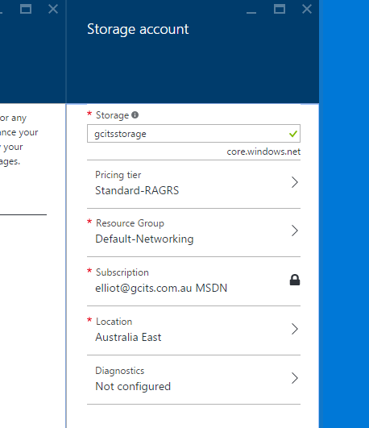

**Step 5:** Now, click **Create.**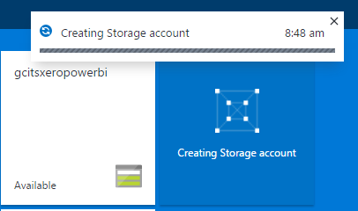

**Step 6:** Wait a few moments for your storage account to be created. Once completed, you can open your brand-new Azure storage account

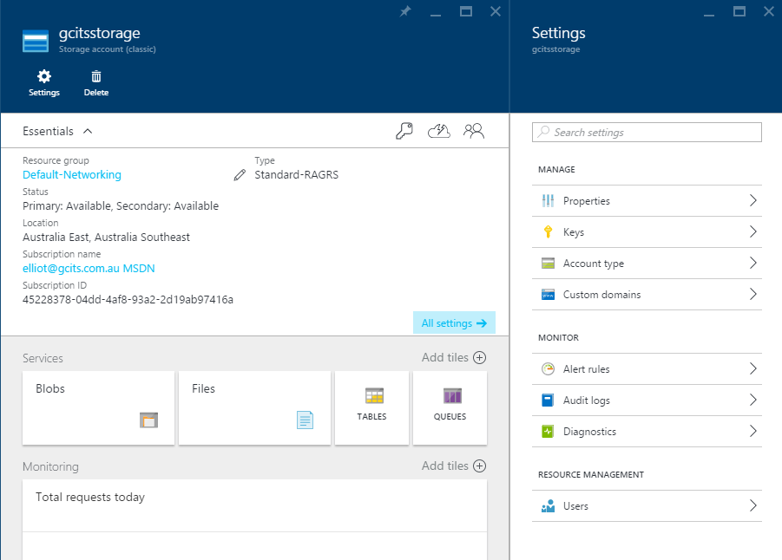

**Step** 7: To make use of this Storage account, click **Keys**on the settings blade to retrieve the **storage account name** and**primary access key**.

