**KO 5 - Able to store application data with Azure Blob storage**

* **B**inary **L**arge **Ob**ject is the storage arena for text, audio, images, and video. Every blob resides inside a container. Blob storage act as the persistent store, where the data is stored for a long time.
* One of the advantages of Blob Storage is that it offers zone-wise redundant processes. Different copies of data are created in the same zone or across two separate zones in a zone redundant. So, creating copies in two distinct zones helps in data recovery.

Steps to Create Blob Storage:

**Step 1)** Log in to [Azure Portal](https://portal.azure.com/)

**Step 2)** The first and foremost step in creating Blob Storage is setting up the ‘Storage Account’.  To create one, log in to the Azure portal, then click on **Storage Accounts**.

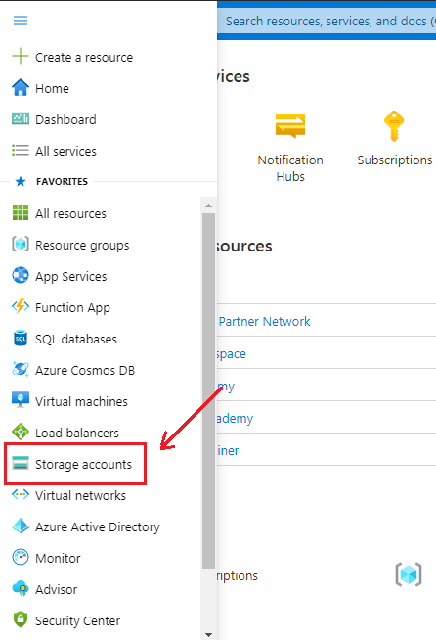

**Step 3**: After clicking on Storge Account, the following screen will appear and then click on **+** **New** to proceed further.

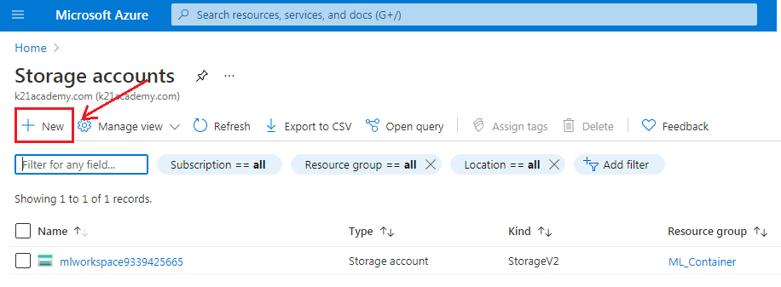

**Step 4**: After clicking on New, it will take you to the next page and asks you to fill in the following details:

1. **Subscription** – It tells you about the billing, invoice details, and the current subscription.
2. **Resource Group** – If you are creating a new resource group, it will show (New) before the name.
3. **Storage Account name** – Specify the name of the account.
4. **Region** – Specify your region or location.
5. Performance – It offers two types of performance option. **Standard** (uses HDD Hard Disk Drives to store data) **Premium** (uses SSD Solid-State Drives to store data)
6. Redundancy – Through Redundancy, Azure ensures that data is protected at times of failure.

Click on **Create**, after filling in all the details.

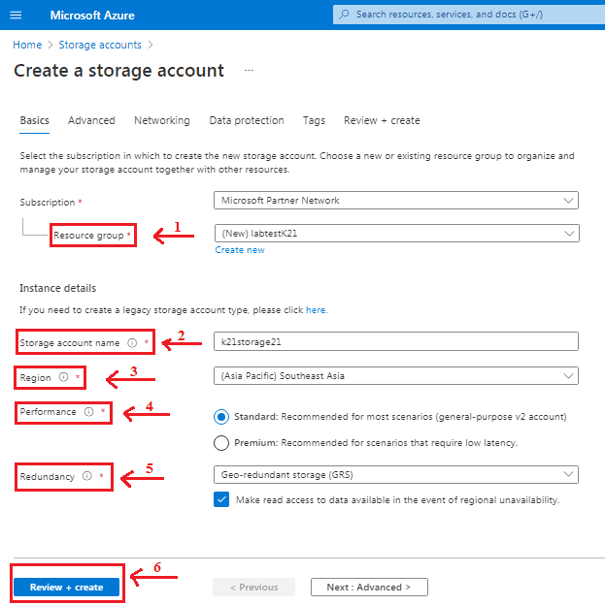

**Step 5**: Azure Storage Account provides four types of Redundancy Storage as shown in the below sample. We will go with Geo-redundant Storage (GRS) for the demo purpose.

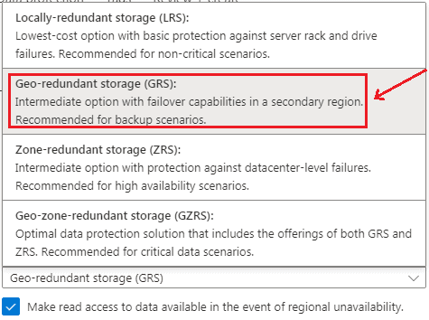

**Step 6:** When you click on the ‘Create’ button, it takes you to the next screen that shows the deployment status. After deployment gets completed, click on **Go to resource** .

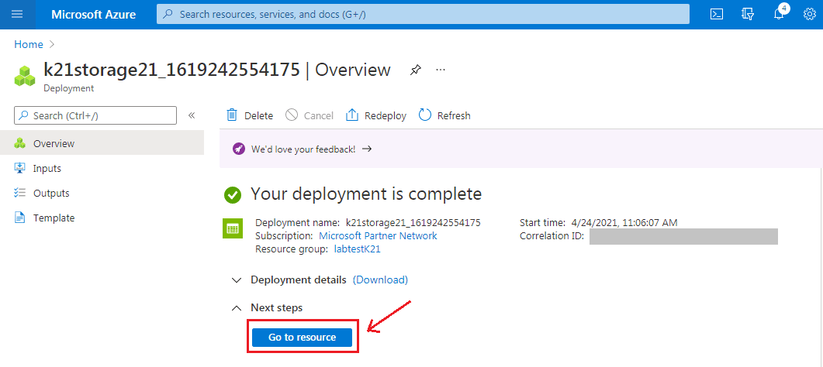

Step 7: The following screen will appear, showing an **Overview** of the created Storage Account. The next step is to click on **Containers** to select Blob Storage. We have chosen the **Hot Access** tier for a demo purpose. One can choose according to their requirements.

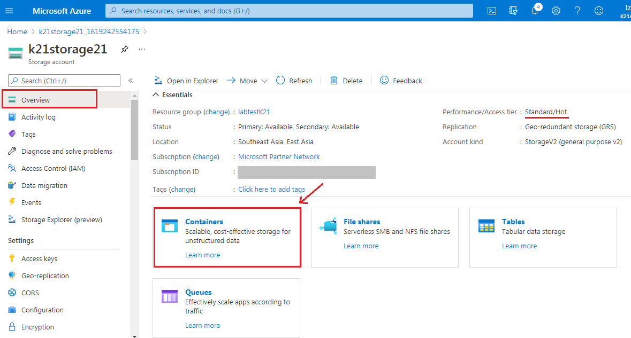

**Step 8**: Now, we have to create a new Container for that click on ‘**+ Container**.

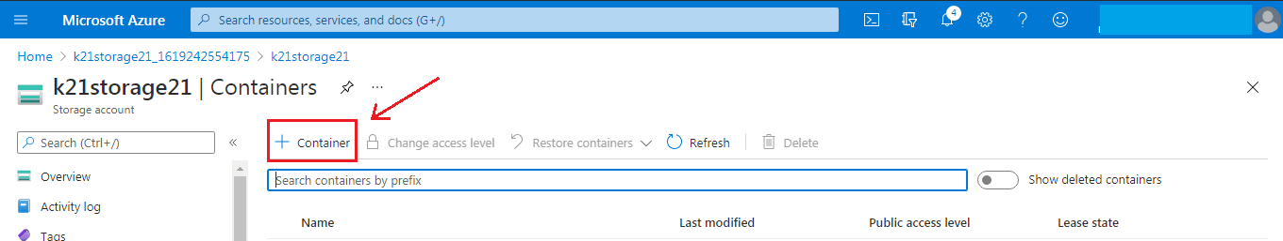

Step 9: After clicking on + Container, it will ask to fill in the container’s name (it should be unique) and select access level. For the demo purpose, we have selected Blob Public Level access. Click ‘**Create** ‘to proceed further.

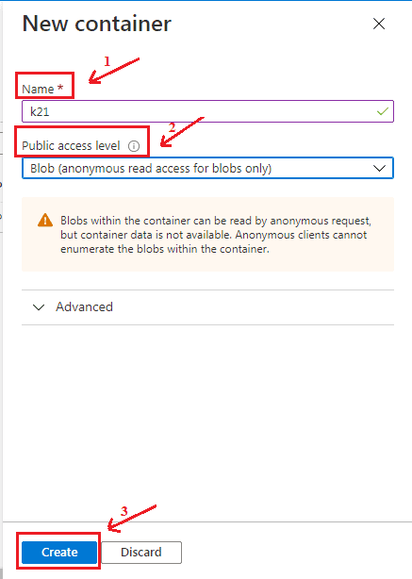

**Step 10**:  Hence we have successfully created the blob storage as we can see container k21 appears under the storage.

