PROJECT SYNOPSIS
"Customer Analytics System – Sentiment & Sales Insights"

SYNOPSIS SUBMITTED IN PARTIAL FULFILMENT OF THE REQUIREMENTS
FOR THE AWARD OF THE DEGREE OF BACHELOR OF TECHNOLOGY (B.TECH)
IN ARTIFICIAL INTELLIGENCE & DATA SCIENCE
SUBMITTED TO
Dr APJ Abdul kalam Technical University Lucknow
Future Institute of Engineering & Technology, Bareilly
SUBMITTED BY:
Ramesh Kumar
(College Roll Number - 2204761630024 )
(College Enrolment Number - 220476163069887 )
2022-2026



Under the Guidance of
Er. Awnish Kr Sharma
Senior Consultant
SOFTPRO INDIA COMPUTER TECHNOLOGIES (P) LTD

Preface
This project report entitled “Softpro Analytics – Sentiment & Sales Insights” is submitted in partial fulfillment of the requirements for the degree of B .Tech in Artificial Intelligence & Data Science

The project has been designed and implemented with the objective of developing a web-based AI-powered system that integrates audio call transcripts with CRM logs to generate actionable insights for counseling and management. By applying speech-to-text transcription, sentiment analysis, and data visualization techniques, this project provides a centralized platform for improving student engagement and conversion.
The report presents a complete overview of the project, including system design, tools and technologies used, implementation details, testing, challenges faced, and future scope.
I sincerely hope that this project will serve as a valuable contribution to both academic learning and practical applications in the field of Artificial Intelligence and Data Analytics.

ACKNOWLEDGEMENT

I would like to express my sincere gratitude to everyone who supported me throughout the successful completion of my project titled "Customer Analytics System – Sentiment & Sales Insights."

First and foremost, I extend my deep sense of gratitude to my project guide,
Er. Awnish Kr Sharma
, for his constant guidance, valuable suggestions, encouragement, and support throughout the development of this project. His technical expertise and mentorship helped me overcome various challenges and successfully accomplish this work.

I would also like to thank the Department of Artificial Intelligence & Data Science Engineering, Future Institute of Engineering & Technology, Bareilly, for providing the necessary infrastructure, resources, and academic environment required for the successful completion of this project.

I extend my heartfelt thanks to all the faculty members and fellow students who directly or indirectly supported me during the development of this project.
Finally, I express my deepest gratitude to my family for their unconditional support, motivation, and encouragement throughout my academic journey.

Certificate of Completion
Dr. A.P.J. Abdul Kalam Technical University (AKTU), Lucknow
Future Institute of Engineering & Technology, Bareilly
This is to certify that the project report entitled
"Customer Analytics System – Sentiment & Sales Insights"

has been successfully completed and submitted by:
( RAMESH KUMAR )
Batch: 2022 – 2026
(College Roll Number - 2204761630024 )
(College Enrolment Number - 220476163069887 )

under the supervision of
Er. Awnish Kr Sharma
Senior Consultant,
Softpro India Computer Technologies (P) Ltd.
in partial fulfillment of the requirement for the award of the degree of
B.Tech in Artificial Intelligence & Data Science
From Dr. A.P.J. Abdul Kalam Technical University (AKTU), Lucknow
Date: 30/8/2025
Place: Lucknow
Signature of Guide
(Er. Awnish Kr Sharma)
Head of Department
( Artificial Intelligence & Data Science )
Seal/Stamp of University

About Company:
Softpro India Computer Technologies (P) Ltd., established in 2004, is one of the leading IT and training companies based in Lucknow, Uttar Pradesh. The company specializes in Software Development, IT Training, Industrial Training, Corporate Training, and Consultancy Services.
Over the years, Softpro India has trained thousands of engineering and computer application students, equipping them with industry-ready technical skills. It also provides customized software solutions to corporate clients in sectors like education, healthcare, finance, and government.
Key Highlights:
- Expertise in Python, Java, MERN, AI/ML, Data Analytics, and Cloud Technologies.
- Provides 6 Weeks / 6 Months Industrial Training for B.Tech, BCA, MCA, and MBA students.
- Offers corporate training programs to bridge the gap between academics and industry needs.
- Runs live projects for students to gain hands-on practical exposure.
The company’s mission is to empower students and professionals with the latest IT skills, ensuring they remain competitive in today’s technology-driven world.

DECLARATION:
I hereby declare that the project report entitled
"Customer Analytics System – Sentiment & Sales Insights"

submitted in partial fulfilment of the requirements for the award of the degree of Bachelor of Technology in Artificial Intelligence & Data Science Engineering at Future Institute of Engineering & Technology, Bareilly, is an authentic record of my own work carried out
under the guidance Er. Awnish Kr Sharma

ABSTRACT

In today's competitive education and training industry, understanding student behavior, concerns, and feedback plays a crucial role in improving counseling effectiveness and increasing conversion rates. Traditional methods of analyzing counselor–student interactions are manual, time-consuming, and often fail to capture valuable insights hidden within audio conversations.

The Customer Analytics System – Sentiment & Sales Insights is a web-based, AI-powered platform developed to automate the analysis of counselor–student interactions. The system integrates speech-to-text transcription, Natural Language Processing (NLP), sentiment analysis, and data visualization into a unified pipeline that transforms unstructured audio and CRM data into meaningful insights.

The system automatically transcribes audio recordings using Whisper/Vosk, merges transcripts with CRM logs, and applies sentiment analysis models to classify student feedback into positive, negative, or neutral categories. An interactive Streamlit dashboard visualizes sentiment distribution, keyword trends, and performance metrics through charts and word clouds. Additionally, a recommendation engine provides actionable suggestions to counselors based on frequently occurring objections such as fees, timing, and placement concerns.

This project aims to reduce manual effort, improve decision-making, enhance student engagement, and provide a scalable and cost-effective analytics solution for educational institutions.

TABLE OF CONTENTS

Title | Page No.
Certificate of Completion | 2
Declaration | 3
Acknowledgement | 4
Preface | 5
About the Company | 6
Abstract | 7
Table of Contents | 8
Chapter 1: Introduction | 9
1.1 Key Objectives of the System | 9
1.2 Problem Statement | 10
1.3 Proposed Solution | 10
1.4 Scope of the Project | 10
Chapter 2: Literature Review | 11
2.1 Traditional Feedback Analysis | 11
2.2 Speech-to-Text Technologies | 11
2.3 Sentiment Analysis Research | 12
2.4 Research Gap | 12
Chapter 3: About the Project | 13
3.1 Project Overview | 13
3.2 Project Workflow | 13
3.3 Project Implementation | 14
3.4 Project Goals | 15
3.5 Key Modules in the Project | 15
Chapter 4: System Architecture & Methodology | 16
4.1 System Architecture | 16
4.2 Methodology | 17
Chapter 5: System Requirements | 18
5.1 Hardware Requirements | 18
5.2 Data Storage Approach | 19
5.3 Software Requirements | 19
5.4 Tools Used for Implementation | 20
Chapter 6: System Design | 21
6.1 High-Level Design | 21
6.2 Low-Level Design | 21
6.3 System Analysis & Feasibility | 22
6.4 Dashboard Design | 23
Chapter 7: Software Testing | 24
Chapter 8: Results and Discussion | 26
Chapter 9: Challenges | 28
Chapter 10: Conclusion | 30
Chapter 11: Future Scope | 31
References | 32

CHAPTER 1: INTRODUCTION

In today's competitive academic environment, institutions rely heavily on effective student counseling to improve admissions, retention, and overall student satisfaction. A significant portion of this counseling is conducted through audio interactions between students and counselors, wherein valuable insights such as student concerns, objections, interests, and sentiments are often concealed within the conversation. Traditionally, analyzing these interactions has been a manual, time-consuming process, leading to missed opportunities and limited scalability.

To overcome these challenges, the Customer Analytics System – Sentiment & Sales Insights has been developed as a web-based, AI-powered platform that integrates audio call transcripts with CRM logs to provide a data-driven decision-making platform. The system leverages speech-to-text transcription, Natural Language Processing (NLP), and sentiment analysis to convert unstructured data into actionable insights.

The project aims to empower counselors, trainers, and management staff with a centralized, interactive dashboard that not only visualizes student sentiment but also generates recommendations for improving conversion rates and addressing student concerns more effectively.

1.1 Key Objectives of the System
- Automation of Analysis – Eliminate manual effort by automatically transcribing counselor–student calls into structured text.
- Sentiment Detection – Classify conversations into positive, negative, or neutral categories to gauge overall student satisfaction.
- Integration with CRM Logs – Merge transcripts with student data (name, year, technology stack, location, etc.) for contextual analysis.
- Visual Dashboards – Provide counselors and management with interactive charts, word clouds, and trend analysis.
- Recommendations Engine – Suggest actionable steps to counselors based on frequent objections (e.g., fees, timing, placement) and sentiment patterns.
- Improved Decision-Making – Assist management in identifying trends, tracking performance, and implementing data-driven strategies.

1.2 Problem Statement
The current counseling process faces the following major challenges:

- Manual analysis of student calls is slow and error-prone.
- There is no centralized platform that combines CRM logs and audio insights.
- Counselors lack data-driven recommendations, relying primarily on intuition.
- Negative feedback often goes unnoticed due to the absence of automated sentiment tracking.

1.3 Proposed Solution
The Customer Analytics System – Sentiment & Sales Insights addresses these issues by automating the entire analytics pipeline: Audio → Text → Sentiment → Insights → Recommendations.

This ensures that every student interaction is captured, analyzed, and utilized to improve counseling effectiveness, enhance training strategies, and boost conversion rates. The design is modular and scalable, ensuring adaptability to future enhancements such as multilingual support, real-time CRM integration, and voice emotion detection.

1.4 Scope of the Project
The scope of this project focuses on automating counselor–student interaction analysis using Artificial Intelligence and Natural Language Processing. The system transcribes calls, analyzes sentiment, merges CRM data, and generates insights through interactive dashboards. Real-time monitoring and cloud deployment are planned as future enhancements.

CHAPTER 2: LITERATURE REVIEW

2.1 Traditional Feedback Analysis
Traditionally, customer feedback was collected through manual methods such as telephone calls, emails, surveys, and handwritten notes. Organizations often relied on manual listening and spreadsheet-based tracking to analyze customer responses.

However, these methods exhibit several significant limitations:
- Time-consuming and labor-intensive.
- Prone to human errors and cognitive bias.
- Difficult to analyze large volumes of data.
- Lack of real-time insights.

Due to these challenges, organizations require automated systems capable of processing large amounts of customer feedback efficiently and accurately.

2.2 Speech-to-Text Technologies
Speech-to-Text (STT) technology converts spoken language into written text using Artificial Intelligence and Deep Learning techniques. Modern STT tools such as OpenAI Whisper and Vosk provide the following capabilities:
- High transcription accuracy.
- Multi-language support.
- Real-time processing capability.
- Noise-robust speech recognition.

These technologies enable organizations to automatically transcribe customer calls, interviews, and voice feedback, making the data readily available for further analysis.

2.3 Sentiment Analysis Research
Sentiment analysis is a Natural Language Processing (NLP) technique used to identify emotions and opinions expressed in text. Earlier approaches employed rule-based methods, which depended on predefined dictionaries and manual rules. However, modern research demonstrates that machine learning and NLP-based models provide superior accuracy and scalability.

Common sentiment categories include:
- Positive.
- Negative.
- Neutral.

Sentiment analysis assists organizations in:
- Understanding customer satisfaction levels.
- Detecting product or service issues.
- Improving marketing strategies and the overall customer experience.

2.4 Research Gap
Despite the rapid growth of Artificial Intelligence, speech recognition, and Natural Language Processing technologies, most existing solutions address individual problems rather than providing an integrated, end-to-end analytics platform.

Existing systems typically perform one of the following tasks:
- Speech-to-text transcription of audio recordings.
- Text-based sentiment analysis of customer feedback.
- Dashboard visualization for structured datasets.

However, there is no unified system that combines all these capabilities into a single automated workflow specifically designed for counselor–student interaction analysis.

Key gaps identified from the literature include:
- Lack of automated integration between audio recordings and CRM logs.
- Absence of real-time sentiment monitoring for counseling interactions.
- Limited availability of domain-specific recommendation systems.
- Heavy dependence on manual analysis and spreadsheets.
- No centralized dashboard for data-driven decision-making.

The proposed Customer Analytics System – Sentiment & Sales Insights addresses these limitations by integrating the entire pipeline: Audio → Transcription → Sentiment → Analytics → Recommendations.

Thus, this project fills the identified research gap by providing a complete AI-powered analytics pipeline specifically tailored for educational counseling environments.

CHAPTER 3: ABOUT THE PROJECT

The Softpro Analytics System is a web-based platform designed to revolutionize the manner in which student–counselor interactions are analyzed and utilized for decision-making. It integrates automatic speech recognition (ASR), Natural Language Processing (NLP), sentiment analysis, and data visualization into a single, streamlined pipeline. The goal of the project is to enable counselors, trainers, and management staff to make informed, data-driven decisions that enhance student engagement and improve conversion rates.

3.1 Project Overview
Name of the Project: Softpro Analytics – Sentiment & Sales Insights
Domain: Artificial Intelligence, Natural Language Processing, and Data Analytics
Technology Stack: Python, Streamlit, Whisper/Vosk, Transformers, Plotly
Target Users: Counselors, Trainers, and Management Staff at Softpro Institute
Duration: 2–3 months for prototype development, with scope for long-term scalability

3.2 Project Workflow
The system automates the entire process from data acquisition to insight generation:

Data Collection
- Audio recordings of student–counselor calls in MP3/WAV format.
- Student information logs stored in CSV format (name, year, technology stack, location, remarks, etc.).

Data Processing
- Audio files are transcribed into text using Whisper (cloud-based) or Vosk (offline) models.
- Student transcripts are merged with CRM logs for contextual analysis.

Sentiment Analysis
- Sentiment is predicted using pretrained Hugging Face models or custom-trained models using TF-IDF with Logistic Regression.
- Each transcript is classified into positive, negative, or neutral categories with associated confidence scores.

Analytics & Visualization
- Sentiment distribution is visualized using pie charts, bar graphs, and line charts.
- Negative keywords are extracted using TF-IDF and displayed as word clouds.
- Counselors can filter results by location, technology stack, or time range.

Recommendation Generation
- A rule-based engine detects recurring student concerns (e.g., fees, timing, placement).
- The engine generates personalized recommendations such as offering evening batches, providing installment fee options, or highlighting placement records.

Output & Reporting
- An interactive, Streamlit-based dashboard provides real-time insights.
- Exportable reports (CSV/PDF) are available for management review and record-keeping.

3.3 Project Implementation
The project follows the Software Development Life Cycle (SDLC), covering the following phases:
- Requirement Analysis: Understanding counselor needs, CRM structure, and call data.
- Design: Modular, layered architecture ensuring scalability and flexibility.
- Coding: Implementation in Python using libraries such as pandas, transformers, whisper, and plotly.
- Testing: Unit, integration, system, and user acceptance testing to ensure reliability.
- Deployment: Streamlit application deployed locally or on an intranet for easy access.

3.4 Project Goals
- Automation: Reduce manual effort in analyzing counselor–student calls.
- Actionable Insights: Provide meaningful recommendations to improve student conversion rates.
- Scalability: Handle 1,000+ students and multiple audio files simultaneously.
- Cost-Effectiveness: Implemented entirely with open-source tools, ensuring zero licensing cost.
- Usability: Designed for non-technical users, requiring minimal training.

3.5 Key Modules in the Project
- Student Management – Manage student profiles and interaction logs.
- Audio Upload & Transcription – Convert counselor–student calls into structured text.
- CRM Log Integration – Merge call transcripts with student interaction logs.
- Sentiment Analysis Engine – Predict and classify feedback sentiments.
- Analytics Dashboard – Visualize data using interactive charts and word clouds.
- Recommendations Engine – Generate counselor suggestions based on student feedback.
- Export Reports – Allow users to download insights for further use.
- User Authentication (Optional) – Ensure secure access to data and dashboards.

CHAPTER 4: SYSTEM ARCHITECTURE & METHODOLOGY

4.1 System Architecture
The system architecture of the Customer Analytics System follows a modular and layered design to ensure scalability, flexibility, and maintainability.

Layer 1: Input Layer
This layer is responsible for collecting raw data from multiple sources:
- Audio recordings of counselor–student interactions.
- Student CRM logs in CSV format.

These inputs serve as the primary data sources for the analytics pipeline.

Layer 2: Processing Layer
The processing layer converts raw audio into structured textual data:
- Whisper/Vosk models transcribe audio into text.
- Transcripts are cleaned and pre-processed.
- Text is merged with CRM logs for contextual analysis.

Layer 3: Analysis Layer
This layer performs Natural Language Processing tasks:
- Sentiment classification (Positive / Negative / Neutral).
- Keyword extraction using TF-IDF.
- Pattern detection and trend analysis.

Layer 4: Visualization Layer
The processed data is presented through an interactive dashboard:
- Pie charts and bar graphs for sentiment distribution.
- Sentiment trend analysis over time.
- Word clouds for keyword visualization.

Layer 5: Recommendation Engine
A rule-based engine generates actionable suggestions based on:
- Sentiment distribution across interactions.
- Frequently occurring objections from students.
- Historical interaction patterns.

This layered architecture ensures that each module can be upgraded independently without affecting the overall system.

4.2 Methodology
The development of the Customer Analytics System follows a structured methodology based on the Software Development Life Cycle (SDLC).

Step 1: Data Collection
Audio recordings and CRM logs are collected as primary data sources. Audio files are stored in MP3/WAV format, while student details are stored in CSV files.

Step 2: Data Pre-Processing
- Audio files are converted into text using Whisper/Vosk.
- Text data is cleaned by removing noise and irrelevant words.
- CRM logs are standardized and merged with transcripts.

Step 3: Feature Engineering
- TF-IDF vectorization extracts important keywords from the text.
- Text is transformed into a machine-learning-ready format.

Step 4: Sentiment Analysis
Sentiment classification is performed using the following approaches:
- Pretrained NLP models from Hugging Face.
- Custom TF-IDF + Logistic Regression model.

Each interaction is labeled as Positive, Negative, or Neutral.

Step 5: Data Visualization
Insights are displayed through interactive charts and word clouds using Plotly and Streamlit.

Step 6: Recommendation Generation
A rule-based engine analyzes sentiment patterns and generates counselor recommendations. This methodology ensures a systematic transformation of raw data into meaningful insights.

CHAPTER 5: SYSTEM REQUIREMENTS

5.1 Hardware Requirements
The hardware requirements are categorized into three tiers based on the scale of usage:

5.1.1 Minimum Configuration (For Prototype / Small-Scale Use)
- Processor: Intel Core i5 (10th Generation or above) / AMD Ryzen 5 equivalent.
- RAM: 8 GB.
- Storage: 256 GB SSD (for faster read/write of audio files and transcripts).
- Graphics: Integrated graphics (processing will be slower but feasible).
- Operating System: Windows 10/11 or Linux Ubuntu 20.04+.

5.1.2 Recommended Configuration (For Smooth Execution of Heavy Models)
- Processor: Intel Core i7 (11th Generation or above) / AMD Ryzen 7 equivalent.
- RAM: 16 GB or higher (for running Whisper and Transformers simultaneously in memory).
- Storage: 512 GB SSD (for models, transcripts, and CRM logs).
- GPU: NVIDIA GTX 1660 / RTX 2060 or higher (CUDA-enabled); minimum 6 GB VRAM for Whisper Large or BERT-based models.
- Operating System: Linux Ubuntu 22.04 LTS (preferred for ML environments).

5.1.3 Advanced / Scalable Configuration (For Enterprise or Large Dataset Training)
- Processor: Intel Core i9 / AMD Ryzen 9 or Threadripper series.
- RAM: 32 GB – 64 GB (for parallel transcription and training of custom sentiment models).
- Storage: 1 TB NVMe SSD (fast disk I/O for handling large audio datasets).
- GPU: NVIDIA RTX 3080 / A100 / Tesla V100 with 16–40 GB VRAM; required for batch processing of 1,000+ audio files and training large NLP models efficiently.
- Deployment Option: On-premise high-performance server or cloud platforms (AWS/GCP/Azure) with GPU instances (e.g., NVIDIA A100, T4, or V100).

5.2 Data Storage Approach
The current system employs CSV and JSON file-based storage to manage and store processed data such as transcripts, sentiment results, and analytics outputs.

This approach was selected for the following reasons:
- Simple and straightforward to implement.
- Suitable for small-scale datasets.
- No database setup required.
- Fast read/write operations for development and testing phases.

The file-based storage is currently sufficient for the project scope and prototype implementation. For future scalability, the system can be extended to incorporate database solutions such as MySQL or MongoDB. Database integration will provide the following benefits:
- Efficient handling of large datasets.
- Multi-user access support.
- Improved data security and backup mechanisms.
- Better performance for real-time analytics.

This design maintains a lightweight system in the present while ensuring scalability for future deployment.

5.3 Software Requirements
The Softpro Analytics System is developed and deployed using open-source tools and modern frameworks.

5.3.1 Operating System
- Minimum: Windows 10 / Linux Ubuntu 20.04.
- Recommended: Windows 11 Pro / Linux Ubuntu 22.04 LTS (preferred for AI & ML model compatibility).

5.3.2 Programming Language
- Python 3.10+ – Core programming language for implementation.

5.3.3 Development Environment
- IDE: Visual Studio Code / PyCharm (for coding and debugging).
- Jupyter Notebook (Optional): For testing ML models and data pre-processing.

5.3.4 Libraries & Frameworks
- Data Processing: pandas, numpy (for handling CSV logs and pre-processing).
- Machine Learning / NLP: scikit-learn (Logistic Regression, TF-IDF vectorization); transformers (Hugging Face) for pretrained sentiment models such as BERT and RoBERTa; whisper (OpenAI) for speech-to-text transcription; vosk (offline ASR alternative) for low-resource environments.
- Visualization: plotly for interactive charts and graphs; matplotlib/seaborn (optional) for static plots.
- UI / Dashboard: streamlit for web-based dashboard development.
- Database (Optional): SQLite / MySQL for storing logs, transcripts, and sentiment outputs.

5.3.5 Deployment Environment
- Local Deployment: Streamlit application hosted on a local machine or internal intranet.
- Cloud Deployment (Optional): AWS (EC2 with GPU, S3 for storage); Google Cloud Platform (Vertex AI, GPU instances); Microsoft Azure (VM with CUDA support).

5.3.6 Version Control
- Git & GitHub/GitLab – for source code management and collaboration.

5.3.7 Additional Tools
- Browser: Google Chrome / Mozilla Firefox (to access the dashboard).
- Package Management: pip / conda (for installing dependencies).
- Virtual Environment: venv or Anaconda (to isolate project dependencies).

5.4 Tools Used for Implementation
The Softpro Analytics System is implemented using modern, open-source tools to ensure flexibility, cost-effectiveness, and scalability.

5.4.1 Programming Language
- Python – Core programming language for data processing, model integration, and application logic.

5.4.2 Frontend / User Interface
- Streamlit – Used for building the interactive dashboard and user interface for uploading data, viewing analytics, and displaying recommendations.

5.4.3 Libraries and Frameworks
- pandas, numpy – For data pre-processing, cleaning, and efficient handling of CSV logs.
- scikit-learn – For machine learning tasks such as training Logistic Regression sentiment models and TF-IDF vectorization.
- transformers (Hugging Face) – For leveraging pretrained sentiment analysis models.
- whisper (OpenAI) / vosk – For automatic speech recognition (transcription of audio calls into text).
- plotly – For visualization of insights via interactive charts and graphs.

5.4.4 Database (Optional)
- SQLite / MySQL – For storing student logs, transcripts, and analysis results when persistent storage is required.

5.4.5 Development Environment
- VS Code / PyCharm – IDEs used for development and debugging.
- Python 3.10+ – Required runtime environment.

5.4.6 Deployment
- Local Server / Intranet – Streamlit application deployed internally for counselors and management to access securely.

CHAPTER 6: SYSTEM DESIGN

6.1 High-Level Design

Level-0 DFD
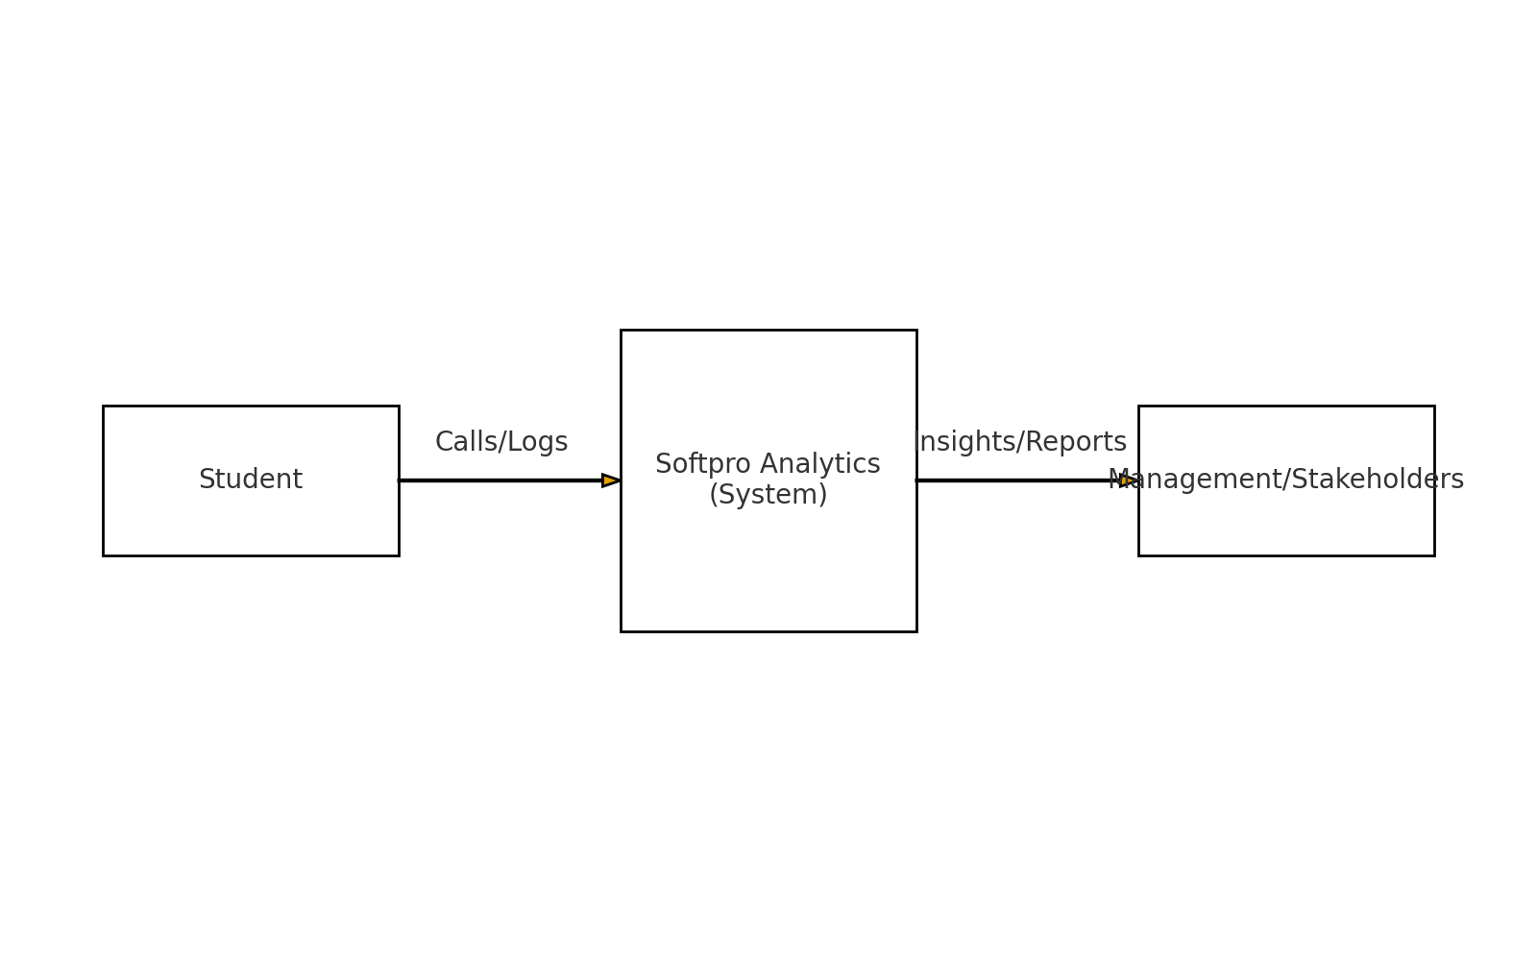
Student → Counselor Call → Softpro Analytics → Insights

Level-1 DFD
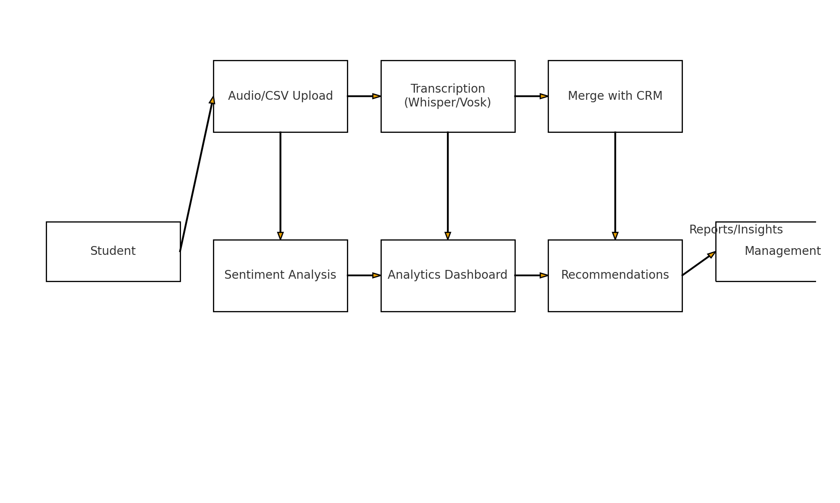
Audio Upload → Transcription → Sentiment Analysis → Analytics → Recommendations

Entity-Relationship (ER) Diagram
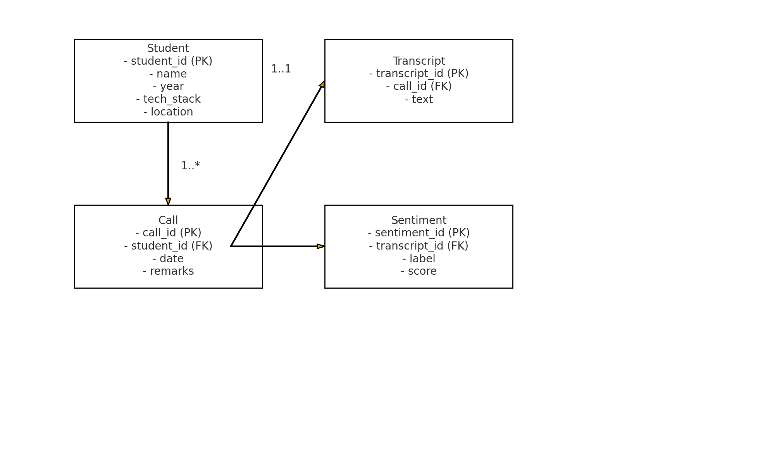

Entities: Student, Call, Transcript, Sentiment, Recommendation.

6.2 Low-Level Design

Database Tables
- Students: StudentID, Name, Year, TechStack, Location.
- Calls: CallID, StudentID, Date, Remarks.
- Transcripts: TranscriptID, CallID, Text.
- Sentiment: SentimentID, TranscriptID, SentimentLabel, SentimentScore.

Module Descriptions
- Student Management – Manage student profiles and interaction logs.
- Audio Upload – Convert audio recordings to structured text.
- Sentiment Analysis – Predict positive/negative/neutral feedback.
- Analytics Dashboard – Visualize insights through interactive charts.
- Recommendations Engine – Generate counselor suggestions based on fees, timing, placement, and other recurring concerns.

6.3 System Analysis & Feasibility

System Design
The design of the Softpro Analytics System follows a modular and layered approach to ensure scalability, maintainability, and clarity.
- Input Layer: Handles uploading of audio recordings and CSV student logs.
- Processing Layer: Includes transcription (Whisper/Vosk), sentiment analysis (custom model or pretrained pipeline), and data merging logic.
- Analysis Layer: Applies Natural Language Processing techniques such as TF-IDF vectorization, classification, and keyword extraction.
- Visualization Layer: Provides interactive dashboards using Streamlit and Plotly for real-time insights.
- Recommendation Engine: Uses rule-based heuristics to suggest improvements in training, counseling, and sales approaches.

This layered design ensures that each module is independently testable and interchangeable. For example, Whisper can be replaced with Vosk for offline transcription without affecting the rest of the pipeline.

User Characteristics
The primary users of Softpro Analytics are counselors, trainers, and management staff at Softpro Institute, characterized as follows:
- Counselors: Non-technical background; require an easy-to-use dashboard to upload recordings and logs, then view recommendations.
- Trainers: Interested in understanding student concerns related to specific technology stacks (Python, Java, MERN, AI/ML).
- Management: Require high-level insights such as overall sentiment trends, location-wise performance (Noida vs. Lucknow), and sales-related objections.
- Students (Indirect Users): Although not direct users of the system, their feedback and call logs drive the analytics process.

The interface is designed to be minimal and intuitive, requiring little to no technical expertise.

System Analysis
The analysis of Softpro Analytics covers functional and non-functional requirements:

Functional Requirements:
- Upload and parse CSV logs.
- Transcribe audio recordings to text.
- Merge transcripts with student interaction logs.
- Perform sentiment analysis (pretrained/custom).
- Generate insights and recommendations.

Non-Functional Requirements:
- Usability: Simple UI accessible to non-technical counselors.
- Scalability: Capable of handling 1,000+ students and multiple audio files.
- Accuracy: Ensure transcription and sentiment outputs are reliable.
- Performance: Process within a reasonable time (under 1 minute for small datasets).

Feasibility Analysis
Feasibility is analyzed across the following dimensions:
- Technical Feasibility: Open-source tools such as Whisper, Vosk, and Transformers are readily available; Python and Streamlit are well-suited for rapid development.
- Economic Feasibility: No licensing costs; hardware requirements limited to a mid-range PC with sufficient RAM/CPU.
- Operational Feasibility: Staff can be easily trained to upload CSVs and recordings; recommendations are actionable and directly improve counseling processes.
- Schedule Feasibility: Prototype can be developed within 2–3 months; additional improvements such as predictive modeling can be added subsequently.

Thus, the project is technically sound, operationally viable, and cost-effective for Softpro Institute.

Context Design
The Context Design illustrates how different entities interact with the system.

Actors:
- Counselor: Uploads CSV files and audio recordings.
- Student: Provides feedback via calls and interaction logs.
- Management: Reviews generated insights and reports.

Processes:
- Counselor uploads call logs and audio recordings.
- System transcribes and merges audio data with logs.
- Sentiment analysis is applied to the merged data.
- Dashboards and recommendations are generated.

Outputs:
- Insights categorized by location, technology stack, and sentiment.
- Recommendations for improving conversion rates and reducing negative sentiments.
- Exportable reports for internal use and record-keeping.

6.4 Dashboard Design
The Softpro Analytics Dashboard is the central interface through which counselors, trainers, and management staff interact with the system. It transforms raw transcripts, CRM logs, and sentiment outputs into clear, visual insights. The design prioritizes a minimal, intuitive layout that requires no technical expertise, making it accessible to all user groups.

Key Components of the Dashboard
- Data Upload Panel: Allows users to upload audio recordings (MP3/WAV) and CSV CRM logs; displays upload status with appropriate error-handling messages for invalid or missing files.
- Transcription & Sentiment Section: Displays automatically generated transcripts of uploaded audio; shows sentiment distribution (Positive, Negative, Neutral) along with confidence scores.
- Visual Analytics – Pie Charts: Sentiment distribution across all calls; Bar Charts: Location-wise and technology stack–wise sentiment comparisons; Line Charts: Monthly sentiment trends for tracking progress over time; Word Clouds: Frequently used negative/positive keywords extracted via TF-IDF.
- Filtering & Drill-Down Options: Filters by location (Lucknow, Noida, etc.), technology stack (Python, Java, MERN, AI/ML), and time range; enables counselors to focus on subsets of data for targeted analysis.
- Recommendations Panel: AI-powered suggestions generated based on sentiment patterns and keyword detection (e.g., objections about fees, timing, and placement); provides actionable counselor tips such as "Offer evening batches," "Highlight placement success stories," or "Adjust fee installment plans."
- Export & Reporting: Generates downloadable CSV/PDF reports containing merged transcripts, sentiment scores, and insights; useful for management reviews and long-term record-keeping.

Benefits of the Dashboard
- Replaces manual analysis with an automated, visual, and interactive system.
- Helps counselors by providing real-time insights into student concerns.
- Assists trainers in understanding technology-related issues raised by students.
- Equips management with high-level overviews of performance trends, objections, and opportunities to improve conversion rates.

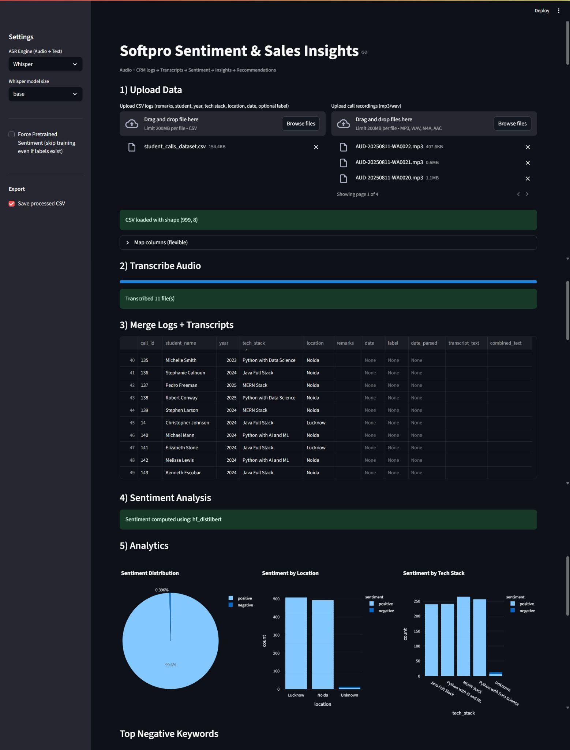
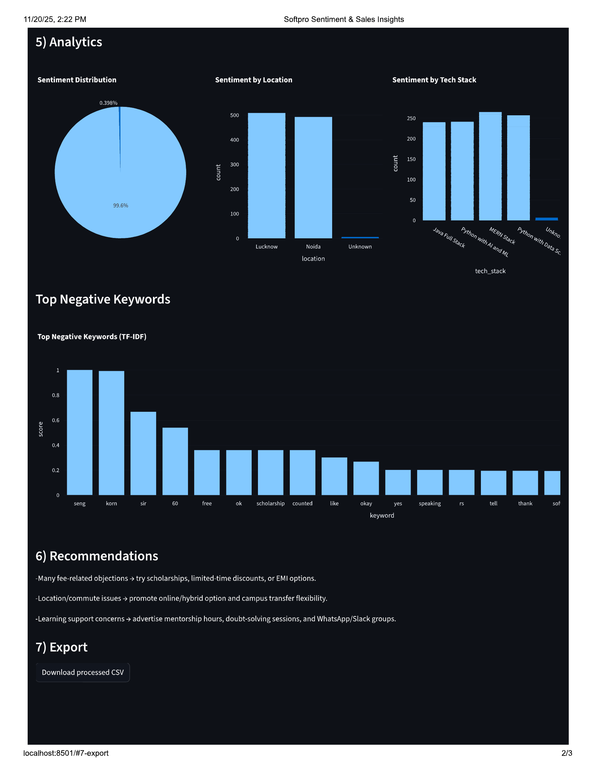

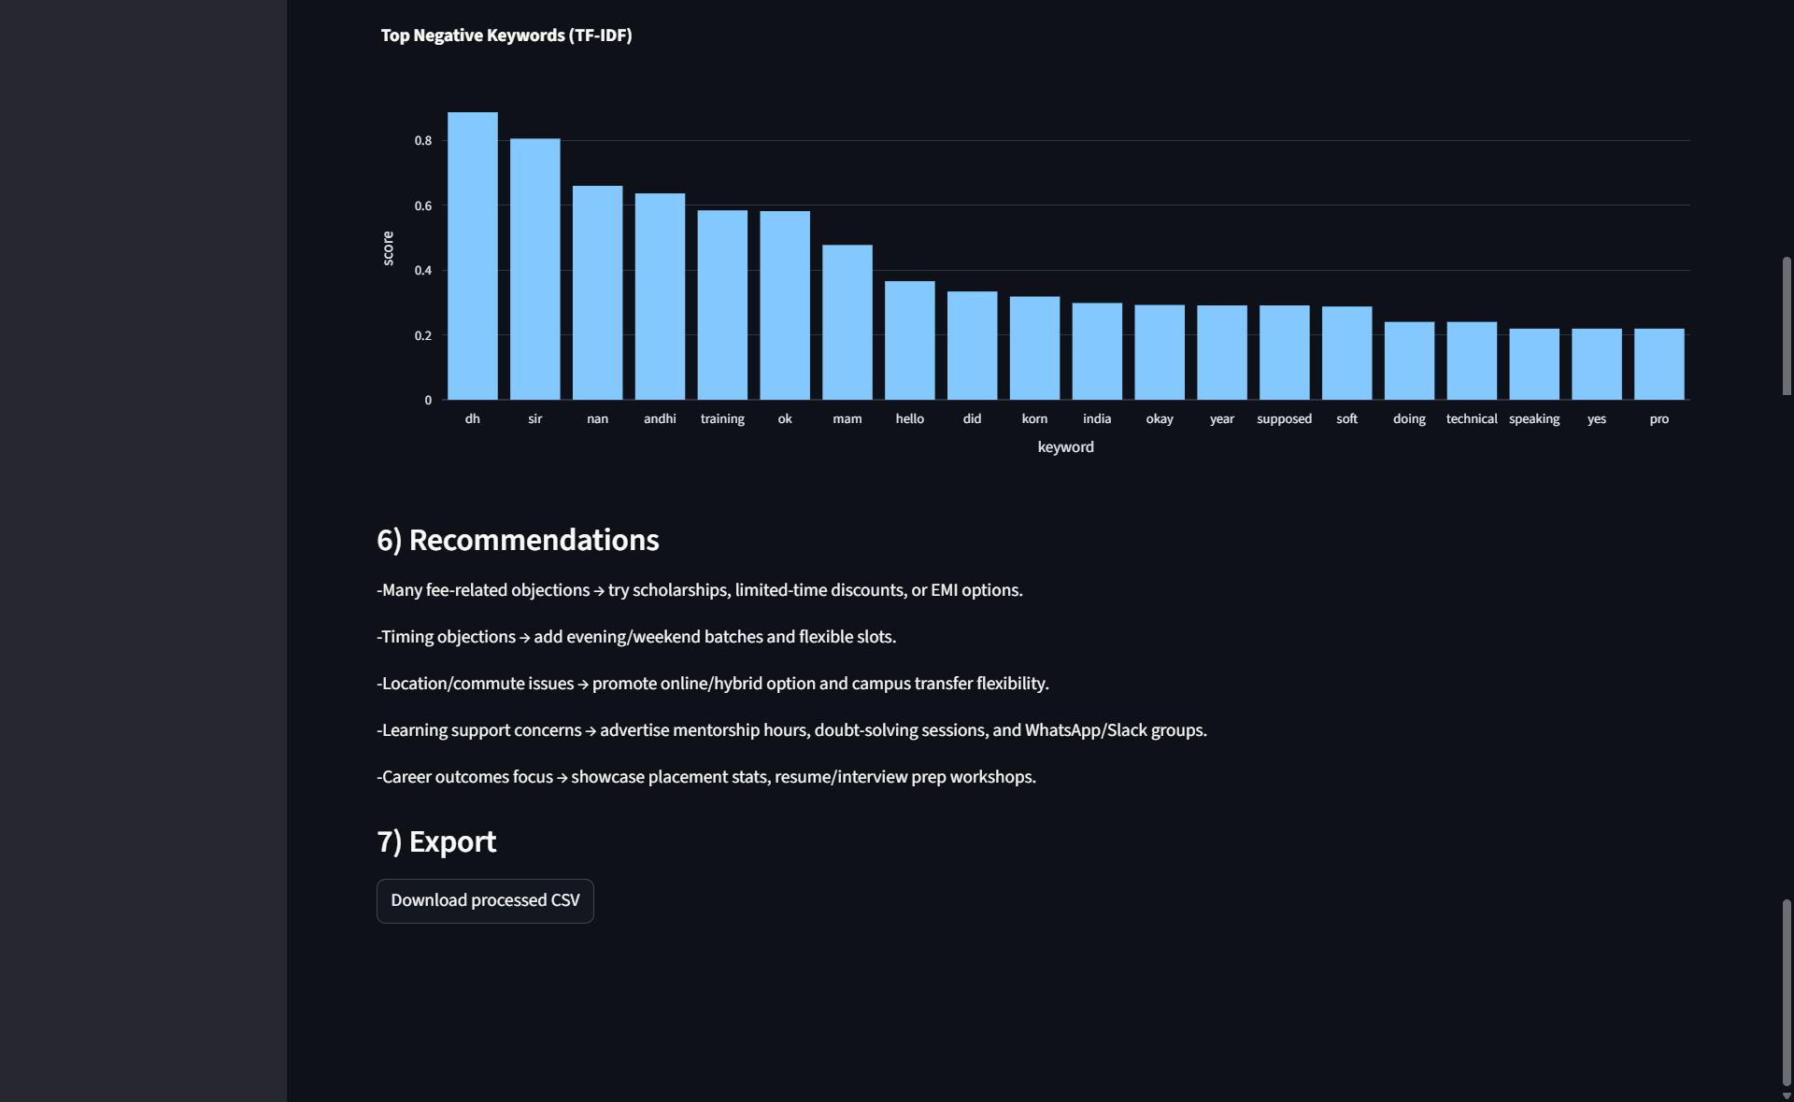

CHAPTER 7: SOFTWARE TESTING

7.1 Importance of Software Testing
Software testing is an essential activity within the Software Development Life Cycle (SDLC). It ensures the correctness, completeness, and overall quality of the developed system. In the Softpro Analytics project, testing validates whether transcription, sentiment analysis, and dashboards function as intended.

The key objectives of software testing in this project are to:
- Detect defects early in the development process.
- Ensure the software meets both functional and non-functional requirements.
- Improve system reliability and user satisfaction.
- Reduce maintenance costs after deployment.

7.2 Testing Strategy
For the Softpro Analytics System, a hybrid testing strategy is applied, comprising the following levels:
- Unit Testing: Tests individual modules such as the transcription function and CSV upload handler.
- Integration Testing: Checks interactions between the audio-to-text, sentiment analysis, and visualization modules.
- System Testing: Validates the complete Streamlit application in a real-world scenario.
- User Acceptance Testing (UAT): Conducted with Softpro's counselors and management to ensure usability and that business requirements are met.

The testing strategy follows an incremental approach, wherein modules are tested in isolation first and subsequently integrated step by step.

7.3 White Box Testing
White box testing focuses on the internal logic and code structure of the system. It is applied during unit testing of Python functions such as transcribe_with_whisper() and gen_recos().

Techniques applied include:
- Statement Coverage: Ensuring every line of code is executed at least once.
- Branch Coverage: Verifying all decision branches (e.g., sentiment positive/negative paths) are tested.
- Path Coverage: Testing all logical paths in functions such as data merging and CSV handling.

In this project, white box testing ensures the correctness of algorithms, including TF-IDF vectorizer training and sentiment classification logic.

7.4 Black Box Testing
Black box testing validates the system without knowledge of its internal code, focusing solely on inputs and expected outputs.

Example test cases include:
- Uploading valid and invalid CSV files and verifying appropriate error handling.
- Uploading MP3/WAV audio files and ensuring correct transcription output.
- Entering empty remarks and verifying that defaults are handled gracefully.
- Analyzing data with and without sentiment labels and confirming consistent outputs.

Black box testing was particularly useful during UAT, where end-users validated whether the dashboard produced meaningful insights and actionable recommendations.

7.5 Testing Implementation in Softpro Analytics
Testing in the Softpro Analytics System was not merely theoretical; it was actively implemented throughout the development process. The following points describe its utilization in detail:

Audio Transcription Validation
- Uploaded multiple MP3/WAV recordings to ensure Whisper correctly converted speech to text.
- Tested with background noise, low volume, and varying accents to evaluate robustness.
- Verified that transcripts matched manual transcriptions within an acceptable accuracy threshold.

CSV Upload & Data Handling
- Tested CSV files containing missing values, incorrect date formats, and extraneous columns.
- Validated that the application handled errors gracefully (e.g., filling missing remarks with an empty string).
- Ensured that merging of CSV logs and transcripts functioned correctly with both call_id and index-based joins.

Sentiment Analysis Output
- Cross-checked pretrained Hugging Face sentiment model results against manually labeled remarks.
- For training mode, tested Logistic Regression with small labeled datasets and validated accuracy reports.
- Verified correct mapping of positive/negative labels even when users provided abbreviated inputs such as P/N.

Analytics Dashboards
- Confirmed that pie chart sentiment distributions matched expected proportions from test data.
- Tested filtering by Location (Noida/Lucknow) and Technology Stack to verify correct grouping.
- Verified that monthly trend lines plotted data in chronological order, even with mixed date formats.

Recommendations Engine (gen_recos)
- Validated rule-based conditions (e.g., negative sentiment exceeding 40% triggers recommendations).
- Tested keyword detection for objections such as fees, timing, and placement by injecting them into sample data.
- Confirmed that suggestions changed dynamically based on sentiment ratios and detected keywords.

User Acceptance Testing (UAT)
- Conducted trials with Softpro counselors who uploaded their own logs and audio recordings.
- Gathered feedback on whether insights were meaningful and refined the user interface accordingly.
- Adjusted recommendations to make them more practical (e.g., "Offer evening batches" when timing issues were frequently detected).

Performance Testing
- Uploaded 1,000+ student records to ensure the application handled large datasets without crashing.
- Verified that transcription of multiple audio files in batch mode completed within a reasonable time frame.

CHAPTER 8: RESULTS AND DISCUSSION

The implementation of the Customer Analytics System – Sentiment & Sales Insights successfully demonstrates the effectiveness of integrating AI-based transcription, sentiment analysis, and dashboard visualization.

8.1 Key Results
- Automated transcription significantly reduced manual effort in processing counselor–student interactions.
- Sentiment analysis accurately categorized student feedback into positive, negative, and neutral classes.
- Dashboard visualizations provided real-time, actionable insights for counselors and management.
- The recommendation engine generated practical and contextually relevant counselor suggestions.

8.2 Key Observations
- Negative feedback was most commonly related to fees and scheduling/timing concerns.
- Positive sentiment increased noticeably when placement information and success stories were highlighted.
- Data-driven recommendations contributed to improved counseling strategies and decision-making.

8.3 Impact of the System
The system provides the following measurable benefits:
- Faster decision-making for counselors and management.
- Improved student engagement through personalized counseling.
- Reduced manual workload in analyzing student interactions.
- Better conversion strategies based on data-driven insights.

The results confirm that the proposed solution effectively transforms unstructured interaction data into actionable insights, validating the objectives outlined at the commencement of the project.

CHAPTER 9: CONCLUSION

The Softpro Analytics project successfully demonstrates how AI-driven tools can transform raw student–counselor interactions into actionable insights. By integrating speech-to-text transcription, sentiment analysis, and CRM data, the system provides the following key outcomes:
- A centralized, automated dashboard that reduces manual analysis effort.
- Actionable recommendations to counselors and management for improving student conversion rates.
- A scalable and cost-effective solution capable of handling large datasets with high accuracy.

The layered, modular design ensures maintainability and adaptability. For example, the transcription engine can seamlessly switch between Whisper and Vosk for offline operation without affecting the rest of the pipeline. With its focus on usability, the system is accessible to non-technical counselors while simultaneously offering deep analytical insights for management.

In essence, the Softpro Analytics System bridges the gap between raw student feedback and data-driven decision-making, ensuring better counseling outcomes and improved business performance for educational institutions.

CHAPTER 10: FUTURE SCOPE

The project provides a strong foundation and also has significant scope for advanced features and enhancements in future versions:

Multilingual Support
Extend transcription and sentiment models to support Hindi, Hinglish, and regional Indian languages for wider applicability across diverse student populations.

Real-Time CRM Integration
Direct integration with CRM APIs to fetch interaction logs automatically, eliminating the need for manual CSV uploads.

Voice Emotion Detection
Detect emotions such as anger, hesitation, or excitement directly from voice tone, complementing text-based sentiment analysis for richer insights.

Mobile-Friendly Version
Develop a lightweight, responsive mobile application/dashboard for on-the-go use by counselors and management staff.

AI-Driven Personalized Scripts
Dynamically generate counselor conversation scripts based on student sentiment, identified objections, and past interactions for more personalized and effective engagement.

Scalability Enhancements
Migrate towards cloud deployment to support real-time performance monitoring across thousands of simultaneous student interactions.

CHAPTER 11: CHALLENGES

During the development of the Softpro Analytics – Sentiment & Sales Insights system, several challenges were encountered at different stages of the Software Development Life Cycle (SDLC). These challenges are both technical and operational in nature.

11.1 Speech-to-Text Accuracy
Problem: Transcribing audio files into text with high accuracy was difficult due to background noise, varying student accents, and low-quality recordings.
Solution: Whisper (cloud-based) was used for better accuracy, with Vosk (offline) as a backup. Multiple audio samples were tested under noisy conditions to fine-tune model reliability.

11.2 Handling Large Data Volumes
Problem: Processing 1,000+ student logs and multiple audio files simultaneously degraded system performance.
Solution: Batch processing was implemented and data handling was optimized using pandas and numpy. Higher hardware and GPU resources were recommended for enterprise-scale deployment.

11.3 Sentiment Classification Limitations
Problem: Pretrained sentiment models sometimes failed to capture context-specific terminology such as fees, timing, or placement objections used in student counseling conversations.
Solution: A custom TF-IDF + Logistic Regression model was developed and trained on domain-specific student counseling data. Keyword extraction was also integrated to improve classification accuracy.

11.4 Integration of Transcripts with CRM Logs
Problem: Mismatched keys (call IDs, student names) caused merging errors between transcripts and CSV logs.
Solution: Flexible matching strategies, including index-based and call_id-based joins, were implemented. Robust error handling was added for missing or inconsistent data entries.

11.5 Dashboard Usability for Non-Technical Users
Problem: Counselors and trainers, being non-technical users, required a simple and intuitive interface.
Solution: The user interface was developed using Streamlit, which allows drag-and-drop file uploads, easy filtering, and real-time visualization without complex navigation.

11.6 Realistic Recommendations
Problem: Generic recommendations were not sufficiently useful in real counseling sessions.
Solution: The rule-based engine was refined to provide context-specific suggestions, such as "Offer evening batches" when timing issues appeared frequently in the data.

11.7 Performance Constraints
Problem: Transcription of large audio files and batch processing of multiple datasets was time-consuming.
Solution: Code was optimized using efficient libraries, proper resource allocation was ensured, and GPU or cloud deployment was recommended for running heavy transcription and NLP models.

11.8 User Acceptance Testing (UAT)
Problem: Initial users (counselors) found certain insights to be irrelevant or difficult to interpret.
Solution: Feedback gathered from counselors during UAT was used to refine both the dashboard layout and recommendation rules, making the results more practical and user-friendly.

REFERENCES

- OpenAI, Whisper: Automatic Speech Recognition System. Available: https://openai.com/research/whisper
- Vosk Speech Recognition Toolkit. Available: https://alphacephei.com/vosk/
- Hugging Face, Transformers Library Documentation. Available: https://huggingface.co/docs/transformers
- Scikit-learn Developers, Machine Learning in Python. Available: https://scikit-learn.org
- Streamlit Inc., Streamlit Documentation. Available: https://docs.streamlit.io
- Plotly Technologies Inc., Plotly Python Graphing Library. Available: https://plotly.com/python/
- Python Software Foundation, Python Documentation. Available: https://docs.python.org

