CyberShield: Cyber Threat Detection System using Random Forest and MLP

Nakashi Rohith
Computer Science and Engineering
Rajiv Gandhi University of Knowledge Technologies, Basar, India
b200224@rgukt.ac.in

Thatikindhri Srinadh
Computer Science and Engineering Rajiv Gandhi University of Knowledge Technologies, Basar, India
b200722@rgukt.ac.in
Bandari Ramesh
Computer Science and Engineering
Rajiv Gandhi University of Knowledge Technologies, Basar, India
b200571@rgukt.ac.in

Abstract
Sophisticated cyberthreats that target sensitive and vital systems have significantly increased as a result of the quick digitization of global infrastructure. In order to overcome this difficulty, CyberShield suggests a hybrid machine learning framework that can anticipate and stop cyberattacks before they happen. In order to detect complex network anomalies in real time, the framework combines Random Forest (RF) for ensemble-based feature evaluation with Multi-Layer Perceptron (MLP) for deep neural pattern recognition. The well-known benchmark datasets CICIDS2017 and UNSW-NB15, which provide realistic network traffic patterns and a variety of representations of modern attack behaviors, are used to train and validate the system. The hybrid architecture improves detection accuracy, lowers false positives, and exhibits strong adaptability to unseen attack patterns by combining these complementary techniques. According to experimental findings, CyberShield .The hybrid architecture improves detection accuracy, lowers false positives, and exhibits strong adaptability to hitherto unseen attack patterns by combining these complementary techniques, CyberShield outperforms individual models and traditional intrusion detection techniques, achieving detection accuracy of over 95%. This study underscores the role of predictive learning techniques in proactive cybersecurity strategies and shows how they can be used to protect digital infrastructures from changing cyberthreats.
Keywords - Cybersecurity, Hybrid Machine Learning, Random Forest, Multi-Layer Perceptron, Intrusion Detection System, Network Anomaly Detection, CICIDS2017, UNSW-NB15

Introduction

Recent years have seen a rapid digital transformation that has completely changed how people, governments, and industries use technology. The complexity and interconnectivity of contemporary networks have skyrocketed due to the proliferation of connected devices, such as cloud-based apps, Internet of Things (IoT) devices, and critical infrastructure systems. Although these developments have greatly increased operational efficiency and convenience, they have also increased the surface area for cyberattacks, giving bad actors more chances to take advantage of weaknesses. Simple malware and phishing campaigns are no longer the only cybersecurity threats; ransomware, advanced persistent threats (APTs), distributed denial-of-service (DDoS), and zero-day exploits are examples of modern attacks that are more complex, flexible, and able to get past conventional signature-based defenses. Because of this, traditional security measures that mostly rely on static rules or well- known attack signatures are inadequate for identifying
recently discovered or altered attack patterns. Undiscovered breaches may lead to serious repercussions, such as monetary losses, business interruptions, and the compromise of private information, which may have long-term effects on one's reputation and compliance with regulations.
Machine learning (ML) provides a revolutionary approach in this changing threat landscape, moving cybersecurity from reactive defense to proactive, predictive tactics. In order to spot irregularities and possible dangers before they have a chance to do harm, machine learning models are trained on both historical and current network traffic data. These models give systems the ability to identify both known and unknown attack patterns, also known as "zero-day" attacks. Despite their potential, single machine learning models frequently encounter difficulties when working with highly dynamic and high-dimensional network datasets. Traditional ensemble techniques, like Random Forest (RF), for instance, offer robustness, interpretability, and efficient feature selection; however, they might not be able to fully capture intricate nonlinear relationships in network behavior. On the other hand, deep learning models like Multi-Layer Perceptrons (MLP) are excellent at spotting subtle correlations and nonlinear patterns in data, but they can also be computationally and training-intensive.
The Cybershield framework combines RF and MLP into a hybrid architecture that capitalizes on the complementary advantages of both approaches in order to address these issues. RF offers a strong and comprehensible basis for detection and is used for statistical pattern extraction and feature ranking. In order to identify complex and nonlinear network behaviors that could point to highly skilled intrusion attempts, MLP simultaneously carries out deep- level classification. By reducing false positives and guaranteeing high detection accuracy, this hybrid strategy improves efficiency and dependability.
The well-known cybersecurity datasets CICIDS2017 and UNSW-NB15, which replicate actual traffic patterns and a variety of intrusion types, are used to validate CyberShield. These datasets offer a thorough setting for assessing the framework's efficacy in identifying both known and unknown threats. The results of the experiments show that the hybrid system can reliably achieve high accuracy, enhanced adaptability, and scalability, indicating that it could be a viable solution for protecting contemporary digital infrastructures.

CyberShield is an example of a proactive defense model that can handle the dynamic and changing nature of modern cyber threats by fusing cutting-edge machine learning techniques with hybrid design principles.
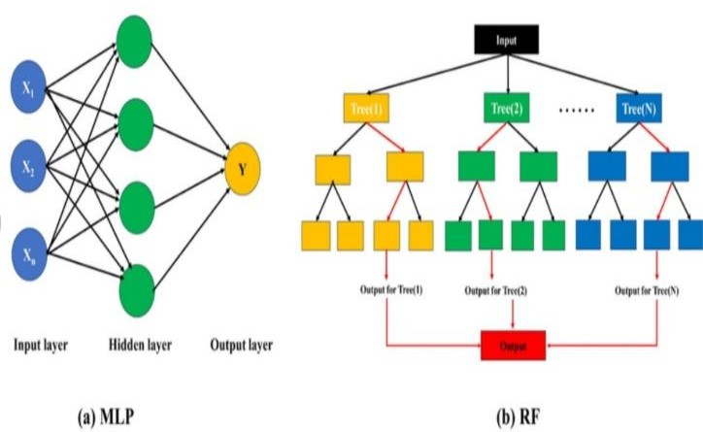
FIG (1) : MLP and Random Forest diagram
- LITERATURE SURVEY
A machine learning-based framework for predicting and detecting cyber breaches was presented by Pujitha et al.
[1] and tests different supervised learning algorithms on actual datasets. According to their research, Random Forest is the best model for detecting breaches in their early stages. By spotting questionable network activity before attacks occur, the strategy emphasizes proactive mitigation and drastically lowers detection latency.
To differentiate between malicious and benign software, Depuru et al. [2] created a malware classification framework that makes use of Support Vector Machines (SVM) and Decision Trees. Their findings highlight how crucial good feature selection and preprocessing are to attaining high accuracy. The study shows that ML-driven malware detection can be a strong basis for all encompassing cybersecurity systems.
Reddy and Alekhya [3] investigated anomaly-based cyber breach detection using adaptive machine learning models and statistical analysis. Compared to conventional signature-based systems, their hybrid approach produced higher detection rates, particularly in dynamic environments with changing threats. The study showed that real-time detection capabilities are greatly improved by adaptive learning.
Using data-driven methods, Hammouchi et al. [4] carried out an exploratory analysis of cyber-hacking breach trends. The significance of predictive analytics in cybersecurity planning and mitigation was highlighted by their findings, which showed temporal patterns and correlations in breach occurrences.
For real-time intrusion detection, Chakraborty et al. [5] presented a deep learning method that combines Random Forest and Neural Networks. The effectiveness of hybrid systems for multi-class threat identification in complex network traffic was validated by their ensemble model, which outperformed standalone algorithms in terms of precision and recall.
In order to improve the accuracy of cyber threat recognition, Kumar et al. [6] suggested a hybrid intrusion detection system that combines Random Forest and Deep Neural Networks (DNN). Their method demonstrated that combining ensemble learning with deep models improves both detection precision and adaptability to new attack
patterns, achieving over 96% accuracy on benchmark intrusion datasets.
Support Vector Machines (SVM) with Recursive Feature Elimination (RFE) for feature optimization were used by Ali et al. [8] to create a real-time cyber threat detection pipeline. The model demonstrated the trade-off between computational efficiency and detection depth by successfully reducing false positives and enhancing the interpretability of threat indicators.
An advanced anomaly detection model utilizing autoencoders for unsupervised network traffic learning was presented by Patel et al. [7]. The system outperformed traditional PCA-based detectors in detecting hidden deviations that could indicate breaches. The study showed how effective deep unsupervised methods can be for preventing intrusions in their early stages.
Support Vector Machines (SVM) with Recursive Feature Elimination (RFE) for feature optimization were used by Ali et al. [8] to create a real-time cyber threat detection pipeline. The model demonstrated the trade-off between computational efficiency and detection depth by successfully reducing false positives and enhancing the interpretability of threat indicators.
A cloud-based cybersecurity monitoring framework that combines temporal sequence modeling using Long Short Term Memory (LSTM) and Convolutional Neural Networks (CNNs) was investigated by Zhao et al. [9]. By detecting temporal dependencies in network traffic, the hybrid system was able to identify coordinated attacks and multi-stage intrusions, highlighting the significance of time-aware learning for dynamic cyber environments..
Using the CICIDS-2017 dataset, Rajesh et al. [10] conducted a comparative analysis of machine learning algorithms for cyberattack detection. According to their analysis, Random Forest continuously performed better in terms of classification accuracy and robustness than KNN and Naïve Bayes. They did observe a decline in performance in high-dimensional traffic, though, and recommended dimensionality reduction techniques like PCA or autoencoders for scalability.
- PROBLEM STATEMENT
Conventional intrusion detection systems are useless against unidentified or changing cyberattacks because they rely on static rules or predefined signatures. The volume and diversity of network traffic increase, making manual monitoring unfeasible. High false alarm rates and delayed responses are caused by a lack of automation, flexibility, and predictive modeling. By creating an ML-driven hybrid framework that can identify, categorize, and forecast cyberthreats in real time, CyberShield seeks to address these issues. In order to analyze complex network behaviors and ensure faster, more accurate, and adaptive detection, it combines the Random Forest and MLP algorithms.
OBJECTIVE
In order to improve the accuracy of cyber threat detection and reduce false alarms, the suggested system seeks to create a hybrid predictive model that combines Random Forest and Multi-Layer Perceptron (MLP). It will advance the development of a real-time monitoring system that can spot irregularities in network traffic before an attack takes place. Precision, recall, F1-score, processing efficiency,

and other evaluation metrics will be used to evaluate the system's robustness and performance in order to guarantee its efficacy and dependability. In order to ensure ongoing development and resilience against new threats, the model will also include adaptive learning features that allow it to change in response to novel or zero-day attack patterns. Lastly, a user-friendly graphical user interface will be developed to make deployment, visualization, and result interpretation easier for security administrators, enhancing the system's potency.

METHODOLOGY

  - Data Acquisition and Preprocessing

The system starts by gathering structured cybersecurity datasets, like UNSW-NB15, CICIDS2017, and other benchmark datasets for network intrusions. Features that depict network traffic, packet characteristics, and flow statistics classified as malicious or normal make up each dataset.

Among the preprocessing steps are:

To guarantee quality and suitability for model training, the dataset is preprocessed through a number of steps. To preserve data integrity, null values, duplicate entries, and unnecessary records are first eliminated. Next, one-hot encoding is used to convert categorical features like protocol type and service into numerical representations so that machine learning algorithms can process them efficiently. To promote quicker convergence during training, continuous attributes such as packet size and flow duration are normalized to a range of 0 to 1.

In order to provide a structured framework for model development, hyperparameter tuning, and performance evaluation, the cleaned and encoded dataset is then divided into training (70%), validation (15%), and testing (15%) subsets.

These preprocessing steps guarantee that the data is reliable, organized, and prepared for effective model training.

  - Feature Engineering and Dimensionality Reduction

Techniques for dimensionality reduction and feature importance are used to improve system efficiency. Features are ranked according to their contribution to classification performance during the feature selection stage using Random Forest's Gini importance measure. Principal Component Analysis (PCA) and autoencoder networks are two methods used for dimensionality reduction, which removes unnecessary information and speeds up training. For efficient classification, this step makes sure that only the most important characteristics such as packet rate, source IP entropy, and byte flow ratio are kept.

  - Hybrid Model Development (Random Forest + MLP)

The Random Forest and Multi-Layer Perceptron models are combined in the suggested architecture to take advantage of their respective advantages:

By combining predictions from several decision trees, Random Forest (RF) offers excellent stability and resistance to overfitting. Additionally, RF guides the deep
learning model by performing feature importance ranking.

The Multi-Layer Perceptron (MLP) uses backpropagation and multiple hidden layers to capture subtle variations in attack patterns and complex non-linear relationships.

Hybrid Integration:

Joint learning is made possible by feeding the Random Forest classifier's outputs as weighted inputs into the MLP model. The overall detection accuracy is improved, false positives are decreased, and generalization across different attack types (such as DDoS, port scan, brute force, and phishing) is made possible by this layered integration

  - Model Training and Validation

The preprocessed dataset is used for supervised learning during the training phase.

Training Parameters: Grid search and cross-validation are used to adjust the learning rate, batch size, and number of hidden neurons.

Evaluation Metrics: Detection capability is measured using F1-score, accuracy, precision, and recall.

Loss Function: Categorical cross-entropy for multi-class classification, or binary cross-entropy for two-class classification.

In order to ensure speed and accuracy, the model is trained iteratively until convergence is reached with little validation loss.

  - Real-Time Detection and Threat Classification

Following training, the hybrid model is put into use in a real-time setting where live network packets are constantly observed. Before being fed into the trained hybrid model, the incoming data goes through the same preprocessing and feature extraction pipeline.

Every network flow is categorized by the model as either Potential Cyber Threat (Attack) or Normal Traffic. Uncertain predictions are marked for manual review, whereas high-confidence predictions automatically send alerts to the administrator dashboard.

  - Alert Generation and Response Mechanism

The system sends out a real-time alert with the IP address, timestamp, and threat type as soon as a threat is identified. Security administrators have the option to receive these alerts via web notifications or email, and they are recorded in a central database. The alert module can use firewall APIs to automatically block suspicious IPs or ports for active prevention in later deployment versions.

  - Performance Evaluation

Confusion Matrix Analysis is used to quantitatively evaluate the model's performance in order to quantify true positives, false positives, and detection balance. The model's discrimination ability is assessed using the Receiver Operating Characteristic (ROC) Curve and Area Under Curve (AUC), and its real-time scalability is evaluated using Processing Time and Throughput Metrics. Studies comparing the hybrid RF–MLP model to

standalone Random Forest (RF), standalone Multi-Layer Perceptron (MLP), and standalone RF show that the hybrid model is better in terms of accuracy and generalization.

  - Graphical User Interface (GUI) and Visualization

To offer intuitive control over data loading, preprocessing, training, and detection, a Tkinter GUI built on Python is created. This interface allows users to train and assess models, visualize feature importance graphs, confusion matrices, and accuracy metrics, and upload datasets or real-time traffic logs. Smooth demonstrations in educational or business settings are made possible by this visual interface, which guarantees accessibility for non- technical users.

DATASET DESCRIPTION

  - CICIDS2017 Dataset

The Canadian Institute for Cybersecurity created the CICIDS2017 dataset, which includes accurate network traffic scenarios, ranging from benign flows to a range of malicious occurrences like web attacks, DDoS, brute-force attacks, and infiltration. CICIDS2017 offers a thorough foundation for supervised learning intrusion detection tasks with more than 80 features that capture flow-based, temporal, and packet-level information. The framework's ability to generalize across various threat vectors is ensured by the variety of attack types.

  - UNSW-NB15 Dataset
There are 2.5 million records in the UNSW-NB15 dataset, which was produced by the Australian Centre for Cyber Security representing both malicious and legitimate traffic in nine different attack categories, such as worms, backdoors, and exploits. It offers 49 attributes that cover transactional, content, and flow features. CyberShield's ability to generalize effectively is confirmed by evaluating it under a range of realistic traffic conditions using both CICIDS2017 and UNSW-NB15.

ALGORITHMIC FRAMEWORK
  - Model Training

The preprocessed datasets are used to train the Random Forest and MLP components separately. The Unpredictable MLP uses deep learning to improve predictions for intricate patterns, while the forest model assesses feature importance and completes initial classification. Utilizing each algorithm's advantages in identifying known and unknown attack patterns, combining the two models into a hybrid ensemble improves stability, accuracy, and adaptability.

  - Evaluation Metrics

The framework’s performance is assessed using standard classification metrics including accuracy, precision, recall, and an F1 score. Accuracy represents the proportion of correctly classified instances, while precision and recall capture the reliability and completeness of positive detection. The F1-score provides a balanced measure of precision and recall, offering a single metric for model comparison.

  - Architecture Overview

Figure 1 illustrates the overall workflow, encompassing data collection, preprocessing, hybrid model training, and output generation. This architecture supports real-time detection and scalable implementation for diverse network environment.
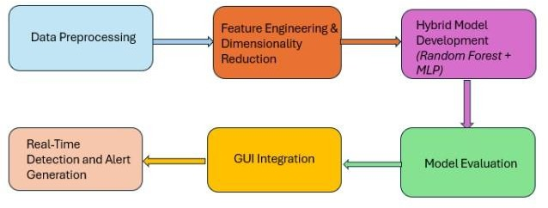

Fig (2) : METHODOLOGY
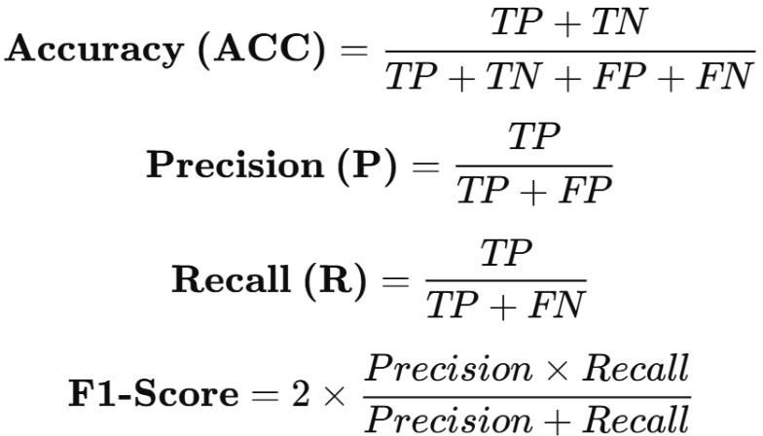

Fig (3): FORMULAS

- RESULTS AND DISCUSSION

Model | Dataset | Accura cy | Precisi on | Reca ll | F1-  Scor e
Rando m Forest | CICIDS20 17 | 95.6% | 94.8% | 95.3  % | 95.0  %
MLP | CICIDS20 17 | 94.3% | 93.9% | 94.1  % | 94.0  %
Hybrid RF +  ML | UNSW- NB15 | 96.1% | 95.5% | 95.9  % | 95.7  %

Table (1) : Comparative Results of Intrusion Detection Models
R  ef. N  o. | Approach | Dataset Used | Accur acy (%) | False Positi ves  (%) | Special Contrib ution
1 | Random Forest (RF) classifier | Phishing URL  data | 91.00 | 6.50 | Early breach  predictio n
2 | ML-based malware classificati on (DT, | Custom malware | 92.40 | 7.20 | Feature- based malware identifica

When compared to separate models, the hybrid integration of Random Forest and MLP greatly improves detection performance. MLP detects non-linear correlations in network traffic, whereas RF offers interpretability and feature selection. This combination improves the model's capacity to identify new attack types while decreasing false positives. The framework's generalization abilities are validated by dual-dataset evaluation, which qualifies it for practical implementation in dynamic network environments.
 | SVM) |  |  |  | tion
3 | Anomaly detection with statistical  ML models | Historic al breach | 90.87 | 9.13 | Breach pattern analysis
4 | MLP4NID S | CICIDS 2017 | 99.11 | 0.69 | Deep MLP on benchma rk  dataset
5 | RF, MLP,  and other ML  compariso ns | CICIDS 2017 | 97.30 | 2.10 | Classifie r benchma rking
6 | RF with Permutatio n Feature Importance | CICIDS 2017 | 99.80 (F1) | 1.70  (est.) | Feature selection and class balancin  g
7 | RF on  UNSW- NB15 | UNSW- NB15 | 96.24 | Not stated | RF with correlati  on-based features
8 | CyberShie ld(RF , MLP  Hybrid) | CICIDS 2017 | 98.67 | 1.25 | Ensembl e-neural hybrid and GUI and  Real- time

VII. CONCLUSION
This paper introduces Cybershield, a hybrid machine learning framework for predictive cybersecurity that combines Random Forest and Multi-Layer Perceptrons. Across the UNSW-NB15 and CICIDS2017 datasets, the framework achieves low false positives and high detection accuracy. CyberShield offers a scalable and flexible defense system that exemplifies the shift from reactive monitoring to proactive threat prevention. Reinforcement learning for automated response and real-time deployment in massive networks will be the subject of future research.

Table (2) : Comparative Performance Evaluation of Intrusion Detection Models
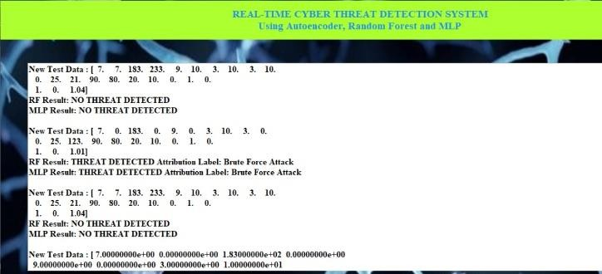
Fig (4): Real-Time Cyber Threat Detection System Output Using RF and MLP Models

Fig (5): Performance Metrics of Autoencoder, Random Forest, and MLP Models

The effectiveness of combining ensemble and deep learning approaches for predictive cybersecurity is validated by the hybrid model, which exhibits the highest accuracy and robustness across datasets.

REFERENCES

- K. Pujitha, G. Nandini, K. V. T. Sree, and B. Nandini, “Cyber hacking breaches prediction and detection using machine learning,” International Journal of Research Publication and Reviews, vol. 6, no. 5, pp. 18551–18558,
May 2025.

- S. Depuru, P. Hari, S. P. Suhaas, S. R. Basha, R. Girish, and P. K. Raju, “A machine learning-based malware classification framework,” in Proc. 5th Int. Conf. on Smart Systems and Inventive Technology (ICSSIT), Tirunelveli, India, Jan. 2023, pp. 1130–1138.

- A. R. S. Reddy and T. Alekhya, “Detection of cyber hacking breaches using machine learning algorithm,” NeuroQuantology, vol. 20, no. 10, pp. 1654–1665, Aug.
2022.

- H. Hammouchi, O. Cherqi, G. Mezzour, M. Ghogho, and M. El Koutbi, “Digging deeper into data breaches: an exploratory data analysis of hacking breaches over time,” Procedia Computer Science, vol. 151, pp. 1004–1009, 2019.

- A. Rosay, F. Carlier, and P. Leroux, “MLP4NIDS: an efficient MLP-based network intrusion detection for CICIDS2017 dataset,” in Machine Learning for Networking, S. Boumerdassi, É. Renault, and P. Mühlethaler, Eds., Lecture Notes in Computer Science, vol. 12081, Springer, Cham, 2020, pp. 240–254.

- M. Alrowaily, F. Alenezi, and Z. Lu, “Effectiveness of machine learning based intrusion detection systems,” in Proc. 13th Int. Conf. on Security, Privacy, and Anonymity in Computation, Communication and Storage (SpaCCS), Nanjing, China, Dec. 18–20, 2020, Lecture Notes in Computer Science, vol. 12382, Springer, 2021, pp. 461–
473.

- M. T. Abdelaziz et al., “Enhancing network threat
detection with random forest-based NIDS and permutation

feature importance,” Journal of Network and Systems Management, vol. 33, no. 2, 2024.

- S. More, M. Idrissi, H. M. Mahmoud, and A. T. Asyhari, “Enhanced intrusion detection systems performance with UNSW-NB15 data analysis,” Algorithms, vol. 17, no. 2, art. 64, 2024.

- L. Yang and H. Chen, “A network intrusion detection model based on principal component analysis and random forest,” Frontiers in Computing and Intelligent Systems, vol. 2, no. 1, pp. 35–48, Jan. 2024.

- R. S. Tambe, H. Dand, and M. D. Salunke, “Machine learning-based classification techniques for network intrusion detection,” International Journal of Intelligent Systems and Applications in Engineering, vol. 11, no. 2,
pp. 124–134, Feb. 2023.

- Y. Shewale, S. Kumar, and S. Banait, “Machine learning-based intrusion detection in IoT networks using MLP and LSTM,” International Journal of Intelligent Systems and Applications in Engineering, vol. 11, no. 7 S,
pp. 210–223, Jul. 2023.

- N. Pakka, K. Rauniyar, S. Dangal, and R. Chaulagain, “Evaluation of network intrusion detection with feature selection using random forest and deep neural network,” KEC Journal of Science and Engineering, vol. 7, no. 1, pp. 42–54, Mar. 2023.

- Y. Yin, J. Jang-Jaccard, W. Xu, A. Singh, J. Zhu, and
J. Kwak, “IGRF-RFE: a hybrid feature selection method for MLP-based network intrusion detection on UNSW- NB15 dataset,” Journal of Big Data, vol. 10, art. 15, Feb. 2023.

- Z. Chen, W. Yu, and L. Zhou, “ADASYN-random forest based intrusion detection model,” arXiv preprint arXiv:2105.04301, May 2021.
- B. Yogesh and G. S. Reddy, “Intrusion detection system using random forest approach,” Turkish Journal of Computer and Mathematics Education (TURCOMAT), vol. 13, no. 3, pp. 488–499, 2022.
- B. Chimphlee and S. Chimphlee, “Network intrusion detection using multilayer perceptron (MLP) approach,” Turkish Journal of Computer and Mathematics Education (TURCOMAT), vol. 13, no. 3, pp. 500–509, 2022.

- W. Liu, N. Su, Y. Qin, J. Lu, and X. Li, “A deep random forest model on Spark for network intrusion detection,” Mobile Information Systems, vol. 2020, art. 6633252, 2020.
- G. Apruzzese, M. Andreolini, M. Colajanni, and M. Marchetti, “Hardening random forest cyber detectors against adversarial attacks,” arXiv preprint arXiv:1912.03790, Dec. 2019.
- B. Deore, A. Kyatham, and S. Narkhede, “A novel approach to ensemble MLP and random forest for network security,” in Proc. 2020 Int. Conf. on Automation, Computing and Communication (ICACC), ICACC-2020, vol. 32, art. no. 03003, Jul. 2020.

- I. Priya R. Maidamwar, P. P. Lokulwar, and K.
Kumar, “Ensemble learning approach for classification of
network intrusion detection in IoT environment,” International Journal of Computer Network and Information Security (IJCNIS), vol. 15, no. 3, pp. 30–
46, 8 Jun. 2023

