Commands and Screenshots

9.

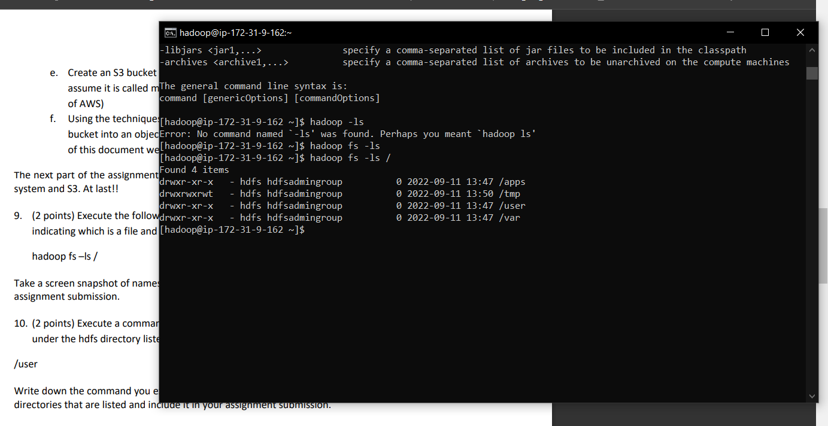

10. list files and dir under USER

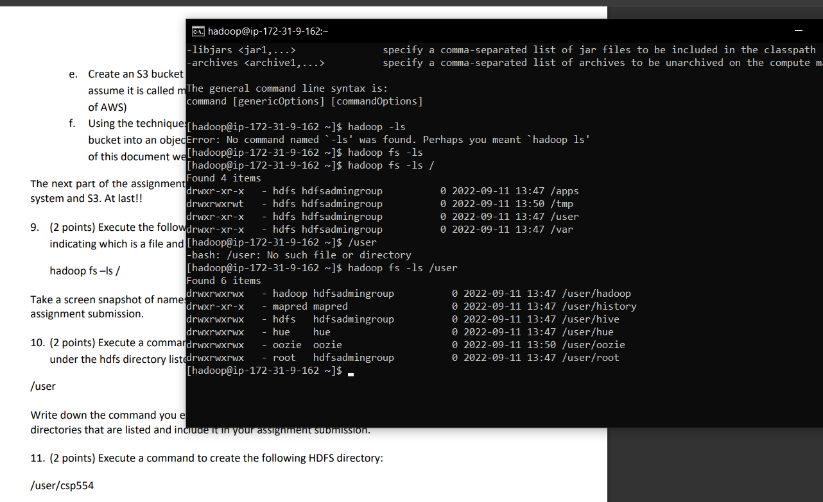

11. /user/csp554

Cmd: hadoop fs -mkdir -p /user/csp554

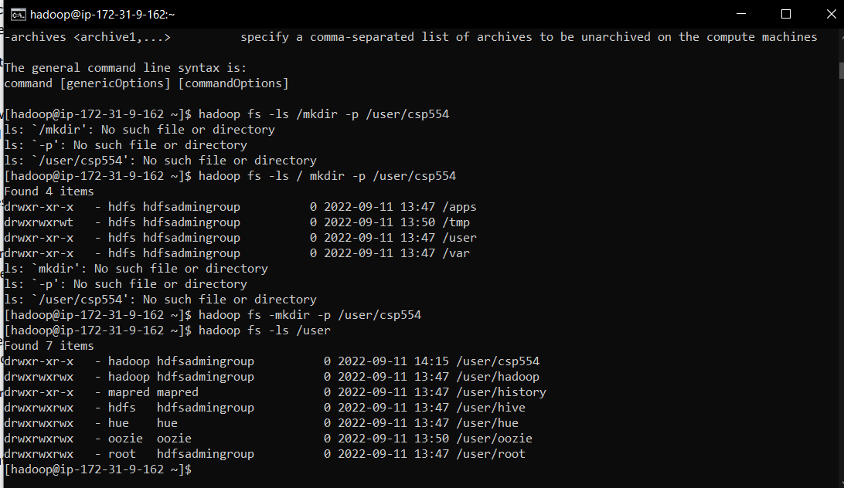

12. /user/csp554-2

Cmd: hadoop fs -mkdir -p /user/csp554-2

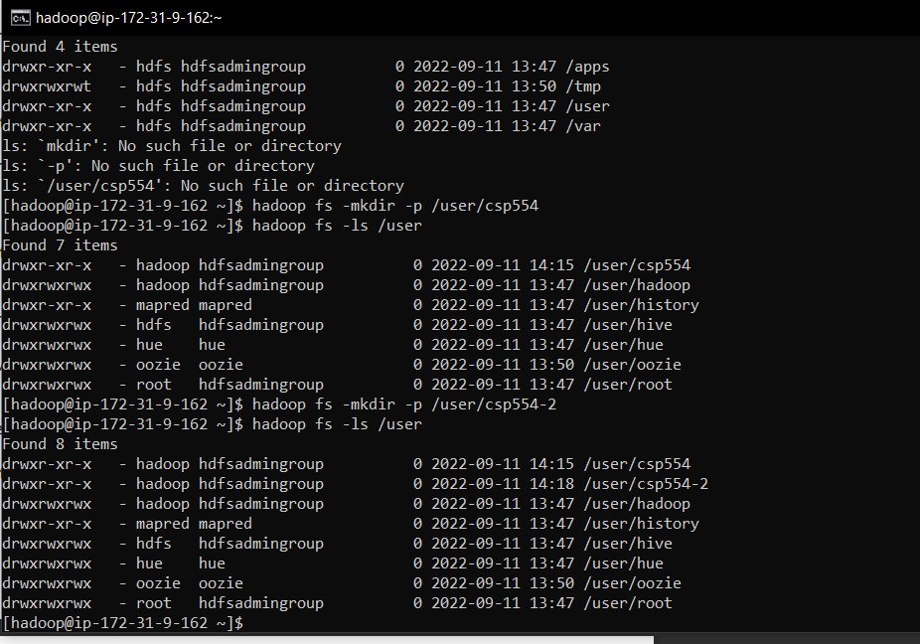

13. Execute a command that copies a given local file to the given hdfs directory

Cmd:

hadoop fs -copyFromLocal -p /home/Hadoop/RameshChandraReddyMusilanna.txt /usr/csp554

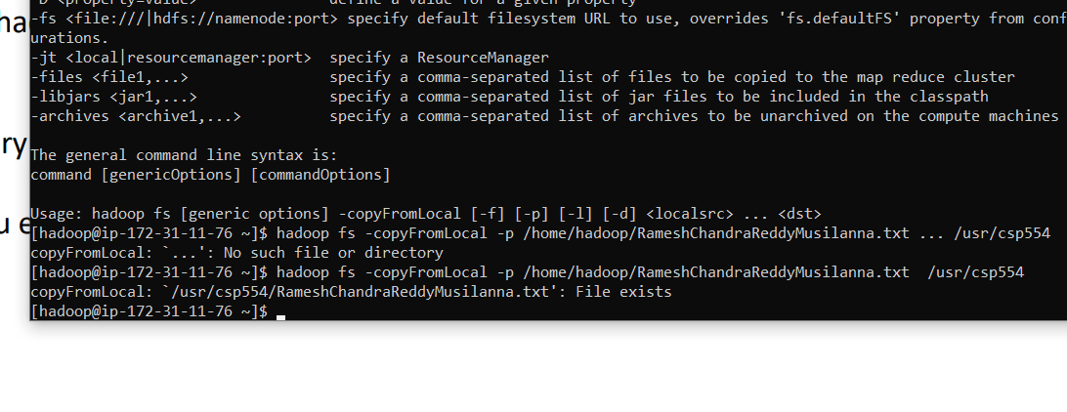

14. Copy a file from one hdfs directory to another hdfs directory and write down the command

Cmd: Hadoop fs -mv /usr/csp554/RameshChandraReddyMusilanna.txt /usr/csp554-2

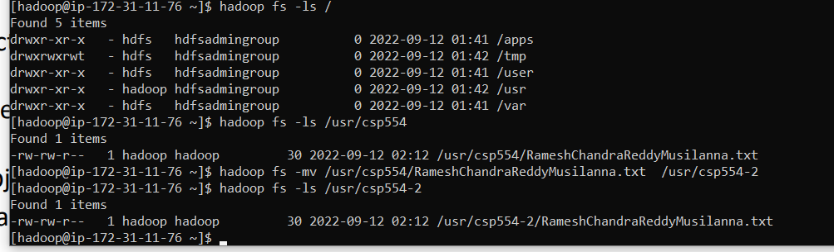

15. Copy the object myid.txt you uploaded to an S3 bucket into the Hadoop master node Linux file system

Cmd: aws s3 cp s3://a20521309.txt /home/Hadoop/A20521209.txt

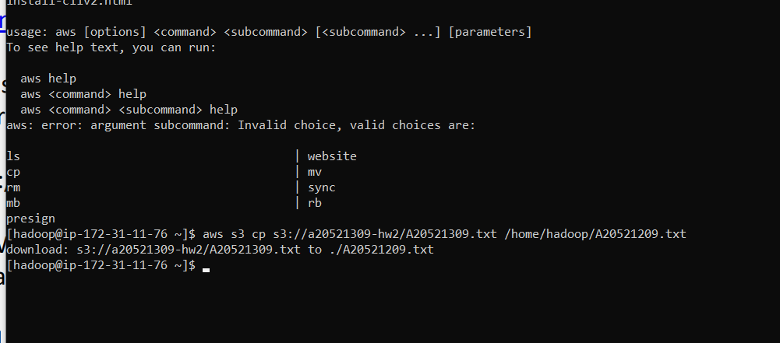

16. Copy the same object myid.txt you created in an S3 bucket into HDFS into the directory /users/csp554

Cmd: Hadoop fs -cp s3://a20521209.txt hdfs:///usr/csp554-2

Hadoop fs -ls /usr/csp554-2

