Global Superstore Power BI Dashboard
“Good morning, everyone!
Let me walk you through my Power BI project — the Global Superstore Dashboard.
I designed this 5-page interactive dashboard to help business teams understand sales, profit, and customer performance from a global perspective.”

🟢 Page 1 – Executive Dashboard
“This first page gives a complete business summary.
Here I’ve shown key KPIs — like Total Sales, Profit, Orders, and Profit Margin.
I also used charts like bar and donut charts to show which region and category are performing best.
With slicers like Year, Region, and Segment, management can quickly filter and view performance by area or product type.
This page basically acts like a company’s health card — it helps top management instantly know what’s working and what’s not.”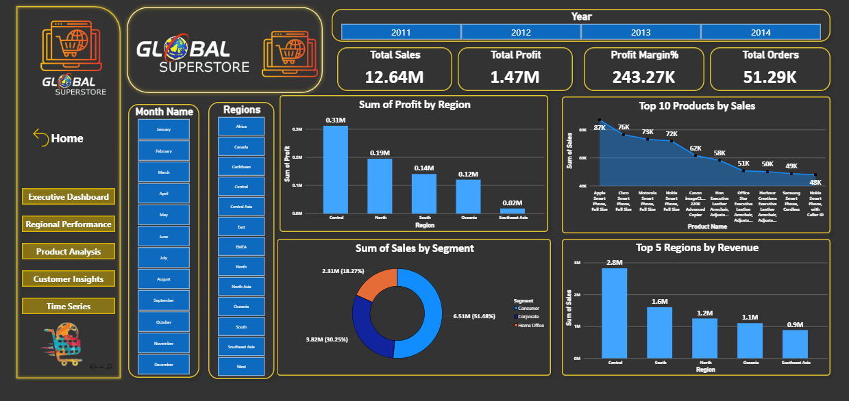

🟣 Page 2 – Regional Performance
“In the second page, I focused on region and country performance.
Here, I used a map chart and bar chart to show top-performing regions and countries in terms of sales and profit.
For example, the West region consistently generates the highest revenue, and the Central region has great profit margins.
This page helps decision-makers understand where the business is strong geographically, and where there’s room for improvement.”
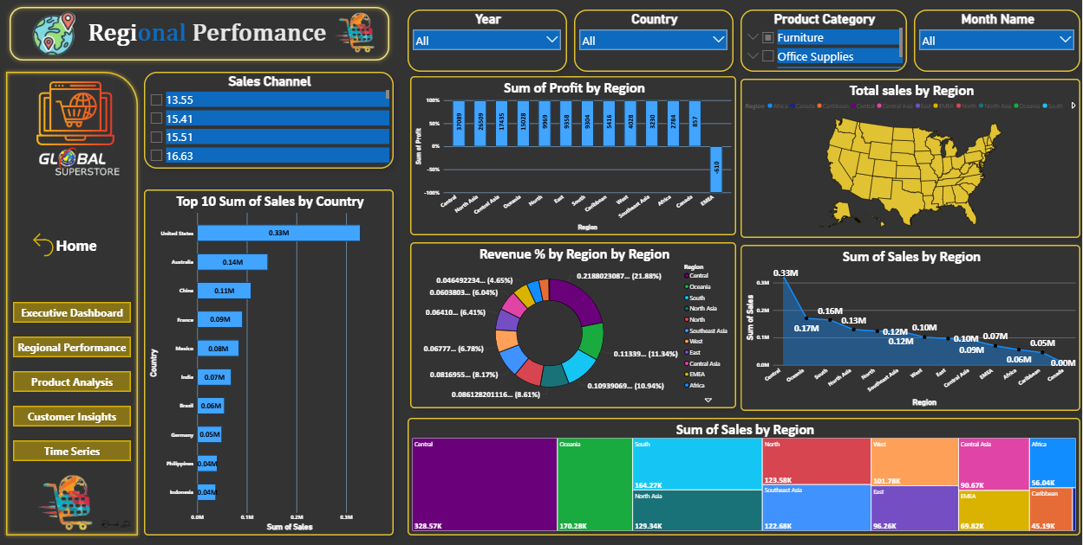

🟡 Page 3 – Product Analysis
“On this page, I wanted to find out which products and categories drive our business the most.
So I used a bar chart and bubble chart to compare discounts, sales, and profits.
I also added a line chart to check monthly performance by category.
Here I found an important insight — when discounts go above 20%, profit starts dropping.
That kind of insight helps managers adjust pricing and discount strategies.”
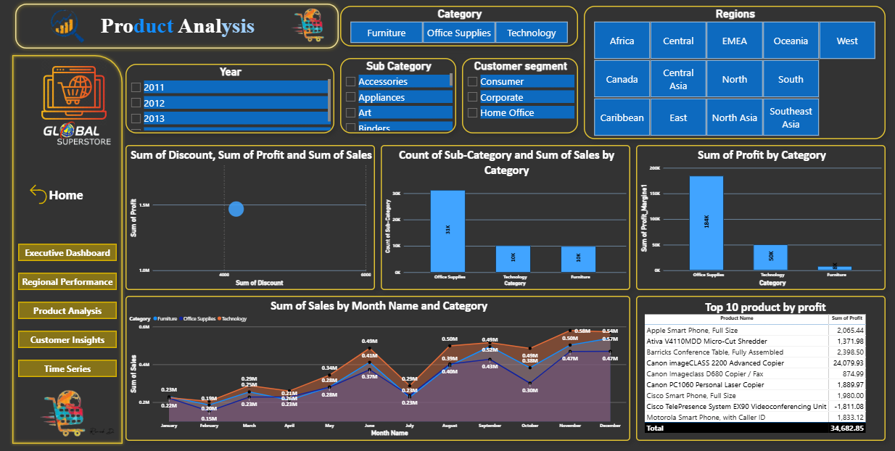

🔵 Page 4 – Customer Insights
“This page focuses on our customers — who are our best customers, how often they buy, and which segments are most profitable.
I used a table for Top 10 customers by sales and profit, and a donut chart to compare new vs repeat customers.
There’s also a KPI card showing average purchase frequency — which helps in understanding customer loyalty.
So this page helps the company build strong relationships with high-value customers.”
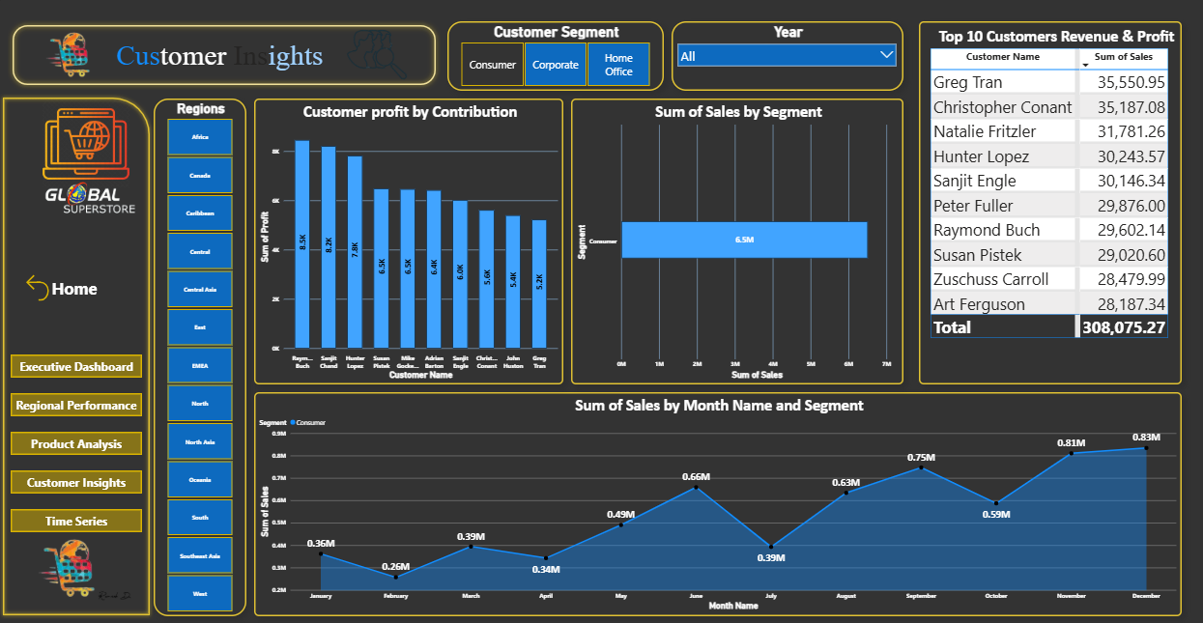

🟠 Page 5 – Time Series Analysis
“The last page focuses on time-based trends.
Here I used line, area, and stacked column charts to show monthly, quarterly, and yearly sales patterns.
I added slicers for Year, Month, Region, and Category — so the user can analyze seasonal sales patterns.
The data clearly shows sales peak in November and December, especially during the holiday season — that’s a great insight for planning marketing campaigns and inventory.”
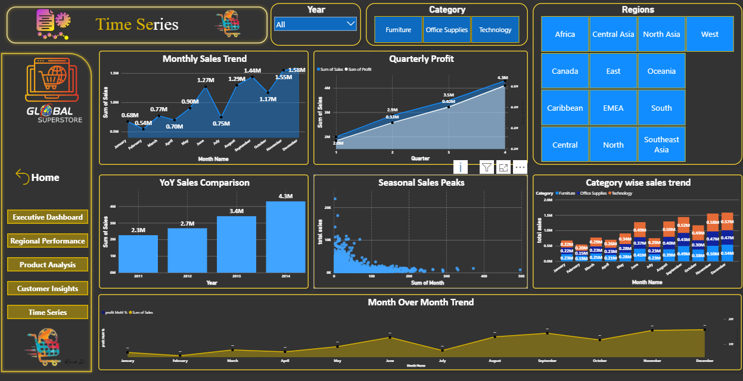
Final Summary:
Using Power BI, I transformed raw Global Superstore data into a meaningful 5-page interactive report.
This dashboard helps managers make data-driven decisions — like identifying top-performing regions, profitable products, and loyal customers.
It also helps track business trends over time and optimize discounts and logistics.
Through this project, I learned how to clean data in Power Query, build DAX measures, design visual dashboards, and most importantly, tell a story through data.”

